Security Guide


Revision Date
November 22, 2022

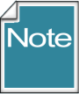 | This guide has consolidated security-related information from several guides, both at the user and administrator levels. Information pertinent to administrators will be indicated as such.

Author
Martin Reisinger

Comments/Suggestions:
Please contact Martin Reisinger, either via feedback@ars-grin.gov, marty.reisinger@usda.gov or mar@rrginc.com with any suggestions or questions related to this document. This and other GRIN-Global –related documentation can be downloaded from the GRIN-Global Project website Documentation Page: https://www.grin-global.org/userdocs.htm

The Appendix contains this document’s revision notes.

Table of Contents

Security: Ownership & Permissions 4
Ownership 4
Changing Ownership 5
SQL for Determining Ownership 5
Changing Permissions 5
Permission Definitions 8
SQL for Determining Permissions 8
This Section is Primarily Relevant to Administrators 9
Parent and Owner Relationships Between Dataviews 9
Background on the Parent Method of Assigning Ownership 10
Adding Users and Implementing Security (for Administrators) 12
Overview 12
Disable Security Entirely 14
Adding New GG Users 14
Error Messages 15
Establishing Groups and Permissions 16
Setting up a Site "Power User" for a Site 18
Create the Permission 18
Create a Group Using the Permission and Add User(S) 19
Appendix: Document Revision Notes 20
– November 22, 2022 20
– July 23, 2021 20
– January 28, 2021 20

Security: Ownership & Permissions
Organizations typically have very unique security needs; GRIN-Global (GG) was designed to be flexible enough to accommodate these diverse needs. In GG, when speaking of security, there are two primary concepts that intersect:
- ownership
- permissions

Ownership
An owner usually can update or delete records which she has created. Several points to remember:
- only one owner per record
- an owner can transfer ownership to another user
- an owner can provide permissions (Read, Update, Delete) to multiple users
In the Curator Tool, in most dataviews, the six columns displayed at the far right are the “audit fields” that inidicate who created the record, who modified it (if it was), and who owns it. Three of the six fields are the associated dates fields.
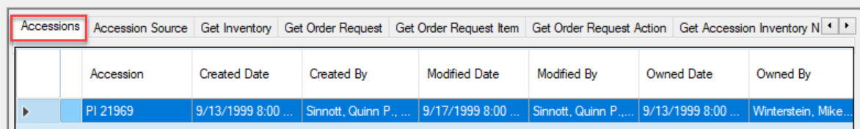

In some cases, the person creating the record is not necessarily the owner of the record. For example, Inventory records are assigned the same owner as the owner of the Inventory Maintenance Policy that was used to create the Inventory record.

Changing Ownership
Changing ownership in the Curator Tool is simple; if you own the record, select it; right-click:
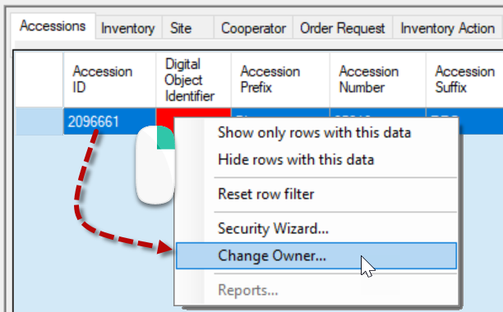 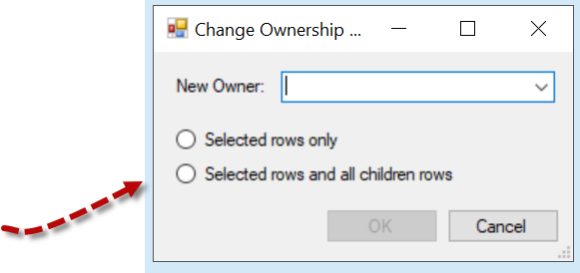
Typically, you would select “Selected rows and all children rows.”
You will be prompted to select the new owner from a list of the organization’s internal users:
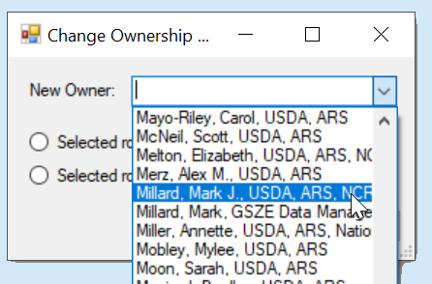

SQL for Determining Ownership
Under Tools on the Public Website, (when logged in), you can run a query to determine ownership hierarchy (For more details, see the Administrator section.)
SELECT st1.table_name AS child, st2.table_name AS owner
FROM sys_table_relationship str
JOIN sys_table_field stf1 ON stf1.sys_table_field_id = str.sys_table_field_id
JOIN sys_table st1 ON st1.sys_table_id = stf1.sys_table_id
JOIN sys_table_field stf2 ON stf2.sys_table_field_id = str.other_table_field_id
JOIN sys_table st2 ON st2.sys_table_id = stf2.sys_table_id
WHERE relationship_type_tag = 'OWNER_PARENT'

Changing Permissions
If you own the record, you can grant specific permissions to designated users so that they may edit the record, and even delete the record.

A permission restricts or grants access to a resource in GRIN-Global; for a Curator Tool user, a resource is typically a row in a table – a record displayed within a dataview.
You use the security wizard to establish permission levels to protect specific record types from accidental (or intentional) deletion. For example, you can establish security permissions so that specific staff in the organization will be able to update specific inventory records, but not delete them.
In the Ownership section above, we discussed how the creator of a record doesn’t necessarily own the record. Inventory records are owned by the owner of the Maintenance Policy that was used when creating the Inventory record. Therefore, someone creating an Inventory record might not have permission to update or delete it.
In another example, a genebank may have student technicians uploading (creating) observation information or creating action records on an accession or inventory, but the genebank does not want the student to alter the data. A permission policy can be established to ensure that this environment is set up to safeguard the data.

Steps to Establish Permissions
- Determine what records you wish to protect: accessions, inventory, orders, etc. Open the respective dataview.
- In the Curator Tool, locate a record (or records) you own – then right click – select Security Wizard
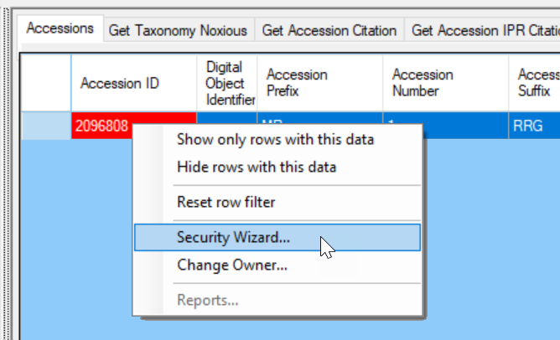
- In the Security Wizard, start from left to right. (image next page)
  - (1) Add a Policy – (2) Rename the policy (optional) (right click).
  - (3-4) Change Update and Delete to Allow (ignore Read and Create does not need to be changed, ever)
  - (5) Include all children tables
  - (6) All rows
  - (7) Select who is to receive the permissions
  - (8) Save
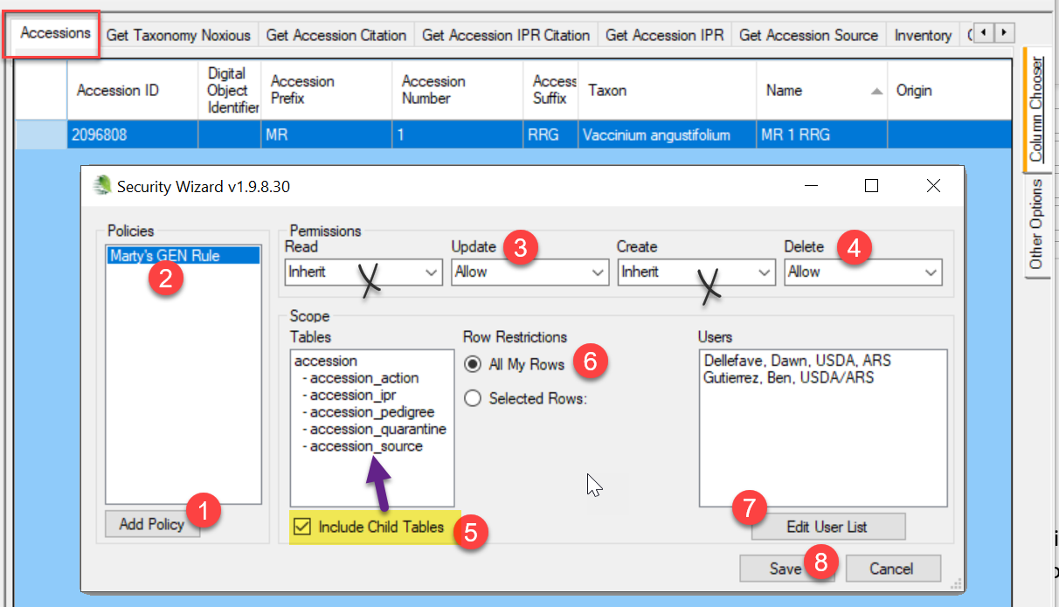
This Security Wizard screen has two fields (crossed over in the image above ) which typically do not apply to the Curator Tool user. “Read”: Most organizations allow the internal staff to read all records. “Create” doesn’t apply either, because in the context of selecting records to assign permissions, the records already exist.
 | Currently the inheritance only cascades one level. Under Scope, you see the child tables to Accession. This implies that it may be necessary for you to establish certain permissions at the accession level, and then again at the inventory level. As needed, you should consider repeating steps 2 for Inventory, and then for Orders, then for Observations.
 | In the Row Restrictions option (labeled #6), select All My Rows to guarantee that records created in the future will also be governed by this policy.

Permission Definitions
The permission definitions are defined in the tables below. To simplify all of this, remember that most permission situations involve allowing or denying users to do certain things – reading, deleting, or updating records. Example: you may want certain users to be able to update “my” inventory records, but never delete them.

Permission Defined
A permission restricts or grants access to a resource in GRIN-Global. A resource is defined as a specific table, dataview, or row. A permission defines four kinds of rights:
A permission of type: | Has the ability to:
Read | Read existing data
Update | Update existing data
Delete | Delete existing data
Create* | Insert new data
* in the CT, ignore this option – it really doesn’t apply; typically, you will set the Update and Delete options since usually within an organization everyone internally should be able to read the records
Each permission can have one of three values:
Value | Description
Allow | Allows access
Deny | Denies access
Inherit | Neither allows nor denies access; access is situational; it is inherited from a previous definition (typically the permission value of the parent table)

SQL for Determining Permissions
Under the Public Website Tools option, you can determine what permission policies have been created for a user.
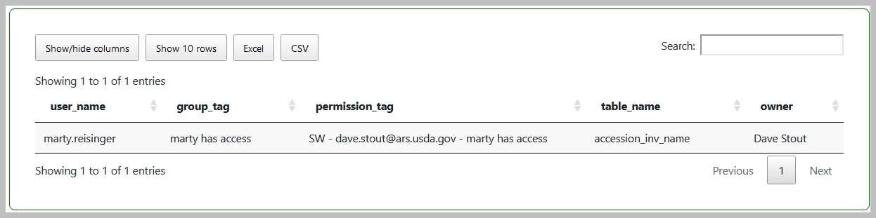
The “SW” in the example above is indicating that the permission was created via the Curator Tool’s Security Wizard.
SELECT su.user_name, sg.group_tag, sp.permission_tag, st.table_name, CONCAT(c.first_name, ' ', c.last_name) AS owner
FROM sys_user su
JOIN sys_group_user_map sgum ON sgum.sys_user_id = su.sys_user_id
JOIN sys_group sg ON sg.sys_group_id = sgum.sys_group_id
JOIN sys_group_permission_map sgpm ON sgpm.sys_group_id = sg.sys_group_id
JOIN sys_permission sp ON sp.sys_permission_id = sgpm.sys_permission_id
LEFT JOIN sys_table st ON st.sys_table_id = sp.sys_table_id
JOIN cooperator c ON c.cooperator_id = sp.created_by
WHERE sp.owned_by != 48
AND user_name LIKE '%reisinger%'

This Section is Primarily Relevant to Administrators

Parent and Owner Relationships Between Dataviews
In the Admin Tool, relationships are mapped between dataviews. For instance, there is a relationship from accession to accession_inventory_name with the Relationship Type defined as "Parent and owner."
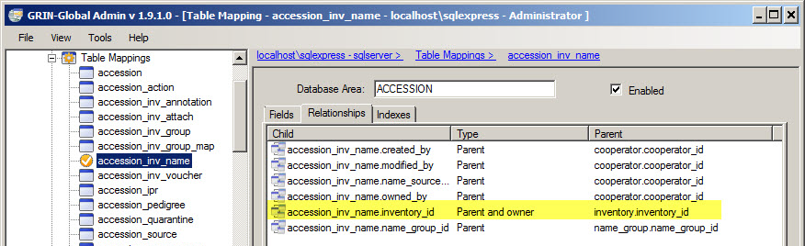
When relationships are mapped between dataviews, the children tables inherit the security settings of the parent. This means if someone creates a record in accession_inventory_name, the owner is the same as the owner of the parent record, in this case the inventory record.
When no relationship of "Parent and owner" has been defined, then the creator is the owner. When doing ownership calculation, relationships are taken into consideration.
The following question is often asked: “What is the rationale behind having the Inventory Site derived from whoever owns the inventory maintenance policy?” The GG designers felt it worked better to assign inventory ownership based on the Maintenance Policy that was used in making the Inventory record than on the Accession to which the inventory was linked. Inventory records are assigned the same owner as the owner of the Inventory Maintenance Policy used to create the Inventory record. This enables another site, such as a backup site that manages inventory for accessions owned elsewhere, to be able to use their own Inventory Maintenance Policy to assure they can then maintain any inventory records that they create. They own the inventory, but the accession is owned elsewhere.

Background on the Parent Method of Assigning Ownership
The basic ownership model is that anyone can create a record in any table. The creator of the record is then typically the owner – that person is the only person who can modify or update the record (except the system administrator). GG was designed so that some subsidiary tables would have ownership that flowed from a parent table, so that the owner of the important parent record would be able to manage the subsidiary child tables. This is controlled by an OWNER-PARENT setting in the sys_table_relationship table that indicates which table, if any, acts as the owning parent.

It is helpful for record management to have all the rows in the associated accession tables owned by the same person and the same is true for the inventory area. Originally, GG was going to have the inventory obtain its ownership from accession, but that caused issues with backup site inventory records, so inventory ownership was switched to the maintenance policy.

If that is an issue for a genebank, a change could be made to the sys_table_relationship table to use accession as the owner of inventory or simply drop setting ownership by parent for the inventory table. That setting can be adjusted with the Admin Tool. In the AT, go into Table Mappings for the Inventory table and use the Relationships tab which shows all the Foreign Key links. Look for the "Parent and owner" Type and change it to "Parent.”

There may be tables that are currently stand-alone that could benefit from adding a Parent and owner relationship. The following SQL shows the tables that currently get ownership from a parent table:

SELECT st1.table_name AS child, st2.table_name AS owner
FROM sys_table_relationship str
JOIN sys_table_field stf1 ON stf1.sys_table_field_id = str.sys_table_field_id
JOIN sys_table st1 ON st1.sys_table_id = stf1.sys_table_id
JOIN sys_table_field stf2 ON stf2.sys_table_field_id = str.other_table_field_id
JOIN sys_table st2 ON st2.sys_table_id = stf2.sys_table_id
WHERE relationship_type_tag = 'OWNER_PARENT'

child | owner
accession_action | accession
accession_inv_annotation | inventory
accession_ipr | accession
accession_pedigree | accession
accession_quarantine | accession
accession_source | accession
accession_source_map | accession_source
accession_inv_voucher | inventory
crop_trait_code | crop_trait
crop_trait_observation | inventory
inventory | inventory_maint_policy
inventory_action | inventory
inventory_quality_status | inventory
inventory_viability | inventory
order_request_action | order_request
order_request_item | order_request
taxonomy_genus | taxonomy_family
genetic_marker | crop
genetic_observation | inventory
accession_inv_attach | inventory
accession_inv_name | inventory
order_request_attach | order_request
accession_inv_group_map | accession_inv_group
geneva_site_inventory | inventory
nc7_site_inventory | inventory
ne9_site_inventory | inventory
nssl_site_inventory | inventory
opgc_site_inventory | inventory
parl_site_inventory | inventory
s9_site_inventory | inventory
w6_site_inventory | inventory
accession_inv_group_attach | accession_inv_group
method_attach | method

Adding Users and Implementing Security (for Administrators)

Purpose
This section contains detailed steps for including information on setting security permissions, as well as a summary for adding new users to GRIN-Global. It summarizes the basic considerations needed when establishing new UserIDs, as well as general security considerations.

Overview
In general terms, there are three security alternatives to be considered:
- Disable security entirely
- Have an intermediate level of security centered around parent and child tables or related dataviews
- Very strict security, as controlled as possible, where security is set at the record level based on specified criteria

The first scenario is discussed on the next page. You can accomplish the second alternative by setting up permission groups as needed and including Users in these groups or by establishing specific permissions and then applying them as needed to individual UserIDs; this is also explained on the next page. The third case, which typically controls a user’s access to particular records, may involve Permissions based on criteria that evaluate a field’s contents.
For example, the permission being established in this Restriction screen is based on the contents in the accession_number_part1 field. The user being granted this permission would be limited to accession records whose accession _number_part1 field was equal to “mar.”
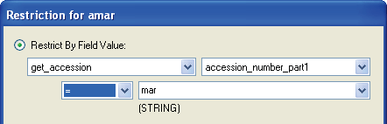
This Restriction screen is available in the Admin Tool when adding new permissions. (The Curator Tool users who are records owners also have similar screens available via the CT Security Wizard. A record owner can indicate whether other users can read, update (edit), write, or delete data at the record level.)

Disable Security Entirely
One (fairly drastic) option is to disable security entirely:
Action | Description
Disable or enable security  system wide | Only the administrators of the installation can disable/enable security. In the Admin Tool, on the Web Application node, right- click DisableSecurity; select Properties; set DisableSecurity to true.  This action disables security across everything and all permissions are ignored.

Adding New GG Users
Refer to the Admin Tool Guide for complete “how-to” directions on setting up new users. Some key points to remember when adding users:
Action | Description
Select the Enabled checkbox | indicates that the user will be allowed to login to the Curator Tool
Select the Active checkbox | indicates the UserID is associated with an active cooperator – any data created or modified by this user will be tagged by his CooperatorID
Select a language for the user | The language setting determines what column headings, button text, etc. the user will see displayed in the Curator Tool
Assign the same Site Code | users who need to share lists within the Curator Tool must have the same Site Code
Add user to the CT Users group | If the user will be using the Curator Tool, he needs to be added to the CT Users group. (By default, a new user is added only to the All Users group – the user has no CT permissions at that point
Assign All Access permission to the user (if the user needs unlimited access) | Gives universal Create/Read/Update/Delete rights. The Administrators group has this permission as does the Administrator UserID.  (Alternatively, you may decide to set up other Groups (see the next row in this table) with narrower permissions and not assign All Access to every user.)
Add user to other groups as needed | Groups will have specific permissions which meet an organization’s very unique needs. Groups are essentially templates for establishing permissions, so that each user does not need to be set up individually, but rather can be assigned to appropriate groups.

Error Messages
If security is enabled (the default situation), users not added to the CT Users Group the will receive several error messages when they log on. The following message displays when a user logs in to the Curator Tool and the user was not added to the CT Users Group:
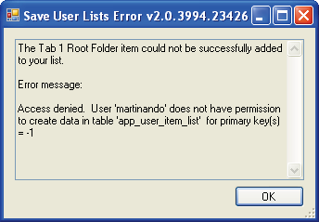

The following error message will immediately be displayed as well, again for the same reason:
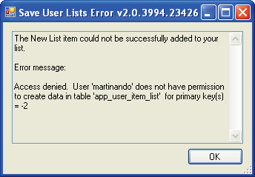

To correct this situation and to avoid the error messages, add the user to the CT Users group.

Establishing Groups and Permissions
However, even when users are included in CT Users , they still will not be able to save new records. This section explains why an organization will want to establish other Groups and Permissions beyond the All Users and CT User groups that come installed with GRIN-Global.
For example, a message similar to the following will be displayed after a failed Save action:
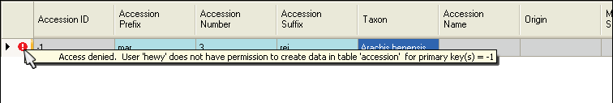
This user has not yet been given any permissions (other than “Read”) to the Accession (or any) table:
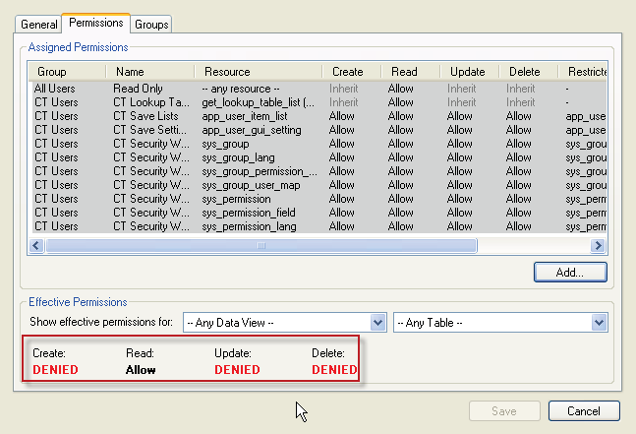

There are two quick methods for remedying this. One fix would be to add the user to the Administrators group (not typically done or recommended); a second method would be to grant the All Access (to any resource) permission to the user as shown in the following image:
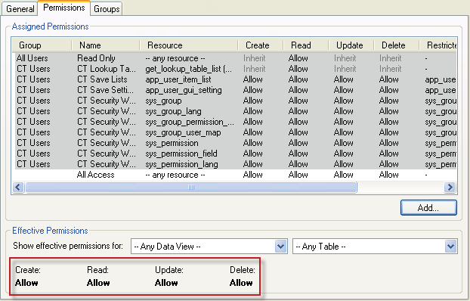
However, a better solution would be to create a new group, modeled after the Administrators group, and then add users to that group. The advantages of doing this rather than simply adding users to the Administrators group are you keep the “true” Administrator permissions separate from other users.
In this example, the Admin-like Group is being created:
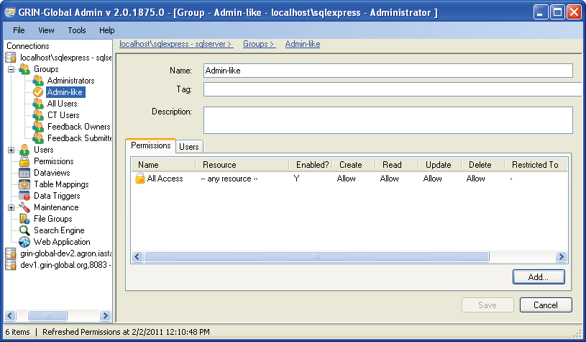

Any users then included in this group would initially have full data access as do administrators. Later, this group’s permissions can be edited if necessary, for example to restrict access to certain data. The “true” administrators would not be impacted.
Also, groups or permissions can be established for certain categories of workers. For instance, an organization might want to establish that users who handle germplasm orders cannot modify accession records. Because of the flexibility with permissions, this can easily be accomplished.

Setting up a Site "Power User" for a Site
Two steps to follow to set up a user so that this user can essentially serve as a site administrator. He or she will be able to change ownership and permissions for his/her respective site.
- Create a permission
- Create a group using the permission and add user(s)

Create the Permission
Use the AT to create the permission. Give the permission a meaningful tag name, such as MANAGE_SITE_NC7. Set at least Update and Delete to Allow, possibly Read or even Create to if there is any doubt of that.
There are a few different ways to assign rights. If you want to give rights to any row in a particular table, change the "Applies To Table:" field from "-- Any Table --" to the appropriate table. If you want to have the rights apply to rows created by any user at a particular site, add a "Restricted To:" setting with Resource = site, Field = site_id, Compare = "=" and Value = [the site id number]. Example:
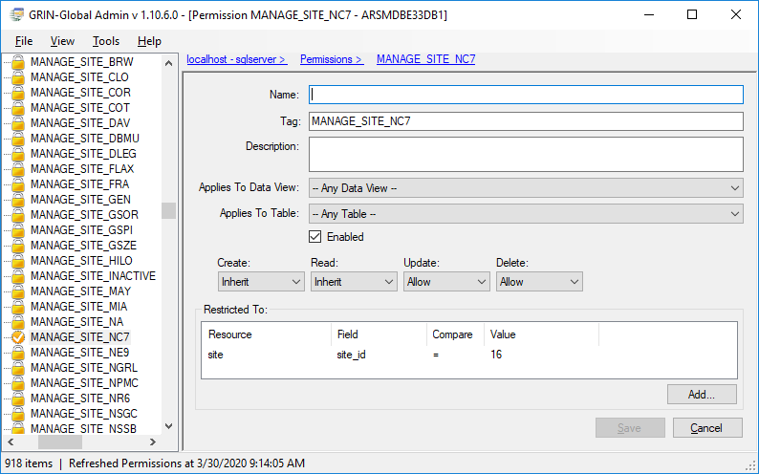
Note that the two settings can be combined.
If you restrict to a site, but don't specify the table, the permission applies to that site's rows in any table.
If you specify a table, but no site restriction, the permission applies to any row in that table.
If you specify both table and site, the permission applies to that site's rows in that table.
If you specify neither a table or site, the permission applies to all rows in all tables and becomes a full blown administrator permission (unless you are denying rights).

Create a Group Using the Permission and Add User(S)
Next create a group with an appropriate name (for example, use the same name as the permission). Add the permission in the Permissions tab and specify the user(s) who will receive the rights in the Users tab.
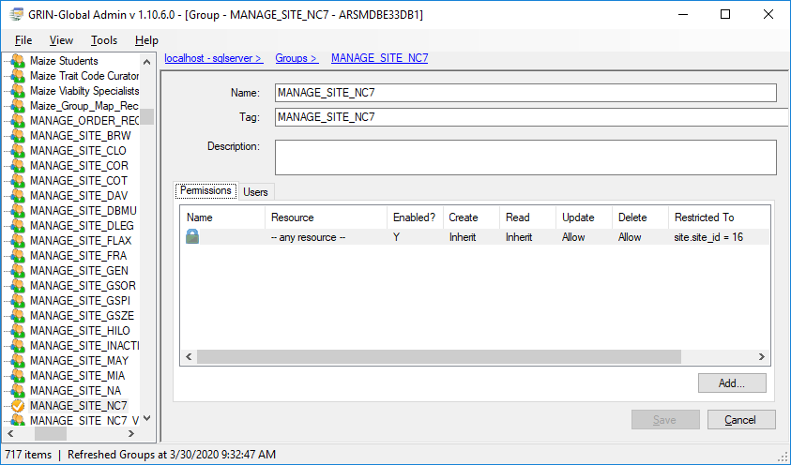

Appendix: Document Revision Notes

– November 22, 2022
- Added SQL example for displaying a user’s permissions

– July 23, 2021
- corrected footer to include the page numbers
- also corrected some pagination breaks

– January 28, 2021
- corrected a typo
- added sample SQL and a link in the Ownership section to the Administrator Section

