Searching in GRIN-Global


Revision Date
January 15, 2026

 | The Search Engine has evolved in GRIN-Global. This documentation refers to the Search Engine used in server release 1.9.9.2 or higher.  Please send any questions related to marty.reisinger@usda.gov or mar@rrginc.com

The Appendix contains change notes pertaining to this document.

Author
Martin Reisinger

Major Contributor
Kurt Endress

TOC
Search Engine and Search Tool Overview 4
Overview 4
SQL Server Full-Text Indexing 4
Using Search Text in the Public Website 6
Search Engine Evolution - Enhancements in Server Release 1.9.9.2 6
Speed Improvements 6
Public Website 7
Advanced Searches 8
What Does the Search Engine Search? 9
List Search on the Public Websites 10
List Search in the Search Tool 11
Extension of the List Search 12
Search Comments 13
Curator Tool – Searching via Dynamic Folders 13
Dynamic Folders 13
IDs & Lookups 14
Wildcards and finding Empty / Missing Stuff / Nulls 16
Using Quotes 16
NOT EQUAL TO 17
Nulls 17
NOT IN 17
Reserved Words & Wildcards -- Examples 19
Wildcard / Operator / Reserved Words 19
IS NULL / IS NOT NULL 20
IN / NOT IN 20
LIKE 20
BETWEEN 20
Date Fields 20
GETDATE() 21
DATEDIFF() 21
WHERE 21
COUNT(*) 21
Subqueries 21
DISTINCT 22
LEN function 22
EXCEPT 22
INTERSECT 23
--DUMPSQL 24
Full Text Indexing 26
Considerations 27
Extended SQL Support 29
WHERE 29
NOT 29
BETWEEN 29
INTERSECT 29
EXCEPT FUNCTION 31
LEN function 31
DateDiff function to find recent viabilities 32
Subqueries 32
DISTINCT 33
NOT EXISTS 33
Displaying the SQL: --DUMPSQL 34
Appendix A: Fields used in the GG Searches 35
Autofields 35
SQL to List the “Autofields” Used in the Search Box 35
Full Text Indexing 36
SQL to List the Fields Having Full Text Indexes 36
Appendix B: SQL Queries on the Public Website 37
Overview 37
3 Basic Components 37
Public Website Searches Using the @ 38
Appendix C: Administrator Notes on Sorting Search Results 39
Appendix D: Document Change Notes 41

Search Engine and Search Tool Overview

Overview
Currently, the main two GRIN-Global (GG) user applications are the Curator Tool and the Search Tool. This document differentiates between the “Search Tool” and the “Search Engine.” The Search Tool is the application which a genebank staff person uses to communicate with the search engine. The search engine is the logic/program that queries the database and returns matching records. Besides the search tool application, the GG public website also uses the search engine. The GG search engine has evolved since GG started and periodically is updated with additional enhancements.

SQL Server Full-Text Indexing
At the U.S. National Plant Germplasm System (NPGS), Microsoft SQL’s Full-Text Indexing feature was implemented simultaneously with server release 1.9.9.2. SQL Server Full-Text Indexing allows searching for single words in large text fields (such as notes) without specifying wildcards.
 | The GG DBA should consider implementing Microsoft SQL’s Full-Text Indexing feature. Microsoft documentation is available on the internet.

Several notes:
- Search Tool & Public Website use the same search engine, but the PW search capabilities are supplemented by some PW code
- The Search Tool is a stand-alone program
- The Search Tool has two distinct modes
  - Text Box
  - Query By Example grid (“QBE”) Recommended method
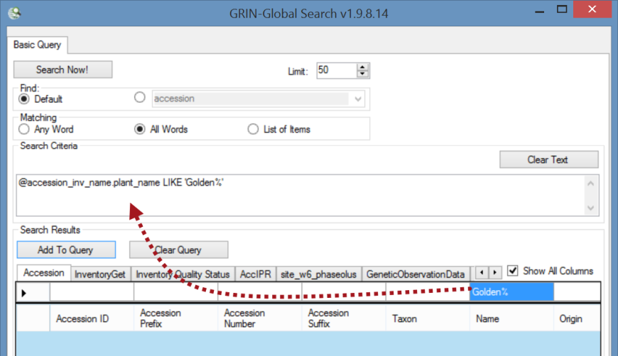

Think of the search engine as using a “wide net.” At first glance, it may not be obvious why some records are returned by the search. The “odd” results are most likely due to the search finding matches in multiple fields and among related records.
In the following example, the search string was “Van deman” In the search results, it is obvious why the first and third accessions are listed, but why the second?
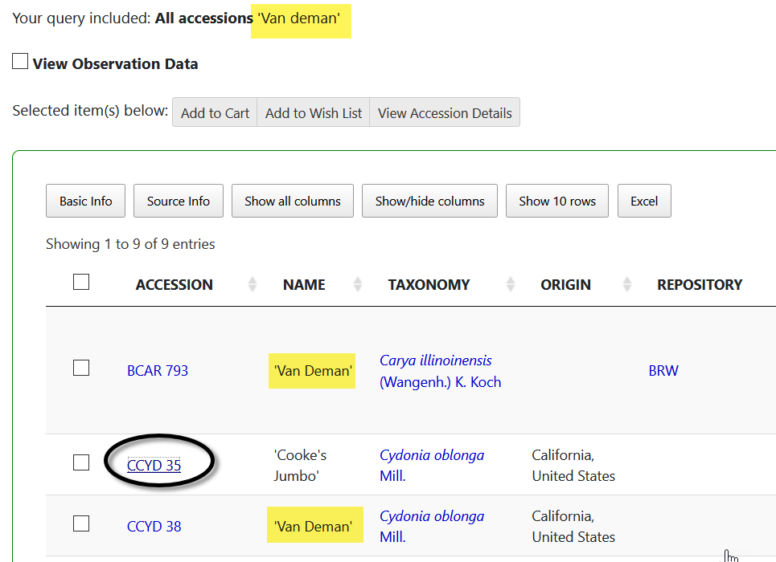
Looking at the accession’s details, the Narrative mentions “Van Deman.” On the PW, the Narrative comes from the Accession Note field, and in this database, that field was one that the DBA had indexed – hence it was searched.
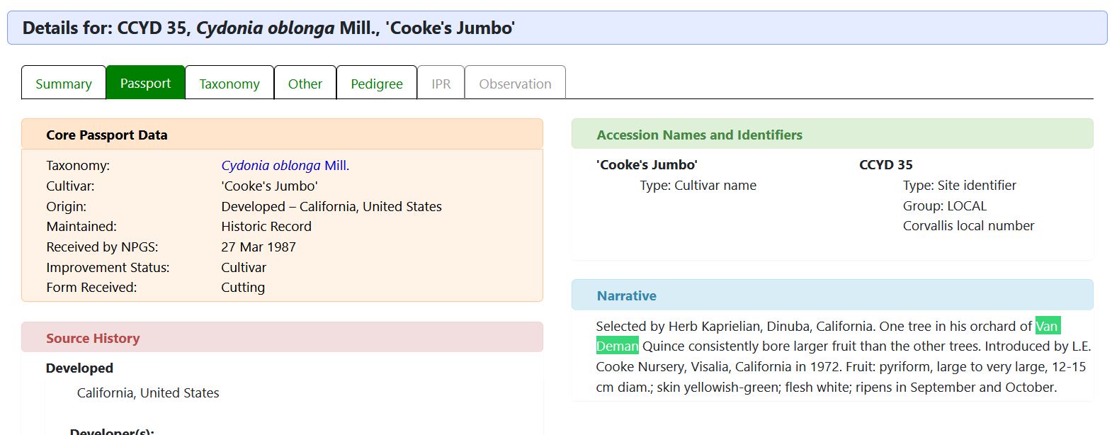

Using Search Text in the Public Website
The Public Website search can handle text in the search when constructed properly, such as the following:
sorghum and @accession.initial_received_date > '2020'
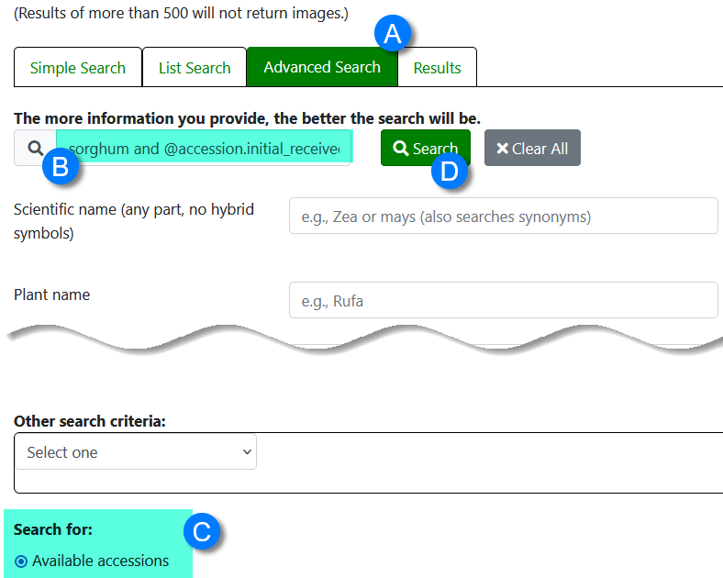
In this example, the user was looking for sorghum accessions that were recently added to the collection (after 2020). More on this in the section Public Website Searches Using the @

Search Engine Evolution - Enhancements in Server Release 1.9.9.2
The Search Engine (SE) has evolved, and in server release 1.9.9.2, the functionality has expanded. For example, the search engine now has extended SQL support. This SE fixes many of the issues between the PW and SE regarding visible, active, and available (status) check boxes. The latest version of the SE implemented a completely new way for the PW to filter by these status values. Other changes include:
- Speed increases on simple searches
- Full text indexing
- List of Items Change
- Changes to Public Website queries
- Extended SQL Support to additional key words: BETWEEN, EXCEPT, UNION, INTERSECT, NOT IN, …

Speed Improvements
Checking for web visibility or availability was slowing down simple PW searches such as PI 500000 because the search’s formatted section might be only @accession.is_web_visible = ‘Y’ -- this would return 800,000 results, taking a few seconds to complete, whereas now the SE examines the freeform section first and converts the results into a criteria to combine with the formatted section.

Public Website
Basically…
the Search For box on the Public Website is equal to the text box in the Search Tool.
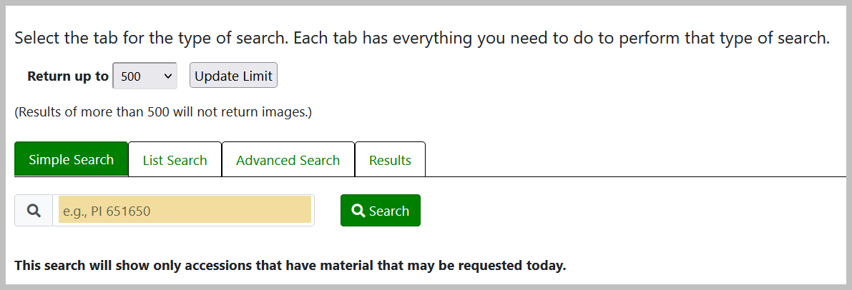=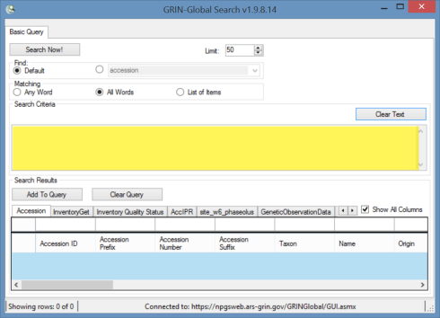
The difference is that in some cases the Public Website uses additional logic to handle the is_web_visible flags and other issues specific to the PW.

There are three levels of sort on the output of the public website searches:
- The highest weighted field is found first (genus hits before others)
- Accessions with PI prefixes before Non-PIs*
- The most-recently received accessions are found first

Organizations other than NPGS that are running GRIN-Global may set the preferred prefix from “PI” to their organizations preferred prefix. Notes for administrators relevant to this are in Appendix B.

When there are more than 500 (or whatever your limit is set to) accessions that are genus hits on PI numbers, the most recent of those is first. If there are less than 500 PI records for the genus you are going to see recent non-PI genus hits further down the list and recent PI non-genus hits even further down. That is not all recent accessions will be at the top because the other sorts have a higher precedence.

The Public Website has a dual personality. External users (non genebank staff), use the PW to search for, and order accessions. Internal staff, whose Public Website logins have been associated by the GG Admin to their CT login, have additional features, including the ability to run SQL queries against the database. Refer to the appendix section SQL Queries for Searching the Database on using the Public Website to search the database using SQL queries.
The search text formatted in the Search Tool text box used by internal genebank staff can also be copied and used in the Search box on the Public Website. This may be handy when an external user requests assistance obtaining information from the database that is not available via any Public Website options. An internal staff user can format the query in the Search Tool, send the query text to the external user and explain how to drop the query text in the search box. (See Public Website search constructs.)

Advanced Searches
On the Advanced Search tab, additional criteria may be included to supplement the text inputted in the search box. The current website’s “Simple Search” is limited. It displays this disclaimer: “This search will show only accessions that have material that may be requested, including those not seasonally available.” Historic or accessions not currently available will not be displayed in the Simple Search results.
We recommend that you use the Advanced Search. 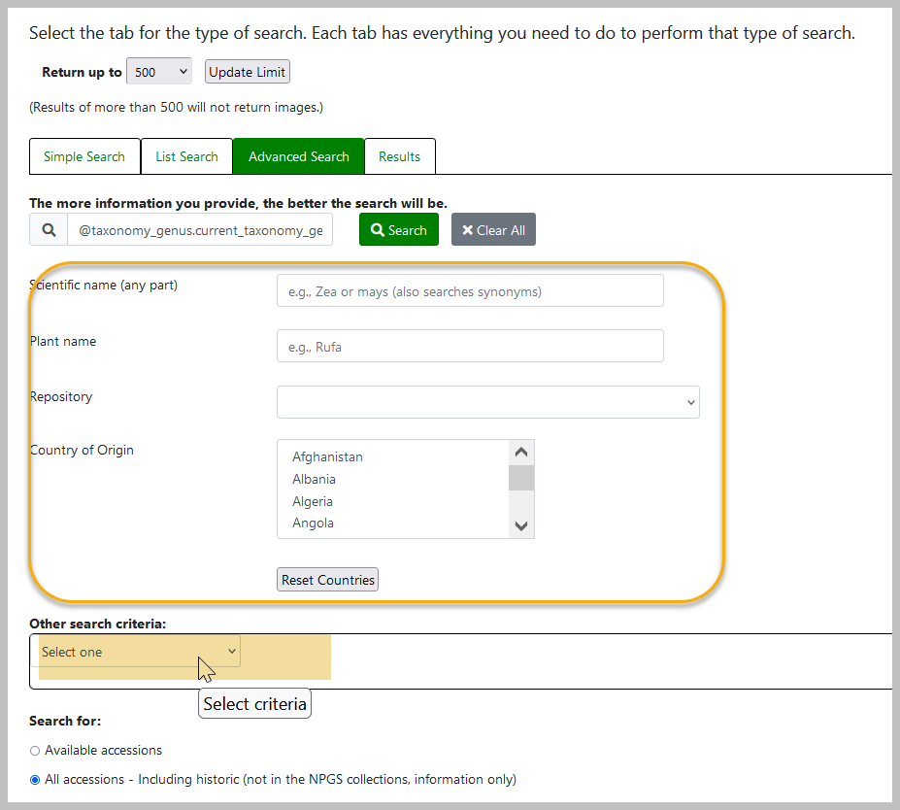

What Does the Search Engine Search?
The search engine (SE) has three main code sections:
- Formatted
- Lists
- Unformatted

- Formatted: What it’s told to search for
The user creates formatted searches from QBE with SQL-like syntax starting with the at sign (@)
Ex: @accession.accession_number_part1 = 'PI' AND @site.site_id IN (3)
- Lists: Identifier (ID) lists
The Search List function looks for certain patterns in the text provided in the listed items. It first determines the number of blocks of text separated by spaces (also known as “tokens”).
Number of Tokens | the Search Engine Assumes | Example
4 | Inventory identifier | NA 51425 .001 PL
3 | Accession identifier | GMAL 3764 .a
1 (text) | Accession identifier | CZ12345twery
1 (numeric) | Order Request identifier | 345102
 | Plant Names
When there are 4 tokens – the SE assumes the items are inventory items, since the inventory identifier may have up to four items (prefix, number, suffix, and inventory type form). When there are three tokens, it assumes these are the three parts of the accession identifier. The List Search is also programmed to use a single token and look for accessions matching the one text string (some genebanks use only the accession prefix field to contain the entire accession identifier).
- Unformatted - Freeform Searches
Enter words (and/or numbers) and the SE tries to find them as best it can
- It will first search IDs such as PI 500000
(using either accession or inventory ID)
- Each word is checked for an exact match on 22 fields (determined by the DBA using the sys_search_autofield table) (see autofields)
- Words are also checked in any existing full-text indexes.
The GG DBA can index any text field, usually large fields such as Note fields (comments) to meet an organization’s requirements. The GG table sys.fulltext.indexes lists these fields. (see Full-Text Indexing)
Users can combine formatted and freeform criteria or append formatted criteria to the end of a list search. Searches work best when the formatted text is appended after the list of items (since that is where the PW tacks it on).

List Search on the Public Websites
In the current Public Website, the List search has its own tab.
On the public website, if you enter a valid order ID in the List Search box, the search will return the accessions included in the request. Refer to the earlier explanation of tokens used by the List Search. Note that accession or inventory record IDs cannot be searched using the List Search.

Public Website List Search
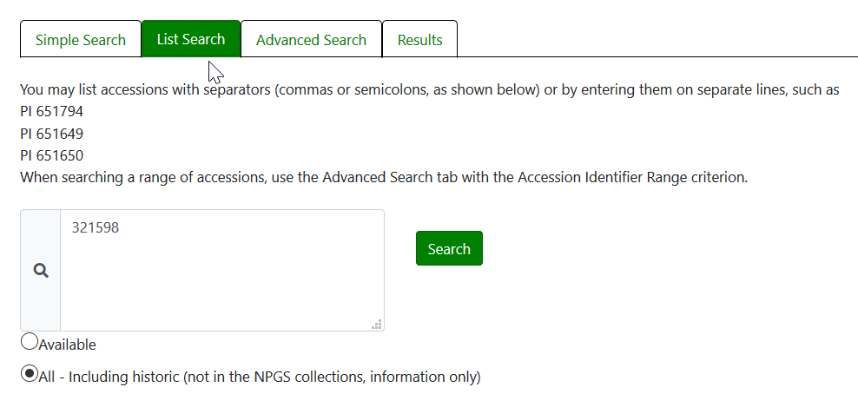

List Search in the Search Tool
You first select the List of Items radio button.
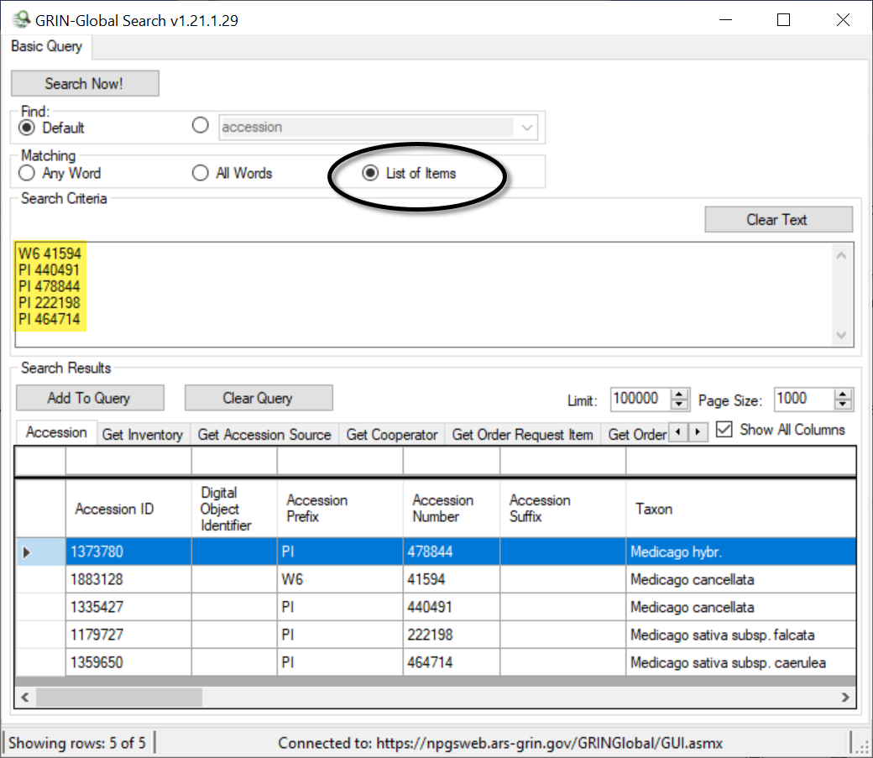

Remember to switch the radio buttons after a List Search! Otherwise, a typical search will fail.
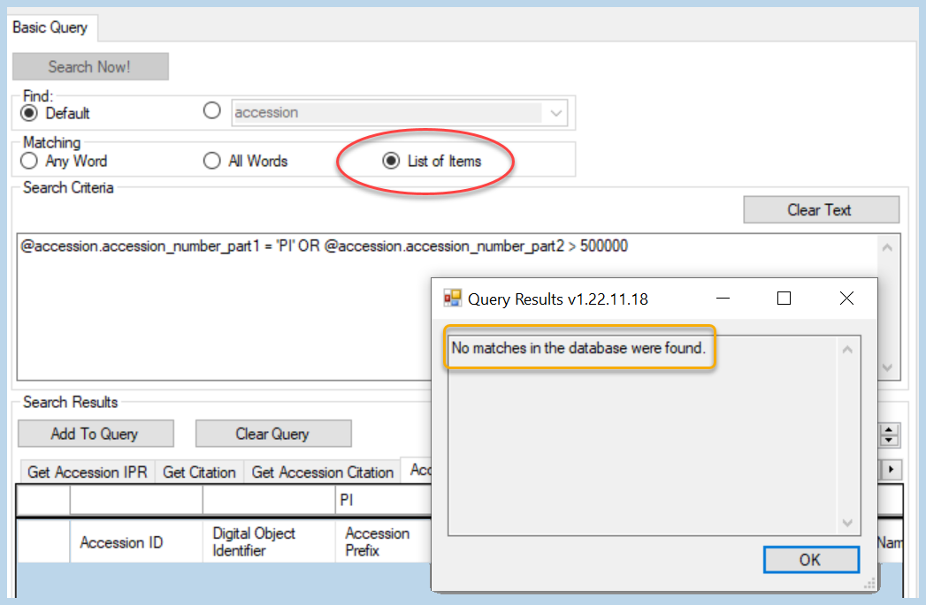

Extension of the List Search
It is possible to append a formatted search string to a list of items. For example, the following example is a valid search:
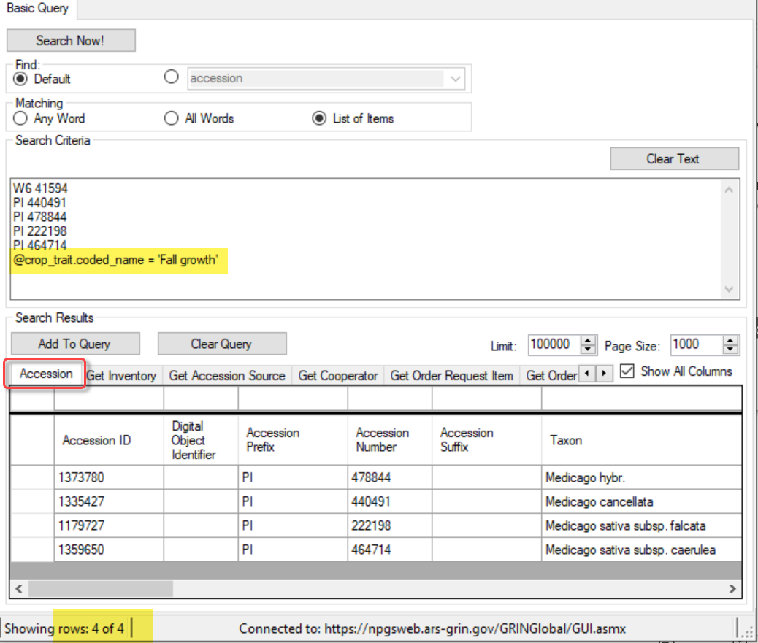
In the search without the @crop_trait.coded_name = 'Fall growth' statement, five accessions were found, but with it, four. When switching to the Crop Trait Observation dataview and re-running the search, the reason is more apparent:
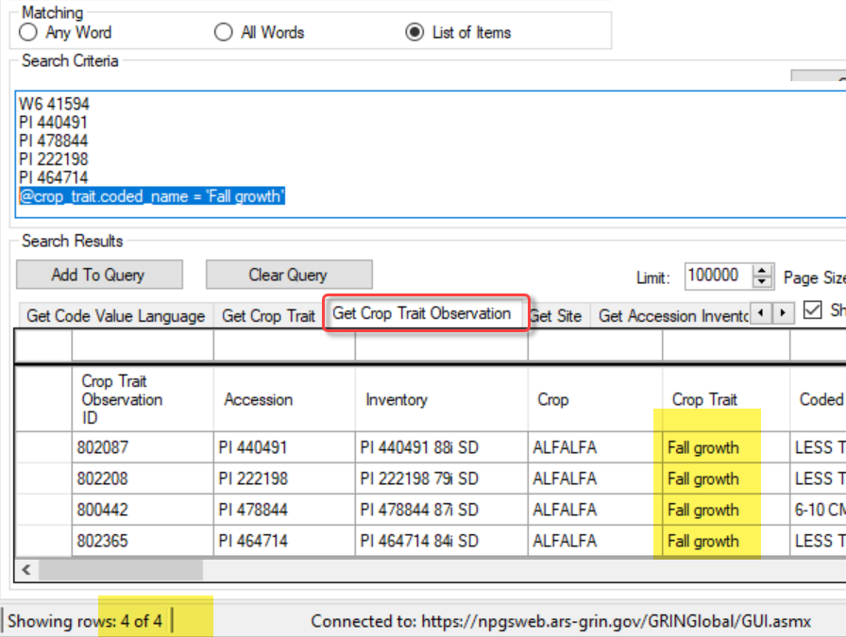

Search Comments
When using the Search Tool, you can include comments. This is helpful when copying the search statement to the Curator Tool to build a Dynamic Folder:
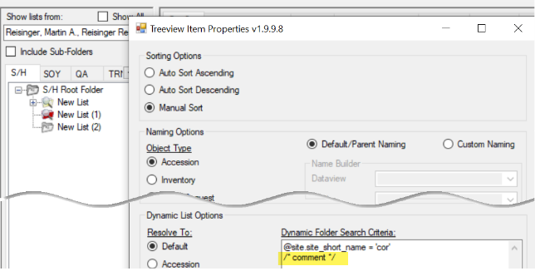
- when you use a double dash -- on a line, anything after the double dash is treated as a comment
- to comment multiple lines, start with /* and then end your comment with */

Curator Tool – Searching via Dynamic Folders

Dynamic Folders
The Curator Tool has two types of folders, static and dynamic. Dynamic folders (also referred to as dynamic queries) are basically stored queries in a CT user’s List Panel. The query most likely was created by copying generated text from a Search Tool query. A big advantage of setting up a dynamic folder is that after the query folder has been created, the folder retains your search criteria and eliminates the need to redoing a query in the Search Tool.
A complete Dynamic Folders guide is online: https://www.grin-global.org/docs/gg_dynamic_folders.pdf

IDs & Lookups
When searching on a field that uses LOOKUP IDs, the ID numbers are listed in the search statement. If you are curious, open the respective dataview and look for the corresponding records.
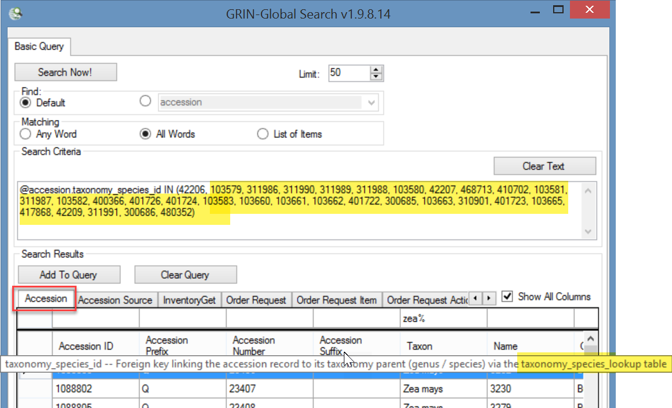
In the screen above, there were 31 species records matching “Zea.” The following screen shows the corresponding 31 species records in the Taxonomy Species dataview:
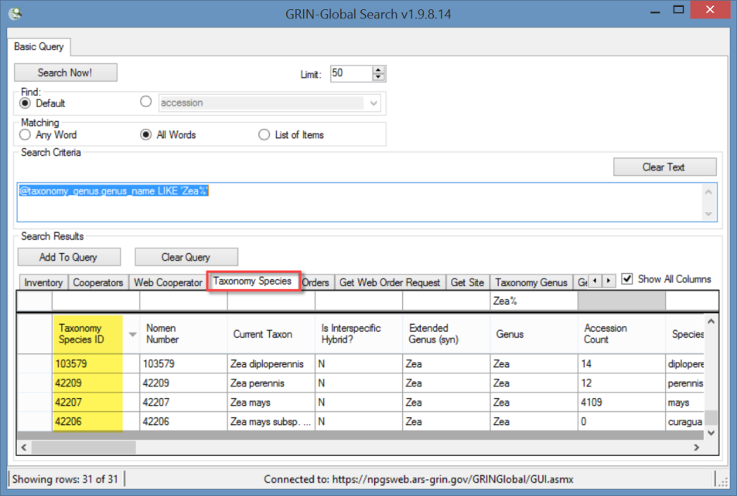

It is relatively simple to design a search to use a list of ID’s, but this is not a List Search. Start by using the Search Tool to begin the proper syntax of a search statement. The user determines what the actual database field name is by inputting a sample number in the field that will be searched:
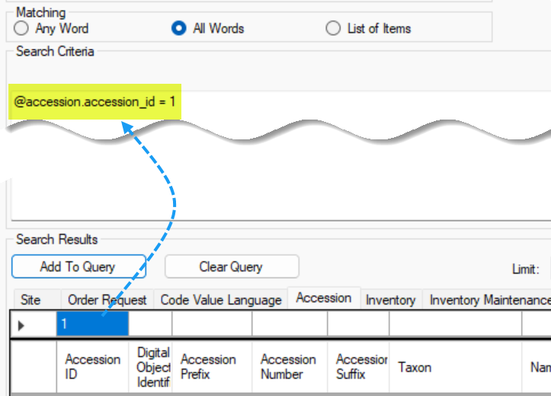
Then edit the text to look similar to the following:
@accession.accession_id IN (
1008936,
1008947,
1008956,
1008973,
1227627,
1227628,
1227629,
1200107
)
… “IN (ID1, ID2, … last ID ) (Each item has a trailing comma except the last one in the list)
Use Excel to add the commas when you are building a lengthy list:
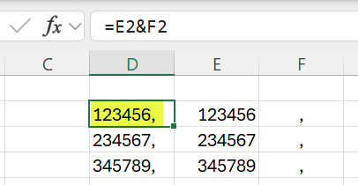

Wildcards and finding Empty / Missing Stuff / Nulls
The Search Tool uses the percent sign (%), the asterisk (*), and the underscore (_) as wildcard characters.
% and * behave differently in the Public Website. Full text indexing will handle asterisks at the end of the word (*), whereas if you use a trailing % sign, only the autofield search is used.
In the Search Too, the * converts to LIKE ‘%’
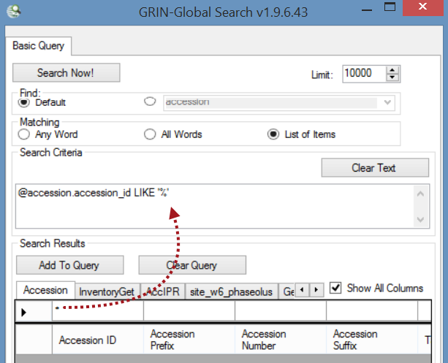

Using Quotes
Using quotes ensures that the full term is searched. Two examples below, with and without quotes - and the number of found records:
Search string | Records Found | What the Search Engine is Looking For
‘yellow rain’ | 0 | the two words yellow rain - exactly as entered
yellow rain | 66 | either word, yellow, or rain, in any of the fields that are searched
‘rain’ | 638 | any occurrence of the word rain in any of the fields being searched
rain | 638 | any occurrence of the word rain in any of the fields being searched

Sometimes it is desirable to find “what’s missing.”

NOT EQUAL TO
!= operator (same as <>)
Use the != or the <> (“not equal to”) operator as needed, as in:
@accession.accession_number_part1 != 'PI'
-or -
@accession.accession_number_part1 <> 'PI

Nulls
NULL values represent missing unknown data. By default, a table column can hold NULL values.
@accession.accession_number_part3 IS NULL

If necessary (because of the dataviews), if the QBE will not generate the IS NULL or IS NOT NULL code, hand code the appropriate clause in the Search Criteria box:
AND inventory.parent_inventory_id IS NOT NULL

NOT IN
Used when fields involve lookup values. For example, when you have a search such as:
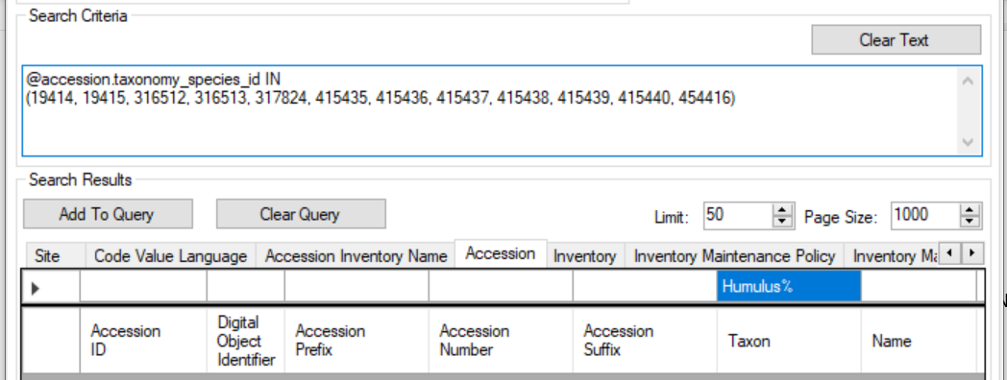
You can use NOT IN to exclude lookup values.

Extended SQL Support
Additional SQL terms can be used now:
- BETWEEN
- WHERE
- EXCEPT
- INTERSECT
- GETDATE()
- DATEDIFF()
- COUNT
- DISTINCT

The ST can’t handle an entire SQL select statement, only a statement beginning with a SQL WHERE clause.

- comments are valid (double dash) --
also valid w/ dynamic folders:
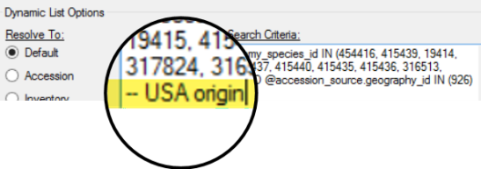
- WHERE may be used in the Search Tool:
WHERE accession.accession_number_part2 BETWEEN 500000 AND 500050

Rather than type from scratch in the Search Tool’s Search Criteria box, first input a s ample in the QBE cells above the grid, and then edit the generated text.
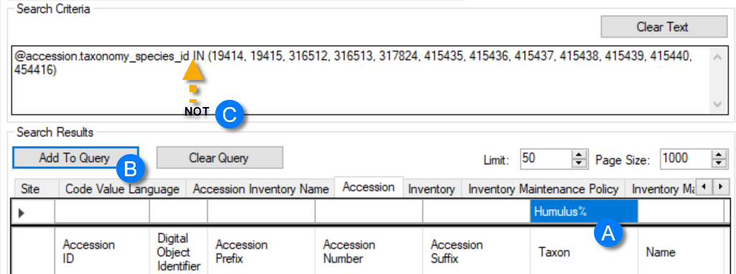

Reserved Words & Wildcards -- Examples
Wildcard / Operator / Reserved Words | Examples /  Notes
%  (percent symbol)  * (asterisk) also  It is recommended to use the % rather than the *.  (Date searches work with %, but not with * - this is a known (reported) bug. ) | Use to broaden searches, especially when the exact spelling is unknown. The field must be a text field. Either wildcard (% or *) allows a match of any string of any length (including zero length)  Examples:  Rubus%  Prunus%var will locate any Prunus with “var” included;  %var% will locate any accessions with the text “var” as part of its taxon  ‘2015%’
_  (underscore) | The wild card underscore character _  Represents any single character. Multiple underscores may be used if needed. The field must be a text field.  Solanum_x% will find:  Solanum x doddsii and  Solanum x sucrense  If you need to search for the underscore character rather than have it act as wildcard, enclose it in brackets, such as:  @inventory_action.action_name_code LIKE 'INS[_]%'  (in this example, the 4th character must be an underscore character)
<>  !=  (not equal to) | Can be used to indicate “not equal to.” The field can be either a text or numeric field.  - when the field is a text field, the criterion must be enclosed by quotes – single quotes: ‘PI’ or double quotes: “PI”  - when the field is a numeric field, the criterion is not enclosed in quotes
IS NULL /  IS NOT NULL | NULL values represent missing unknown data. By default, a table column can hold NULL values.  Note: NULL and 0 are not equivalent.
IN /  NOT IN | Used when the criterion field is using a lookup table. (Lookups generate an IN (…) clause.) The numbers in the parentheses are the Lookup Key values in the database.
LIKE | The LIKE operator is used to search for a specified pattern.  Example: LIKE ‘CAPSICUM%’  In this case the QBE is saying find any text that begins with “Capsicum.” The trailing percent symbol indicates that any records with any text after “capsicum” should be included if found.
BETWEEN | When a range of values is needed, construct your criteria using a range.  For example:  @order_request.ordered_date > ‘2015-01-31’ AND  order_request.ordered_date < ‘2015-03-01’  (finds the orders for February, 2015)  Same results, using BETWEEN  @order_request.ordered_date  BETWEEN '2015-01-31' AND '2015-03-01'  Note: BETWEEN can be used with text as well, such as searching for a range between ‘GBK-0100’ and ‘GBK-0200’
Date Fields | Searching for dates can be tricky because the date field includes the time of day as well. Refer to Date Fields for details.  The following are valid searches:  @accession.created_date like '2015%'  @accession.created_date like '2015-09-%'  @accession.created_date like '2015-09-05%'  @accession.created_date like '2015-%-05%'
GETDATE() | Retrieves database current date/time in SQL Server
DATEDIFF() | Calculates the difference between two dates
WHERE | The ST can’t handle an entire SQL select statement, but it can handle parts of a SQL WHERE clause. The Search Engine looks at which fields you use so it knows which table to join when it builds the FROM clause. And the dataview definition specifies which fields get selected.  WHERE taxonomy_genus.genus_name like 'Triticum%'  AND NOT EXISTS (SELECT * FROM accession_source acs  WHERE accession.accession_id = acs.accession_id  AND acs.source_type_code = 'COLLECTED')
COUNT(*) | A query using COUNT to find rows with many inventories (from one accession)  in the Search Tool or dynamic folder:  @ taxonomy_genus.genus_name = 'Zea'  AND (SELECT COUNT(*) FROM inventory i WHERE i.accession_id = accession.accession_id) > 32
Subqueries | A subquery is a query within a query – the inner query is resolved first.  Can be used in various ways, such as to search by specific owner  Example:  @accession.owned_by IN (SELECT cooperator_id FROM cooperator WHERE last_name = 'Millard')  Example: A query using COUNT to find rows with many inventories (from one accession)  in the Search Tool or dynamic folder:  @ taxonomy_genus.genus_name = 'Zea'  AND (SELECT COUNT(*) FROM inventory i WHERE i.accession_id = accession.accession_id) > 32
DISTINCT  [server >= 1.9.9.2] | The SELECT DISTINCT statement is used to return only distinct (different) values. Inside a table, a column often contains many duplicate values; and sometimes you only want to list the different (distinct) values.  Example: List accession records with inventories having more than 2 different owners  WHERE taxonomy_genus.genus_name = 'Zea'  AND (SELECT COUNT(distinct i.owned_by) FROM inventory i WHERE i.accession_id = accession.accession_id) > 2  In the Search Tool, change the first line to:  @taxonomy_genus.genus_name = 'Zea'
LEN function  [server >= 1.9.9.2] | The LEN function determines the string length. This could be used to find long plant names  WHERE LEN(accession_inv_name.plant_name) > 36
EXCEPT  [server >= 1.9.9.2] | Returns any distinct values from the query to the left of the EXCEPT operator that are not also returned from the right query.  The following EXCEPT query is used to track orders not yet completed (order_request.completed_date IS NULL) when a curator has been alerted (action_name_code = 'CURALERTED') about an NC7 order (site_id = 16), but he has not cleared it and the order is still pending (the curator hasn’t cleared the order (action_name_code = 'CURCLEARED').  EXCEPT  @site.site_id IN (16) AND @order_request.completed_date IS NULL AND @order_request_action.action_name_code = 'CURALERTED' AND @order_request_action.cooperator_id IN (122186)
INTERSECT  [The GG server release must be >= 1.9.9.2] | The INTERSECT operator is used to combine like rows from two queries. It returns rows that are in common between both results.  For example, using the search tool, find accessions with specific observation values for two different traits. Example: find kernel color White and primary race Corn Belt Dent.  @crop.name = 'Maize' AND @crop_trait_lang.title = 'Primary Race' AND @crop_trait_code_lang.title = 'Corn Belt Dent'  INTERSECT  @crop.name = 'Maize' AND @crop_trait_lang.title = 'KERNEL COLOR' AND @crop_trait_code_lang.title = 'White'  INTERSECT  @site.site_id IN (16) AND @inventory.is_distributable = 'Y' AND @inventory.is_available = 'Y'  A similar, but faster version of the query, using the trait IDs:  @crop_trait_observation.crop_trait_id = 89001 AND @crop_trait_code_lang.title = 'Corn Belt Dent'  INTERSECT  @crop_trait_observation.crop_trait_id = 89027 AND @crop_trait_code_lang.title = 'White'  INTERSECT  @site.site_id IN (16) AND @inventory.is_distributable = 'Y' AND @inventory.is_available = 'Y'
--DUMPSQL  [server >= 1.9.9.2] | With –DUMPSQL, the search engine has an option to deliberately throw an error and show the SQL it generated when the first line of the query is this comment: --DUMPSQL (See DUMPSQL.)  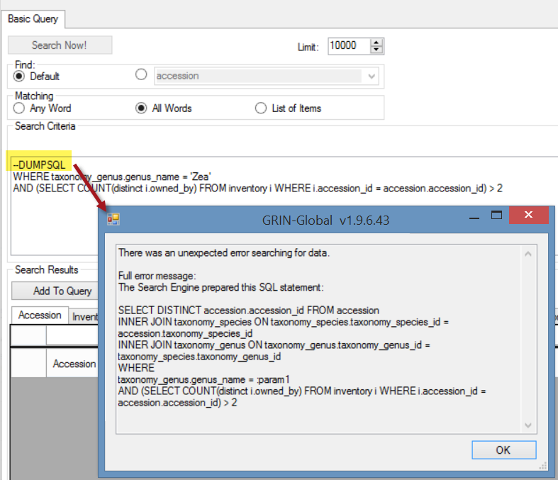

Maintenance Policy, such as in the following example:
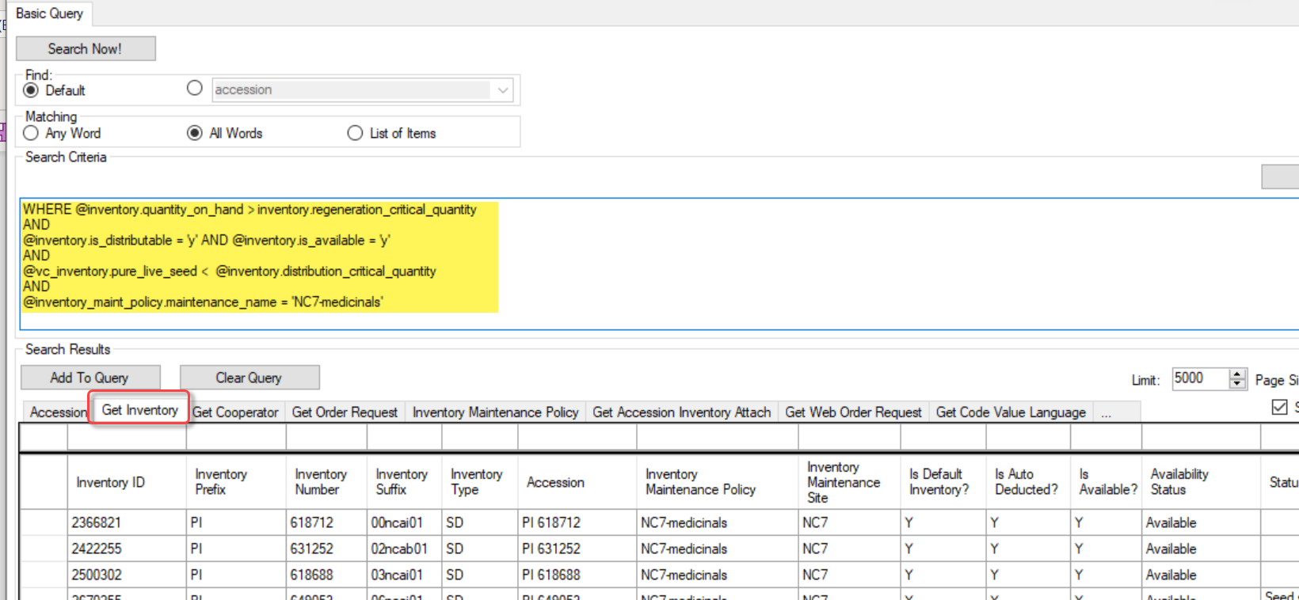
The code above:
WHERE @inventory.quantity_on_hand > inventory.regeneration_critical_quantity
AND
@inventory.is_distributable = 'y' AND @inventory.is_available = 'y'
AND
@vc_inventory.pure_live_seed < @inventory.distribution_critical_quantity
AND
@inventory_maint_policy.maintenance_name = 'NC7-medicinals'
In the query above, 13 inventory lots were identified as having quantities of viable seeds that were less than the desired distribution quantities.
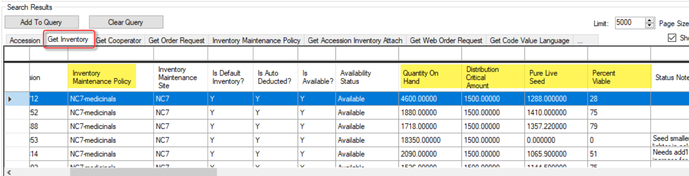

Full Text Indexing
A full text index will have an entry in a generated index for each term or word found in a specified table field. These indexes are established by the genebank’s GG administrator for specific fields in the database; additional fields can be indexed over time. This feature provides significant changes to the Public Website users’ searches.
Administrator’s Note: Full text indexing requires the GG administrator to use SQL Server’s Full Text Indexing methodology. See also Appendix A.

Example:
Releases pre- 1.9.9.2 | Release 1.9.9.2
PW: ‘%weedy red rice%’ | PW: weedy red rice

NPGS:
In Release 1.9.9.2 and later, the following fields are now set to full text indexing:
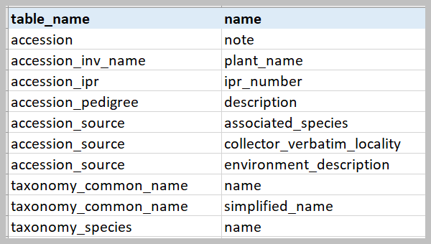
Some stop words (such as "the" and "and") that are both common and typically not meaningful are ignored by the search. (sample stop words)
How would you know what fields are indexed? When logged into the Public Website, run the following SQL:
SELECT DISTINCT
object_name(fic.[object_id])as table_name,
[name]
FROM
sys.fulltext_index_columns fic
INNER JOIN sys.columns c
ON c.[object_id] = fic.[object_id]
AND c.[column_id] = fic.[column_id]

Considerations
A Public Website search for %Cornus rugosa% may find accessions which at first glance in the list may seem like not a valid match. In this example, the following displays in NPGS’s database:
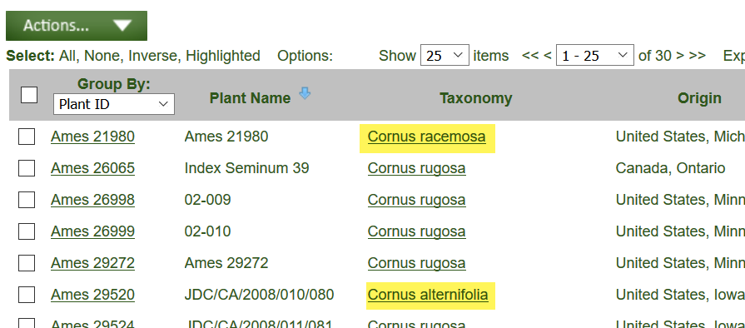
Using the Ames 21980 accession, the detail page shows:
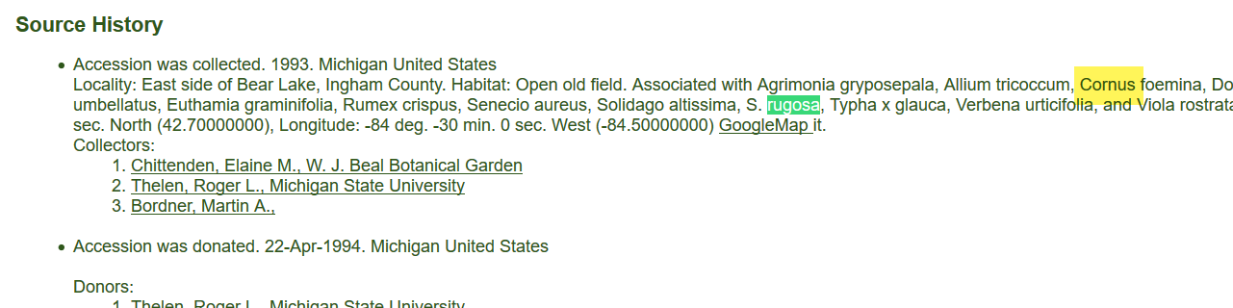
The search is basically asking for either word to be found, Cornus, or rugosa. Any words specified between the %...%
When the same string is used, but in quotes – ‘%Cornus rugosa%’ – the list of records will not include that record:
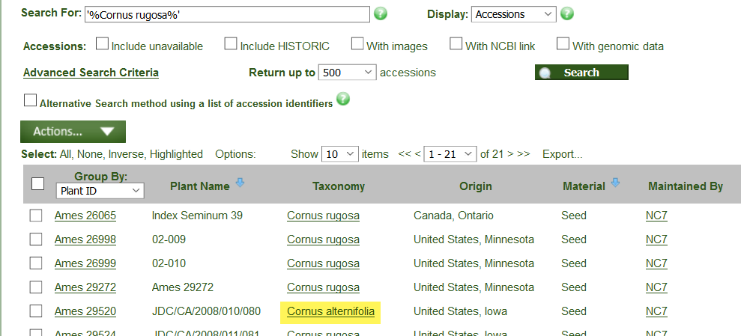
Using the Ames 29520 accession, the detail page shows:
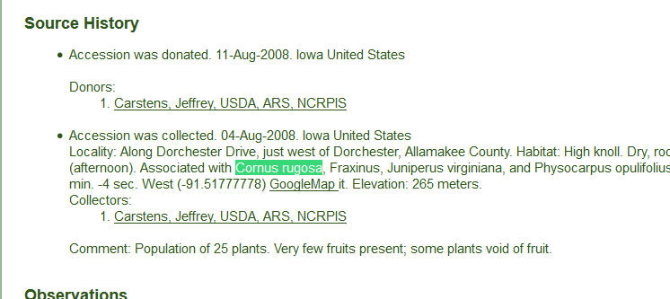
Using the quotes ensures that the full term is searched, in this case, Cornus rugosa.
Two examples, with and without quotes - and the number of found records:
Search string | Records Found | What the Search Engine is Looking For
‘yellow rain’ | 0 | the two words yellow rain - exactly as entered
yellow rain | 66 | either word, yellow, or rain, in any of the fields that are searched
‘rain’ | 638 | any occurrence of the word rain in any of the fields being searched
rain | 638 | any occurrence of the word rain in any of the fields being searched

Extended SQL Support

WHERE
SQL WHERE clauses work in the Search Tool. However, since the search engine doesn’t use table aliases, use full table names when constructing statements.
@taxonomy_genus.genus_name LIKE 'Glycine%' equals
WHERE taxonomy_genus.genus_name LIKE 'Glycine%'
In the following example, a comment (text preceded with -- ) is also illustrated.
The following code can be used in the Search Tool:
-- Find accessions owned by Esther which are active, but not available
WHERE accession.owned_by=107186
AND accession.status_code = 'ACTIVE'
AND NOT EXISTS (SELECT * FROM inventory WHERE accession_id = accession.accession_id
AND is_distributable = 'Y' AND is_available = 'Y' and owned_by=107186)

NOT
…now allowed in freeform queries:
Ex: Bahamas AND NOT gossypium
Ex: Malus NOT (KAZ or Canada or USA or GBR)

BETWEEN
@accession.accession_number_part2 BETWEEN 500000 AND 500050
@order_request.ordered_date BETWEEN '2015-01-31' AND '2015-03-01'

INTERSECT
https://www.techonthenet.com/sql/intersect.php
The INTERSECT operator is used to combine like rows from two queries. It returns rows that are in common between both results.
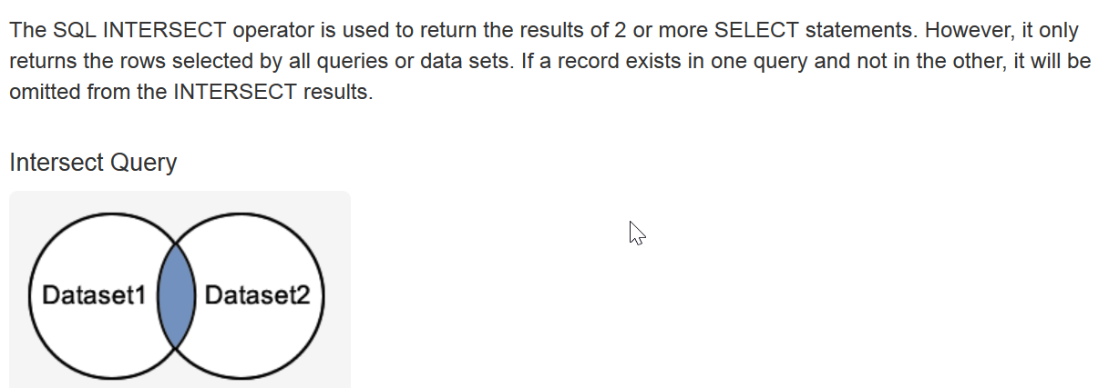
For example, using the search tool, find accessions with specific observation values for two different traits. Example: find kernel color White and primary race Corn Belt Dent.
@crop.name = 'Maize' AND @crop_trait_lang.title = 'Primary Race' AND @crop_trait_code_lang.title = 'Corn Belt Dent'
INTERSECT
@crop.name = 'Maize' AND @crop_trait_lang.title = 'KERNEL COLOR' AND @crop_trait_code_lang.title = 'White'
INTERSECT
@site.site_id IN (16) AND @inventory.is_distributable = 'Y' AND @inventory.is_available = 'Y'

A similar, but faster version of the query, using the trait IDs:
@crop_trait_observation.crop_trait_id = 89001 AND @crop_trait_code_lang.title = 'Corn Belt Dent'
INTERSECT
@crop_trait_observation.crop_trait_id = 89027 AND @crop_trait_code_lang.title = 'White'
INTERSECT
@site.site_id IN (16) AND @inventory.is_distributable = 'Y' AND @inventory.is_available = 'Y'

Besides INTERSECT, UNION and EXCEPT can be used to fine tune searches.
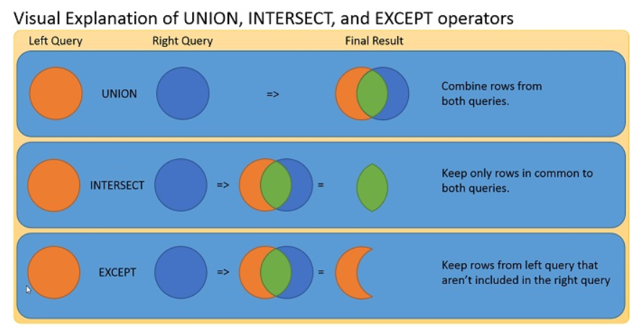

INTERSECT Example: Looking for aronia accessions that have an available inventory and have an inventory with an image attached, available or not. That requires fancier SQL, such as an INTERSECT.
This search produces incorrect results:
@taxonomy_genus.genus_name = 'aronia'
and @accession.status_code = 'ACTIVE'
and @accession.is_web_visible = 'Y'
AND @inventory.is_distributable = 'Y'
AND @inventory.is_available = 'Y'
AND @accession_inv_attach.category_code = 'IMAGE'

With INTERSECT, the search produces correct results:
@taxonomy_genus.genus_name = 'aronia'
and @accession.status_code = 'ACTIVE'
and @accession.is_web_visible = 'Y'
INTERSECT @inventory.is_distributable = 'Y' AND @inventory.is_available = 'Y'
INTERSECT @accession_inv_attach.category_code = 'IMAGE'

EXCEPT FUNCTION
Returns any distinct values from the query to the left of the EXCEPT operator that are not also returned from the right query.
The following EXCEPT query is used to track the orders when a curator has been alerted (action_name_code = 'CURALERTED') about an NC7 order (site_id = 16), but he has not cleared it and the order is still pending (the curator hasn’t cleared the order (action_name_code = 'CURCLEARED').
@site.site_id IN (16) AND @order_request.completed_date IS NULL AND @order_request_action.action_name_code = 'CURALERTED' AND @order_request_action.cooperator_id IN (122186)
EXCEPT
@order_request_action.action_name_code = 'CURCLEARED' AND @order_request_action.cooperator_id IN (122186)
-- Millard is 122186

LEN function
The LEN function determines the string length. This could be used to find long plant names
WHERE LEN(accession_inv_name.plant_name) > 36

DateDiff function to find recent viabilities
WHERE datediff(day, inventory_viability.tested_date, getdate() ) < 180
@inventory_viability.inventory_viability_id LIKE '%'
AND datediff(day, inventory_viability.tested_date, getdate() ) < 180

Subqueries
A subquery is a query within a query – the inner query is resolved first.
Can be used in various ways, such as to search by specific owner
Ex: @accession.owned_by IN (SELECT cooperator_id FROM cooperator WHERE last_name = 'Millard')
Ex2: A nested subquery for site name:
@accession.owned_by IN
(SELECT cooperator_id FROM cooperator WHERE site_id =
(SELECT site_id FROM site WHERE site_short_name = 'NC7'))
Ex3: A query using COUNT to find rows with many inventories (from one accession)
in the Search Tool or dynamic folder:
@ taxonomy_genus.genus_name = 'Zea'
AND (SELECT COUNT(*) FROM inventory i WHERE i.accession_id = accession.accession_id) > 32
in a SQL query:
WHERE taxonomy_genus.genus_name = 'Zea'
AND (SELECT COUNT(*) FROM inventory i WHERE i.accession_id = accession.accession_id) > 32

Ex4: A query using a dataview’s calculated field COUNT to determine the number of orders with a specified number of items for a specified year:
@order_request.completed_date LIKE '%2019%'
AND @site.site_short_name = 'NC7'
AND (SELECT count(*) FROM order_request_item WHERE order_request_id = order_request.order_request_id) >=250

DISTINCT
The SELECT DISTINCT statement is used to return only distinct (different) values. Inside a table, a column often contains many duplicate values; and sometimes you only want to list the different (distinct) values.
Example: List More than 2 inventory owners
WHERE taxonomy_genus.genus_name = 'Zea'
AND (SELECT COUNT(distinct i.owned_by) FROM inventory i WHERE i.accession_id = accession.accession_id) > 2

NOT EXISTS
Similar to EXCEPT…
The EXISTS operator is used to test for the existence of any record in a subquery. The EXISTS operator returns true if the subquery returns one or more records. If a subquery returns any rows at all, EXISTS subquery is TRUE, and NOT EXISTS subquery is FALSE.
SELECT column_name(s)
FROM table_name
WHERE EXISTS
(SELECT column_name FROM table_name WHERE condition);
Example: Find records without a recent viability test
WHERE
inventory.inventory_id IS NOT NULL /* necessary if resolving outside inventory */
AND NOT EXISTS
(SELECT * FROM inventory_viability iv
WHERE iv.inventory_id = inventory.inventory_id -- link subquery to main select
AND datediff(day, iv.tested_date, getdate() ) < 365)

Displaying the SQL: --DUMPSQL
- SE4 has an option to deliberately throw an error and show the SQL it generated when the first line of the query is this comment: --DUMPSQL

Appendix A: Fields used in the GG Searches
The GRIN-Global administrator can determine which fields are to be searched using two different approaches. GG “Auto” fields may be designated in the sys_search_autofield table. The second method requires the GG administrator to use SQL Server’s Full Text Indexing methodology.

Autofields
The following fields were designated by the National Plant Germplasm System (NPGS) GG administrator to be used for text box searches. (Every GG genebank can determine what fields are to be included.)
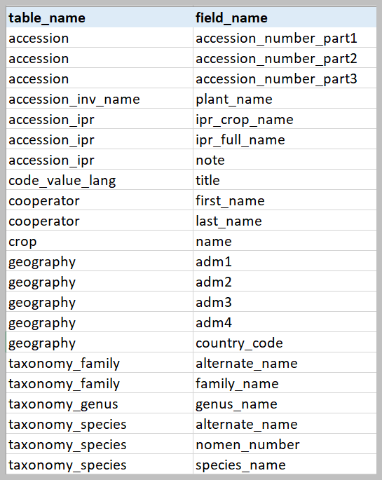

SQL to List the “Autofields” Used in the Search Box
SELECT table_name, field_name
FROM sys_search_autofield ssa
JOIN sys_table_field stf ON stf.sys_table_field_id = ssa.sys_table_field_id
JOIN sys_table st ON st.sys_table_id = stf.sys_table_id
ORDER BY 1,2

Full Text Indexing
The fields listed below were indexed by the National Plant Germplasm System (NPGS) GG administrator.

SQL to List the Fields Having Full Text Indexes
SELECT DISTINCT
object_name(fic.[object_id])as table_name,
[name]
FROM
sys.fulltext_index_columns fic
INNER JOIN sys.columns c
ON c.[object_id] = fic.[object_id]
AND c.[column_id] = fic.[column_id]

Appendix B: SQL Queries on the Public Website

Overview
Genebank staff who have had their Public Website account connected to their Curator Tool account by their GG administrator, when logged into the Public Website, will have the Tools option visible on the menu. From there, select Web Query to display the box for inputting SQL. Log in; select Tools | Web Query You can copy or type valid SQL in the box as shown:
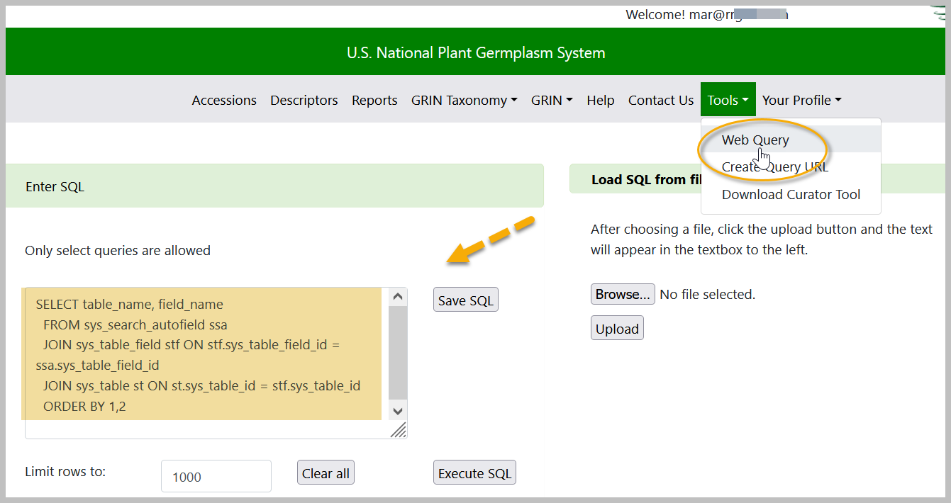
You can open a .txt or Word file in which SQL has been stored and cut in paste into the query box, or use the PW feature to Create a query SQL text file.

3 Basic Components
In general, in GRIN-Global, most SQL statements will use these three words.
SELECT – what columns to display
FROM – what tables to search
WHERE – what criteria
In a valid SQL command, indicate what data you want to display and the conditions. In the GRIN-Global Public Website, a user cannot modify data – only read. Statements such as INSERT or DELETE do not work on the PW page.
Online there are multiple documents, tutorials, and examples on how to use SQL queries on the Public Website. See https://www.grin-global.org/sql_examples.htm.

Public Website Searches Using the @
On the Public Website, you can also use @ search constructs. While it is not user friendly, if you know the actual table and field names, using these searches provides more search capabilities on the Public Website. Also, internal genebank staff can share these constructs with external users when appropriate.
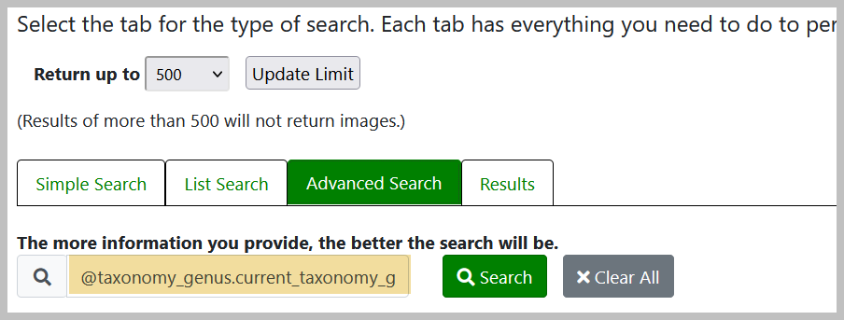

Appendix C: Administrator Notes on Sorting Search Results
There are three levels of sort on the output of Public Website searches:
- Highest weighted field hits first (genus hits before others)
- Accessions with PI prefixes are listed before Non-PIs*
- Most recently received accessions are listed first
* Organizations other than NPGS that are running GRIN-Global may set the preferred prefix from “PI” to their organizations preferred prefix.
If there are more than 500 (or whatever your maximum limit is set to) accessions that are genus hits on PI numbers, the most recent of those is first. If there are less than 500 PI records for the genus you are searching, going to see recent non-PI genus hits further down the list and recent PI non-genus hits even further down. That is, not all recent accessions will be at the top because the other sorts have a higher precedence.
If as administrator of a GG system you want to change any of that behavior, you’ll need to know how the sorting is controlled.
The first sort is by the weights of the freeform text fields, controlled by the get_search_autofields dataview. The weights assigned to autosearch fields can be adjusted in the following CASE clause:
, CASE
WHEN field_name IN ('genus_name', 'title') THEN 0
WHEN field_name IN ('species_name', 'adm1',
'accession_number_part1') THEN 1
ELSE 2
END AS weight
Note that “title” refers to the country name from the code lang translation. So hitting on genus name or country name are equally weighted, then species name, state name, or accession prefix for the next level, then the rest of the autosearch fields and finally the full text index hits (not controlled by the dataview).
The other two levels of sort are controlled by the PW dataviews web_search_overview_2 and web_search_overview_noimages_2 with an ORDER BY clause at the end of the dataview:
-- Put PI numbers first, then sort by date received
ORDER BY CASE WHEN a.accession_number_part1 = 'PI' THEN 0 ELSE 1 END, COALESCE(a.initial_received_date, a.created_date) DESC, pi_number
Actually there is a fourth level of sort by PI number if the received date is exactly the same. Another system could change that ORDER BY to whatever suits them.

The Search Tool retrieves the data in a different fashion. So the sort order as described above for the Public Website doesn’t apply.

Appendix D: Document Change Notes

– January 15, 2026
- elaborated on simple vs. advanced searches
- illustrated how to build and search a list of LOOKUP IDs

– June 26, 2025
- Additional information regarding IS NULL

– August 27, 2024
- editing / wording changes

– July 26, 2024
- editing / minor wording changes

– December 21, 2022
- added Note regarding BETWEEN
- also, corrected BETWEEN example

– June 21, 2022
- added Appendix B and details regarding PW sort priority preferences

– February 25, 2022
- added a dynamic query section with a link to the online Dynamic Query guide

– January 10, 2022
- mainly formatting changes

– July 12, 2021
- enhanced the section regarding calculating the actual quantities of viable seeds

– April 20, 2021
- formatted the table headings for the reserved words; therefore the headings are now included in the TOC

– February 2, 2021
- elaborated on the three search types; added screen examples

– October 1, 2020
- added note on comments
- enhanced notes on using search text on the Public Website

– September 20, 2020
- enhanced List Search notes

– August 12, 2020
- expanded information on BETWEEN

– February 29, 2020
- added use case searching using Live Seed (a calculated field)

– April 24, 2019
- changed example and wording for the WHERE clause

– December 17, 2018
- changed example and wording for the WHERE clause

