Observations and Descriptors:
CROP Dataviews


Revision Date
October 9, 2024

Author
Martin Reisinger

In GRIN-Global (GG), observations can be recorded for a crop’s traits, but to do so means that the crop, its trait, and if the trait uses a scale, its codes must have been created first. This document describes several inter-related dataviews used for managing crops, their traits and codes, and ultimately the descriptor data (“observations”) are created in the Curator Tool. You also see how traits can be reviewed in the Public Website.
In most organizations using GG, only a few users (or perhaps a database administrator or documentation manager) will define the crop, trait descriptors and their related code records, whereas many genebank staff will use the Curator Tool to enter observation data.
Change notes pertaining to this document are also summarized in the appendix. Review the Table of Contents which contains links to the document’s sections.

This and other GRIN-Global–related documentation can be downloaded from the GRIN-Global project website: https://www.grin-global.org/ The URL for this document is: https://www.grin-global.org/docs/elderberry_crop_added.pdf

Comments/Suggestions:
Please contact mailto:marty.reisinger@usda.gov or mar@rrginc.com with any suggestions or questions related to this document.

Contents
Overview 4
Observations on the Public Website 4
Where do you find Crop / Observations data in the Public Website? 6
Mapping Species to a Crop 6
Adding a taxon to multiple crops (Taxonomy Crop Map) 10
Determining a Crop’s species 10
Determining a Species’ crop 11
Viewing Crop Observations in the Public Website 11
Displaying CROP Descriptors, species, and other Information 14
Public Website – Alternative Method for Displaying Descriptors 15
Crop and Trait Dataviews 15
Creating Observation Records 17
Crop Trait Observation Record 18
Determination by a Trigger if the Accession Species Fits Under a Crop 18
Attach Observations to the Accession or Inventory? 19
Bulk Importing of Observations 19
English vs. ENG 26
Archived Observations 28
Crop (related) Dataviews 29
Overview 29
Crop 29
Crop Trait 31
Three Observation Types: Numeric, Text, and Coded (Introduction) 32
Numeric Traits 33
Coded Traits 34
Text Traits 35
Titles and Descriptions 36
Crop Trait Language Dataview 36
CORE Subset of Accessions 39
Crop Trait Code 40
Crop Trait Code Language Dataview 41
Attachments (File attachments) 42
Crop Attach 42
Crop Trait Attach 43
Using Descriptors to Establish a Core Subset of Accessions 44
Methods 46
Method Attachments 47
Correcting Observation Records to Point to a Different Accession 47
Appendix A: Changes in this Document 48
Appendix B: Step-by-Step Directions for Creating a New Descriptor 50
Step-by-Step Directions for Creating a New Crop and Descriptor 50
Appendix C: Examples 51
WHEAT (HABIT) 52
English Version 52
Eng Version 52
WHEAT (AWNCOLOR) 53
WHEAT (HESSIAN FLY) 54
English Version 54
Eng Version 54
MAIZE (NORTHERN LEAF BLIGHT) 55
MAIZE (NORTHERN LEAF BLIGHT RACE O) 56
MAIZE (VIGOR) 57
BACTERIAL STEM ROT (SWEET POTATO) 58
English Version 58
ENG Version 58
CHROMOSOME COUNT (SWEET POTATO) 59
FLOWERCOLOR (SWEET POTATO) 60
Developing crop descriptor lists 61

Overview

Observations on the Public Website
“Characterization of germplasm is essential to provide information on the traits of accessions assuring the maximum utilization of the germplasm collection to the final users. “ Read more… from the CGIAR Crop Genebank KnowledgeBase.
The Public Website (PW) can display characteristic/evaluation data for any accession whose observations have been recorded.
 | A crop’s trait only displays on the Public Website when at least one observation has been recorded and is public (not “archived”).
In GRIN-Global, observations are organized by crops. In GG, a “crop” can be loosely defined as a set of species determined by the curator or genebank to comprise the crop. GG has the capability to have overlapping crops, meaning that two (or more) “crops” may have the same species. This will be explained in detail later.
To review observations for a species, the PW user accesses the Descriptors menu option. The user then selects a crop; if that crop has observation data in the database, the crop’s descriptors (traits) will be listed. At that point the user can refine the search by selecting the various descriptors and by specifying values for the criteria.
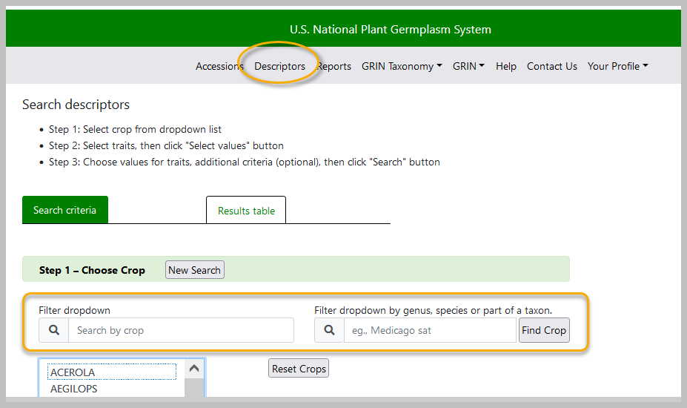

What is needed to record an observation in GRIN-Global?
Several steps must be taken with the GG database before you can record an observation. Many of these steps are done only once.
Since all observations are connected to inventory, the Inventory record must be in the database. (In GG, every accession has at a minimum the system inventory record with typecode “**” -- which observations can be linked to.)

The following illustrates the general flow in inputting the data in the crop-related dataviews – this flow should be followed in establishing any new crop trait:
Step | Input Data for the... | Dataview to use
1 | Crop | Crop
2 | Mapping of crop to species | Taxonomy Crop Map
3 | Trait | Crop Trait  Crop Trait Lang
4 | Codes  (when a trait uses a scale (“codes”) | Crop Trait Code  Crop Trait Code Lang

Then, to record observations, in addition to the above steps…
5 | Method | Method
6 | Observation(s) | Crop Trait Observation

If you don’t have the crop defined in the Crop dataview, you cannot input any of the traits related to the crop. Similarly, before you can create the codes for a trait, you must define the traits first.
Conversely, you cannot delete a crop from the Crop table if it has traits associated to it. Similarly, traits cannot be removed from the Crop Trait dataview unless all the dependent data in the children dataviews has been removed first.
Generally a curator identifies specific traits to be measured / observed and establishes respective trait records. The curator decides how these observations will be presented to the public. Will they have a text value, a numeric value, or a coded value? (Coded values are used when a scale is involved. For example, a scale from 1 to 9 is used to represent relative heights across a range.)
In summary, the essential steps for recording observations are:
- Define a Crop record
- Map the crop to species, using the Taxonomy Crop Map table
- The curator plans what observations will be made and usually creates a specific Method record that details how the observations will be made and eventually records the growing and any other conditions that will have affected the outcome.
- Define the Crop Trait record(s)
- Define the Crop Trait Code records when any of the traits are coded (that is, they use a scale)
- In GG, two related “language” tables are involved: Crop Trait Lang and Crop Trait Code Lang. These are used to define the titles and descriptions (for English and/or any installed languages).
- Record observations in the GG Crop Trait Observation table

Where do you find Crop / Observations data in the Public Website?
Use the Descriptors page. You can also enter a species to determine what crop it is under.

Mapping Species to a Crop
Curators typically decide which species to include in a crop. In GRIN-Global, the taxa are said to be “mapped” to a crop. In setting up a crop, the curator will create one crop record. The curator will use the Taxonomy Crop Map table to map all the species that she wants included in the crop.
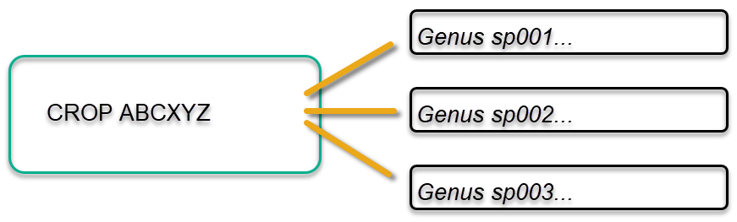
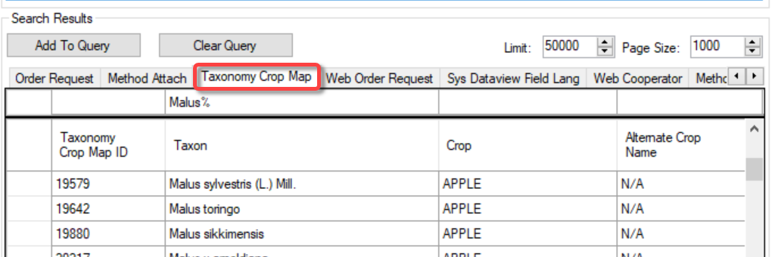
The setup of crop, traits, trait codes, and the crop mapping, requires some initial effort. Once set up, observations can be recorded.
All Taxonomy Crop Map records need N/A in the Alternate Crop Name. Don’t ask why! Keeping this simple, think of the N/A as “required.” (This has a history that dates back to GRIN-Global’s predecessor software, GRIN.)
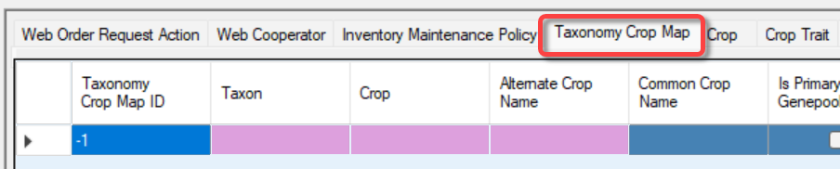

Trigger Determination if the Accession Species Fits Under a Crop
When a user adds an observation record using the Curator Tool, a database trigger reviews the Taxonomy Crop Map table to determine if the accession's species has been previously mapped to a crop.
If observations have never been recorded for a crop, and no records have been manually created in the Taxonomy Crop Map table for that crop, there is no crop-to-taxon relationship (yet). In that case, saving the first observation record will automatically map the species of the inventory to a crop, thereby establishing a relationship going forward between the specified crop and the taxon. This is accomplished by a trigger.
The trigger writes a specific kind of record in the Taxonomy Crop Map table - an “N/A record” – indicating that that the species is now associated with that crop. These N/A records have three essential fields filled in: Taxon, Crop, and the Alternate Crop Name.
After a species has been mapped to a crop, subsequent observations for that same species will automatically be expected to be for the same crop. Additional observations must use the same crop unless another Crop-Species entry is made in the Crop Map Table.
Usually, an organization will have a taxon associated with just one crop, but it is possible to have a taxon associated with multiple crops, as shown above.
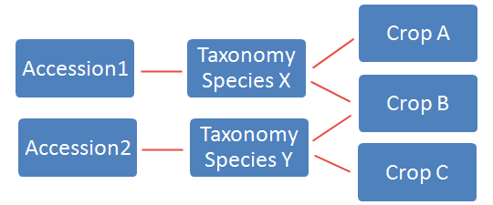

In the example below, two sites in NPGS, Geneva and Davis, manage the same species. By having two map records for V. aestivalis, both sites can now record observations for their respective accessions.
At NPGS, this map table may also have other records that do not have “N/A” in the Alternate Crop Name field, but these records can be ignored for this mapping discussion. These records are vestigial to another usage, no longer relevant to GRIN-Global.
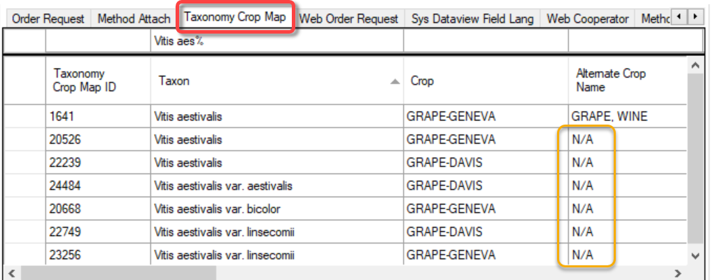
A common question is raised: Why can’t I add observations to a crop? An error message displays indicating that the “Accession species and crop species do not match,” as shown below:
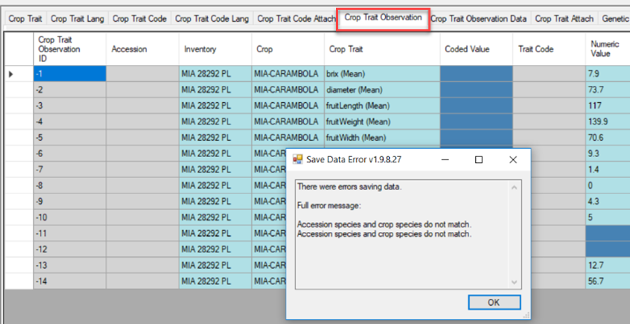
This message is a clue that the Taxon was used previously with a different crop. Before saving these observations, the user will need to create an additional “N/A” Taxonomy Crop Map record, associating the species to another crop (if that is truly what is wanted). Alternatively, this error message could be a clue that an incorrect Inventory identifier was used in the Observation record.

Adding a taxon to multiple crops (Taxonomy Crop Map)
In the Curator Tool, use the Taxonomy Crop Map dataview:
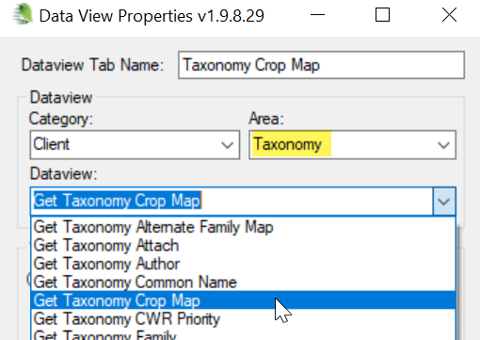
Create the desired Taxon-Crop N/A records as needed: 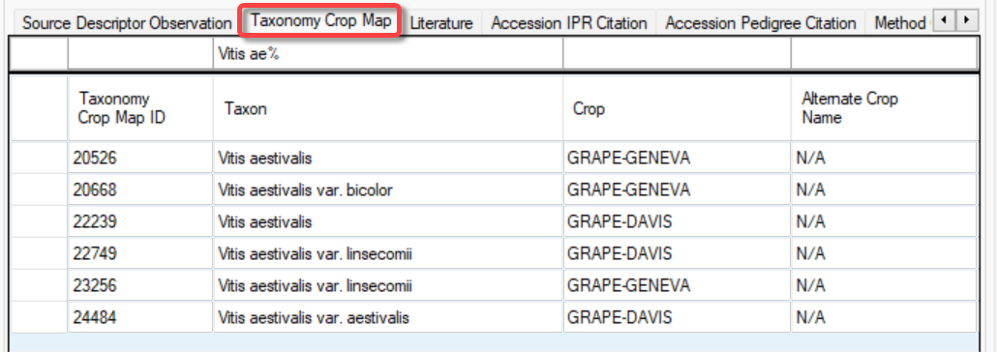

Determining a Crop’s species
Search in the Taxonomy Crop Map table, or use the Public Website crop page:
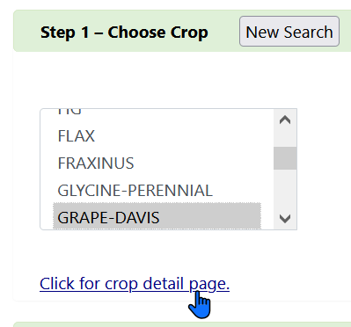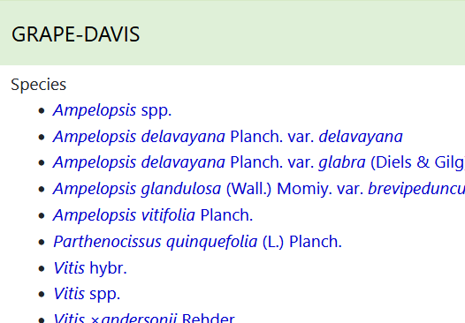

Determining a Species’ crop
On the Public Website, use the Descriptors page and enter the species:
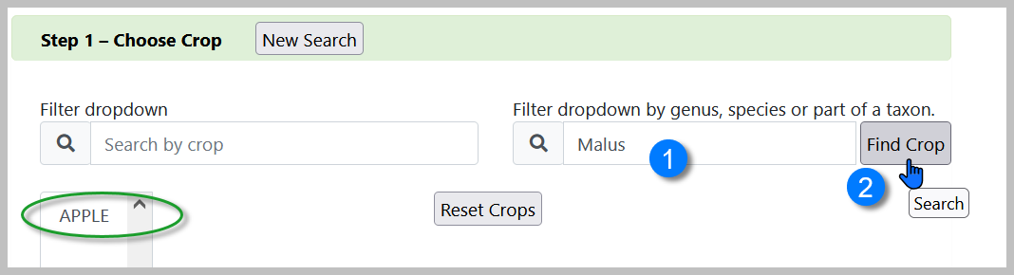
In the Search Tool, use the Taxonomy Crop Map dataview:
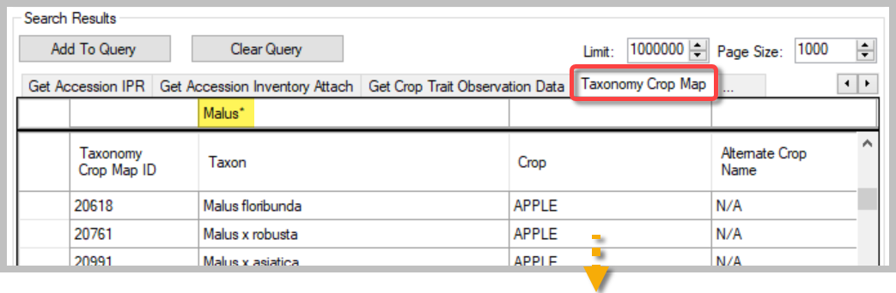

Viewing Crop Observations in the Public Website
There are several ways to view observations in the Public Website. One method is to search by Descriptors – the Public Website has a Descriptors menu option.
To review any observation, a crop must be initially selected:
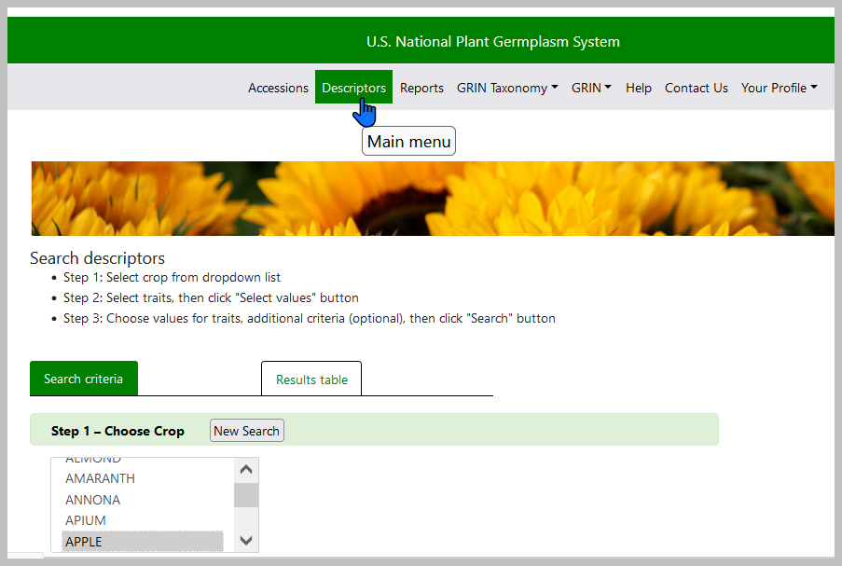
After the Crop is selected, if it has had observations associated with its inventory/accessions, a list of descriptors will display. This is an indication then that observations using these descriptors have been made and are stored in the database. Using the checkboxes, the desired descriptors are selected.
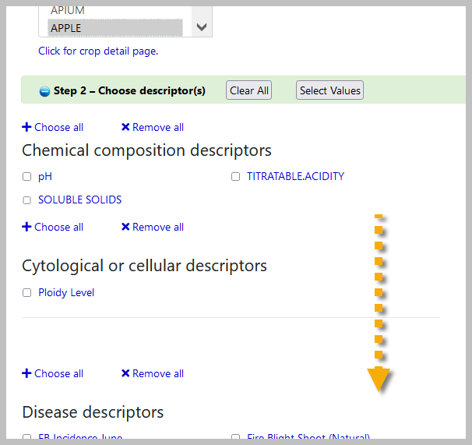
Criteria can then be selected for each chosen descriptor:
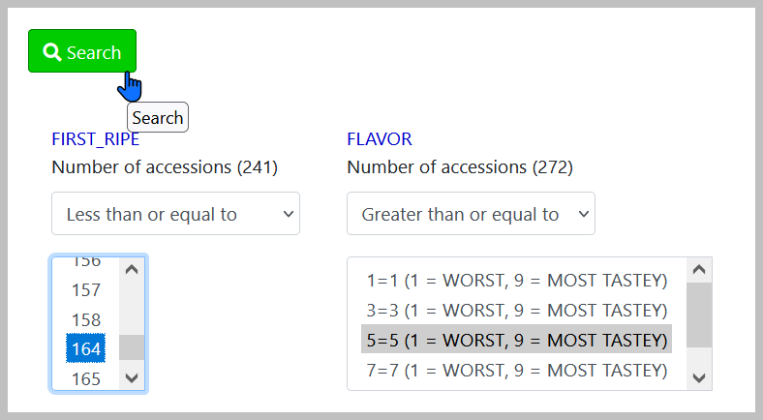
Results (User can order germplasm, export the data, etc.)
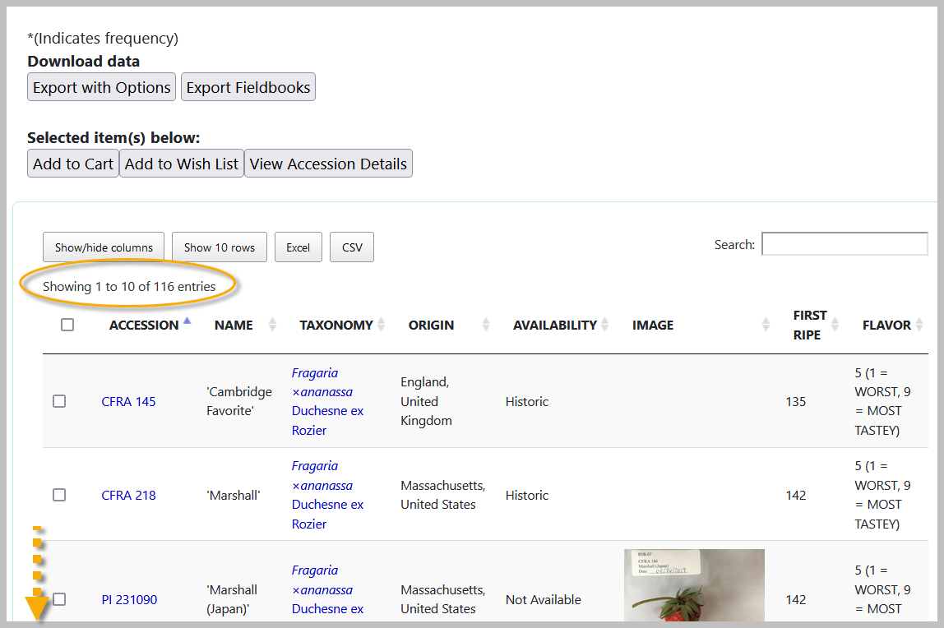
In the value boxes you can select actual values in the database. The condition dropdown is used to indicate the filtering condition -- "ANY" is the default, but you can change that to "GREATER THAN," "EQUAL TO," etc.
When using criteria boxes, you can select multiple criteria:
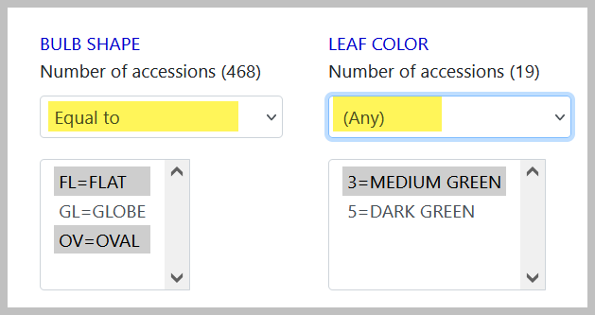

Export with Options
The following window lists the additional columns that can be exported:
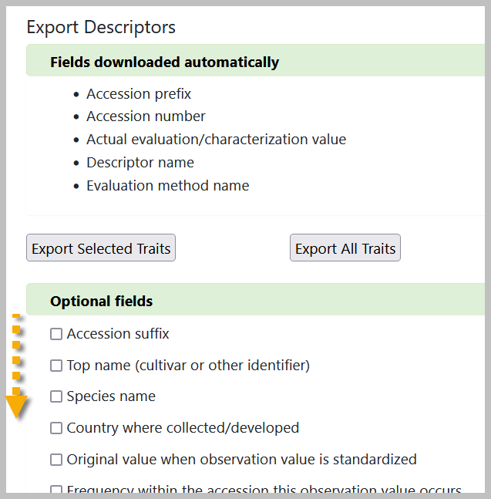

There is an additional feature available only to genebank staff who have their Public Website Username attached to their Curator Tool account – when they are logged in, on this window, they will see an Export Fieldbooks button. 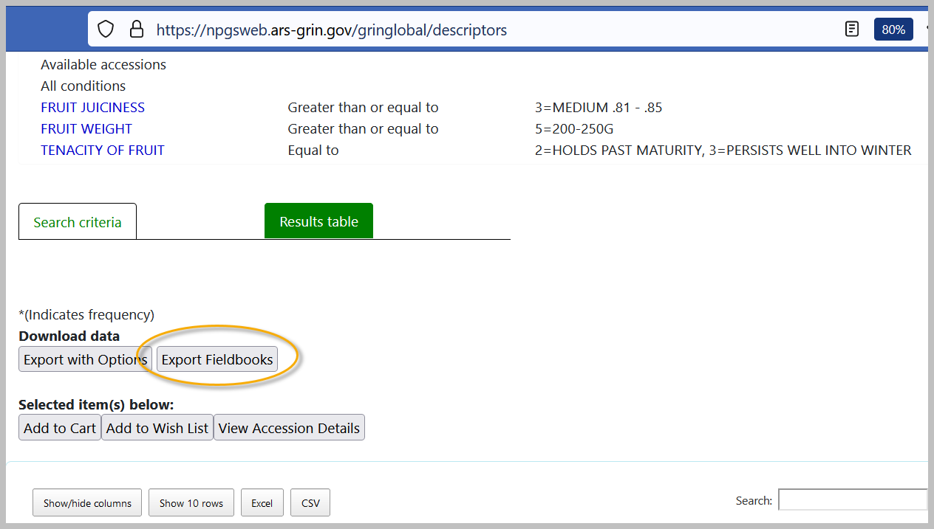

Displaying CROP Descriptors, species, and other Information
Click the link to access additional lists.
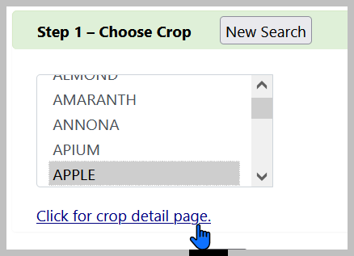
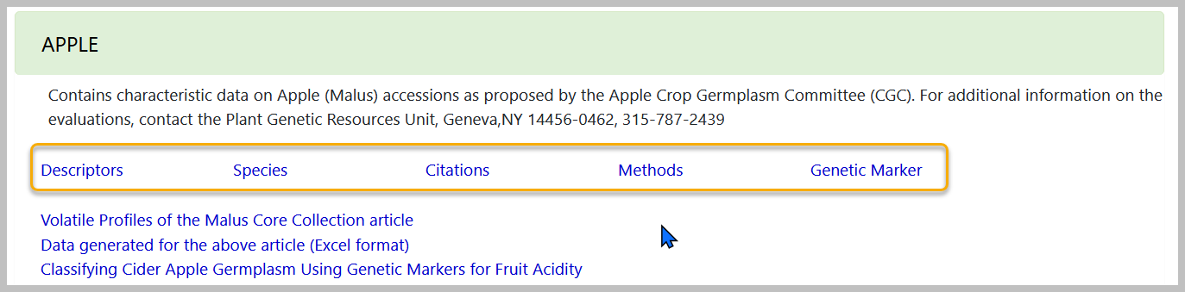

Public Website – Alternative Method for Displaying Descriptors
Under Search Results, you can select View Observation Data.
The search results display several columns of observations for accessions that met the search criteria. To display all of the observations, use the Export feature to create a CSV file for further review.
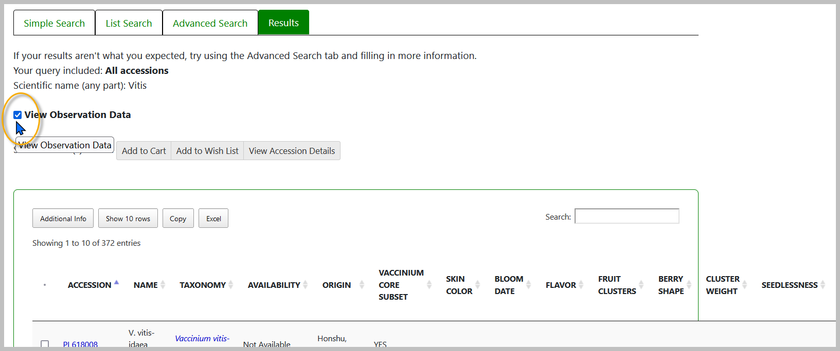

Crop and Trait Dataviews
GRIN-Global has many inter-related Crop tables. In the Curator Tool, you can see most of the related dataviews under the Crop area:
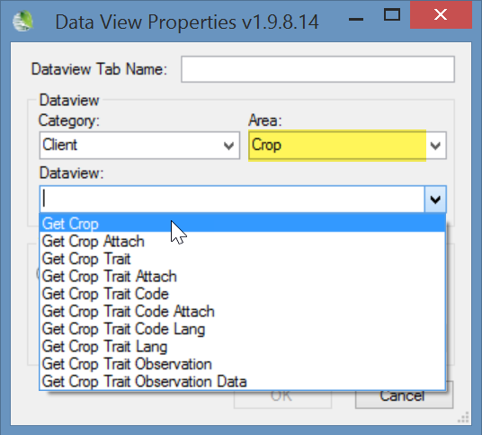
Each of these dataviews are described in detail in this document. Also, in Appendix B, step-by-step directions explain how to create a descriptor.

Another dataview critical for setting up crops, the Taxonomy Crop Map dataview, is in the Taxonomy area.
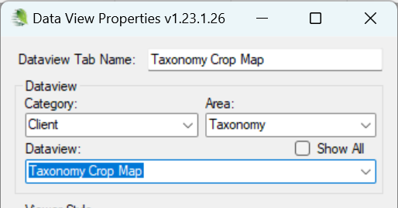

Two similarly named dataviews exist:
Crop Trait Observation and Crop Trait Observation Data.
“Crop Trait Observation” supplies data that displays in the Public Website.
The Crop Trait Observation Data table was designed to hold raw data, with the intention that in a future CT release, an observation wizard would be designed to summarize the raw data into the Observation table/dataview. Currently, the data in the data table is independent and not aggregated in the Crop Trait Observation summary table.

For NPGS, the GRIN data was transferred into the Observation table, hence use the Observation dataview to view the former GRIN records.

Creating Observation Records
Before an observation can be recorded, in GG, multiple crop-related records must be created. The curator or someone designated in the genebank must define the crops, the traits, and any codes that may be used with specific traits.

The following illustrates the general flow in inputting the data in the crop-related dataviews – this flow should be followed in establishing any new crop trait:
Step | Input Data for the... | Dataview to use
1 | Crop | Crop
2 | Mapping of crop to species | Taxonomy Crop Map
3 | Trait | Crop Trait  Crop Trait Lang
4 | Codes  (when a trait uses a scale (“codes”) | Crop Trait Code  Crop Trait Code Lang

Then, to record observations, in addition to the above steps…
5 | Method | Method
6 | Observation(s) | Crop Trait Observation

Details for creating these crop-related records are in the section titled: The Crop Family of Dataviews. As you can see from above, recording observation records requires pre-work to establish the related crop records.
Assuming the descriptors (“crop traits”) have already been added for the crops for which you are recording observations, in the Curator Tool you will use the Observation dataview to enter your evaluation results. In this section of the document, besides showing how to record observation records, a language switching option is explained so that you can input codes rather than their longer titles.

 | The observation requires a method to be indicated, so ensure that the relevant methods have been defined first before attempting to add observations. (Use the Method dataview.)

Crop Trait Observation Record
The Crop Trait Observation dataview has four obvious required fields:
- Inventory
- Crop
- Crop Trait
- Method
Violet colored cells are required; gray fields are read-only.
However, each observation record must have one of its three “value” fields filled in. The highlighted fields highlighted above– Coded Value, Numeric Value, and Text Value are mutually exclusive – only one of the three fields should be completed. There is no trigger to ensure this – it is possible that you can fill more than one value field. But the only value field that matters is the one defined by the Trait record.
When a trait is a coded field, a lookup picker window displays when that field is selected, as shown here:
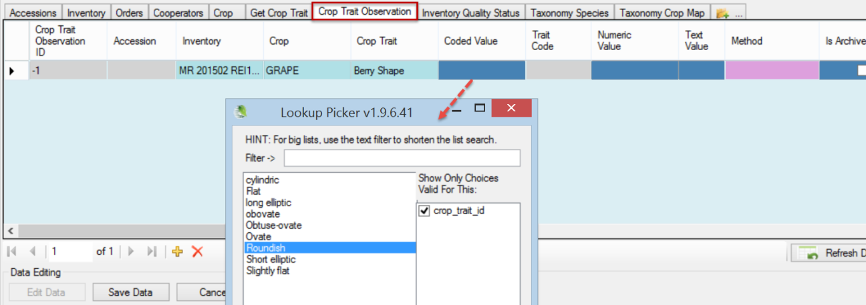
After the Observation record has been saved, the Accession and Trait Code fields fill in with their respective values:

Determination by a Trigger if the Accession Species Fits Under a Crop
When the user adds an observation, a trigger reviews a map table (the Taxonomy Crop Map table) to determine if the accession's species has been previously mapped to a crop. When that is the case, the observation must use the same crop. If the accession's taxon has not yet been mapped to a crop, then saving the observation record will map the species to a crop, thereby establishing a relationship going forward between the specified crop and the taxon.
The screen below shows what happens to an observation record being saved when the incorrect Crop is selected. In this case, the user should have selected HOPS, since the accession's taxon was Humulus lupulus, and that species had been previously mapped to HOPS.
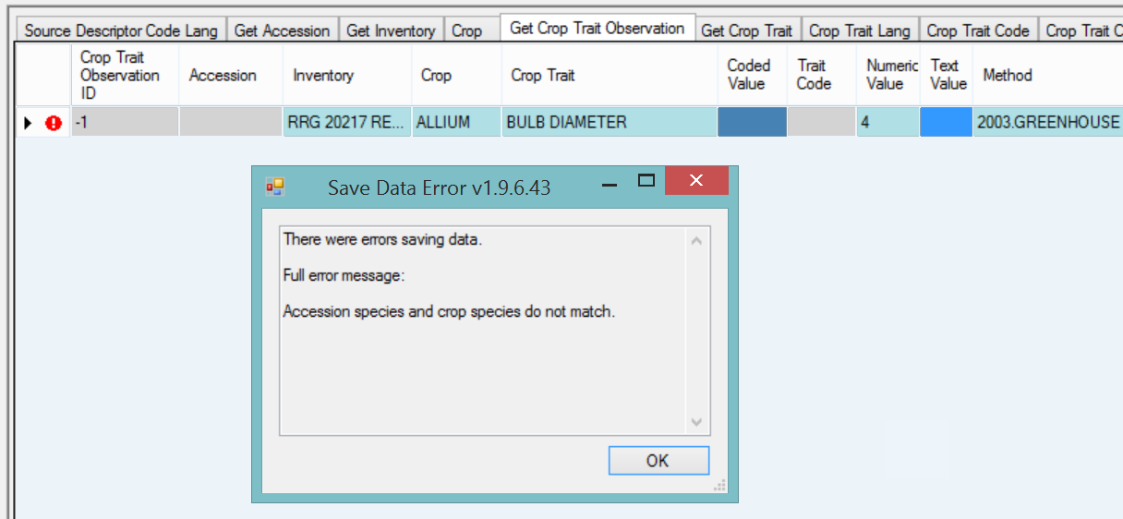

Attach Observations to the Accession or Inventory?
Observations are typically associated with a specific inventory record; however, because of the flexibility provided by the schema design, an observation can be associated with either an inventory record (a specific “lot”) or with the accession in general. Also, frequently in the case of historical observations, they have been saved, but not associated with a specific inventory. Rather than lose this data, it can be recorded in GRIN-Global and associated with the accession’s system inventory record (type = “**”)
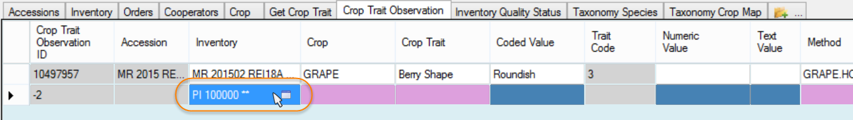

Bulk Importing of Observations
At some point you may have many observations to load into GRIN-Global. Inputting them one at a time is time consuming and inefficient, especially if you already have the data stored in a spreadsheet. Instead, it is much more practical to “bulk import” the observation data.
Many users will prefer working with the Trait Codes rather than their titles, (Coded Values), especially when bulk importing. Refer to the English vs. ENG section for more details.

Sample Observation Data for Apples
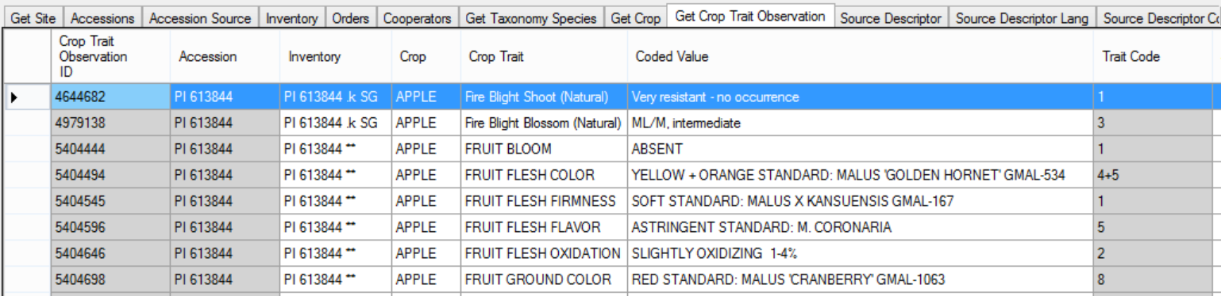

In the following scenario, assume that the observations being recorded are for the Apple trait FRUIT JUICINESS. FRUIT JUICINESS is a coded trait. There are several methods for determining what the possible valid codes are.
In EDIT mode, one simplistic method is to use the Get Crop Trait Observation dataview. Begin by adding a new record and then use the Coded Value lookup to determine what codes are valid for the descriptor. Unfortunately there isn’t an easy way to copy these codes into a spreadsheet, so you may transcribe them inaccurately if you attempt to type them.
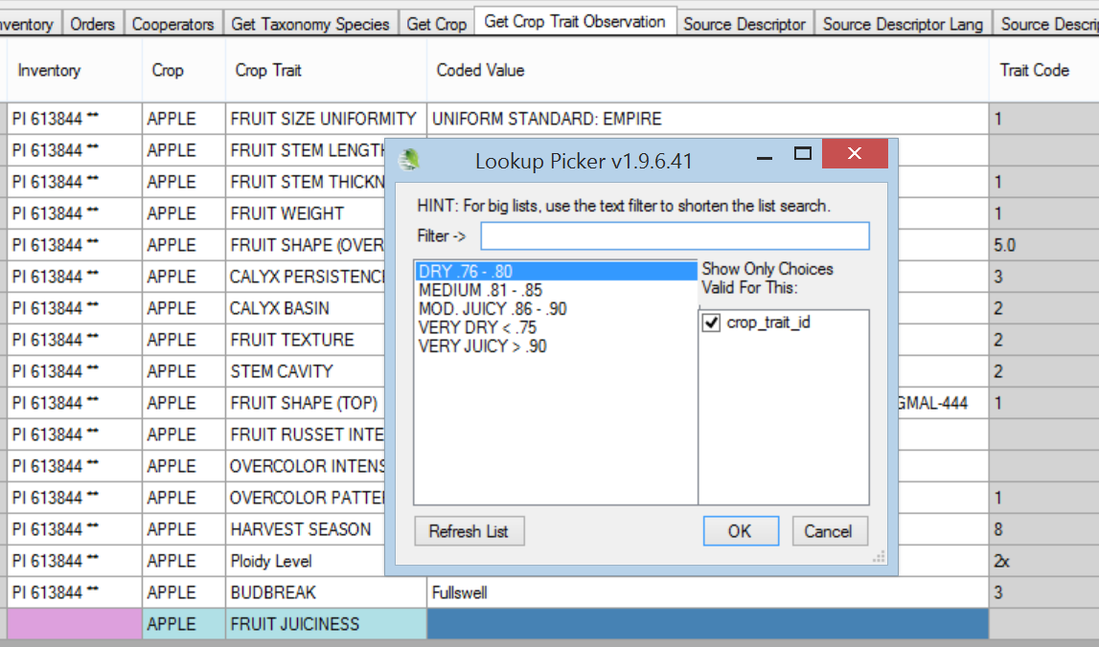
A safer way to get the codes is to use the Search Tool.
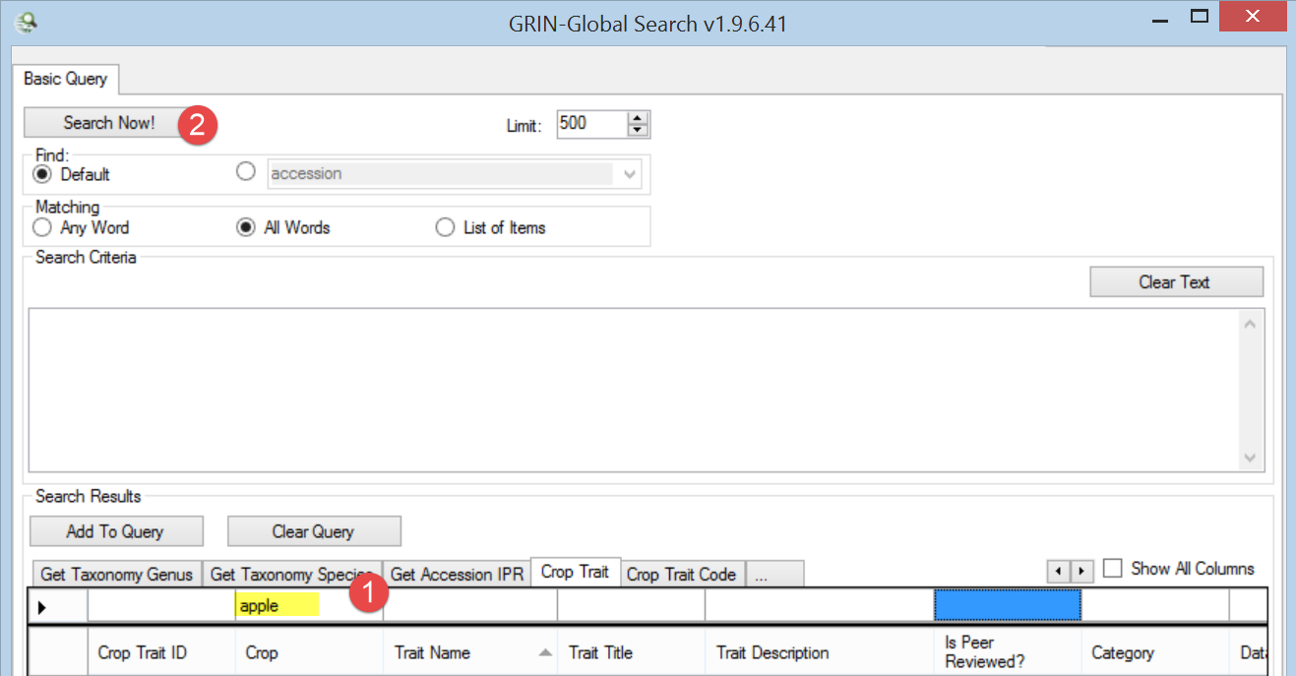
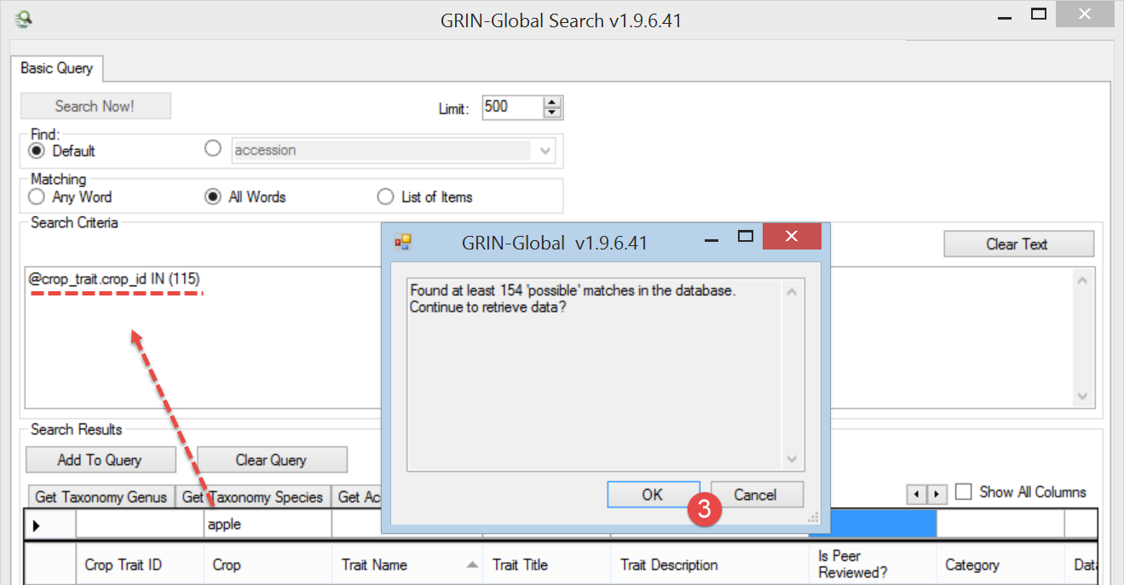
Sorting the list of records found by the Trait Name and scrolling down the list will display the row for FRUIT JUICINESS. Notice that the Trait Title is FRUIT JUICINESS; the Trait Name is FRUITJUIC. Add FRUITJUIC to the query:
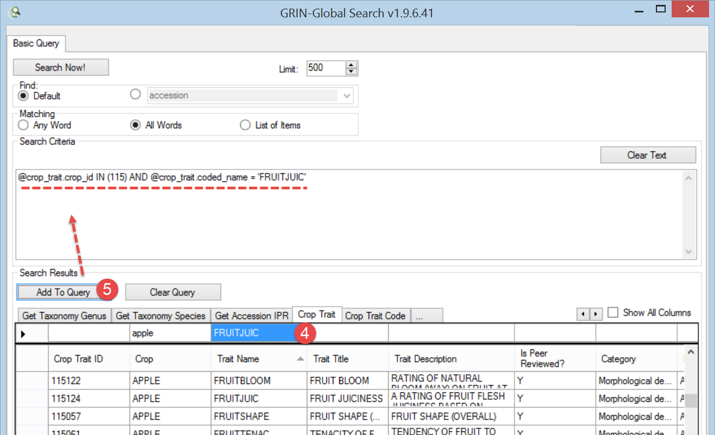
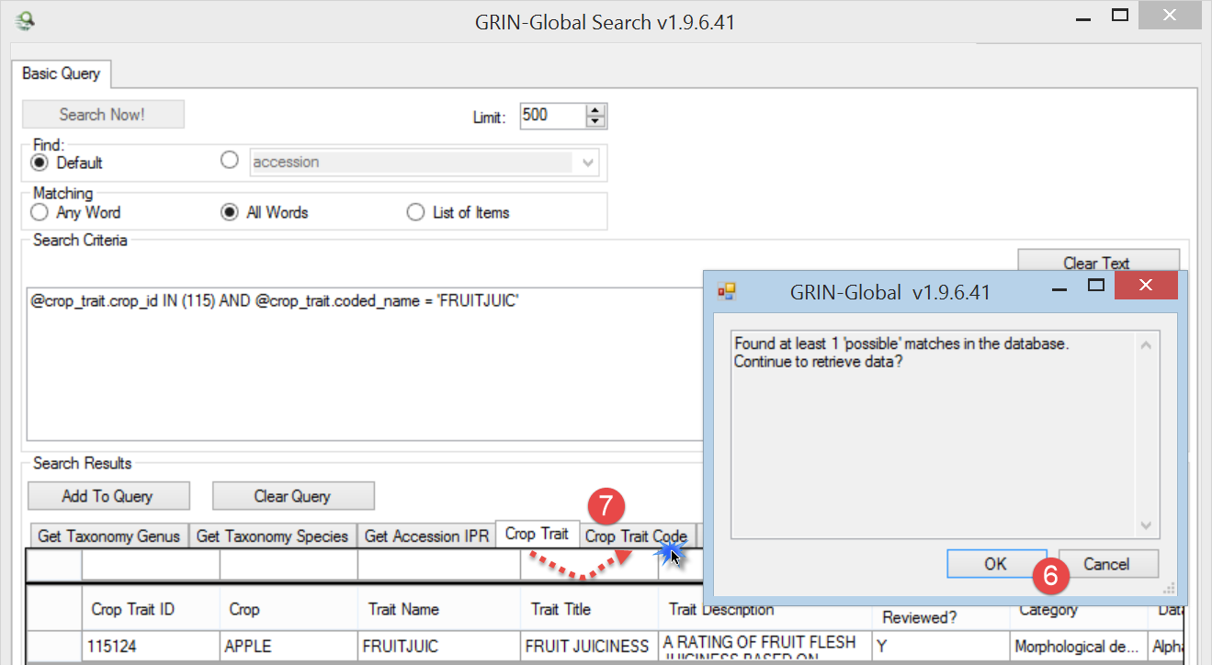
Switch to the Crop Trait Code dataview and the codes for the FRUITJUIC trait display:
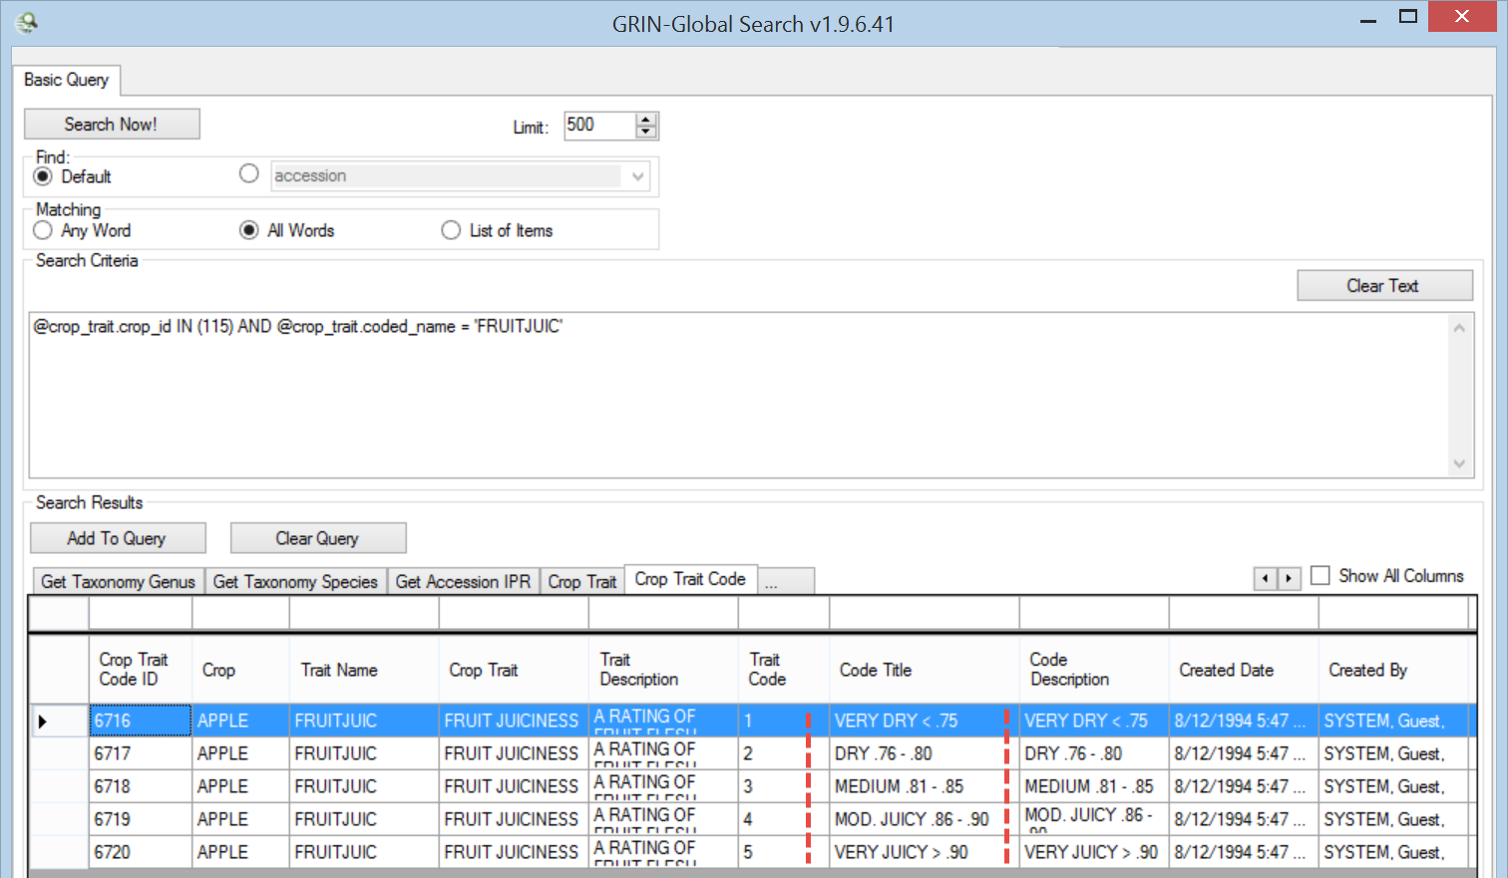
You can highlight the rows (in this case the five records for FRUIT JUICINESS) and drag them into Excel:
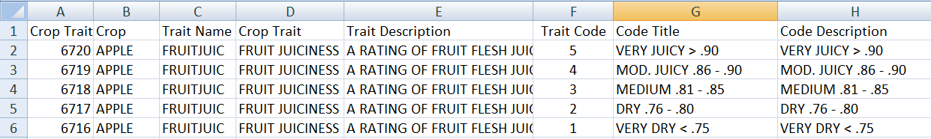
Now let’s see what is needed to save an observation record.
In this partial screen capture of a Crop Trait Observation dataview, because of the violet color, we can determine that four fields are required:
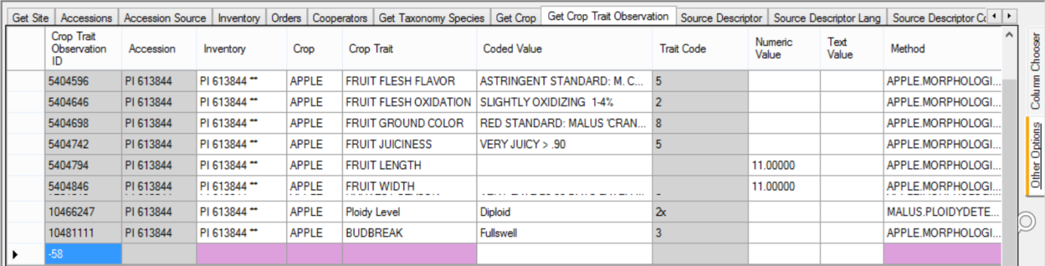

Required Fields:
- Inventory
- Crop
- Crop Trait
- Method
- and also, not highlighted in pink, one of the three “Value” fields
If the trait was defined as a coded descriptor, then you also need to supply a valid code in the Coded Value field. Notice in the above example that the Trait Code column has a gray color, indicating that in this dataview you cannot input or drag data into this field.
In the Curator Tool, with the Crop Trait Observation dataview active, drag a record that already has the Crop Trait FRUIT JUICINESS to a spreadsheet:
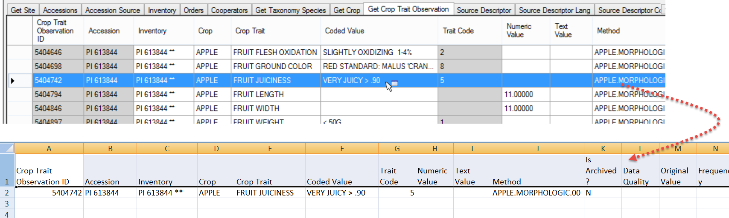
Now you can use the spreadsheet as a template for building your observation records. In this scenario we are only illustrating the bulk adding of FRUIT JUCINESS observations, but you can add any observations, as long as you provide the required fields and when traits are coded traits, you provide valid codes.
Previously we had dumped the valid codes into a spreadsheet. Use the values from the Crop Trait Code dataview’s Code Title column when creating the observation records. (Further below, in the English vs. ENG section, we’ll discuss how you can use the Trait Codes instead.)
 | If you setup your spreadsheet with the valid Crop Trait Code dataview’s Code Title values directly above the Code Value heading, you will benefit from Excel’s handy feature which supplies an item from the list as you type.  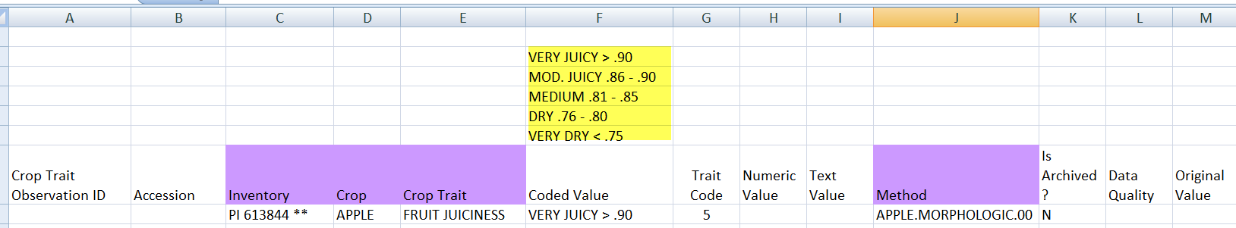
Eventually you will have the new observation data in the spreadsheet ready to be dragged into the Curator Tool. Highlight the headings – you do not need them all, but you must include the empty Crop Trait Observation ID column. Including the empty Accession column is fine.
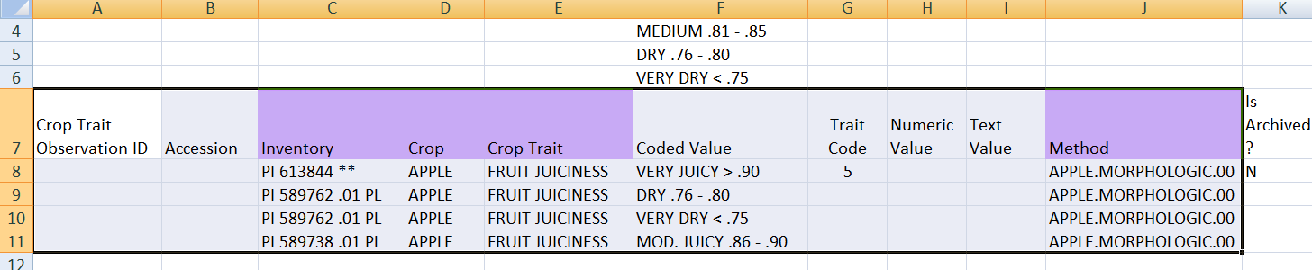
After dragging into the CT, but before saving:
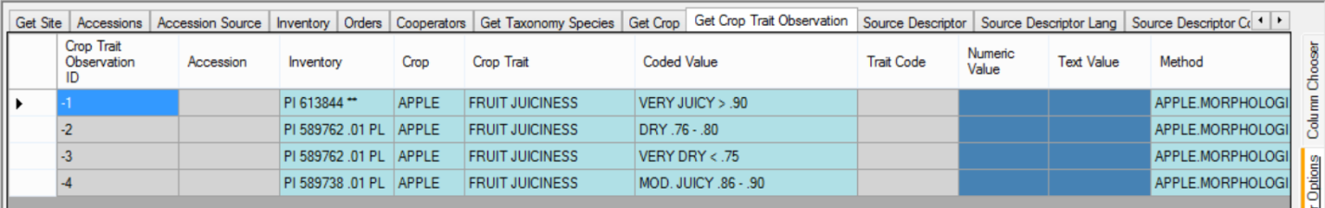
After the Save:
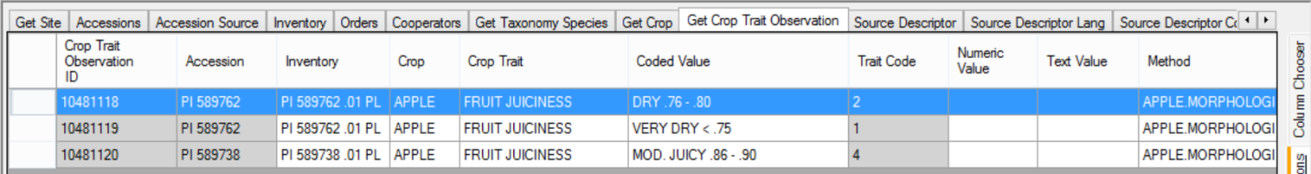
Why only three records in the CT whereas the Excel table had four? The first record, which we used as a template, was already in the database. During the save process, the Curator Tool highlights the duplicate and does not allow it to be saved again. Since it was already in the database, we only saved the three new records. A better alternative would have been for the staff person to first delete the row of the previously existing observation record, and only drag to the CT the three new data rows (and the heading row).
As an aside, the three observations in this example were associated to inventory records, not accessions. Remember that observations associated with system inventory records are associated to the accession.

English vs. ENG
A set of “ENG” dataviews were created to allow the codes to be used, rather than the lengthier titles. Some people prefer using the ENG dataviews because less typing is typically involved, reducing the chance of typos.
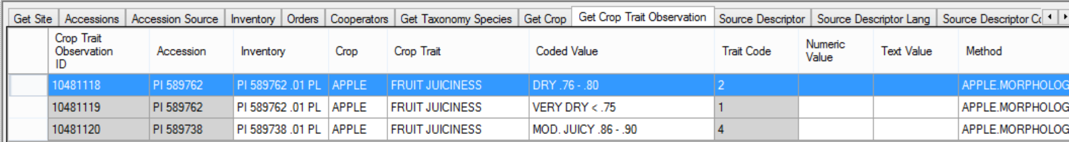
In the CT, rarely used is a feature in which the CT user selects his preferred language. (Historically, GG was designed to work with any language, but in reality, almost all genebanks prefer English. Over time, the headings’ text in the other language’s dataviews have not been maintained, so switching to a different language is no longer recommended. Using ENG is the one exception.
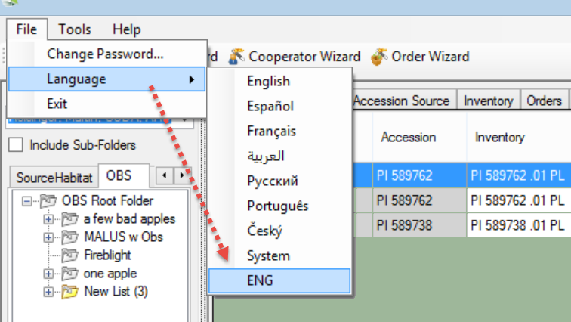

After you switch languages, you will be prompted to update your lookup tables. Since we are only working with the descriptors, we only need to update two:
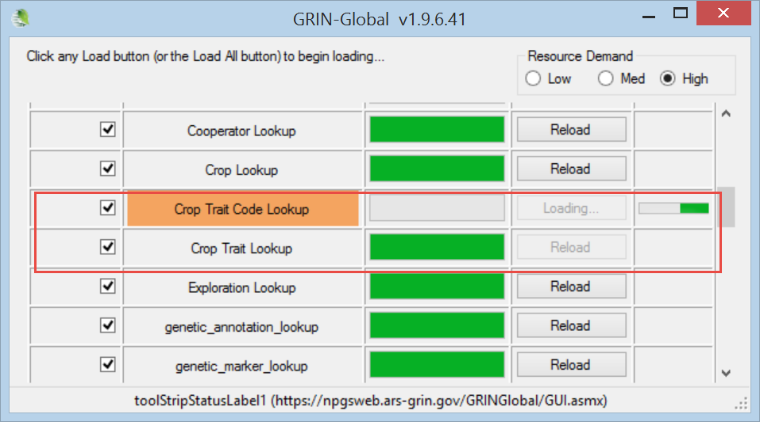
(The screen capture above illustrates that the Crop Trait Lookup has already completed, but the updating of the Crop Trait Code Lookup is still in progress.)
Click the Refresh button, and the Observation dataview (ENG) now looks like this:
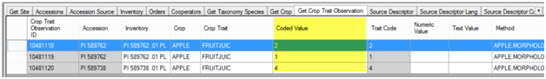
Compare the ENG version above with the English version we saw previously:
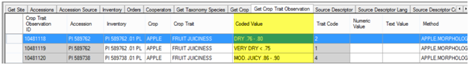
Notice especially the Crop Trait and the Coded Value fields. The ENG version is much simpler to bulk update.
Typically, CT users after completing their bulk updating will switch from the ENG language version back to English. The same two lookup tables, now the English version, will need to be updated before proceeding.

The following is another example. In this example, the Crop Trait Fruit Shape for the crop Watermelons is shown:

English Version:
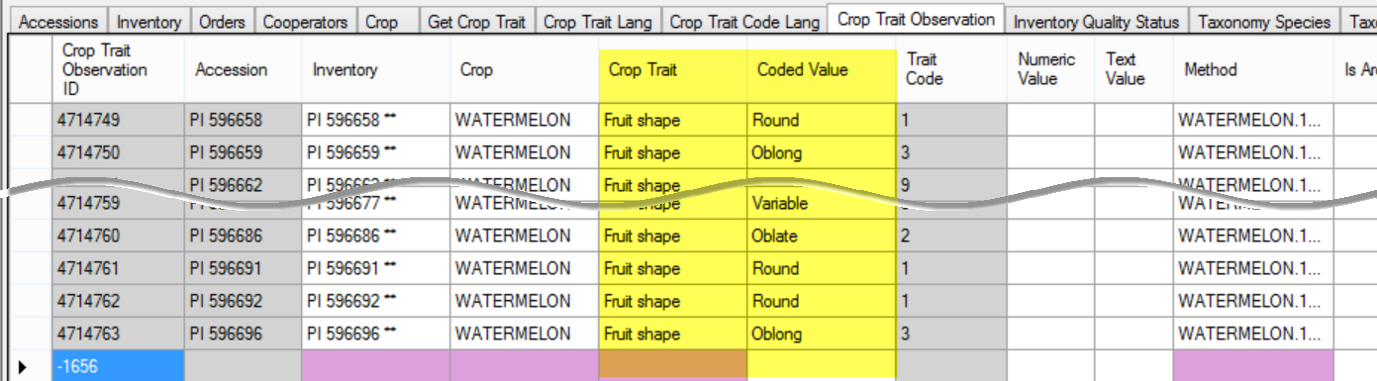

ENG Version:
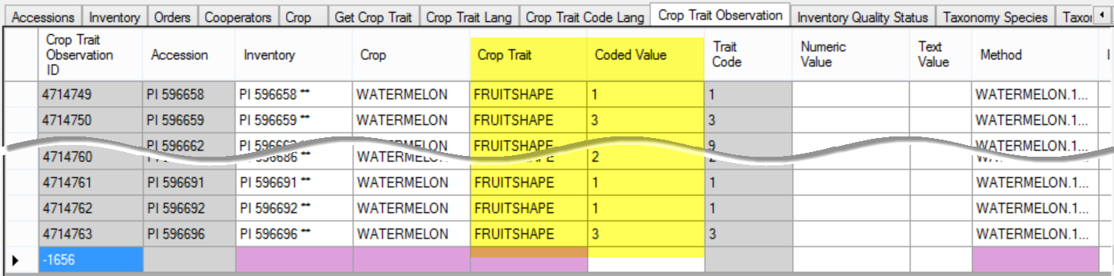

Another GG document, English vs. ENG, has more details on working with the ENG alternative language, but for the purpose of working with crop traits, the information above should be adequate.

Archived Observations
Observation records have a TRUE/FALSE flag indicating whether the data for this observation has been archived. The default is “N.” However, when set to “Y,” the GRIN-Global Public Website user will not be able to search this observation data, and the observation record is not displayed in the observation detail page. This term “archived” may be misleading to some – the records are not being moved or archived somewhere else, they are simply no longer visible on the Public Website.

Crop (related) Dataviews

Overview
There are five crop-related dataviews that need to be considered when setting up the crops and crop traits for your organization before Observations can be recorded. Refer to the section titled Creating Observation Records.
In this section, each of the Crop-related dataviews will be examined.

Descriptor Standards and Guidelines
Refer to Bioversity’s webpage on descriptors and standards and their Technical Bulletin Number 13, “Developing crop descriptor lists, Guidelines for developers” which cover the topic of crop descriptors in detail. Their webpage on descriptors states: “Descriptors lists and Derived Standards represent an important tool for a standardized characterization system and it is promoted by Bioversity throughout the world. It provides an international format and a universally understood 'language' for plant genetic resources data. The adoption of this scheme for data encoding, or at least the production of a transformation method to convert other schemes to the Bioversity format, will produce a rapid, reliable and efficient means for information exchange, storage, retrieval and communication, and will assist with the utilization of germplasm.”
The following definitions of descriptors are from the International Board for Plant Genetic Resources (IBPGR):
- characterization descriptors: ”consists of recording those characters which are highly heritable, can be easily seen by the eye and are expressed in all environments.”
- preliminary evaluation descriptors: “consists of recording a limited number of additional traits thought desirable by a consensus of users of the particular crop.”

Crop
The hierarchy of the crop related tables begins with the Crop table.

Crop Dataview
Two fields in this dataview can be inputted:
- Crop (required)
- Note
The note for each crop provides some general details about who is responsible for maintaining the crop descriptors or where additional information can be found. In setting up crop characterization and evaluation descriptor:
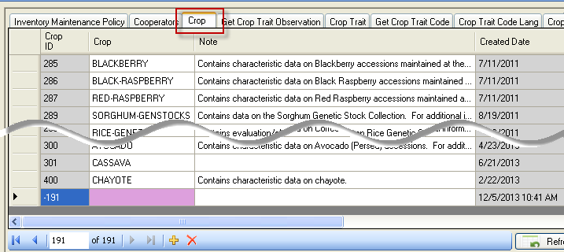
Notes in the Crop record will be visible on the Public Website crop page:
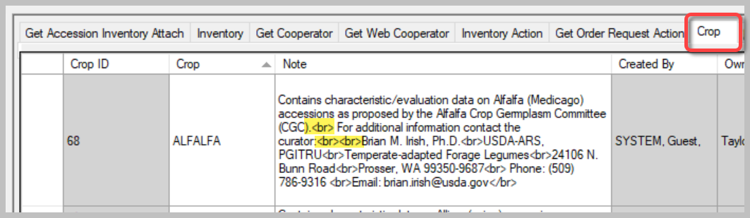
Public Website
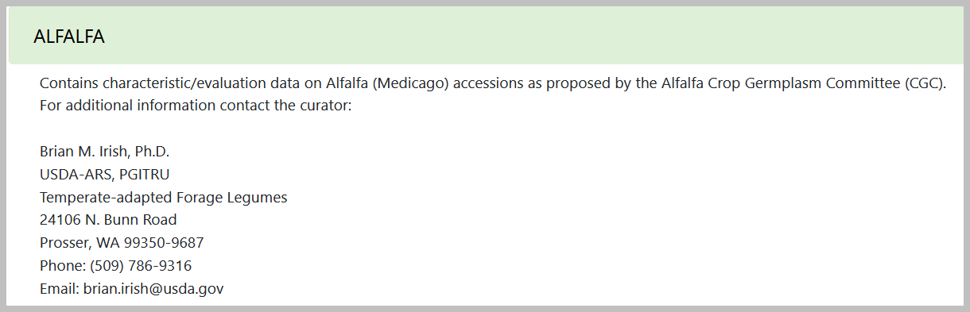
In the Note field, the HTML code <br> that controls line breaks was used to produce a nice format.

Crop Trait

Crop Trait Dataview
This dataview accesses the descriptor table for the crop or descriptor set. It includes both characterization (plant height, oil content, days to flower, etc.) and evaluation parameters (resistance to an insect species, response to fertilizer, etc.) Required fields:
- Crop
- Trait Name
- Category
- Data Type
A new Crop Trait being added (not saved yet): 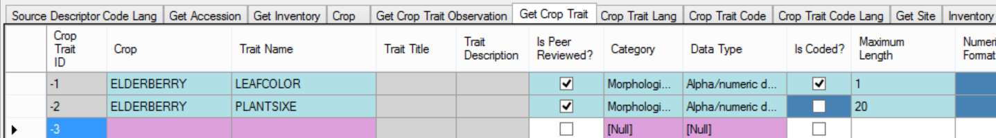

Three Observation Types: Numeric, Text, and Coded (Introduction)
A trait is designed to hold one of three kinds of values. When recording an observation record, one of the values is required. The Trait record determines which is to be entered:
- Text
- Numeric
- Coded
Examples are also online at: https://rrginc.com/gg_training/resources/2024_nordgen_descriptors/session4_descriptors_nordgen_2024mar06.pdf
When defining the trait in the CT, two fields in combination determine the data type:
Value type | Field:  Data Type | Field:  Is Coded?
Text | Alpha/numeric descriptor | - no -
Numeric | Numeric descriptor | - no -
Coded | Can be any Data Type | - yes -

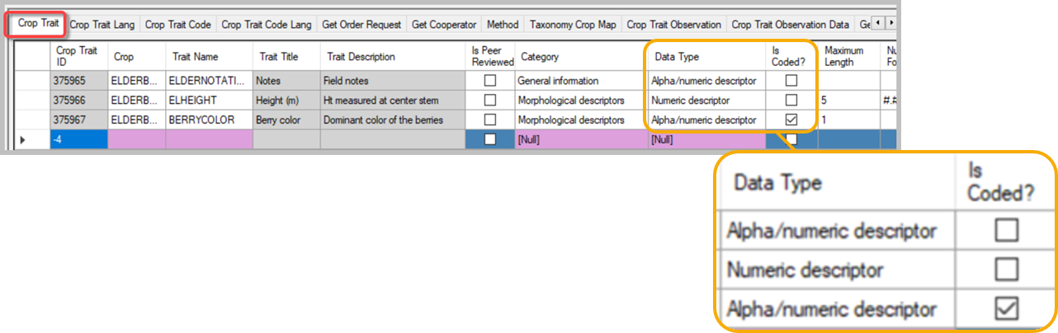

Numeric Traits
In the following illustration, Ear Height has been designed as a numeric trait.
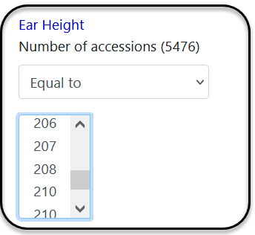
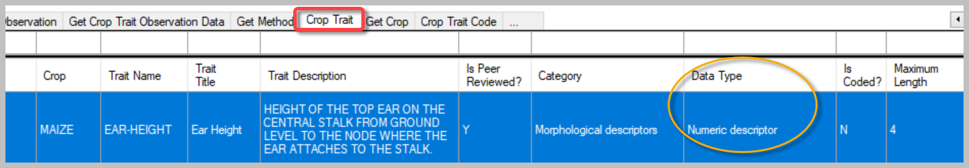
When defining a numeric trait, you may want to indicate how the number can be formatted as well as a possible range. There are four fields that assist in controlling allowed values.
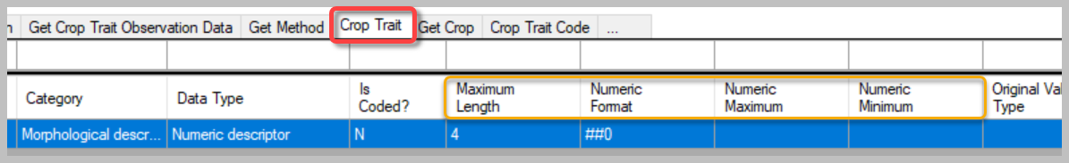
Maximum and Minimum are self-explanatory; by setting these, you can control the range of allowable values. Another field, the Maximum Length, is referring to the number of allowed digits.
The Numeric Format field is not as intuitive. This field is useful in limiting the number of digits that will display on the public website. The most frequently used symbols are the #, the 0, and the decimal point. Examples are shown below.
Format specifier | Item | Description | Examples
"0" | Zero placeholder | Each zero placeholder is replaced with the corresponding digit when present; otherwise, zero displays | 1234.5678 ("00000") -> 01235  0.45678 ("0.00“) -> 0.46
"#" | Digit placeholder | Replaces the "#" symbol with the corresponding digit when present; otherwise, no digit displays.  No digit displays if the corresponding digit in the input string is a  non-significant 0. | 1234.5678 ("#####")  -> 1235  0003 ("####") -> 3  0.45678 ("#.##“) -> .46
"." | Decimal point | Determines the location of the decimal separator in the result string. | 0.45678 ("0.00", en-US) -> 0.46

Coded Traits
Coded traits make scales possible. That is, the user can search from a scale such as small to large instead of searching for specific numeric values (3 meters).
Coded traits initially require more work from the CT user, because a set of values must be created for the trait – each value will have a code record. Additionally, each code should be assigned a title and description, meaning that a corresponding Trait Code Language record must be created for each Trait Code record. However, the benefit to the PW user is that they can search for a range of values.

The following is an example of a coded trait. With Ear Shape, five codes, 1 thru 5, have been defined.:
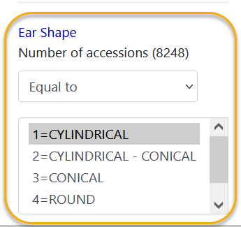
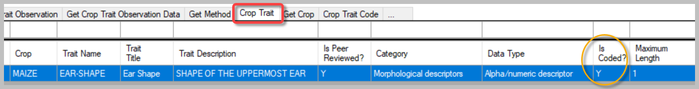
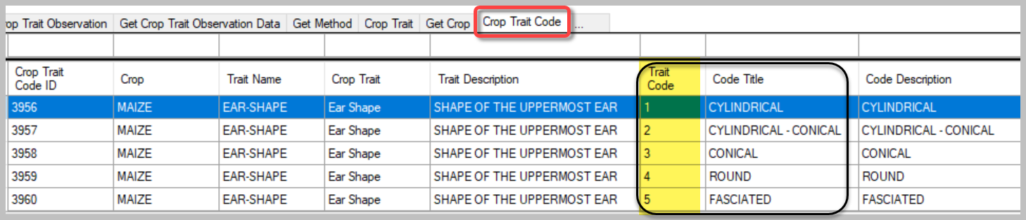

Text Traits
A text trait is just that, text is stored for the trait’s values. In this example, at first you might think it is coded, but each phrase in the criterion box is actual text that was recorded in an observation.
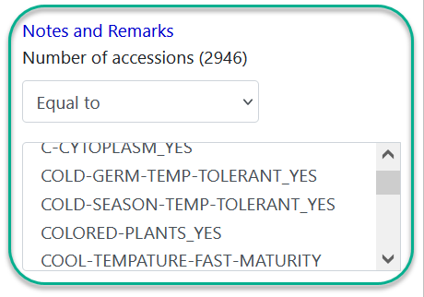
The trait in the following example will have text observations because of how the trait wasn’t originally defined: – the Data Type is not numeric and it isn’t coded (N in the Is Coded? field):
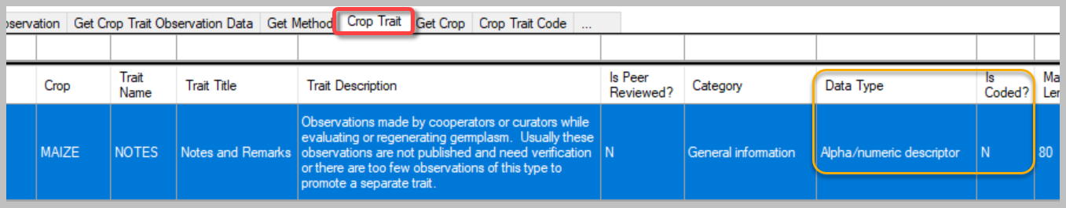
In this example, the curator decided there were too many possibilities to set up as coded, but he did use the text consistently. 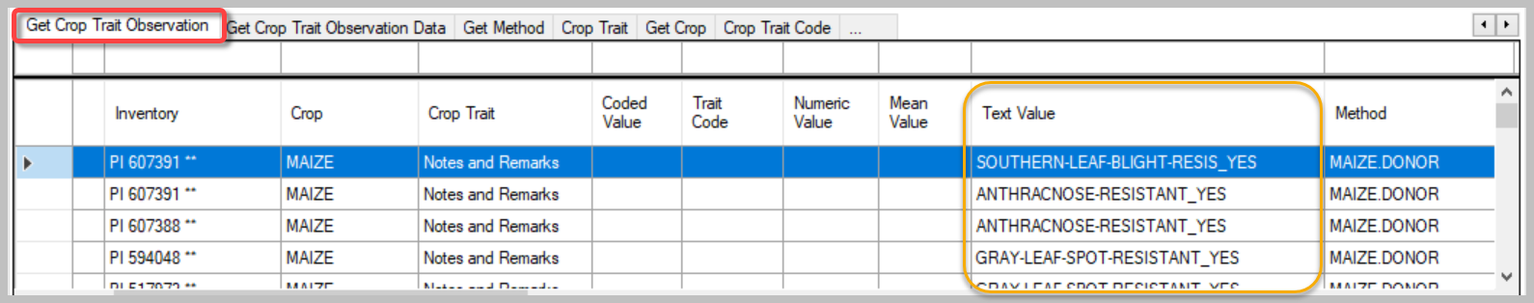

Titles and Descriptions
The read-only fields, Trait Title and Trait Description, will be supplied after a corresponding Crop Trait Language record has been completed.
Until the Crop Trait gets its Title and Description (via the Crop Trait Lang dataview), the list item displays as it does below – :croptraitid=crop trait record ID
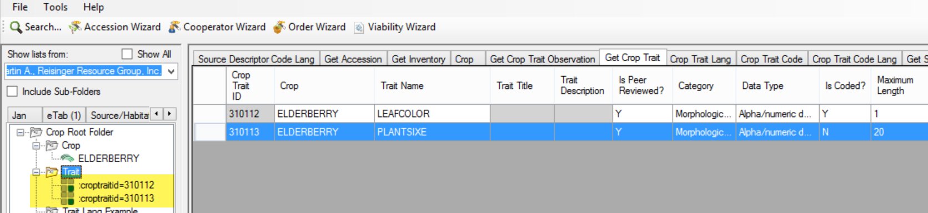
The next step, to get the Trait Title and Trait Description, would be to add the respective Crop Trait Lang records. If you do that immediately after creating the Crop Trait records, you most likely will get errors:
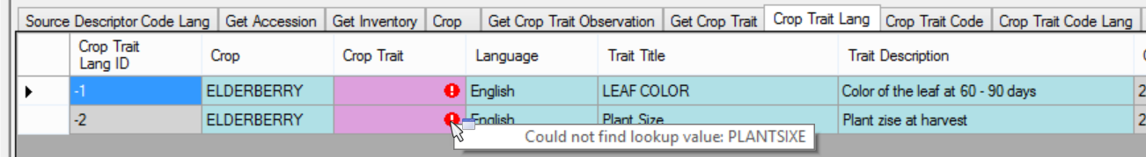
To avoid receiving those errors, click the Refresh Data button when the Crop Trait dataview is active. Then, when saving the corresponding Crop Trait Language records, the Trait Title and the Trait Description fields will be accepted and display:
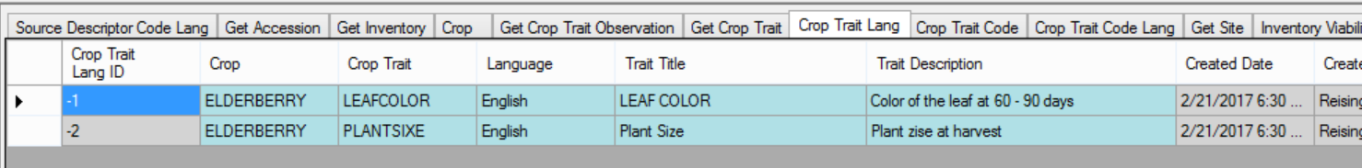

Crop Trait Language Dataview
The Crop Trait Language dataview has three required fields:
- Crop
- Crop Trait
- Language
Although they are optional, the main purpose of this dataview is to supply the Trait Title and Trait Description fields for a specific language.
Notice in the following screen, the Trait Name is displayed in the lookup list. After the Trait Title is entered and the Crop Trait Language record saved, the Trait Title will display in future lookups.
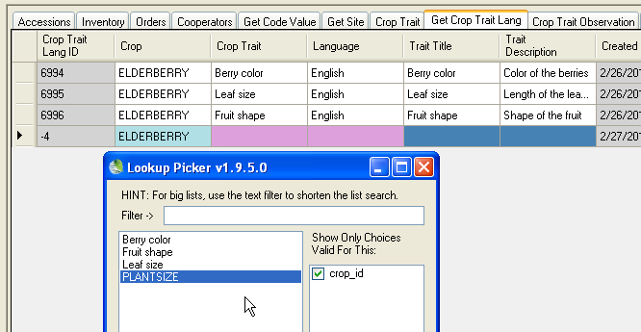
Leave the crop_id filter checked!

A new Crop Trait Language record:
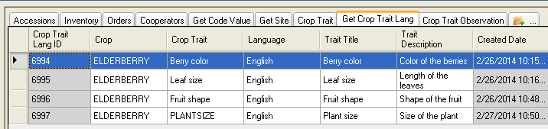
Here’s the lookup now:
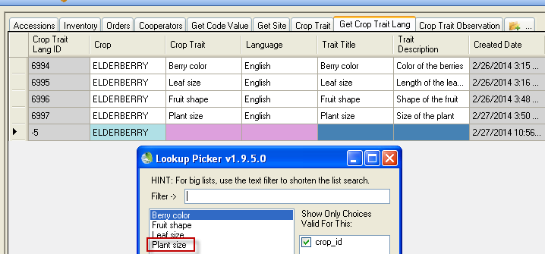

Using either the Curator Tool or the Search Tool, you can get a complete list of the crops. The Crop dataview automatically displays all of the Crop records when the active folder in the List Panel is empty.
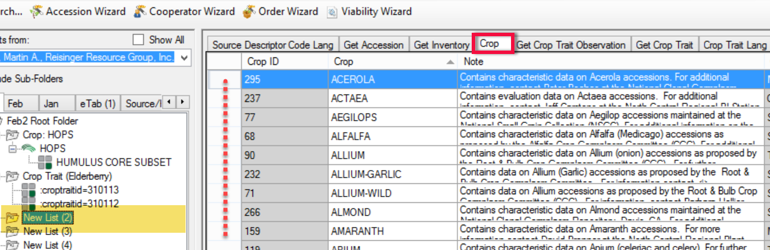

Drag one crop record to an empty folder in the left list panel to “filter” for accessions having observations for that trait.
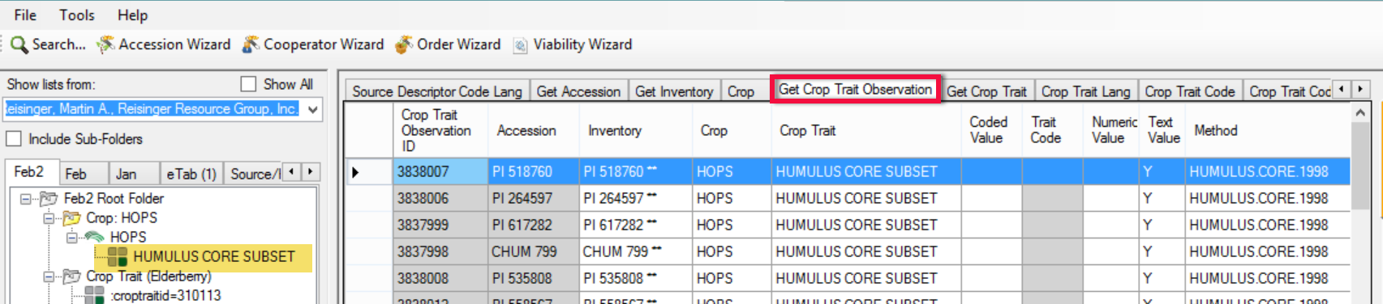
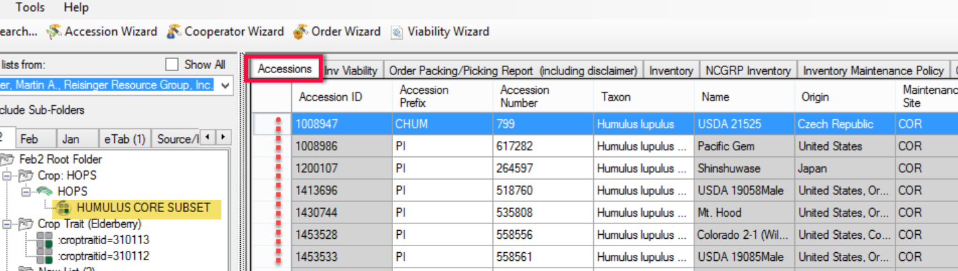

CORE Subset of Accessions
The concept of a CORE trait evolved from GRIN. The idea is that a curator assembles a subset of the entire collection. To make it easier for ordering the subset, if each accession to be included in the subset has the same trait, CORE, then the Public Website user can search for the CORE trait, and then select all those accession as a group.
In the example below, the site created two subsets: CORE, and a MINI-CORE.
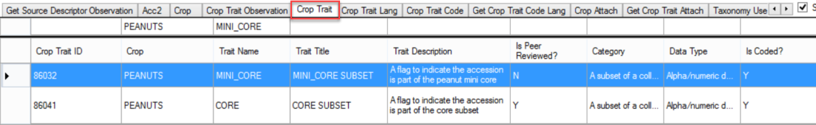
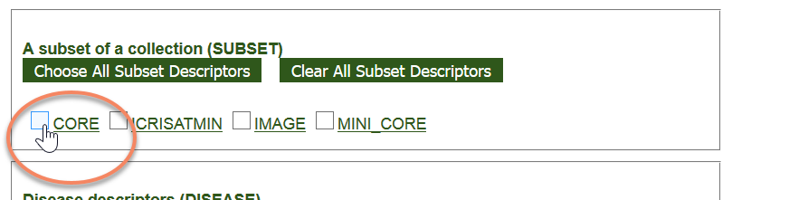
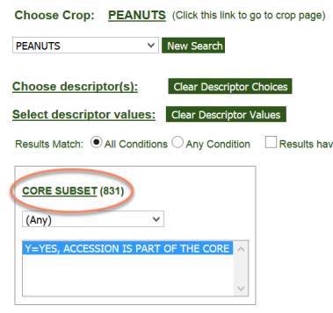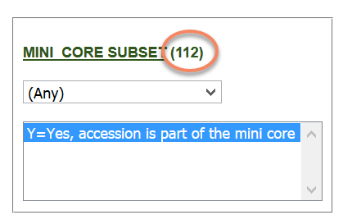

Crop Trait Code

Crop Trait Code Dataview
Table of the list of acceptable code values for the crop descriptors.
In a previous example, Plant size was set up here as a coded field. (Some organizations may simply record the actual height measurement as a numeric Plant Size trait. Nevertheless, for this example, we will establish this trait as a coded field to illustrate what is needed when setting up a coded field.)
When adding a code via the Crop Trait Code dataview, three fields are to be supplied – all three are required:
- Crop
- Crop Trait
- Trait Code
The Crop and Crop Trait fields use lookups to have their entries selected; the actual code is inputted in the Trait Code field. The read-only fields Trait Name and Trait Description will be automatically filled after the save.
Lookups sometimes need to prodded a bit. For example, if you created a Crop Trait and then immediately decided to create codes for that trait, the Crop Trait lookup may not have caught up with (synchronized with) the server. If you don’t’ see the trait, update the Crop Trait lookup.

Crop Trait Code example:
Before:
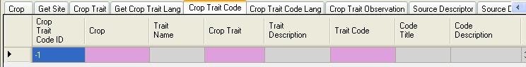
After the Save:
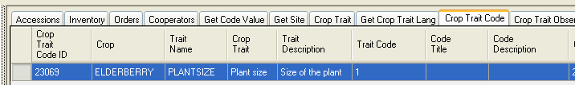
Later, after a corresponding Crop Trait Code Language record was saved:
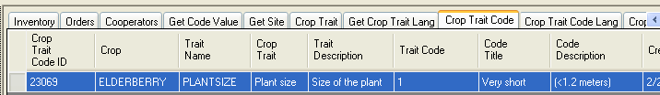

The Code Title and Code Description fields are also “read-only;” they will be filled after the corresponding Crop Trait Code Language record has been created.
In Edit mode, use Ctrl – N to create additional records below the one new record; and add any additional Trait Codes that will be used.

Crop Trait Code Language Dataview
The Crop Trait Code Language record is used to assign a Code Title and Code Description to a Crop Trait Code record. Six fields can be supplied (while not shown in the violet color and technically not required fields, why else would you create this record if you were not supplying the Code Title and Code Description fields?)
Required fields:
- Crop
- Crop Trait
- Code Definition
- Language
Optional but pertinent:
- Code Ttile
- Code Description
Before:
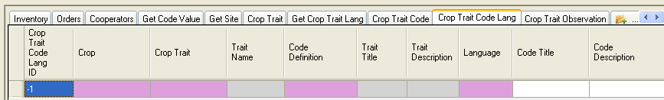
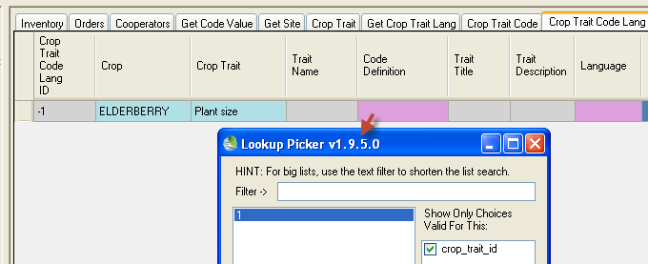
After:
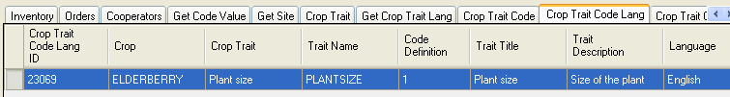

Shown here are the Crop Trait Code Language records for all five codes designed for the “Plant size” Crop Trait for the ELDERBERRY crop:
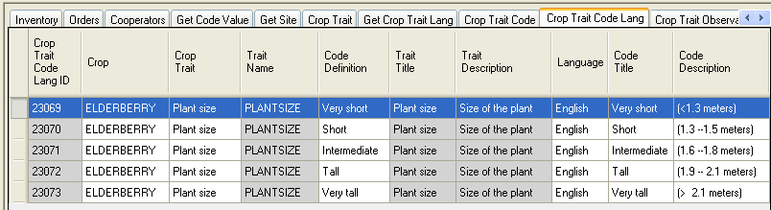

Attachments (File attachments)

Crop Attach
This dataview has a unique function. Crop Attach records may be added to include links to files displayed on the Crop page.
Use the Attachment Wizard to attach files with Crops or Crop Traits. Refer to the Attachment Wizard document for details.

In the following example, The PEANUTS crop has two links, one with a URL Link for the Category type, and the other an Image attachment:
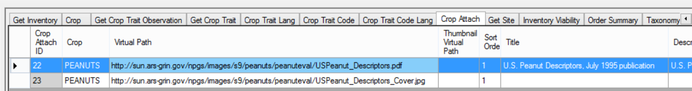
…scrolling to the right to see the remainder of the records:
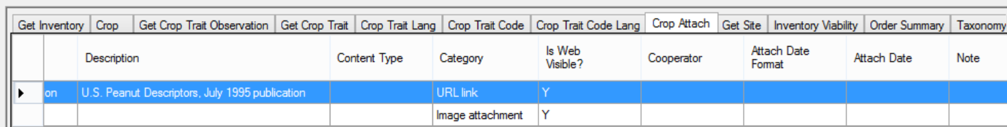

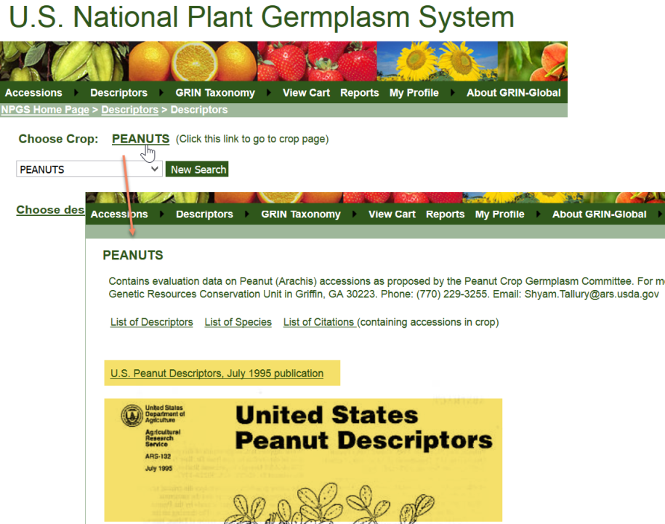

Crop Trait Attach
Similar to the Crop Attach dataview, with the Crop Trait Attach dataview, you can have images or links associated with Crop Traits. In the following example, SAFFLOWER has two traits which have an ”attachment.”
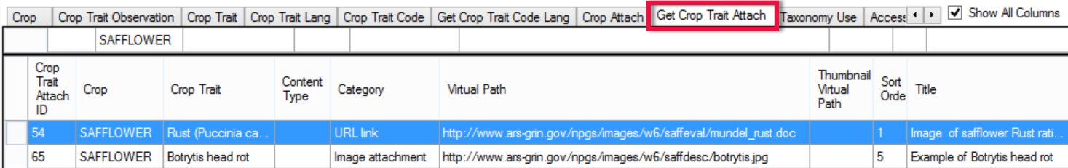
In the first record listed above, the trait is using a URL link to a Word document:
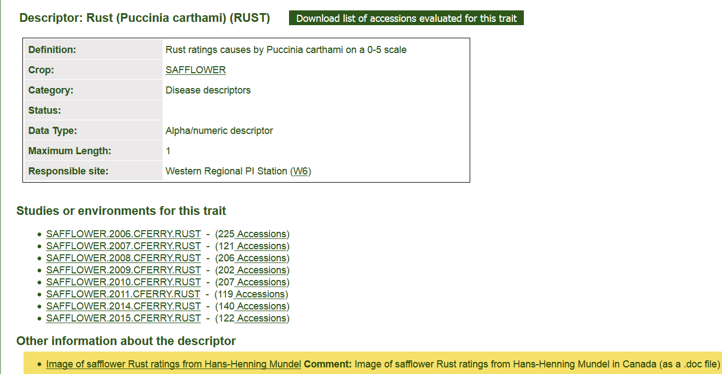
In the second record, the trait has an associated image:
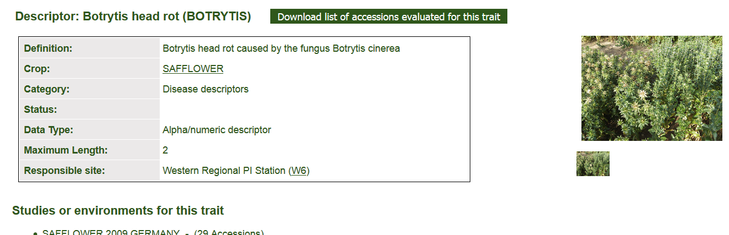

Using Descriptors to Establish a Core Subset of Accessions
GRIN-Global descriptors can be used as a means for creating subsets of collections. In other words, the curator may assemble a subset of accessions which are representative of the collection, based on various factors
In the NPGS Peanuts collection, they have four subsets available on the Public Website:
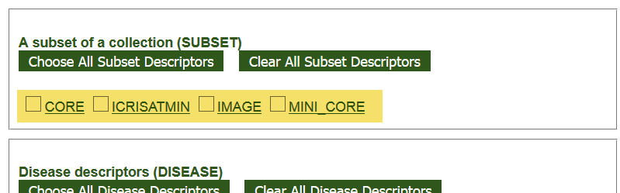
In this specific case, when the CORE trait is selected, 819 representative accessions will be listed. Under the Crop’s descriptors, a PW user can order this collection at one time. The MINI-CORE has a smaller subset:
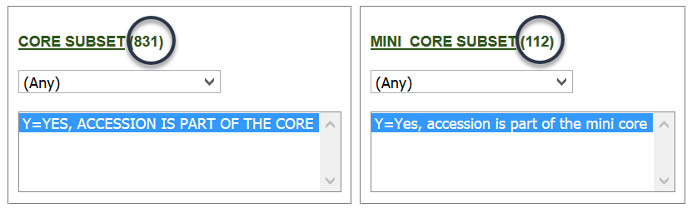
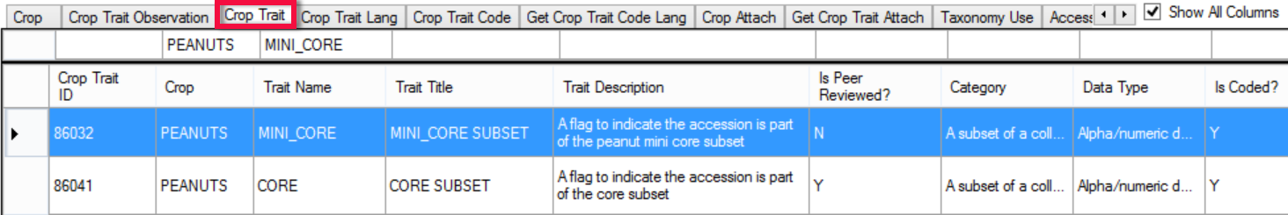
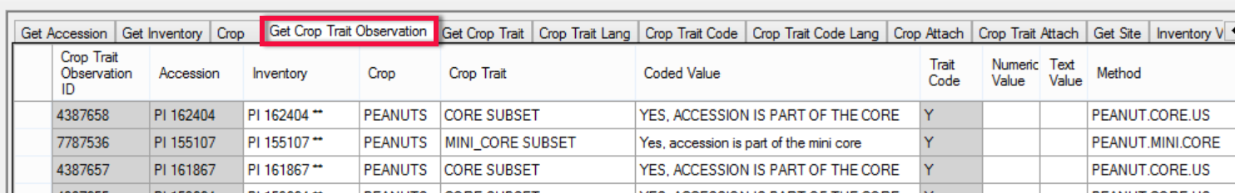

Method Examples for the CORE and Mini-CORE Trait
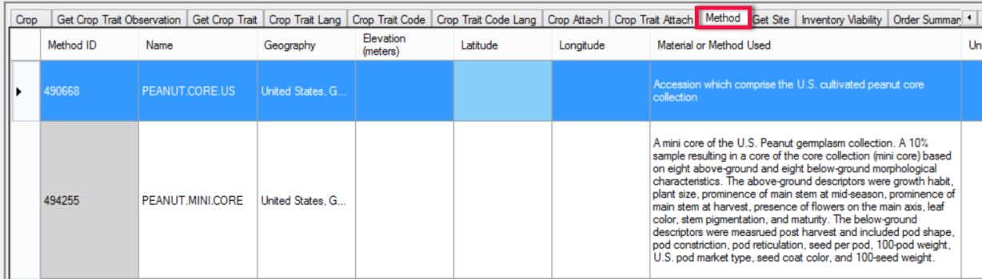

Methods
Methods provide a narrative and document the conditions pertinent to the observations. Before any observations are recorded, the relevant method must be defined. For observations, the method typically describes where and how the plant was grown and tested. When creating method records, include details – provide specifics and adequate information about the environment, the trial, etc.
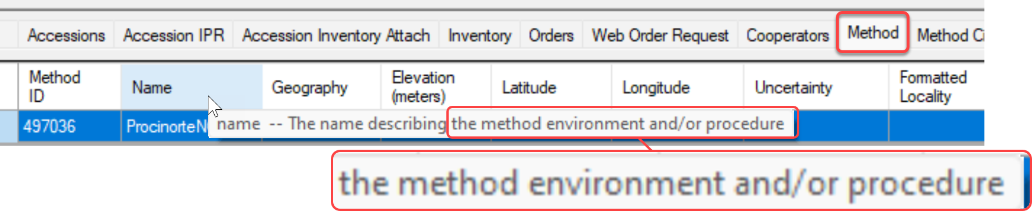
- What you measure (e.g., plant height, days to flowering, days to harvest)
- How you measure (using a ruler, instrument, laboratory equipment, etc.)
- When you measure it (early vegetative stage, early reproductive stage, flowering stage, harvest)
- Who you have followed when obtaining descriptors (FAO, Bioversity, UPOV)
- Any changes or additions to the list of descriptors (modified or new descriptors)
- How you have controlled different factors that affect characterization data

The Method record should be created before any observations are taken. You can describe the expected field conditions, etc. After the observations are made, the Method record should be reviewed and edited to note the actual conditions or variables that may have impacted the observations.

Methods or the Note field in Method Citations is perhaps an easier way to indicate comparative data used when making observations. An example of a method with a link to both an Excel file and an HTML file on a photoperiod insensitive sorghum collection can be found at: https://npgsweb.ars-grin.gov/gringlobal/method.aspx?id=492511. It includes a check mean and standard deviation data to correlate with the descriptors.
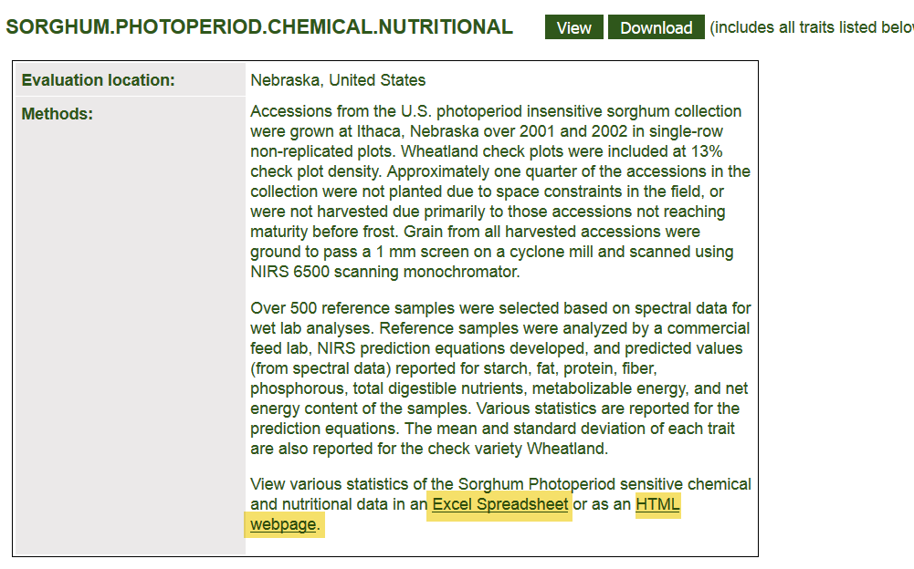
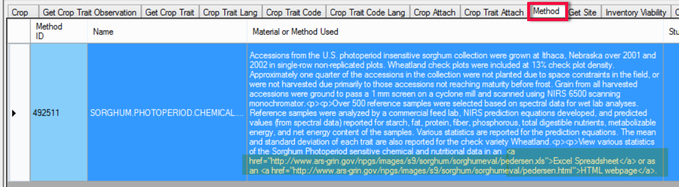
HTML code, the <a href> attribute, is used to display the links on the Public website.

Method Attachments

Consider describing the method in a document (PDF) and save as a Method Attachment
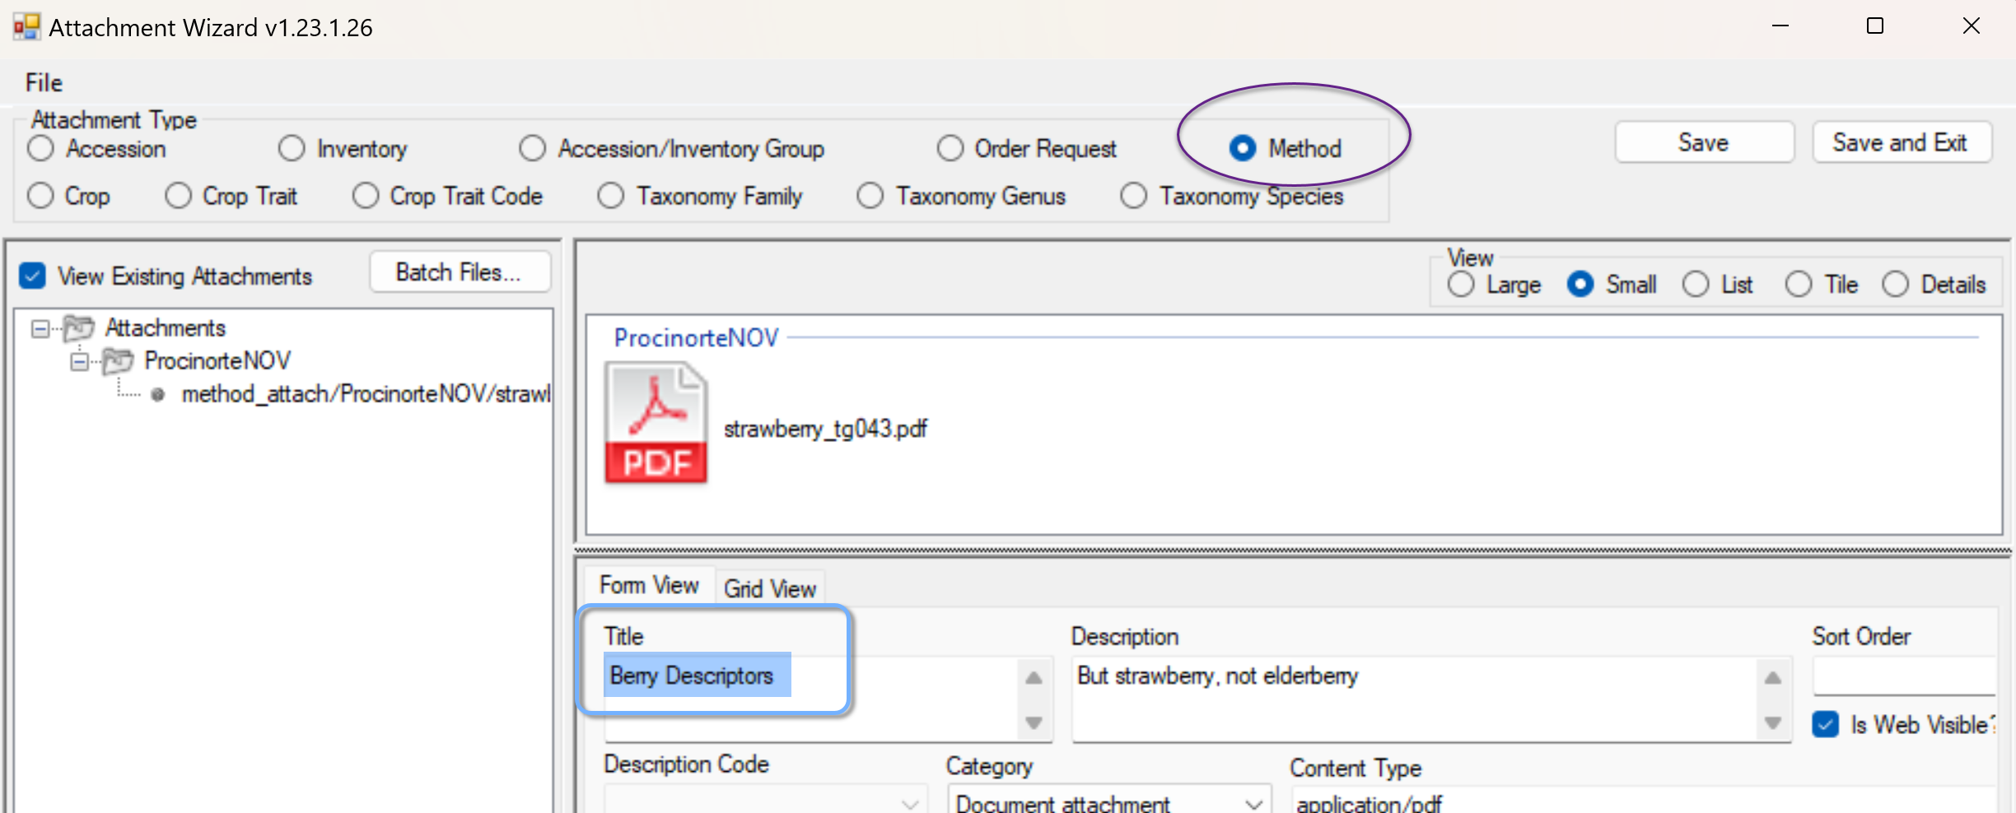

Correcting Observation Records to Point to a Different Accession
Sometimes the question is asked: “How do I correct an observation record when we realize the observation is pointing to an incorrect accession?”
In the following example, suppose the accession PI 269004 should have been PI 269005:
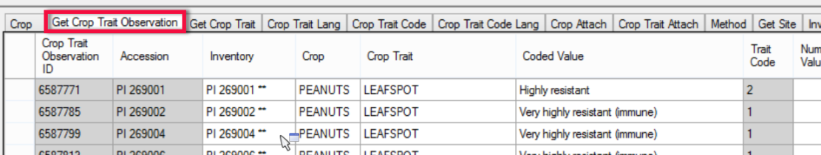
You cannot edit the Accession field since that is grayed out. In edit mode, click in the inventory field to display the Lookup Picker window. Deselect the accession_id filter, and then type or backspace to change the accession identifier to PI 269005:
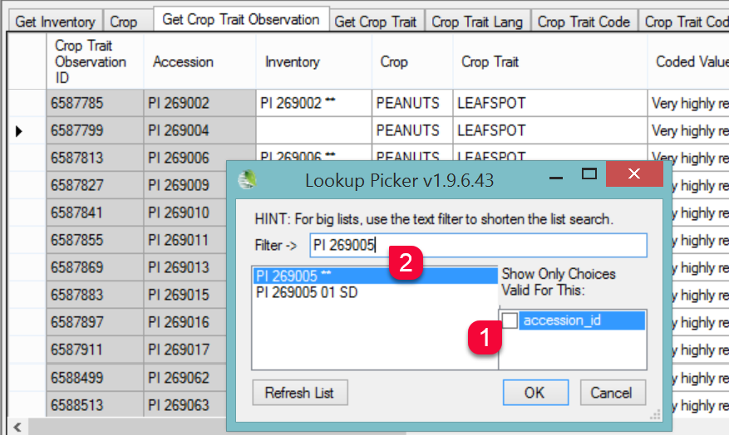
In the above example, since the observation was on the accession level and not for a specific inventory, the accession’s system inventory record (Type **) was selected.

Appendix A: Changes in this Document

2024, October 9
- Added details on numeric formatting
- Formatting and TOC changes

2024, April 3
- Major edit of text
- Inclusion of links to presentation files

2023, February 7
- Major edit of text
- Included new images and screens from the PW2
- Included images and search tool examples of the three value types

2020, February 28
- additional text to explain crop mapping and the association between a taxon and multiple crops

2019, March 20
- additional text and graphics to explain multiple crops

July 24, 2018
- added text to explain how an accession can be included in multiple crops; a Crop Map dataview example was included

January 6, 2018
- added text regarding the Observation Data dataview
- changed Appendix B to reference a new document that illustrates adding a new crop and trait

May 5, 2017
- added Appendix C: Examples

March 17, 2017
- added notes about crop maps
- added Appendix B, a section illustrating the step by step procedure for creating a new descriptor

February 24, 2017
- replaced outdated screens
- modified text to emphasize the how-to steps for creating descriptors
- added section on creating a Core subset of Accessions
- added sections on the Crop_Attach and the Crop_Trait_Attach dataviews
- added text for correcting the observations assigned to the incorrect accession

October 21, 2015
- reviewed document and replaced outdated screens

February 23, 2015
- added extensive overviewed
- replaced Observations screens which have been modified
- replaced PW pages to include Descriptors option on the menu

Appendix B: Step-by-Step Directions for Creating a New Descriptor

Step-by-Step Directions for Creating a New Crop and Descriptor
Refer to the document https://www.grin-global.org/docs/elderberry_crop_added.docx This document demonstrates the step-by-step process involved in recording evaluations (observations) in GRIN-Global. A new elderberry crop is created here as an example crop and then a trait (Leaf Color) for the elderberry crop is defined. As part of this example, the trait is a “coded trait” meaning it only accepts specific codes. Finally, sample observations are recorded to illustrate the results displayed in the Public Website.

Appendix C: Examples
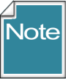 | These examples on the following pages were randomly selected to show how coded traits appear when using the Lookup Picker within the Curator Tool. Note that these traits were brought into GRIN-Global from the USDA GRIN. There are included here to illustrate the Trait Codes and Trait Code Titles display as well as to compare how the ENG version of the dataviews can be used to display the codes instead of the titles. Some users prefer using the ENG version when copying data in bulk from a spreadsheet to the Curator Tool.

WHEAT (HABIT)

English Version
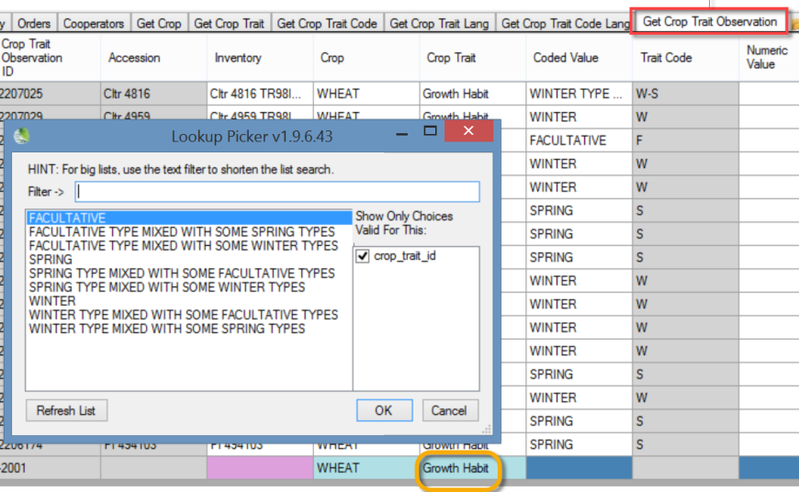

Eng Version
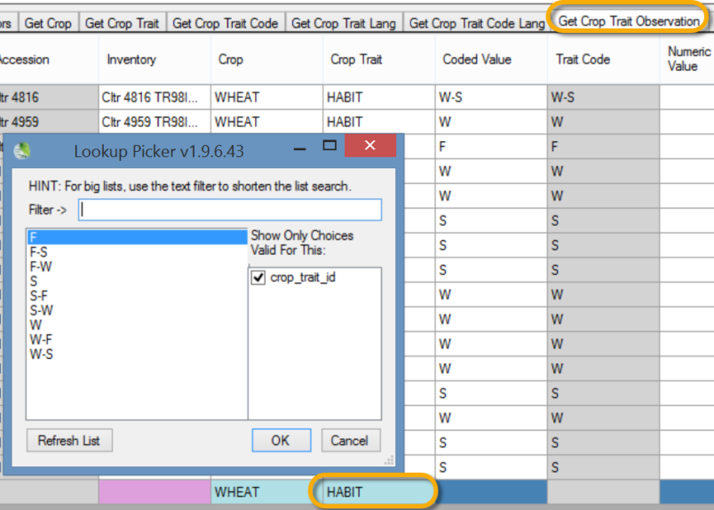

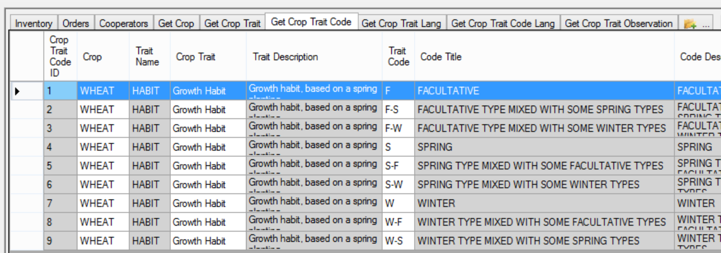

WHEAT (AWNCOLOR)
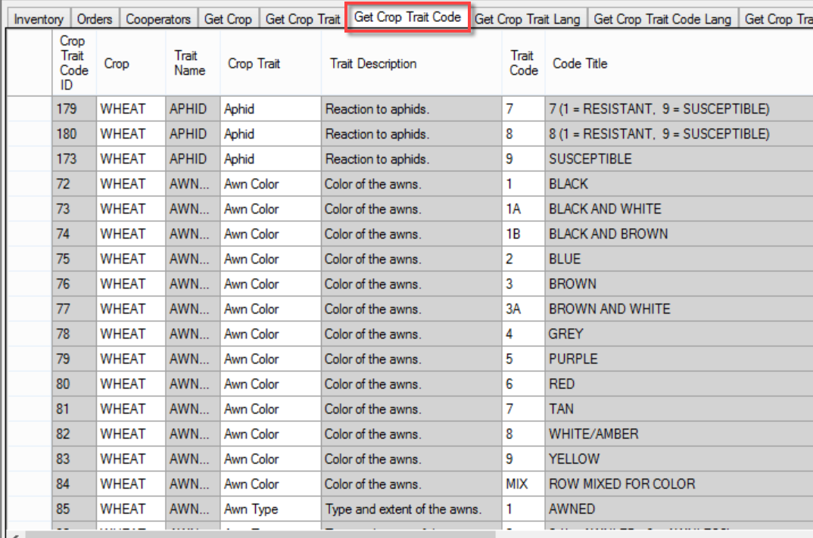
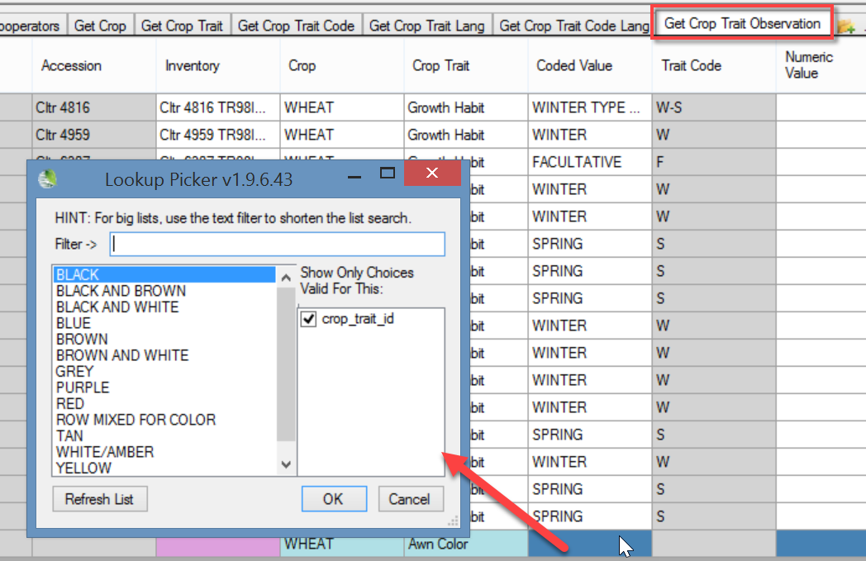

WHEAT (HESSIAN FLY)

English Version
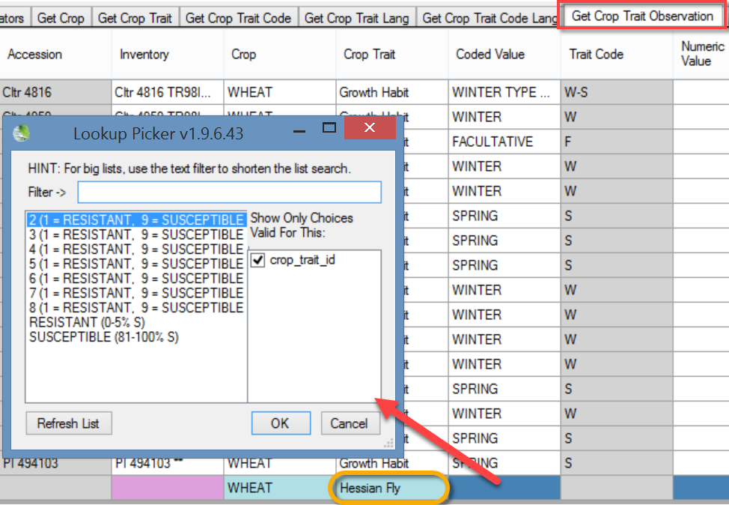

Eng Version
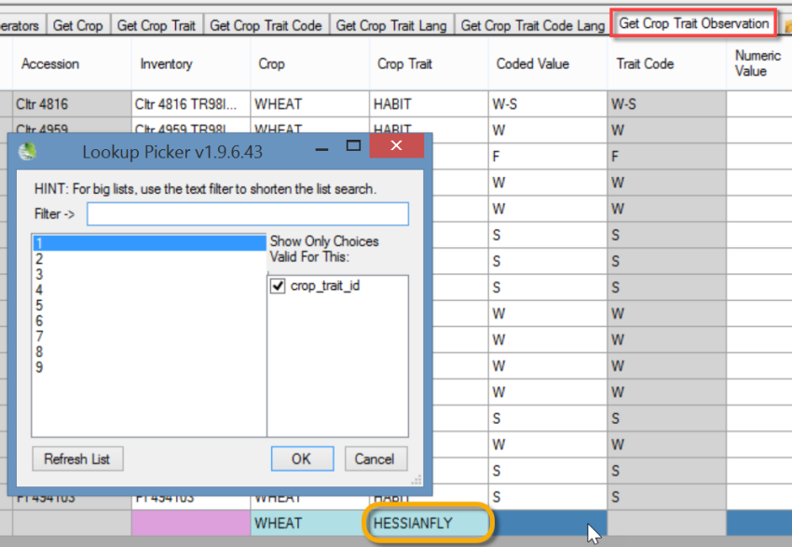
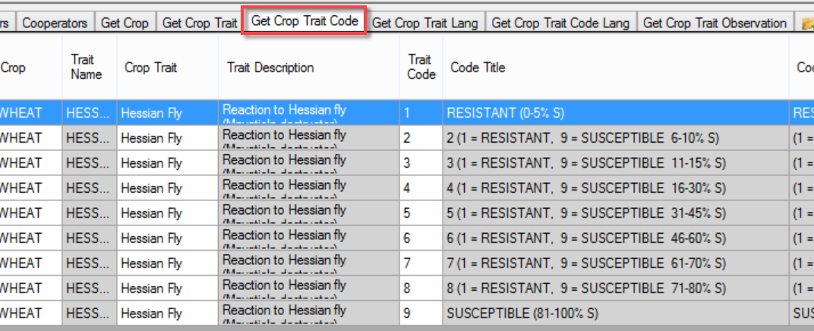

MAIZE (NORTHERN LEAF BLIGHT)
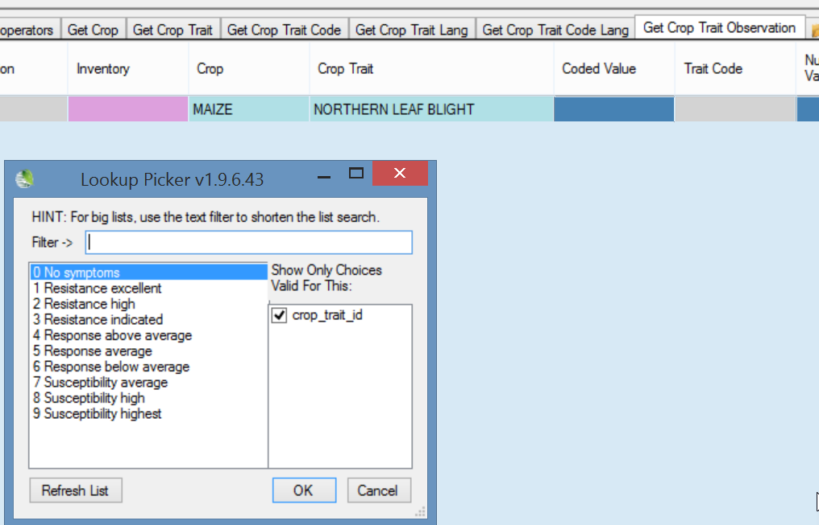

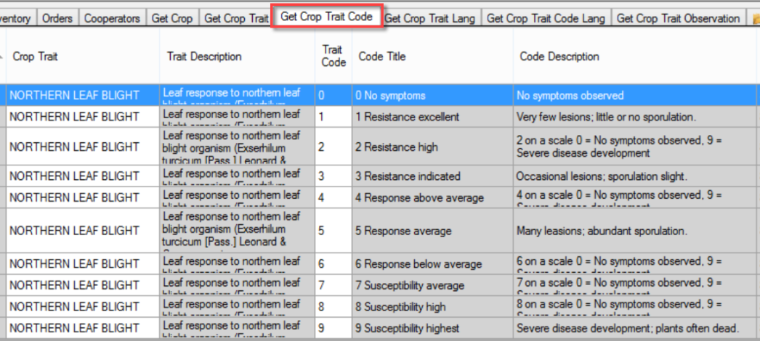

MAIZE (NORTHERN LEAF BLIGHT RACE O)
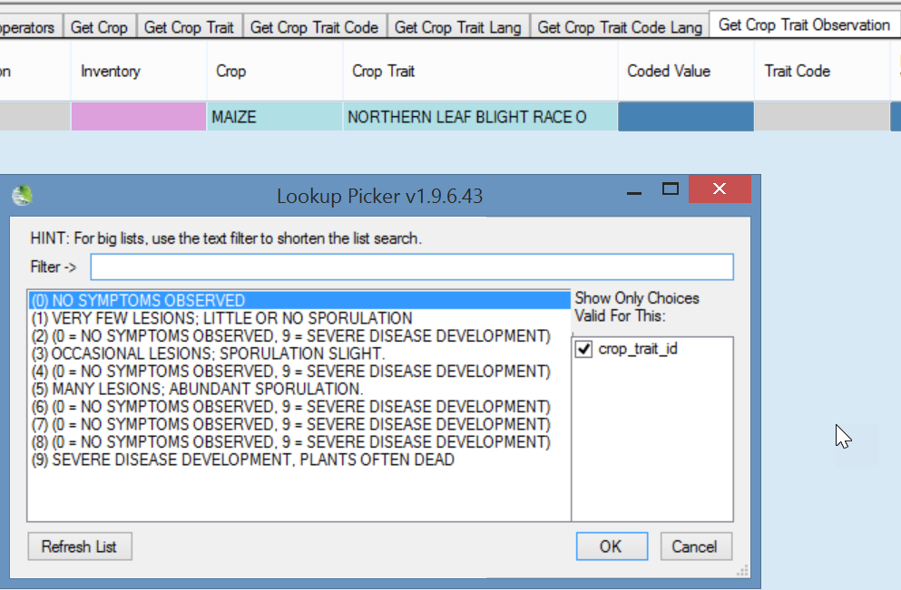
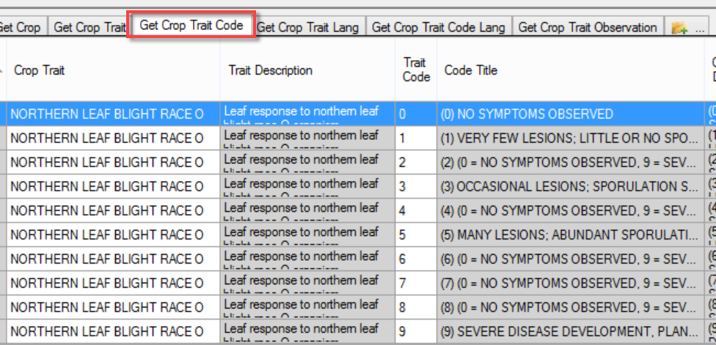

MAIZE (VIGOR)
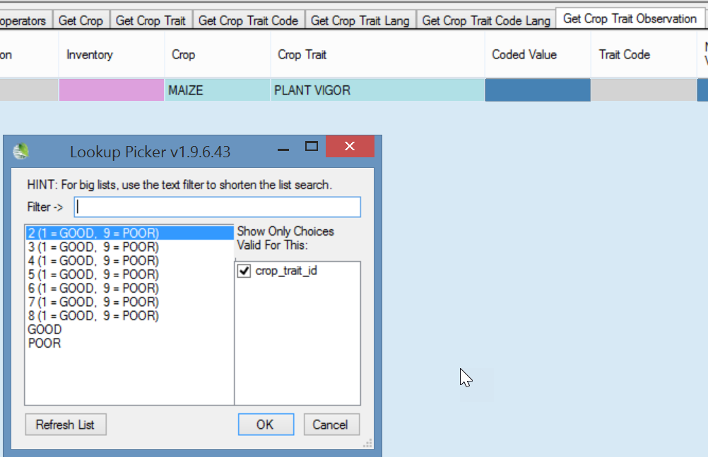

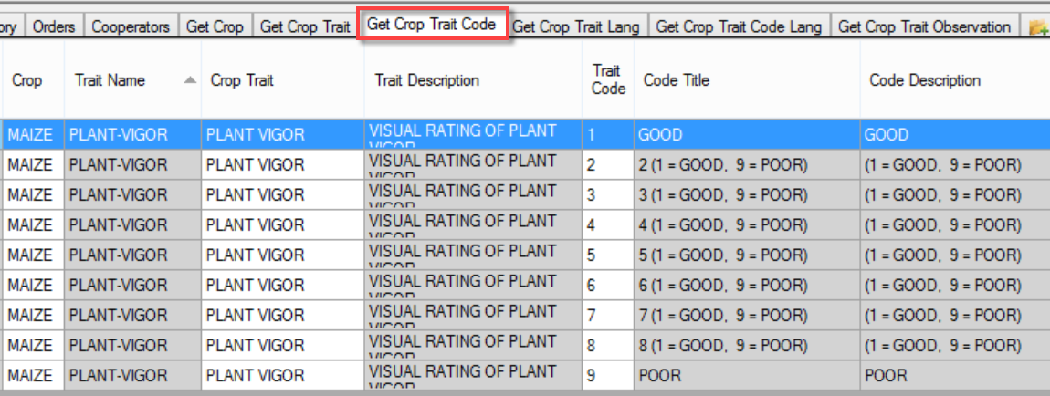

BACTERIAL STEM ROT (SWEET POTATO)
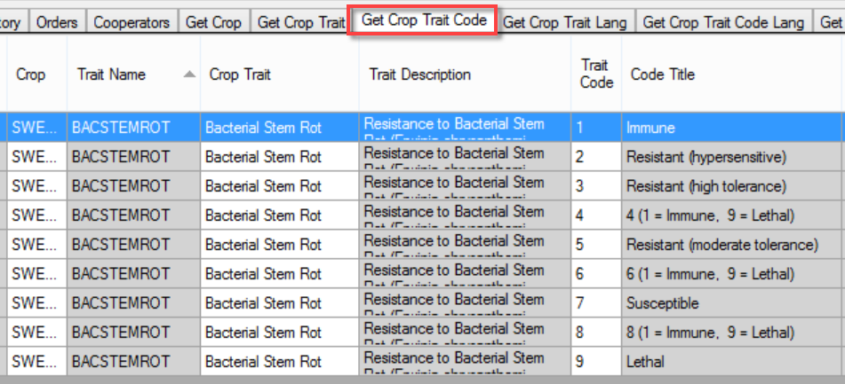

English Version
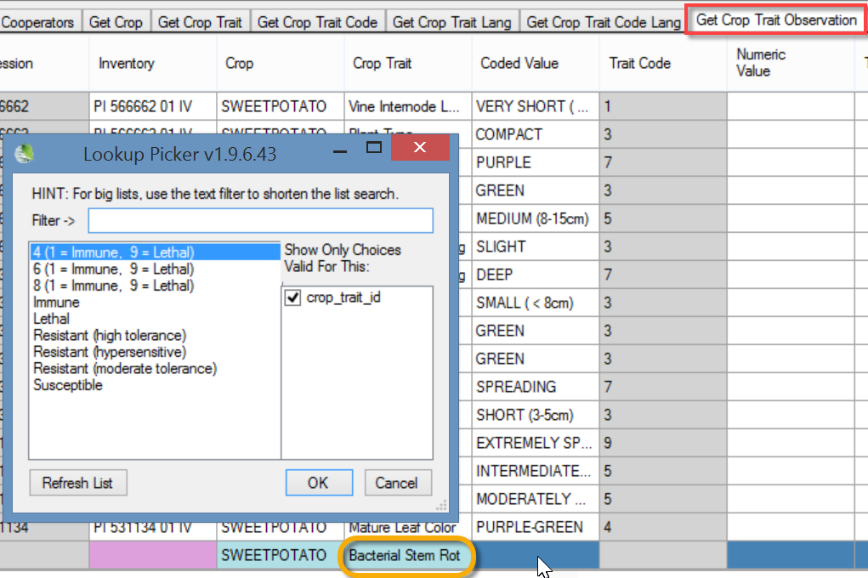

ENG Version
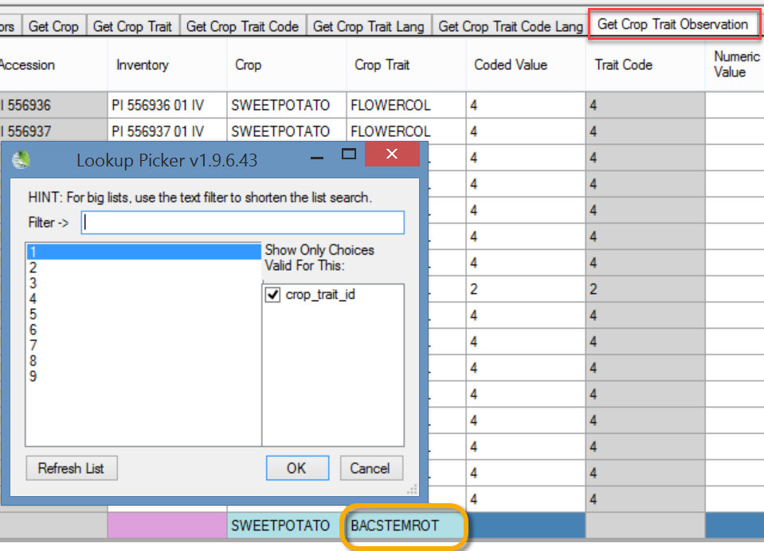

CHROMOSOME COUNT (SWEET POTATO)
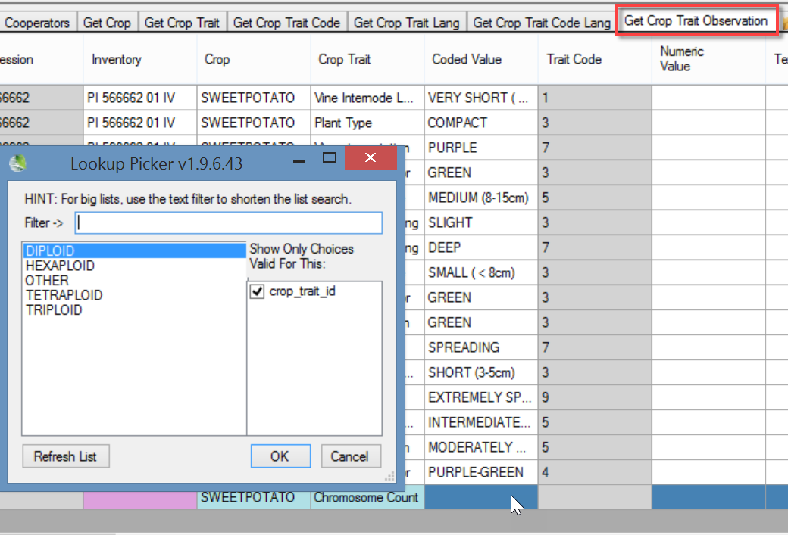
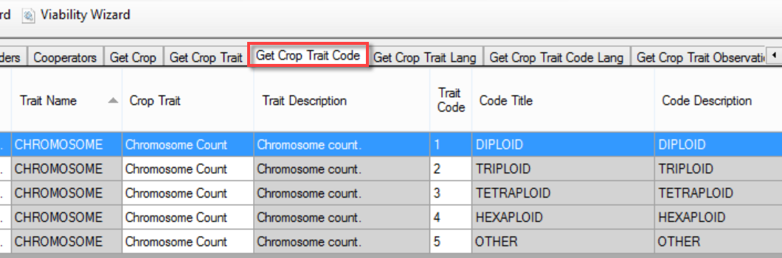

FLOWERCOLOR (SWEET POTATO)
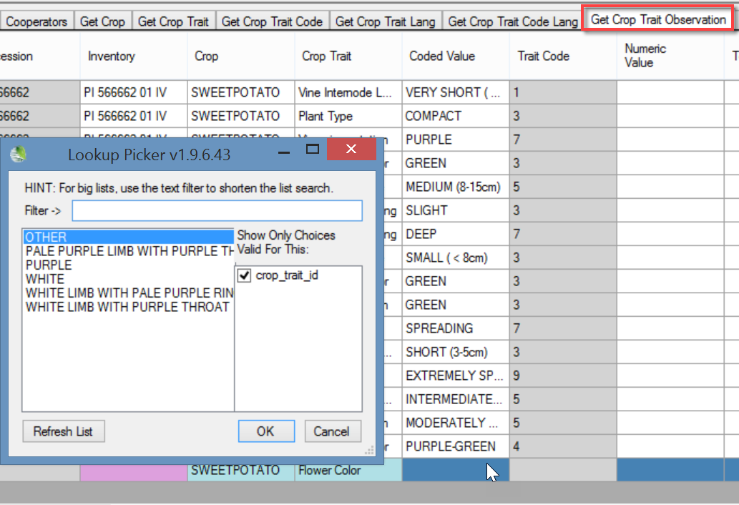
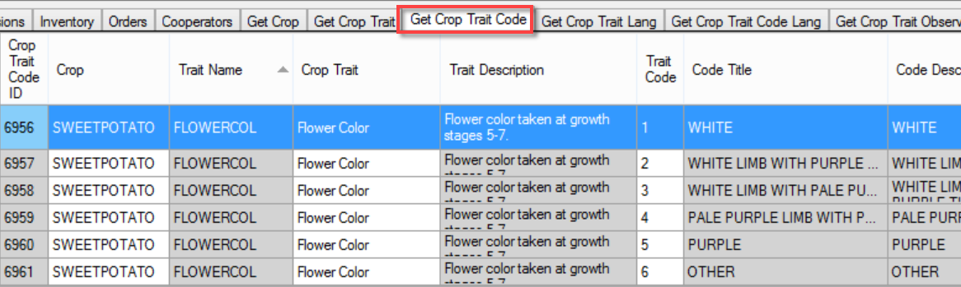

Developing crop descriptor lists

Crop Genebank Knowledge Base
See the Bioversity Technical Bulletin No. 13: Developing crop descriptor lists, Guidelines for developers online at https://cropgenebank.sgrp.cgiar.org/index.php/learning-space-mainmenu-454/manuals-and-handbooks-mainmenu-533/descriptors-mainmenu-547
Examples from page 26:
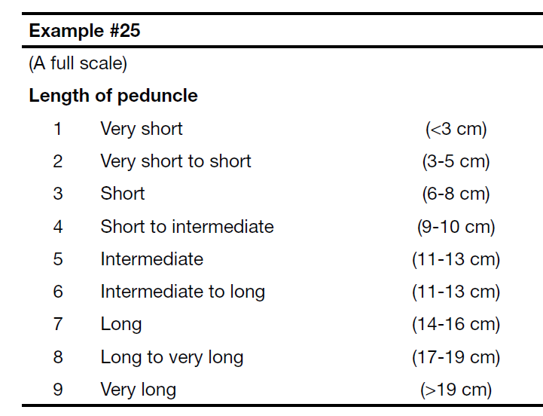
If this were a trait to be coded in GG, the Trait’s Codes and Code Titles could be:
Code | Code Title
1 | 1. Very Short (<3cm)
2 | 2. Very short to short (3-5cm)
3 | 3. Short (6-8 cm)
4 | 4. Short to intermediate (9-10 cm)
5 | 5. Intermediate (11-13 cm)
6 | 6. Intermediate to long (11-13 cm)  (*note -- duplicating as above from the original text, but perhaps this scale actually needs a correction since 5 and 6 have the same lengths?)
7 | 7. Long (14-16 cm)
8 | 8. Long to very long (17-19 cm)
9 | 9. Very long (>19 cm)

