Lookup Tables in the Curator Tool


Revision Date
August 1, 2024

 | This guide documents how the Curator Tool interacts with the server via lookup tables and provides “how to” instructions and details for users who need to maintain their CT’s lookup tables.  Please send any questions related to mailto:marty.reisinger@usda.gov.

The Appendix contains change notes pertaining to this document.

Author
Martin Reisinger

TOC
Lookup Tables Overview 2
Overview 2
Restricted Fields (Lookup Picker) 3
Using the Lookup Picker 4
Looking for Organizations when using the Cooperator Lookup 6
What is a Lookup? 6
Lookup Table Warnings 7
Indicators When a Lookup Table Isn’t Updated 8
Updating the Lookup Tables 10
Updating Lookup Tables After Startup 10
Refresh List When Looking for a Specific Lookup Value 12
An Initial Startup of the Curator Tool 12
Load All and Load Buttons 13
Remove the Lookup Table files from the User’s PC 15
Auto-Update Checkboxes 16
Resource Demand Alternatives 16
Appendices 18
Appendix A: Document Change Notes 18
Appendix B: Developer Notes 19
Developer Notes Regarding the Lookup Table Buttons 19

Lookup Tables Overview

Overview

Much more detail is provided below, but know that you can easily and manually update lookup tables any time, depending on what you are doing, or what is needed. See the Refresh section.

When adding or editing data into tables, there are times when ideally the Curator Tool controls what can be entered. For example, since every inventory record must have a parent accession record, if you were adding a new inventory record, you would want to select its related accession from a list of existing accessions. (Another way of saying this is you cannot enter an inventory record if its accession record hasn’t been already added to the GG database.)

In the following example, the user moved the cursor over the Accession field. The Inventory tab is active, and the grid is in Edit mode (the violet color is only visible when in Edit mode). When the user rolled the mouse, the cursor changed from a simple pointer to one that includes a small table graphic:
This cursor indicates that the file is using a lookup table; you cannot type in this cell, but rather you must use the Lookup Table window to select an item from a list.
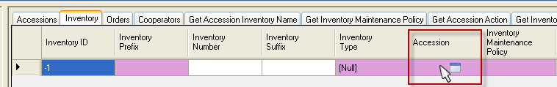

Complete directions for using lookups when entering or editing data is found in the Restricted Fields subsection of the Creating New Records section of this guide.

Restricted Fields (Lookup Picker)
Almost all dataviews have some fields that are “restricted.” In any restricted field, you cannot input the data, you must select the data from a list of possible items. Some of these restricted fields use a “LookupPicker” that displays in a popup window. (Other restricted fields use codes that display in a list.)
When in read-only mode, a restricted field will look similar to any other text field. However, in edit mode, when you move the cursor over the field, the cursor may change to a different style, similar to the following: When you input the first character, the LookupPicker window will display. (Clicking in the cell also opens the LookupPicker window.)
The following example illustrates using the LookupPicker for the Taxonomy field. In this example, the user typed “Ru” – the entries were filtered to those items in the table beginning with “Ru.”
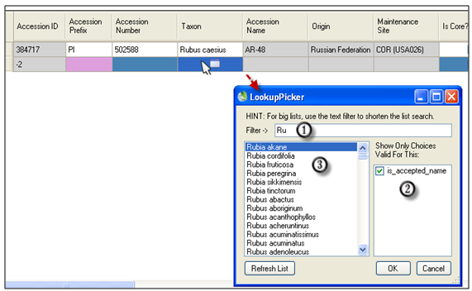

Using the Lookup Picker
1. Click in a cell where data is required; start typing. As you type more letters in the Filterbox (#1 in the screen image), the filtering becomes more specific. Use the mouse to click on the desired entry in the list box #3; click OK to select that item.
You can also use wildcards when inputting in the filter box. In the following example, the user was looking for accessions having “rei” somewhere within the prefix-number-suffix fields, so the user typed a “%” wildcard before typing the “rei”
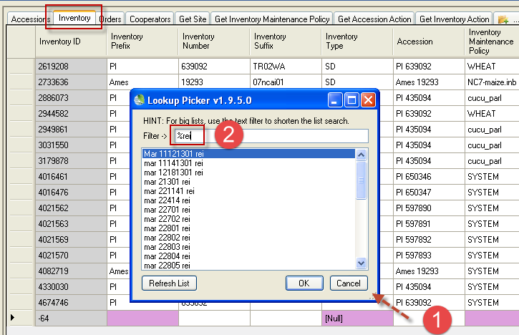

If you are editing and the field already has an entry, and you want something different, blank out (remove) the text shown to remove the original entry and start “fresh.” In the following example, Bockleman is initially displayed in the Curator field.
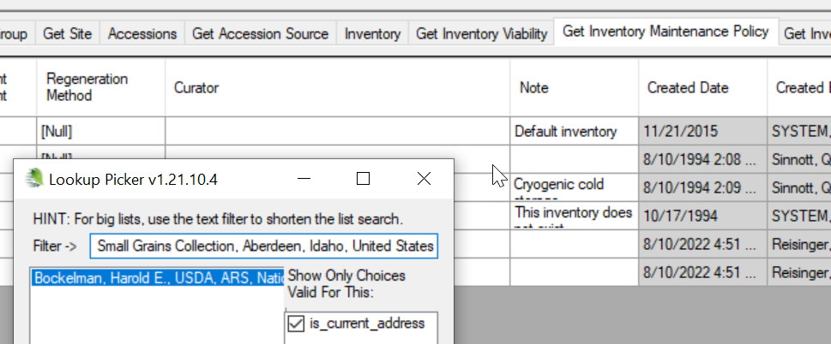
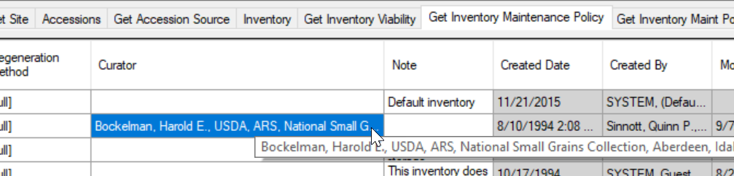
When the Lookup Picker window displays, removing his information will display the complete list of possible items:
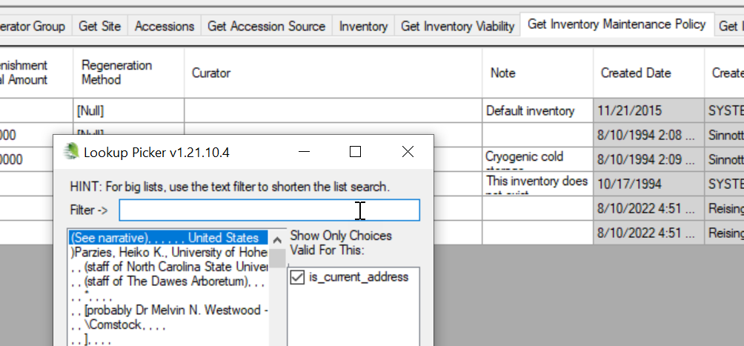
2. Lookups can have different options for restricting (filtering) what choices are valid. These items are listed in the box on the right side of the window. In the example below, one is displayed: is_accepted_name. You can constrict or expand the search by selecting or deselecting the check boxes. Keeping this box selected in this example will limit the Taxons to those considered to be the accepted names.
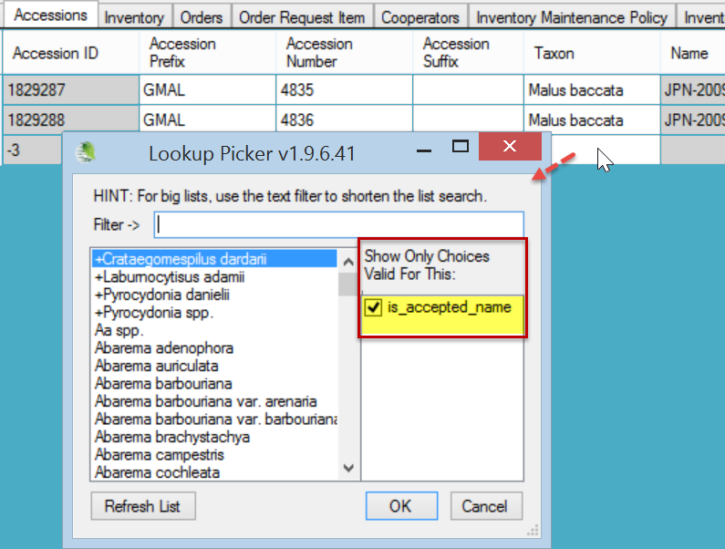

Looking for Organizations when using the Cooperator Lookup
In GG, a cooperator can be a person or an organization. The general guideline for an organization is that its record has no data in the Lastname and Firstname fields. When looking for an organization in a lookup, type: , , (comma space comma space) and then only the organizations will be listed.

What is a Lookup?
The Curator Tool was designed with a set of tables, the “lookups,” installed on each user’s PC. When the CT is initially installed, a database is established on the user’s PC. This database will have about 40 lookup tables. What purpose do they serve? The lookups were intended to speed up queries to the database on the server, which in most organizations is remote.
The basic idea is that the lookups point to records on the server. The lookup table records are not redundant – they do not contain all of the data that is stored in the records in the server’s tables. The lookup table records point to the IDs of the server’s records.
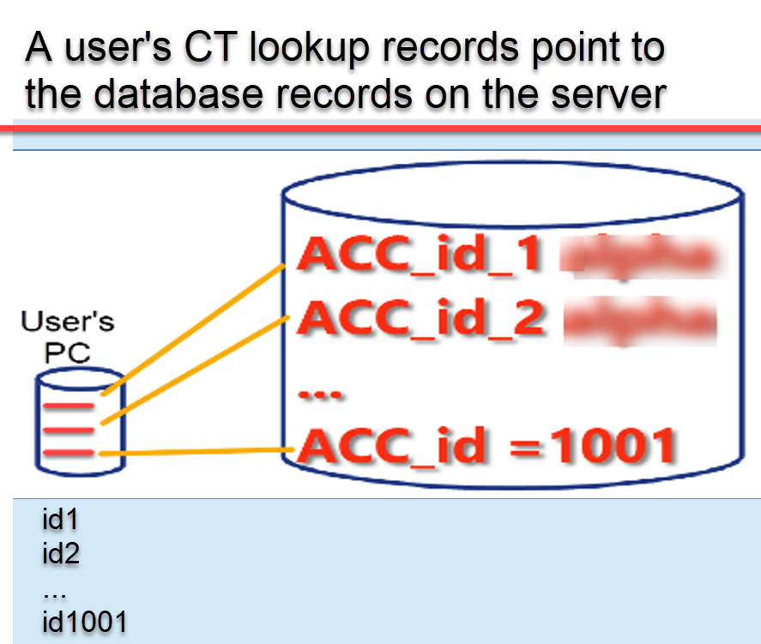

Unfortunately, sometimes the lookup tables may not ne synchronized properly with the server tables IDs. An extreme example would happen if the database administrator overlaid the server’s database with a new version, and records in the newer version had been deleted or added – the user’s lookup tables would not be aware of those changes. Fortunately, most of the time, the lookup are synchronized, because every time the user starts up the CT, the lookup tables are automatically updated in the background.

Lookup Table Warnings

Users are prompted the first time they open the CT to update their lookup tables. After that, the lookups maintain themselves automatically. You can also update the lookup tables manually at any time.
The first time* you start the Curator Tool, you will be prompted if your lookup tables are not completely updated:
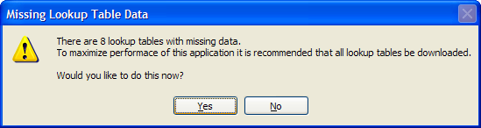
* The number of lookup tables varies, depending on the database.
The rest of this section contains detailed instructions on handling the lookup tables.

After the initial startup, every time the CT starts, it automatically updates the lookups – all of the lookups, sequentially. When you use the CT on a daily/regular basis, this updating should not take long, especially if the connection to the server is good. The more frequently you use the CT, the less time it takes to update them when you start up the CT. On the other hand, if you use the CT on an infrequent basis, the CT will take longer to update the lookup tables in order to reflect all of the new records that have been added to the GG database since the last time the CT was used.

Indicators When a Lookup Table Isn’t Updated
As one example, when the Taxonomy Lookup table needs updating, you may notice numbers displaying in a dataview’s Taxonomy field or a search window’s Taxon field instead of the actual taxonomic name.
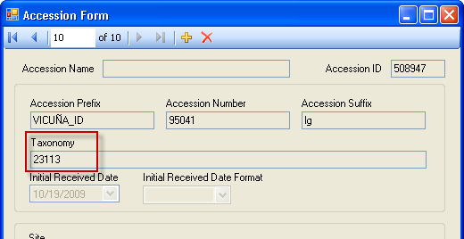

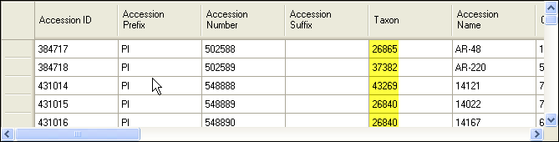

Another indicator when a Lookup Table isn’t updated occurs when the list of items isn’t complete. For example, when in the Taxon field and using the Lookup Picker, you may realize there are missing taxons. In that case, you should load the Taxonomy Lookup table. (These numbers are the values stored in the records’ key field in that particular lookup table.)

In the illustration below, the orange color is the indicator that the respective lookup tables are not current
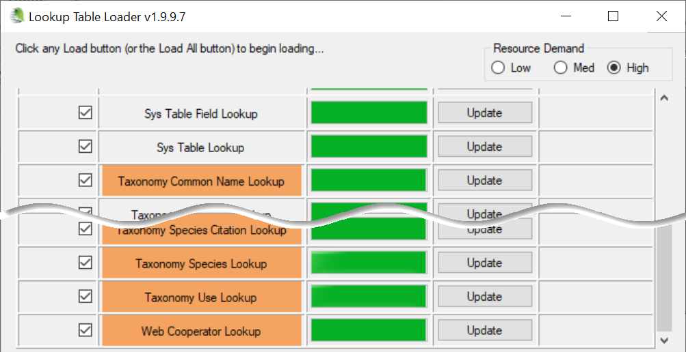

In the CT, sometimes a warning message will display, indicating the related lookup table is not current:
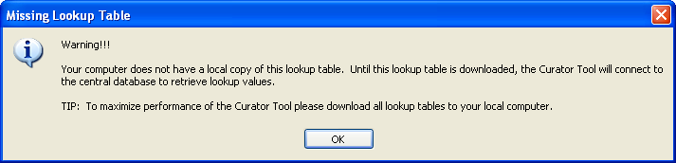

or…
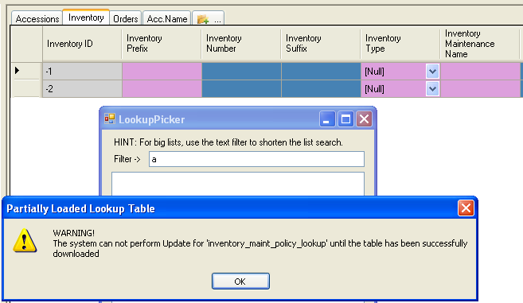

Updating the Lookup Tables
Every time the Curator Tool is started, the lookup tables are automatically updated. However, you can manually update the Lookup tables at any time while the Curator Tool is running, but generally that is not necessary.
The status bar in the Curator Tool window showing the lookups being updated at start up:
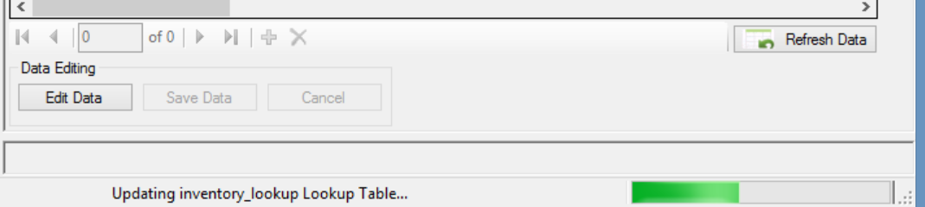
Because the lookup tables are maintained automatically, in a production environment, you normally would never need to manually update the lookup tables.

Updating Lookup Tables After Startup
You can manually update lookup tables any time, depending on what you are doing, or what is needed.

Refresh Data button
Click the Refresh Data button on the main CT window to update the specific Lookup tables used by the dataview currently being viewed. However, the Refresh Data button is now programmed to ultimately update all of the lookup tables. First the lookup tables associated with the current dataview are refreshed; you will need to wait for that process to finish. After that, all of the lookups will be refreshed in the background (updating to match the server) –you do not need to wait for them to finish updating.
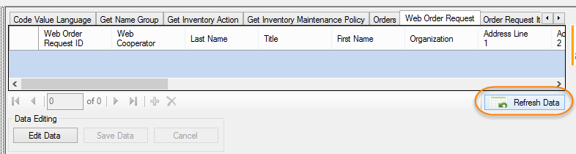
 | Since the Refresh Data button ultimately updates all of the lookups, you can use that button in lieu of clicking on the Load All button in the Lookup Table Loader window (a method described in a following section).  When you click Refresh Data -- all of the lookup tables update, not just the lookups used by the current dataview. But the lookups are not all loaded the same way. Three actions happen when the Refresh Data button is pressed:  - first, the lookup tables used by the active dataview are updated in the foreground - meaning you can't do anything until they are updated  - the data in the dataview is then refreshed  - after that is complete, the remaining lookups get updated in the background  Recommendation: use a dataview that is fairly simple - such as the get_site DV. On the left panel, open an empty folder. Click the Refresh Data button. The get_site DV uses only one lookup -- the cooperator_lookup. Updating that dataview in the foreground should go fairly fast. After that updating has completed, you are free to continue working with the CT while the remaining lookups are updating in the background.

Refresh List When Looking for a Specific Lookup Value
When using the LookupPicker window, such as when looking for the Taxon for an Accession, you can click the Refresh List button to ensure that the list is current. You do not need to click every time – only when the item is not listed but you know it should be – clicking the Refresh List button ensures that the list is current.
After updating, if the item is not listed, in this case the Taxon, you will know then that the item is not in the database.
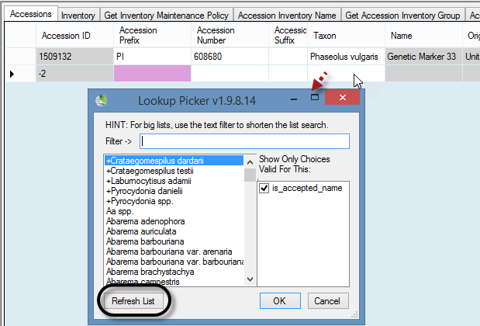

An Initial Startup of the Curator Tool
When a newly installed Curator Tool is started the first time, you will be prompted to update all of the lookup tables “There are nn lookup tables …recommended that all lookup tables be downloaded.” Select Yes. (The number will vary, depending on the CT version and the data in the database.)
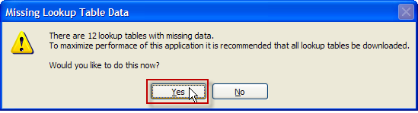
Clicking the Yes button does not update the lookup tables; selecting “Yes” only displays the Lookup Table Loader window. Any lookup tables needing to be updated are highlighted in orange – typically their adjacent button will be labeled Update. Click on all of the Update buttons to update – just viewing the window does not initiate the updating process. Click Load All when this is a new CT installation.
You can minimize the window and do other work on your PC; the updating will proceed in the background.
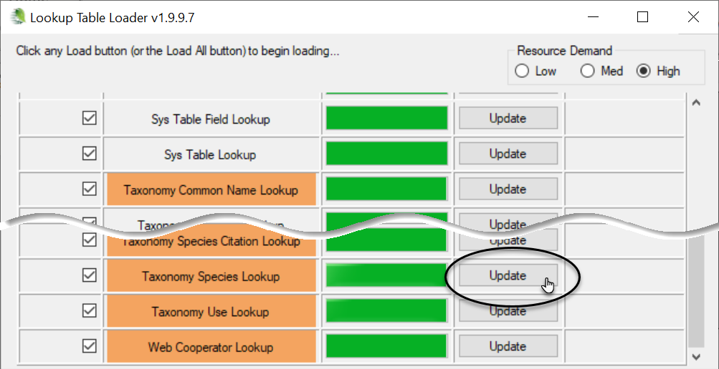

Load All and Load Buttons
Sometimes, during a testing phase , a GG administrator may replace one database with a completely new database. In this situation, click the Load All button –twice. The first time the Load All button will update, that is, load only new records into the Lookup tables. Wait until the progress activity is visibly complete before clicking the Load All button a second time. The second time causes each lookup table to be dropped and re-added (effectively loading the lookup table from "scratch" (from the beginning) – this may require one hour or so, depending on the size of your data). In typical production environments, the scenario of replacing one database with another will not occur – only a new CT installation will require a Load All to be invoked.
To ensure that your lookup tables are current, review the Lookup Table Loader window and examine the second column labeled Lookup Table Name. Any table whose name is displayed in orange is not current and should be updated; click the Update button of the corresponding lookup table. (Sometimes, as shown in the example below, the table name wasn’t in orange, but there was an Update button – this situation is rare.)
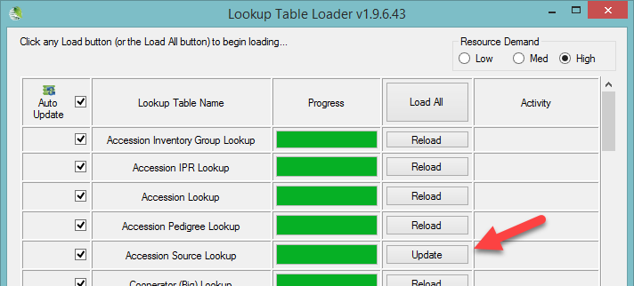
Some lookup tables may be empty. This is the case if the corresponding table in the database does not have any records yet. For example, in a new database, the Genetic Marker table will be empty. (Alternatively, use the Refresh Data option – see the Refresh Data section.)

Manually Updating Lookups Using the Lookup Table Maintenance Button
Use the Other Options tab any time you want to initiate the loading/updating of any of the Lookup Tables. Click on Other Options tab; then click the Lookup Table Maintenance button:
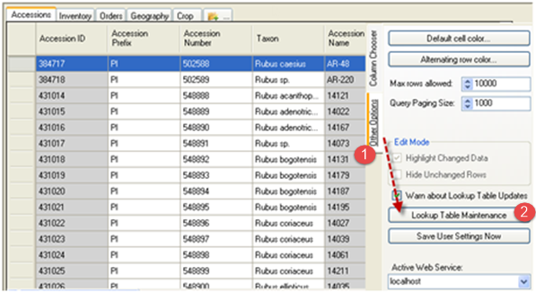

The Other Options tab also has a Warn about Lookup Table Updates checkbox that should remain selected (checked) to enable this lookup table warning.
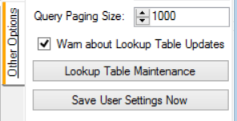

Remove the Lookup Table files from the User’s PC
 | Administrators / users with elevated Windows privileges can use SQL Server Management Studio to physically remove the Lookup table files from the user’s PC. Best done when the CT is not actively running. This forces a rebuild of the Lookup tables which should then be current and properly reflect the server records.  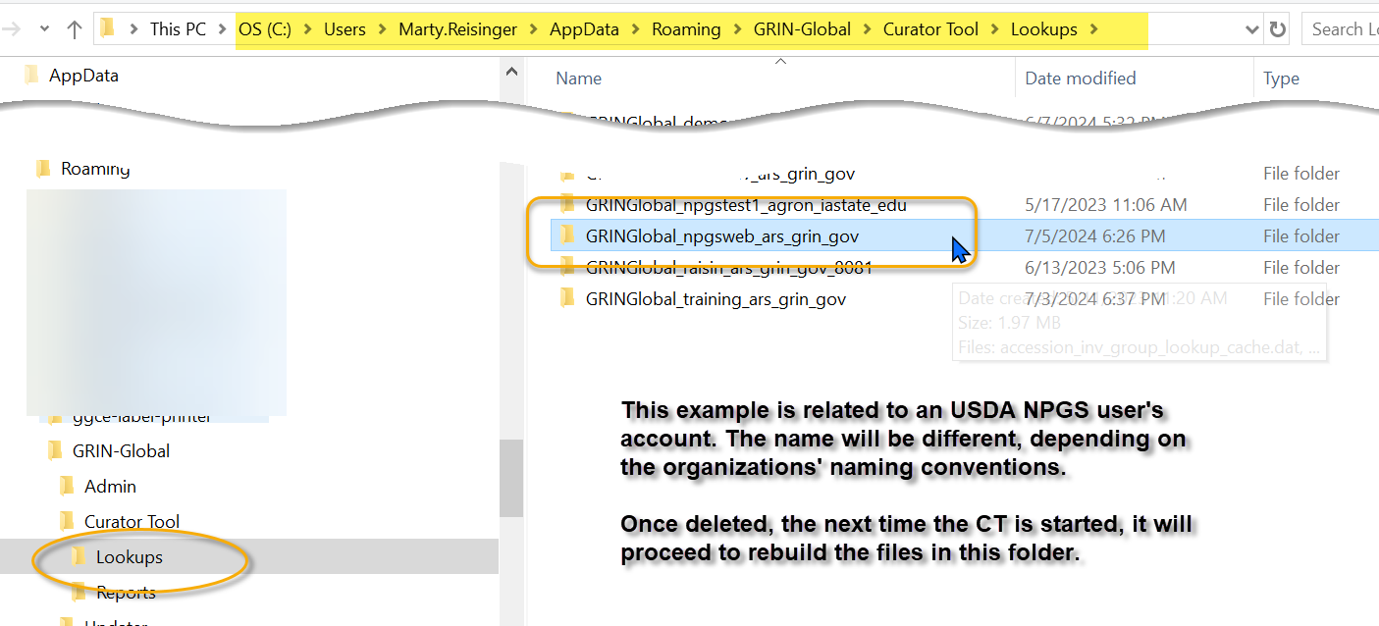

Auto-Update Checkboxes
The lookup tables are listed alphabetically. Any tables not current are highlighted (in orange). All checkboxes on the left (by default) are selected (checked) – the checkmark indicates that these lookup tables will be automatically maintained. Keep these checked.
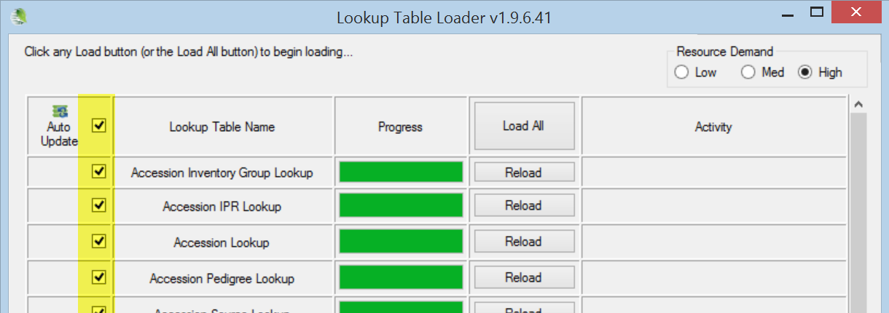

If you turn off your PC while tables are still being loaded, the next time you start the Curator Tool the loading will continue loading where it had previously stopped.

Resource Demand Alternatives
(For most fairly current computers, this topic is a “non-issue.”) The Lookup Table Loader window has a Resource Demand set of radio buttons, by default the High button is selected:
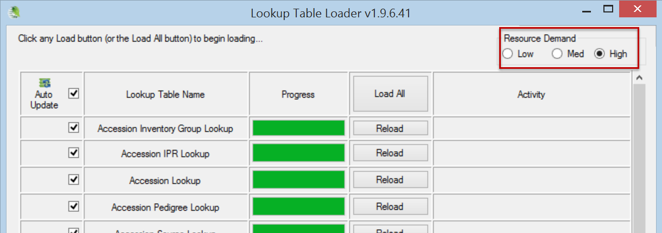 Before clicking on the Load All or any Load button, first indicate how much of your computer’s resources should be allocated to the background downloading process, relative to everything else that you will be running on your PC. Most computers can handle the default “High” for maximum performance. (Later, if you find that the process aborts, you can lower the setting.)
You can’t change the resource demand option after you proceed with the loading. So how do you determine which level to select? You might try the “High” option first; worst case is that at some point the PC displays a “Table Load Error” message similar to the following:
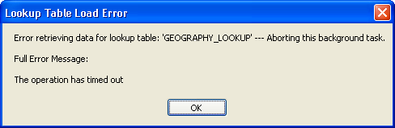
When that happens, proceed by loading the Lookup Table Loader again, but try the next lower Resource Demand level.

Appendices

Appendix A: Document Change Notes

– August 1, 2024
- added text and related image showing the Lookup folder on the CT user’s

– August 10, 2022
- added section from CT User Guide regarding filtering in a lookup for organizations only

– September 21, 2020
- split out this material from CT User Guide

Appendix B: Developer Notes

Developer Notes Regarding the Lookup Table Buttons
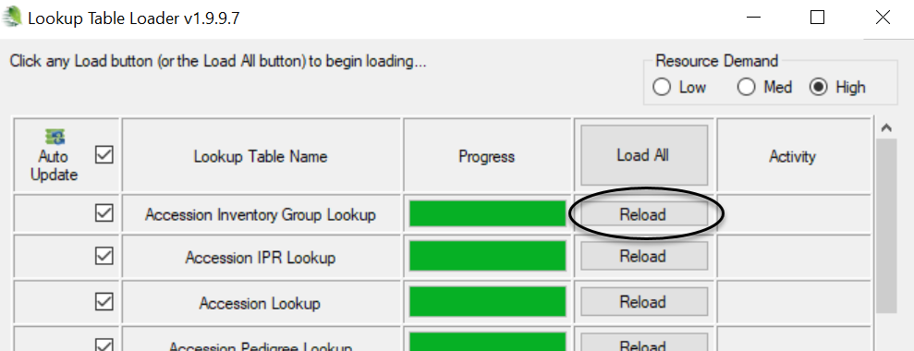

The button will display Load if
- The local Lookup table has never been successfully loaded – meaning that the local Lookup database does not have a last known status of COMPLETED or UPDATED (the status of the each Lookup table is updated to COMPLETED when a LOAD or RELOAD is successfully completed and is marked as UPDATED when any update of that table completes successfully).
The button will display Reload if:
- The local Lookup database has a last known status of COMPLETED or UPDATED (the status of each Lookup table is updated to COMPLETED when a LOAD or RELOAD is successfully COMPLETED and is marked as UPDATED when any update of that table completes successfully).
- The Lookup table has successfully completed an UPDATE during the current CT session (something that happens automatically during CT start up but can take a while for some larger LOOKUP tables – such as Inventory).
The button will display Update if:
- The local LOOKUP database has a last known status of COMPLETED or UPDATED (the status of each LOOKUP table is updated to COMPLETED when a LOAD or RELOAD is successfully COMPLETED and is marked as UPDATED when any update of that table completes successfully).
- The lookup table has NOT finished completing an UPDATE during the current CT session.

