Inventory Attachment Wizard


Revision Date
February 19, 2021
The revised Inventory Attachment Wizard was included in the Curator Tool used by the NPGS on December 1, 2017 (version 1.9.8.14). This document includes changes to the wizard included in Curator Tool version 1.9.8.27 and later versions.
 | Please send any questions related to the wizard to feedback@ars-grin.gov.

The Appendix contains change notes pertaining to this document.

Author
Martin Reisinger

TOC

Background 3
Alternative Method to the Attachment Wizard 3
Viewing Existing Images (and other file types) 4
Attaching Files with the Wizard (Summary) 7
File Naming Expectations 7
Main Wizard Window 8
Form View Fields 8
File Naming Conventions 13
Filename Components 13
Attach Date Details 15
Plant Part 15
Attaching Files: Detailed Steps (3 Methods) 16
Browse Method to Select Attachments 16
Drag and Drop Method to Select Attachments 19
Attaching Files Directly 20
Viewing Images 20
Deleting Attachments 21
Locations of Attachment Files 22
Editing Attachment Records 23
PDF Links Displayed on Public Website 23
Manually Identifying Inventory to the Attached Files 25
What Types of Files Can be Attached? [File Menu] 27
File Filters 27
File Naming Automation 27
URL Links 28
To Add a URL Link 28
Using the Wizard to add a URL Link When Other Attachments Exist 30
Appendix A: Making a Batch of Folders 31
MD – Make Directory DOS Command 31
Changing Options for Folders (so that they display (Show hidden folders)) 32
Default File Explorer Settings 32
Appendix B: Document Change Notes 34

Background
GRIN-Global can store and display images and other file types. The Inventory Attachment Wizard has been designed specifically to load files and associate them with inventory records.
The GRIN-Global schema has several attachment fields; however, this wizard only addresses attaching files to inventory and accessions. The files may be attached either to a physical inventory record or to an accession’s system inventory record. When attached to a system inventory record, the file is associated with the accession and not with a specific inventory lot. Future development is planned to handle attachments to other record types.
Throughout the remainder of this document, the Inventory Attachment Wizard will be referred to as the “wizard.” The current wizard was first included in the Curator Tool version 1.9.8.14. (Previous versions of the Curator Tool had a different inventory attachment wizard.)
The wizard can be used to:
- review existing attached files
- associate files with an inventory or accession record
URL links can also be treated as “attachments.” However, they are added to the database in a different manner than physical file attachments. Refer to the URL Links section for details.

Alternative Method to the Attachment Wizard
Before exploring the wizard, be aware that you can very easily drag filenames from a Windows Explorer screen to the Curator Tool. You can either drag the attachment files to an accession or an inventory item in a list in the left List Panel.
In this example, dragging two PDF’s, the user could drag them to either item: MAR 112 RRG or MAR 112 RRG SD. When dragging to the accession item, the images are attached to the system inventory record.
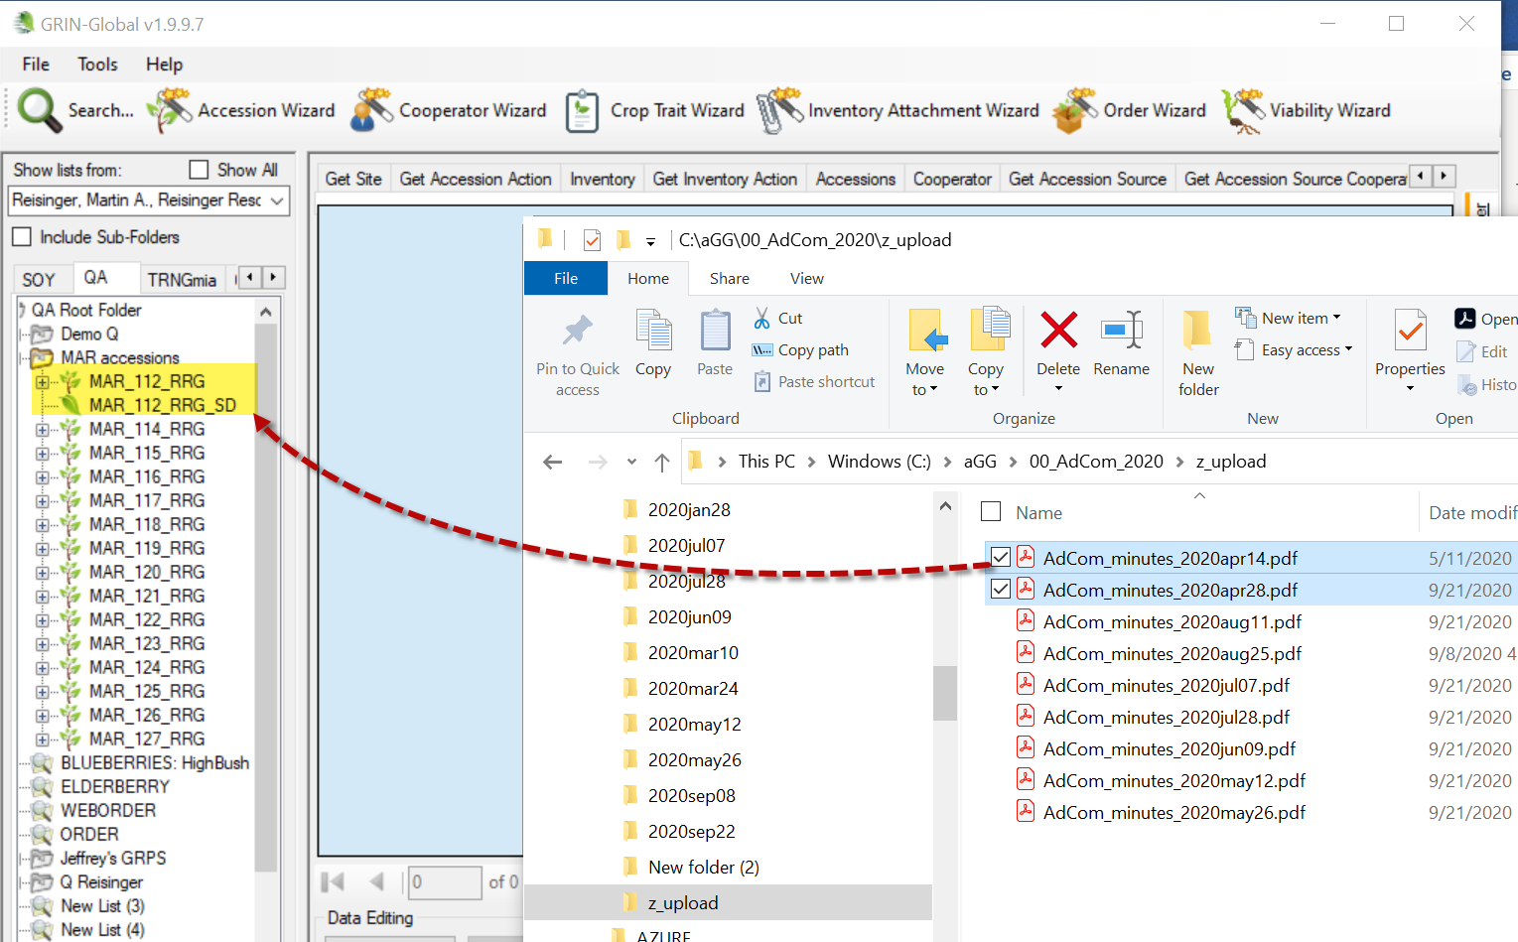

Viewing Existing Images (and other file types)
A user may have a list of accessions in the Curator Tool which the user can either review or add images to, via the wizard.
(Usually with the Accessions dataview active):
- start with a list of accessions and the Accession tab
- select the accession(s)
- invoke the Wizard
- select the View Existing Attachments checkbox
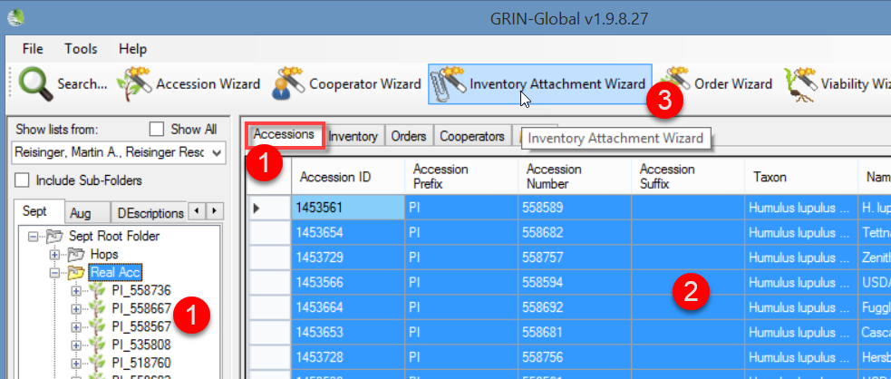
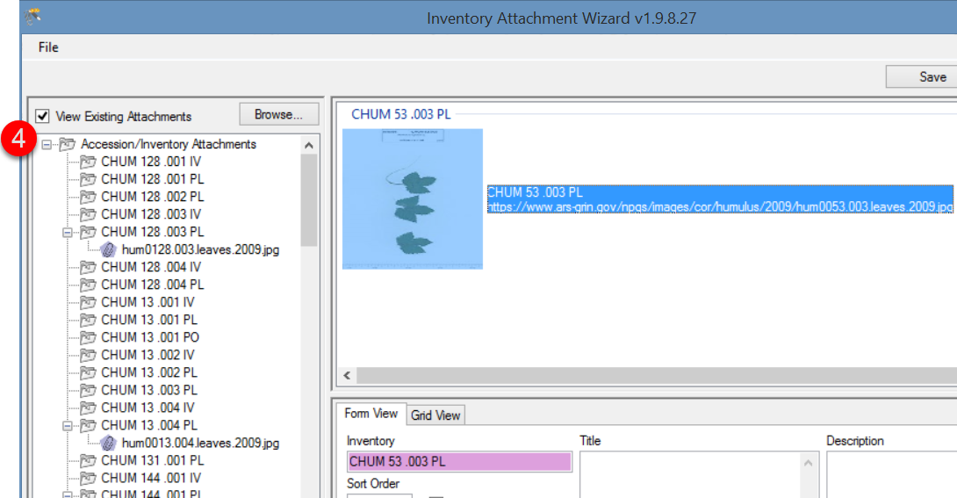

The original get_accession_inventory_attach dataview bundled with the Curator Tool also has an associated form. This form will not display some image files, depending on their file type. Recommendation: Use the new inventory_attachment wizard exclusively to view images.
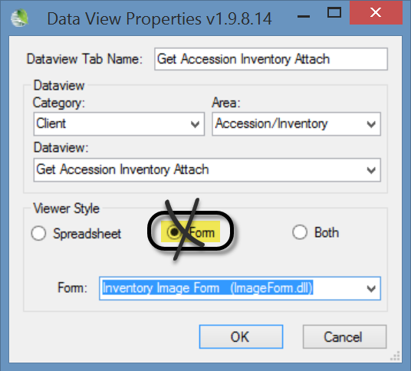
 | Double-click the thumbnail image to display the image in a window. Since the association of file viewers with file types can be configured differently on each PC, it depends what viewer will launch to display your image. For a full explanation, refer to the article How to Change File Associations in Windows at https://www.lifewire.com/how-to-change-file-associations-in-windows-2624477

Attaching Files with the Wizard (Summary)
Complete the same steps used earlier for reviewing existing files.
- start with a list of accessions and the Accession tab
- select the accession(s)
- invoke the Wizard
- select the View Existing Attachments checkbox
Then either highlight and select files in Windows Explorer and drag them to the folder icon in the wizard’s left panel, or click the Browse button in the wizard.
For each method’s details, see:
- Drag And Drop
- Browse
With either method, after the wizard displays the files in the upper right panel, click the Save or Save and Exit buttons.
Multiple wizard windows can be open simultaneously.

File Naming Expectations
The file name of the attachment or the folder name where the source attachment files are stored plays a key role in how the wizard names the files when attaching the files. Suggestions for the filenames are provided in the File Naming section.

Main Wizard Window
The image below illustrates a wizard window when no accessions/inventory have been selected or when the active folder or selected item in a List in the Curator Tool does not have any associated files.
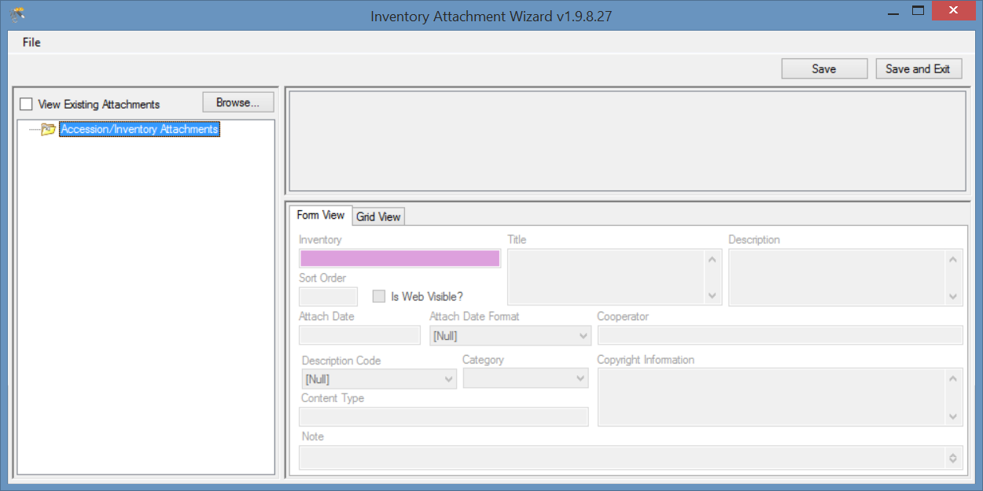

Form View Fields
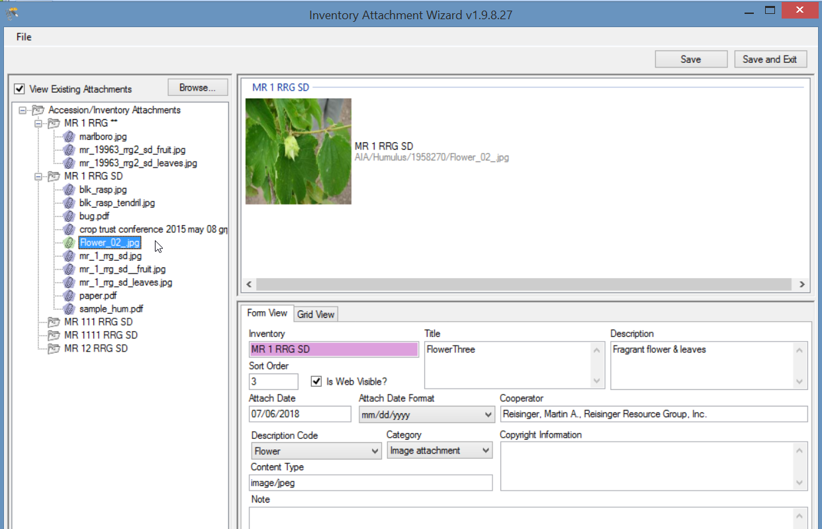

Inventory
Inventory with which the attachment file is associated.

Title
Displays when the user rolls over the mouse on the image thumbnail on the main accession details page. (The cooperator information is also displayed.)
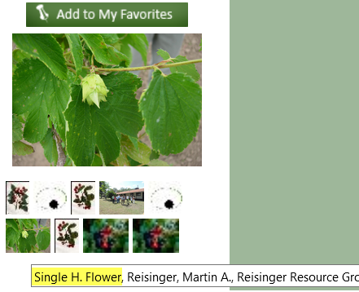

Description
Data supplied in the Description field displays when the image is viewed in a browser window:
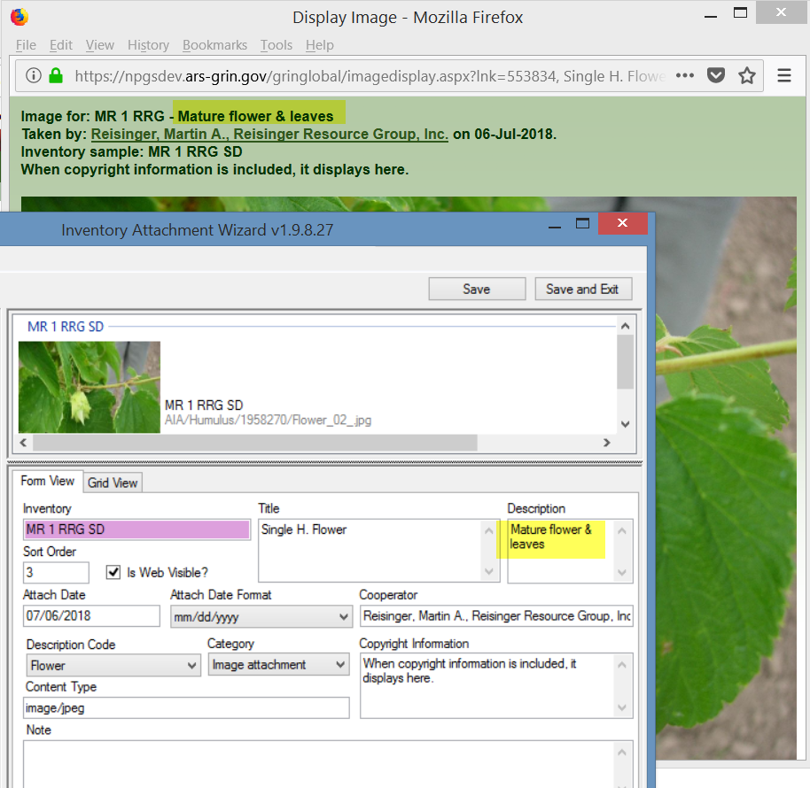
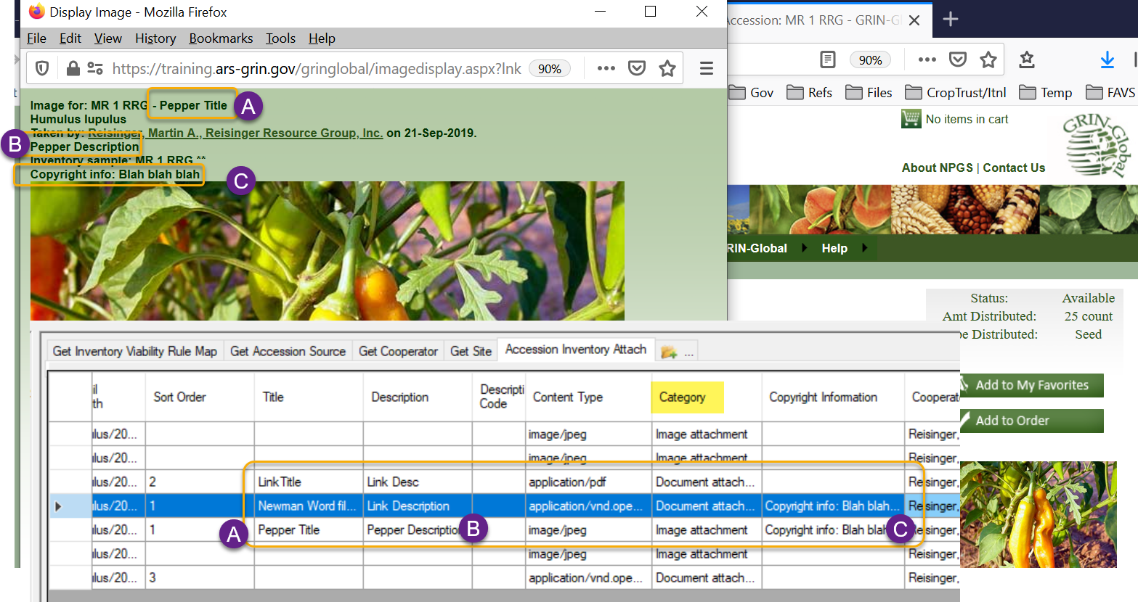

Sort Order
The Sort Order field is used by the PW for displaying images in a relative order. All of the image thumbprints are clustered in one group, and starting from the lowest Sort Order number, are displayed top left to bottom right. Similarly, the PDF files are listed below in relative order with the lowest number first.
If you specify the order, complete the order field for each attachment, otherwise the sort results will not be as expected.
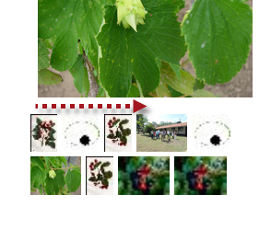
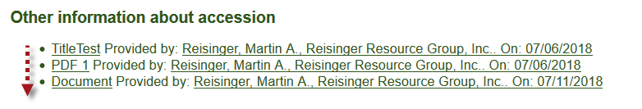

Is Web Visible?
This flag field determines is the image is displayed on the Public Website (or not).

Attach Date (& Attach Date Format)
If no date data is provided, the date displayed will default to the date attached. (In the current GG, digital photo image Exif data is not used, but plans are to explore this capability in future releases.)
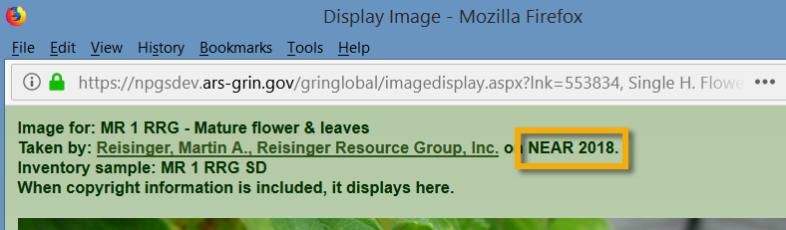
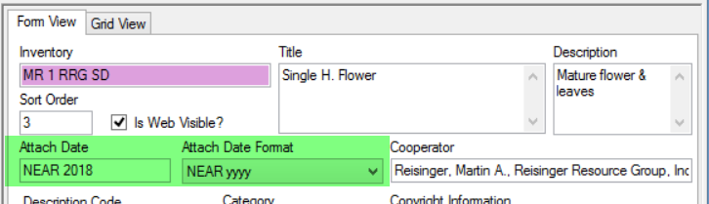

Cooperator
The cooperator field is displayed with the image (as shown above).

Description Code
The code group ATTACH_DESCRIPTION_CODE contains the list of valid Description codes. (The GG Admin maintains this code group and can modify to meet the organization’s needs. A CT user on the PW with a linked PW account in the Tools | Web Query feature can display any code and code values using the SQL below; refer to the SQL online documentation for complete details.)
The SQL is:
SELECT cv.code_value_id, cv.group_name as group_name,
cv.value, cvl.title, cvl.description
FROM code_value cv
LEFT JOIN code_value_lang cvl ON cv.code_value_id = cvl.code_value_id
AND cvl.sys_lang_id = 1
WHERE cv.group_name = 'attach_description_code'
ORDER BY group_name, cv.value
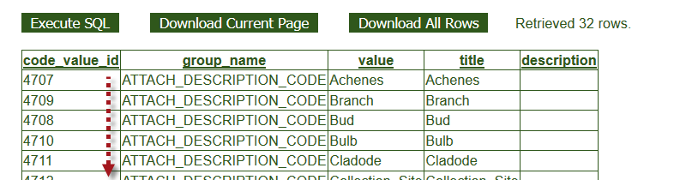

Category
The code group ATTACH_CATEGORY contains the list of valid Category codes. (The GG Admin maintains this code group and can modify to meet the organization’s needs.) If edited after initially loading images, the correct code must be properly selected. For example, Image attachment for images files.

Use the same SQL as shown above for the Description Code, but change the WHERE clause to ‘WHERE cv.group_name = 'attach_category'

Copyright Information
A text field that displays in the browser window.
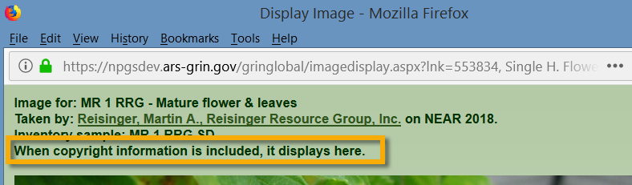

Content Type
The Content Type field is determined by the attachment wizard’s logic. It is using the image file’s extension and is based on standards (MIME); this makes it possible to display the attached file.

Note
Note is a text field which does not display on the Public Website, but may be used to document the file.
_____________

File Naming Conventions
The wizard uses programmed logic in the process of uploading images or attachments. The wizard requires either a valid Inventory identifier which includes the (inventory prefix/number/suffix/type), or, if the inventory–type is omitted, a proper accession identifier (accession prefix/number/suffix). When the inventory_type code is omitted, the wizard attaches the files to the system inventory record, thus relating the files at the accession level and not with a specific inventory lot.
(“Type” is the germplasm form, such as seed, in-vitro, etc.)
- All attached files (for all inventory_ids) for the same accession_id are stored in the same folder
- The wizard looks for an inventory identifier (Prefix, Number, Suffix, Inventory Type) within the filename; when not found, the wizard will review the folder name (pathname). It will look “up the path“ – if it can’t find a name in the parent folder, it will look at the parent’s parent folder, etc.
The GG type code for a system inventory record is **. Since Windows does not allow asterisks (**) to be used as a filename character, use only an accession- prefix, –number, and –suffix.
Alternatively, use a folder with the accession name so that one (or many) images in that folder can be associated with the respective accession.
- When the wizard saves the image files, it will insert the accession’s Genus and accession_id as part of the virtual pathname .
When the attaching of the source files is successful , the wizard names the server destination location during the attachment process with a virtual pathname. This accession_inventory_attachment dataview example shows the paths created for a sample file:
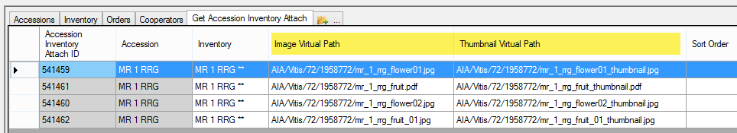

Filename Components
The naming of the images files is critical, because the name components are used to fill certain fields in the attachment record.
There are optional file naming parameters which can be used with attachment files. When using the Browse method to attach files, the attachment file name or the folder name where the source attachment files are stored determines the association to the inventory records. When the wizard cannot determine a matching inventory record, it will prompt with temporary inventory records requiring the user to manually associate the attachment files to inventory.
File naming options can include a plant part, an image number, and a date (such as the date the photo was taken). For example, the following name is indicating the inventory PI 500000 TR05az SD, January 1, 2005, image number 1, and panicle. \pi_500000_tr05az_SD_01-01-2005_01_panicle.jpg
You must include the inventory or accession identifier; all of the other fields are optional.
Component | Format | Example
inventory identifier*  (& underscore) | inventory_number_part1 + “_” + inventory_number_part2 + “_” + inventory_number_part3 + “_” +  form-type-code +  “_” | pi_500000_tr05az_sd_
accession identifier*  (& underscore) | accession_number_part1 + “_” + accession _number_part2 + “_” + accession _number_part3 + “_” +  “_” | PI_500000_
date (& underscore)  (optional) | mm-dd-yyyy +  “_”  (See Attach Date Details section) | 01-01-2005_
image_number (& underscore)  (** optional) | nn +  “_” | 01_
plant_part  (optional) | (see Plant Part section); not exclusively plant parts) | panicle
* If the identifier is not part of the filename, then the identifier must be the folder name. When the identifier is part of the filename, the trailing underscore (_) must be included as part of the filename.
** Unique image numbers make it possible to have multiple images for the same inventory, plant part, and date.
When using the Browse function, if your folders are setup in a fashion similar to the following, with each folder named after an accession, you can browse the higher level parent folder, to attach all of the attachment files from the folders to their respective accessions.
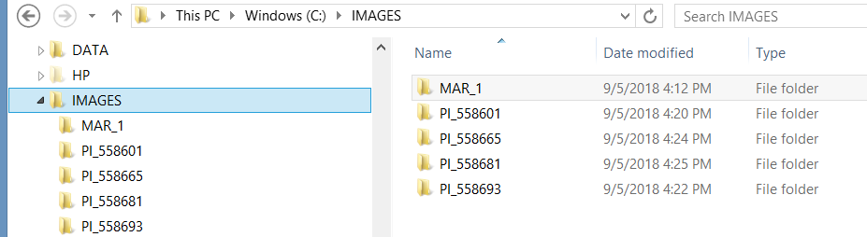

Attach Date Details
The attachment file’s name or location can determine if a date is automatically inserted into the file’s Attach Date field.
- When the attachment file’s filename contains a valid date properly formatted, that date will be added to the Attach Date field. The valid format is "mm-dd-yyyy"
- When a date isn’t included in the filename, the programming logic reviews the folder names in the path structure to see if any folder name includes a date. The logic looks at the current folder, and then each higher folder level until it finds a date. When that happens, that date will be inserted as the attached date. (This would allow the same date to be applied to many files in one folder.)
- Finally, if neither the filename or folder name contains a date, then the current date is inserted in the attachment file's Attach Date field.
Similar to the searching hierarchy described above for dates, the wizard also looks for the other naming components such as accession or inventory identifiers, plant part, etc.

Plant Part
For the “plant_part” component of the filename, in the NPGS, the following terms are valid. These codes are stored* in the ATTACH_DESCRIPTION_CODE code group :
Achenes | Flower | Panicle | Spike
Branch | Fruit | Plant | Spine
Bud | Greenhouse | Pod | Stalk
Bulb | Head | Root | Stem
Cladode | Kernels | Seed | Stipule
Collection_Site | Leaves | Seedling | Tendril
Ear | Miscellaneous | Shoot | Umbel
Field | Nut | Silique | Vegetative
* the current list of valid ATTACH_DESCRIPTION_CODES can be obtained by running a SQL script mentioned earlier.
- All attached files (for all inventory_ids) for the same accession_id are stored in the same folder
- The wizard looks for an inventory identifier (Prefix, Number, Suffix, Inventory Type) within the filename; when not found, the wizard will review the folder name (pathname). It will look “up the path“ – if it can’t find a name in the parent folder, it will look at the parent’s parent folder, etc.
The GG type code for a system inventory record is **. When associating images at the accession level, omit any reference to the ** type code since Windows does not allow asterisks (**) to be used as a filename character. Instead, simply use the accession- prefix, –number, and –suffix. Alternatively, use a folder with the accession name so that one (or many) images in that folder can be associated with the respective accession.
With folder names, the trailing underscore is not needed as part of the folder name, but the filenames must have the trailing underscore
- The source folder structure can include the genus name and subfolder (under the genus folder) for each accession_id, but this is not required. When the wizard saves the image files, it will insert the accession’s Genus and accession_id as part of the virtual pathname .

Attaching Files: Detailed Steps (3 Methods)

Browse Method to Select Attachments
In the following series of screens, by using the Browse command in the wizard, the user has attached images from a folder that was named with the accession identifier: MR 19921 RRG. In order to work properly, using Browse you must have either the folder or the image files named in such as way (as explained in the File Naming Components section) so that the wizard can associate them to the respective accession/inventory.
- start with a list of accessions
- select the accession(s)

Wizard is Initiated
Click the Inventory Attachment Wizard button.
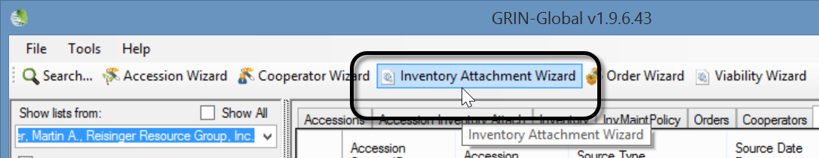
The wizard window displays; click Browse:
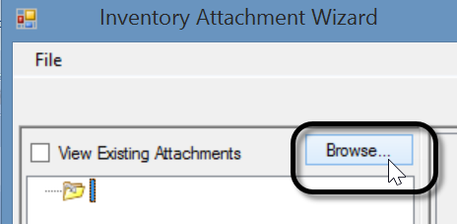
Optional: select the View Existing Attachments checkbox
The alternative method is to switch to a File Explorer screen at this point and begin a drag and drop operation.

Browse to the folder where the attachments are stored (PC or network drives available to the PC); select the folder; click OK -- to begin the selection of the attachments:
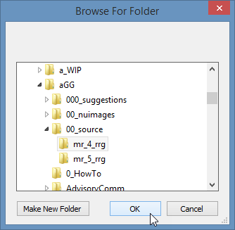
(This image is used here to illustrate what files were in that selected folder.)
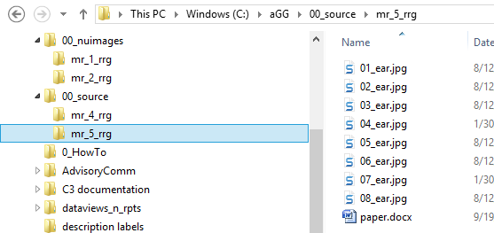
The files are listed in the left panel of the wizard. Thumbnail images are displayed in the upper right panel:
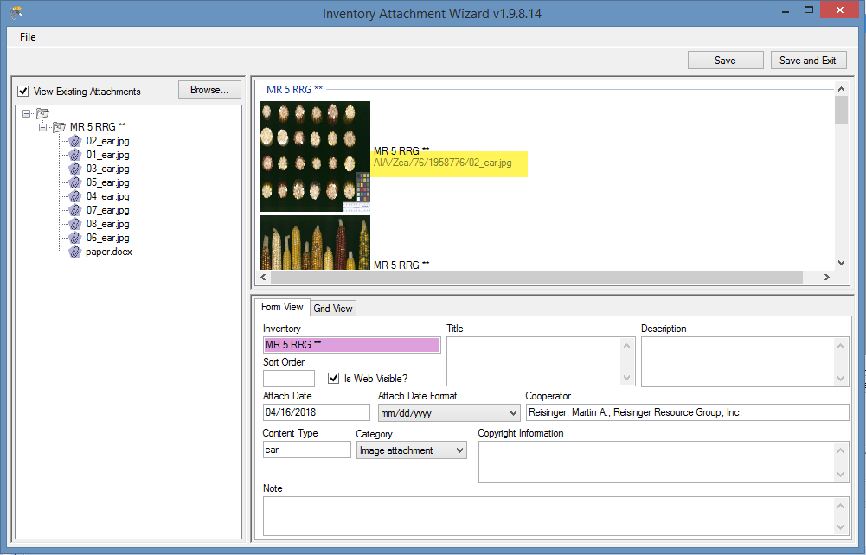
If you select the Grid View tab in the lower right panel, you will see the destination path where the files are stored. (The path is labeled “Virtual” because as shown below, the full location information is masked. The GG administrator determines the actual physical storage space.)
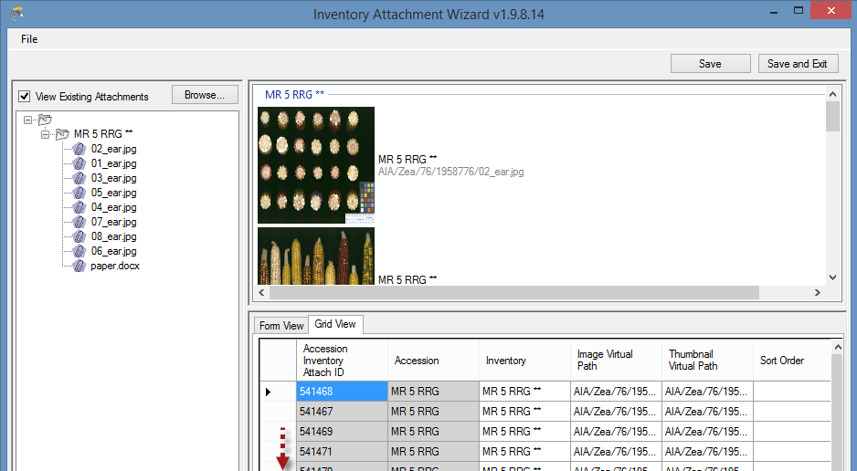
The user clicks either the Save or the Save and Exit button.

Drag and Drop Method to Select Attachments
This is the alternative method to using the Browse method. The two methods produce similar results. However, when you use the Browse method, all of the folder’s files are included, whereas when dragging and dropping, you can select which files to do so.

Example Using the Drag and Drop Method to Select Attachment Files
In the following series of screens, by using the drag and drop method with the wizard, the user has attached images from a folder that was named with the accession identifier: MR 19921 RRG.
- start with a list of accessions
- select the accession(s)

Wizard is Initiated
Click the Wizard button.
Switch to a Window’s File Explorer window; click on a folder, or alternatively, select files in a folder using standard Windows keyboard and mouse combinations, and then drag onto the wizard’s folder icon in top, left panel of the wizard window:
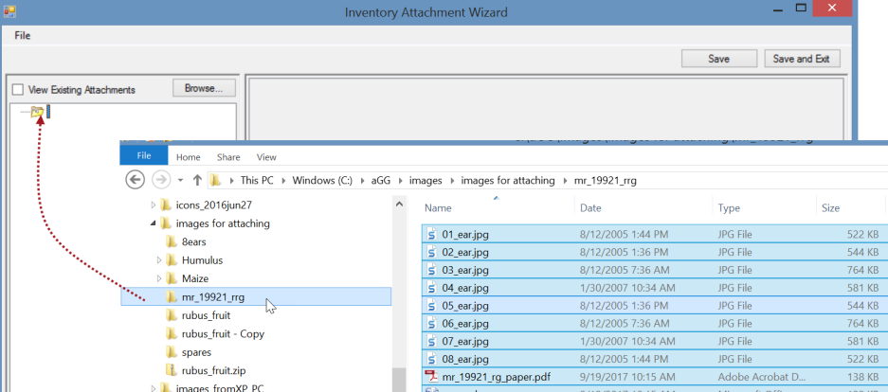
The result: the files are listed under a subfolder. The thumbnail images will also be displayed in the upper right panel.
_____________

Attaching Files Directly
An alternative to launching the Attachment Wizard is to drag image files directly from a Windows Explorer window to the accession icons in the CT’s left list panel. The images are attached, but also this action immediately launches the Accession Inventory Attachment wizard.
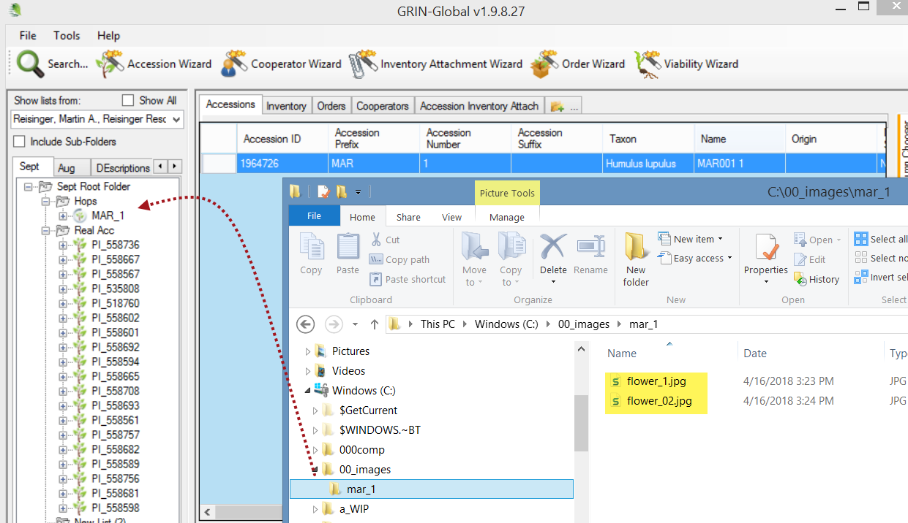

Viewing Images
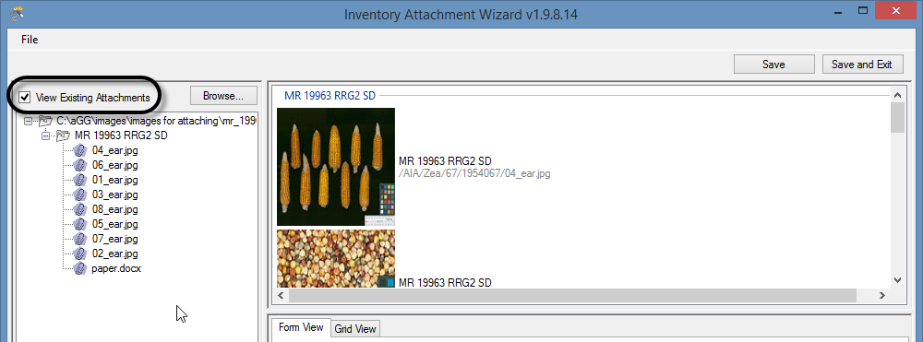
If the Grid View tab in the lower right panel is selected, you will see the destination path where the files are stored. (The path is labeled “Virtual” because as shown below, the full location information is masked. The GG administrator determines the actual physical storage space.)
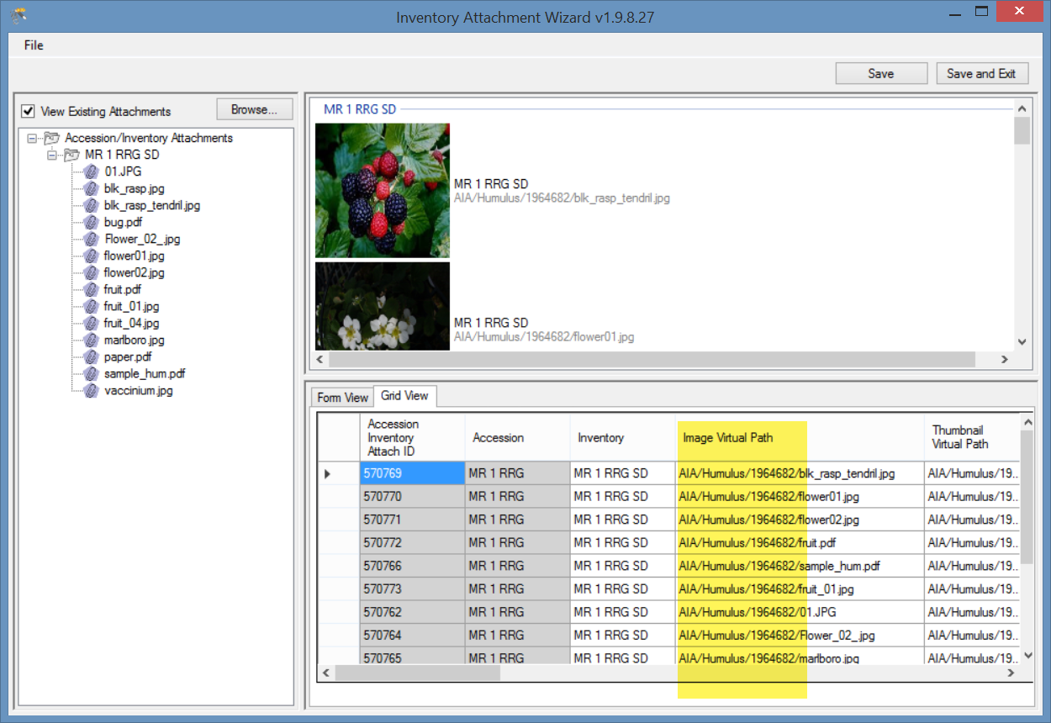
The letters “AIA” (accession inventory attachment) are used to designate one folder level. The genus (in this example, Humulus) is inserted as another level, and the ID (1964682) of the accession record as another.

Deleting Attachments
Don’t confuse deleting the attachment records with deleting the attachments. Currently, if the attachment resides on a storage location that the Middle Tier has permission to delete the file, then the file will be removed from the storage location - but if the Middle Tier does not have permission to remove files, then the attachment file will remain at that storage location but the accession_inv_attach record will still be deleted. (In NPGS, all GG attachment files added via the attachment wizard can be deleted.)
When looking at the grid in the inventory_attachment wizard, you are viewing the attachment records.
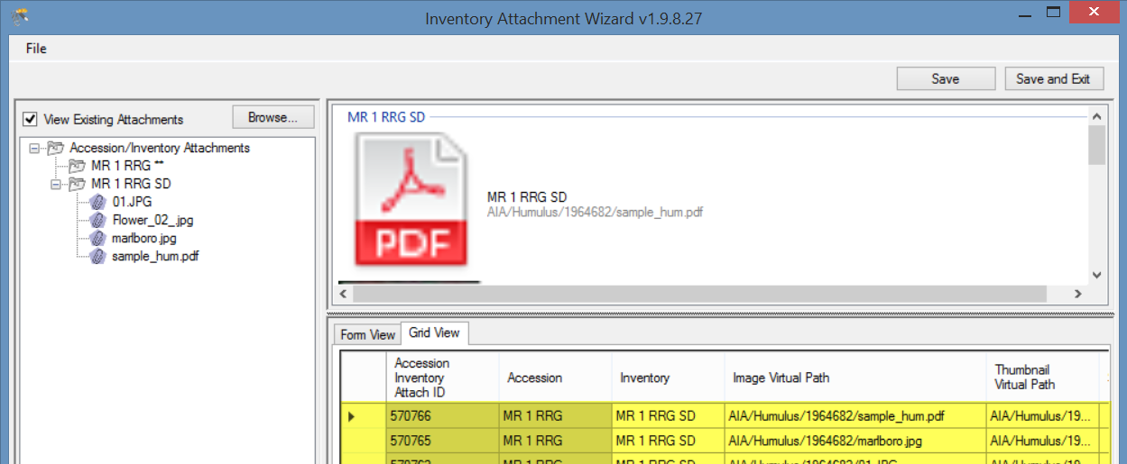
To delete an attachment record, click in the left row header cell(s)* to select records to be deleted; press the Delete key; click on the Save or Save and Exit buttons.
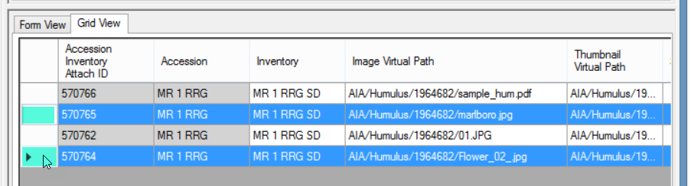* hold the CTRL key when clicking to select multiple records, or SHIFT for contiguous records (rows)

Locations of Attachment Files
Each organization running GRIN-Global will have its own unique file server where the image and document files are stored. The GG administrator can assist with deleting the files if necessary.
The following information is intended primarily for Administrators:
The full directory path breaks down into several parts:
Example: C:\inetpub\wwwroot\gringlobal\uploads\images\AIA\Humulus
The web installer puts the GG site in C:\inetpub\wwwroot\gringlobal Then the Middle Tier (MT) controls the next part of the path. It always puts the images in the uploads\images directory under the GG site install directory. (You couldn't change that without altering the MT code and rebuilding.) Then the AIA\humulus part comes from a dataview that tells the Wizard what to use. If an admin wanted to, they could change that part by altering the inventory_attach_wizard_get_filepath dataview.
______
NPGS
In the NPGS, use the following convention to locate an attached file at the URL:
https://npgsweb.ars-grin.gov/gringlobal/uploads/images/image virtual path
For example, using the first attachment record in the screen above:
https://npgsweb.ars-grin.gov/gringlobal/uploads/images/ AIA/Humulus/1964682/sample_hum.pdf
(In this example, the number 1964682 is the accession_ID value.)
If you delete the attachment and wish to reuse the same naming convention, but with a different attached file, you can. It is not necessary to first delete the attachment record(s), simply upload the new attachment(s).

Editing Attachment Records
If you own the attachment records or have the permission to edit the records, you can view them in the attachment wizard, make the changes in the respective fields, and then save the records. Either wizard view tab may be used (Form View or Grid View).
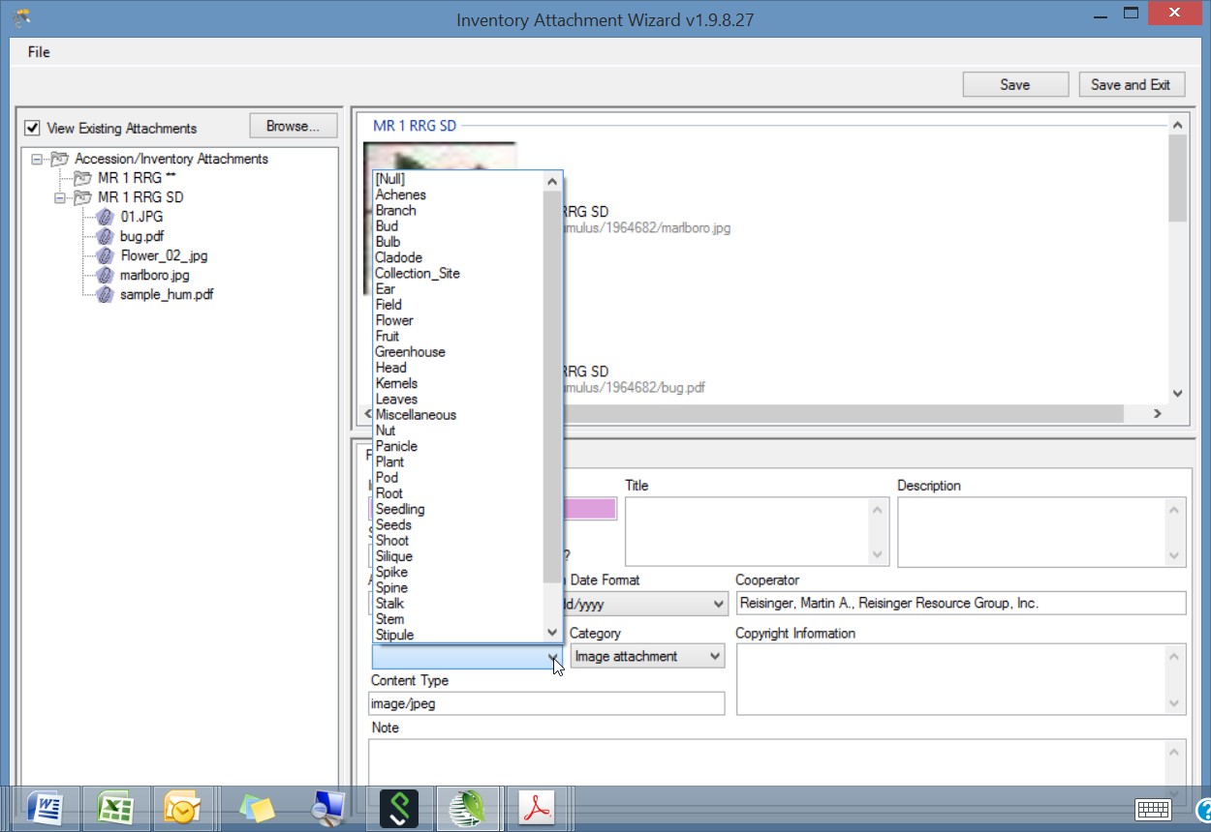

PDF Links Displayed on Public Website
The wizard automatically recognizes a PDF as such and will set the Category setting to Document attachment. Supply a Title and ensure the Is Web Visible box is checked if the document is to be displayed online.
Documents are listed at the bottom of the accession’s detail page.

Sort Order
The Sort Order field is used by the PW for displaying images in a relative order. The PDF files are listed in relative order with the lowest number first.

Title
The Title is listed with a hyperlink to the document. When the Title is omitted, the link is labeled “Document” as shown for the second document listed below:
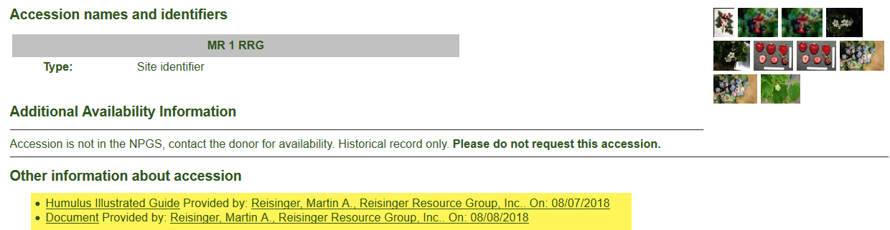
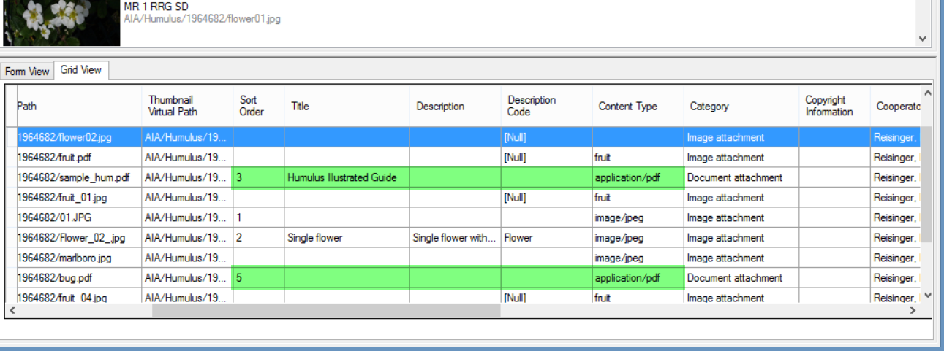
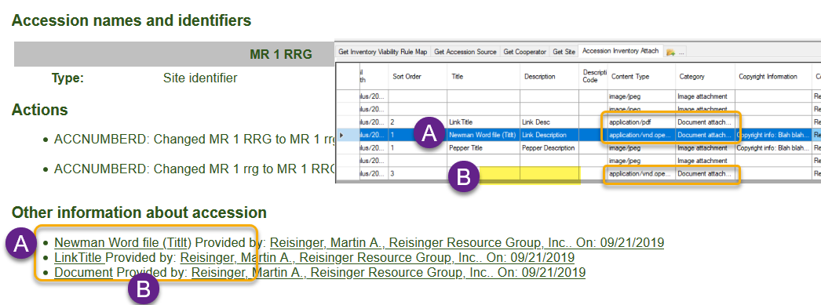

Manually Identifying Inventory to the Attached Files
If the wizard cannot determine from the filename or the folder name what inventory to associate with the attached files, the folder in the wizard left panel will be denoted with a “-1” placeholder; similarly, in the grid in the lower right panel, the inventory will be listed with a -1 value.
In this example, no identifier had been provided by either the attachment files’ names or the source folder name:
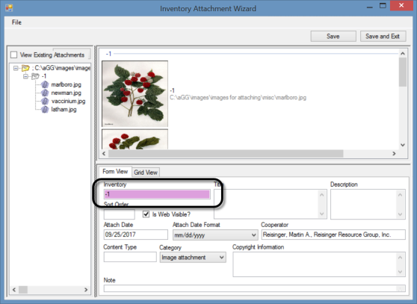
Use the Filter box to search the Inventory Lookup table for the desired inventory record.

Before
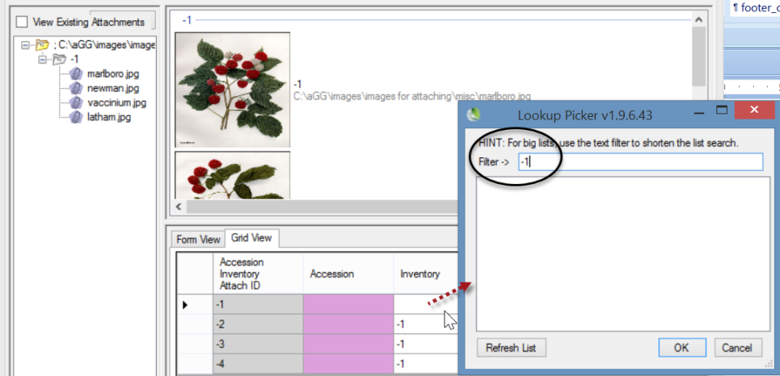

After:
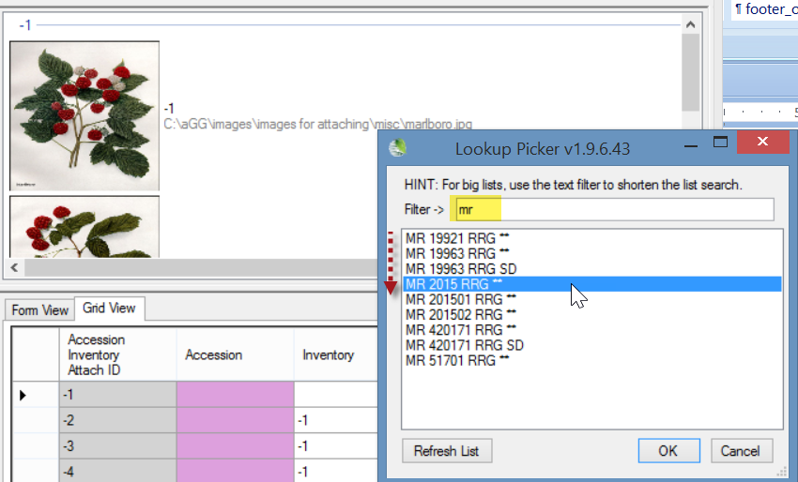
These screens show the Accession field with a pink color, which in GG typically indicates that this field is required. In the wizard, the field will eventually fill in after the inventory is selected – you cannot input data in the Accession field.
Use Ctrl-D to copy down if the same inventory applies.
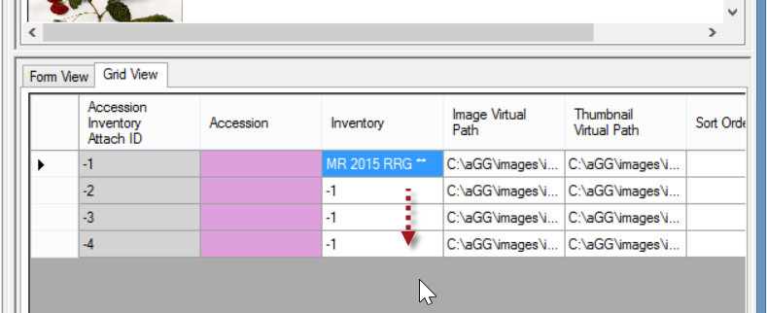
When using the Ctrl-D copy down technique, after doing so, click off the blue highlighted area to view the copied cells. If the files are to be associated with different inventory records, continue to use the Lookup Picker as needed.
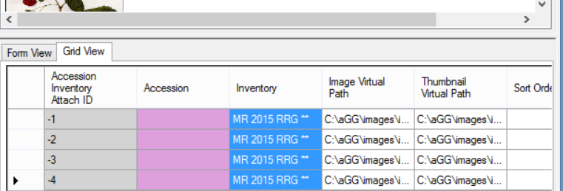

What Types of Files Can be Attached? [File Menu]
The wizard window has a menu with one item, File, which in turn has one item, Options…. The primary reason for selecting File | Options… is to indicate which file extensions the wizard can handle (“Include”).
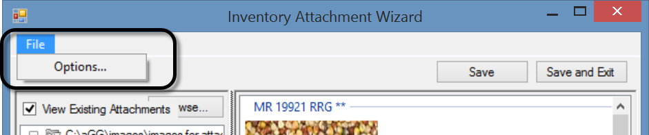
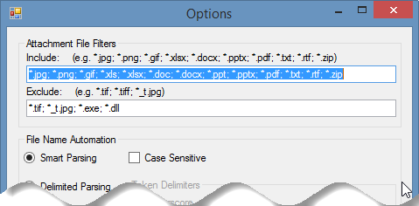

File Filters

Include
The list of possible file extensions has been seeded with many file types that are most likely to be added as attachments. However, if you need to specify additional file types, add the file extension to the list by supplying the semicolon separator (;), an asterisk (*), period (.), and the extension. For example, if you needed to add web pages, you would consider the following:
*.jpg; *.png; *.gif; *.xls; *.xlsx; *.doc; *.docx; *.ppt; *.pptx; *.pdf; *.txt; *.rtf; *.zip; *.htm; *html
where the red text indicates the new file extensions to be included.

Exclude
This list has a few obvious file types that need to be excluded. As with the Include option, if you need to specify additional file extensions to the existing list, do so in the same manner as described above.

File Naming Automation

Smart Parsing
As background information, parsing means to split text or other input into pieces of data that can be easily stored or manipulated. Each of the text pieces that is parsed is considered a “token.” The Smart Parsing radio button is pre-selected. The software is programmed to recognize certain conventions explained later in the File Naming Conventions section.

The following options are not implemented at this time. if you select the other checkboxes, the wizard does not retain that choice.
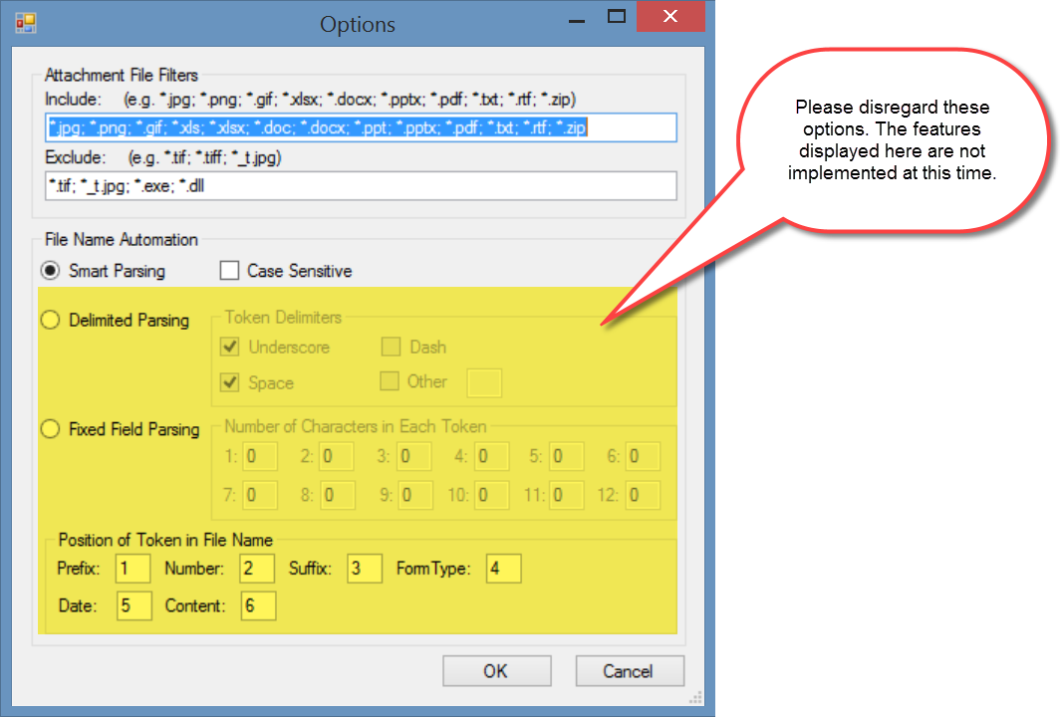
- Delimited Parsing
- Fixed Field Parsing
- Position of Token in File Name

URL Links
URL links can also be added to the database and associated with accession/inventory, but not in the same manner as physical files. When adding many links, use the Accession Inventory Attachment dataview. If the accession / inventory does not already have any other attachments, you must use the dataview. For those accession / inventory records that do have at least one attachment, you can also use the attachment wizard, but in manner different from the methods used in attaching physical files.

To Add a URL Link
Open the Accession Inventory Attachment dataview; click the Edit Data button. Two required fields display in pink. Select the inventory from the Lookup Picker; enter the link’s complete URL text in the Image Virtual Path field.
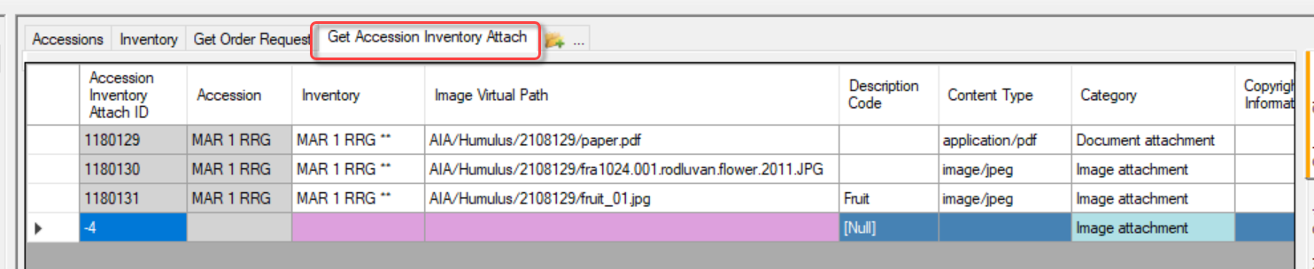
Two other steps: change the Category to URL Link; enter a meaningful Title:
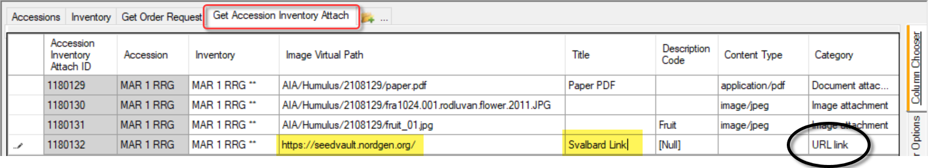
If you need to bulk add many URLs, you can set up a spreadsheet to drag and drop the records, following the steps as with any other drag and drop process.

In the new Public Website, these links display in the Accession’s Other tab:
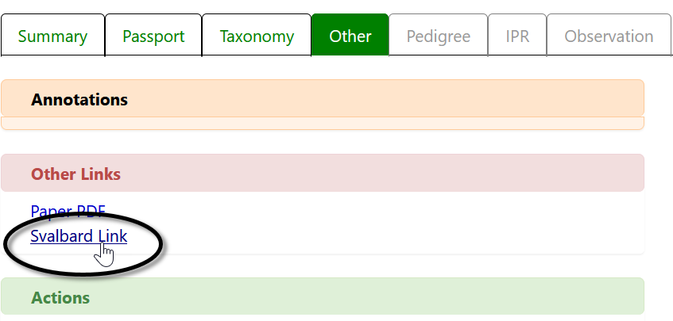

In the original GG Public Website, the link displays at the bottom of the accession’s detail page:
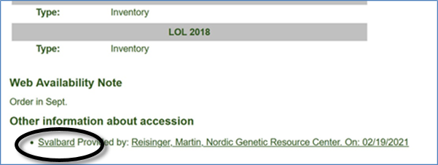

Using the Wizard to add a URL Link When Other Attachments Exist
If attachments exist for an accession/inventory record, you can add a new line in the wizard’s grid. Use CTRL + N to create a new record:
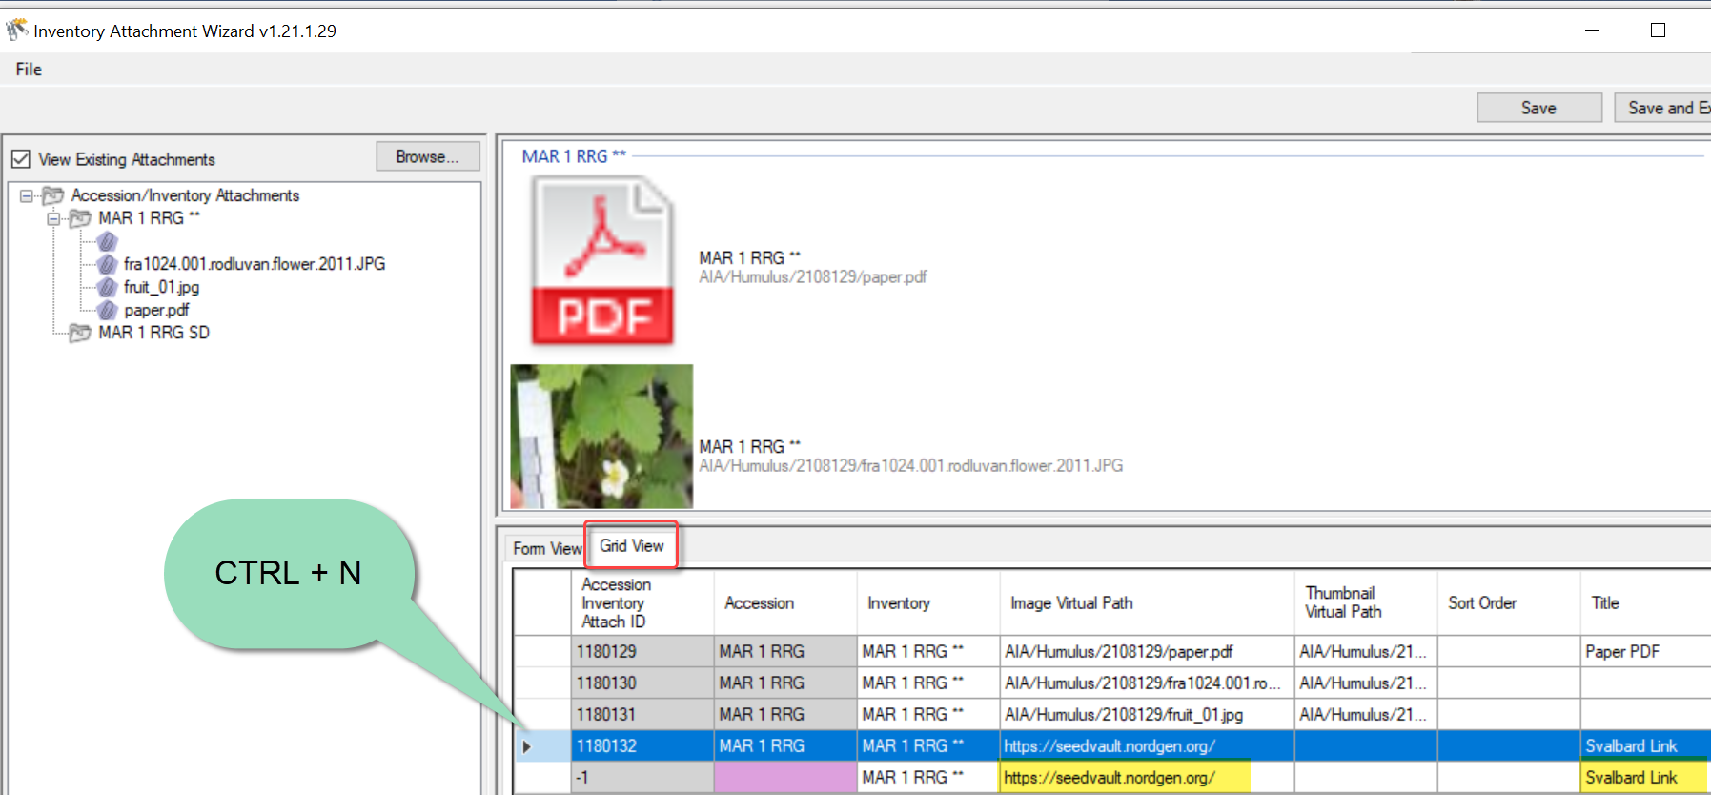
 | If you accidentally create a new row, that row can be deleted. Select the row; press the Delete key. A prompt will display to which you can affirm “OK” to delete the unwanted attachment record.

Appendix A: Making a Batch of Folders

MD – Make Directory DOS Command
One way to use the wizard is to select attachment files for many accessions, with each accession having its own folder with the images and other files in the respective folders.
In the following screen, within Windows Explorer, the file kim.bat was double-clicked. The result was it created the 3 new highlighted folders named after three accessions. Note that the names include an underscore character between the prefix (PI) and the accession number:
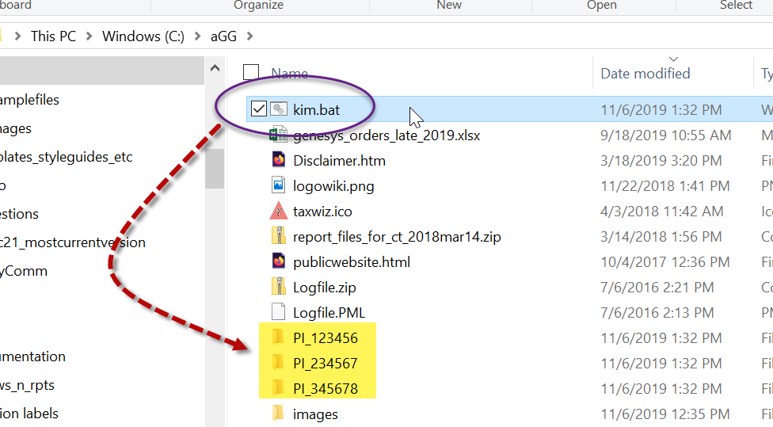
So, what was special about kim.bat?
- it is a plain, ordinary text file with the extension “.bat”
- three lines of text were in kim.bat:
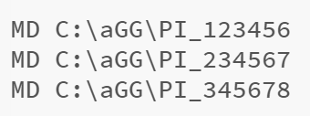
- when clicked, the file executes DOS commands and in this case, creates three folders. (MD is Make Directory. After MD is a space character, and then the path C:\aGG where the folders are to be created.
Change the Folder Options to display file extensions and other good stuff (details in pages below).

Changing Options for Folders (so that they display (Show hidden folders))
Unfortunately, Microsoft decided to hide certain folders as well as file extensions by default. The default view; the folder C:\ProgramData is hidden:
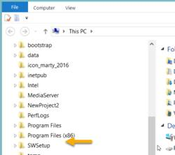
Whenever I get a new PC, I immediately change 3 of the default settings. I use File Explorer extensively, so I change the settings for "Display full path," "Show hidden files…," and "Hide extensions for known types" to be able to see “hidden” folders and files.

Default File Explorer Settings
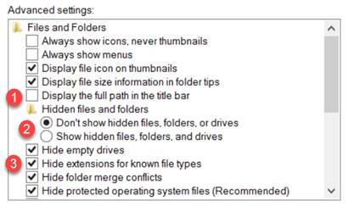

Preferred settings which you can make the default for the entire PC:
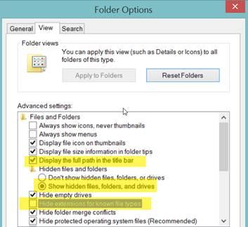
To make the display options apply to all folders, select the Apply to Folders button:
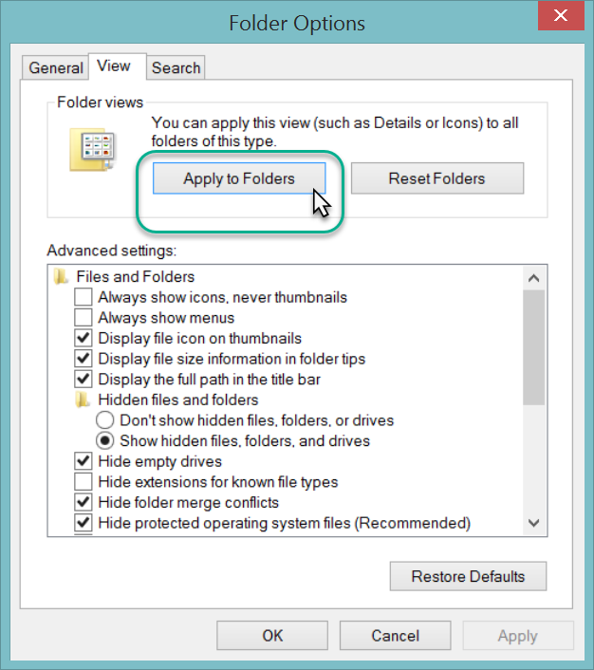
The C:\ProgramData should display. You may need to close the File Explorer window and then reopen it.
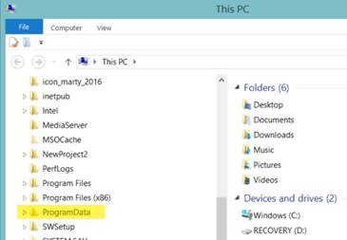

Appendix B: Document Change Notes

– February 19, 2021
- added the URL Link section; added text and images to explain how to add URL links as attachments

– January 19, 2021
- added text to illustrate server location where images are saved when attached by the wizard

– January 14, 2021
- added text to illustrate server location where images are saved when attached by the wizard

– September 21, 2020
- added screens and text to illustrate manually dragging Windows Explorer filenames to accession or inventory items in the CT list panel

– November 12, 2019
- added screens and text to illustrate Titles, Descriptions, and Copyright Information fields
- added Appendix A, explaining how to create many folders at one time in Windows Explorer

– September 5, 2018
- added new screen showing the accession tab being selected before starting the wizard
- added tip regarding the need to fill in order for each attachment

– August 29, 2018
- added note about the hierarchy of the logic used in searching for identifiers, plant parts, etc.

– August 24, 2018
- added note about directly dragging image files to an accession list item in the list panel

