Inventory


Revision Date
April 3, 2026

 | This guide provides details on the Inventory-related dataviews. The GRIN-Global database has approximately 10 inventory related tables and the Curator Tool has approximately the same number of Inventory dataviews.  The Appendix contains change notes pertaining to this document.

Author
Martin Reisinger

Comments/Suggestions
Please contact marty.reisinger@usda.gov or mar@rrginc.com with any suggestions or questions related to this document. This and other GRIN-Global–related documentation can be downloaded from the GRIN-Global project website.

Table of Contents

Introduction 5
Overview 5
Inventory Records & Dataviews 5
Inventory Dataview Areas 6
Each Inventory Record has a Parent Accession Record 7
How does Inventory relate to what is displayed on the GG Public Website? 8
Two broad kinds of Inventory Records: System and Physical 9
Recording New Inventory Items 9
To Add a New Inventory Record 10
Inventory Dataview Form 11
Each Inventory Record has a Parent Accession Record 13
Inventory Dataview Field Details 13
Prerequisite Fields 13
Accession 13
Inventory Maintenance Policy 13
Unique Identifier - Inventory Naming Conventions 14
Naming Examples 14
Inventory Type 15
Availability and Visibility Fields 16
Multiple Inventories Available and Seasonally Available 17
Inventory Maintenance Policy 19
Purpose of the Inventory Maintenance Policies 22
Fields common to both Inventory Maintenance Policy and Inventory records 23
Inventory Maintenance Policy’s Impact on Orders 25
Adding Inventory Maintenance Policy Records 25
Availability Status Trigger 26
Availability Status 27
Is Auto Deducted? 28
Is Available? 28
Status Note 28
Is Distributable? 28
Availability Status 28
Availability Start and End Date 28
Other Inventory Fields 29
Inventory Maintenance Site 29
Quantity On Hand 29
Pathogen Status 29
Locations Section 1…4 29
Production Location 29
Latitude and Longitude 29
Rootstock 29
Parent Inventory 29
Backup Inventory 29
Hundred Seed Weight 30
Pollination Method 30
Pollination Vector 30
Preservation Method 30
Regeneration Method 30
Plant Sex 30
Propagation Date 30
Propagation Date Format 30
Note 30
Name 30
Taxon 30
Origin 30
Percent Viable 30
Tested Date 30
Inventory 31
Pure Live Seed and Percent Viable 31
Inventory Dataviews in the Accession_Inventory Area 31
Names 31
Name Groups 32
How to Associate an Accession with a Name Group 32
Accession Inventory Groups 33
Create Accession Inventory Groups 33
Accession Inventory Group Map 33
Annotations 34
Attach(ments) 34
Voucher 35
Inventory Actions 35
Examples of Inventory Actions 36
Inventory Actions Fields 37
Fields 37
Inventory Quality Status 38
Fields 38
Viability Testing 39
Viability 39
Viability Wizard and the Viability Dataviews 39
Inventory Viability Dataview 39
Germination Tests 40
Viability Rule Dataview 40
Pure Live Seed (Calculating Live Seed by Using Germination Test Rates) 40
Pathology Testing 43
Regenerating Inventory 43
Search for Low Inventory 43
Create Replenishment Orders 44
Prioritize Inventory that Need Replenishment 44
Add Low Inventory Items to an Order via the Order Wizard 44
Create New Inventory Records Indicating Their Parents 45
Appendix: Inventory Naming Conventions 47
Inventory Suffix 47
Appendix: Frequently Asked Questions (Inventory) 49
Question: 49
Answer: 49
Appendix: Document Change Notes 50

Introduction

Overview
Using GRIN-Global (GG), a genebank can manage all accession samples maintained in its collection. In GG, the physical germplasm for each accession is considered “inventory.”
Managing inventory well should be the primary focus of any genebank. A genebank should be able to ensure the accessions in their care are viable, readily located, etc.
It is important to distinguish “Accession” from “Inventory.” In GG, two separate tables co-exist in the database. Before an inventory can be recorded, a corresponding accession record must first have been created.
Typically, an accession will have multiple inventory lots – different generations, form types (plants, seeds…), germplasm stored at different locations or for backup purposes, etc. Each physical lot should have its own respective GG inventory record.
In GG, the first step when a genebank acquires an accession is to ensure its passport data is entered in the database – an accession record is created. Initially, only a few of the accession record’s passport data fields may be known, but that doesn’t mean the genebank should wait until it knows everything about the accession before entering the accession data into the database.
 | GG System Inventory records. When an accession record is initially added to the database, the GG software automatically creates a related “system” inventory record. This system inventory record does not refer to any physical inventory, but is used within the GG software to connect certain records to an accession record. This concept is discussed in detail in the System Inventory Records section. The main thing to understand at this point is (a) the accession’s system inventory record is generated automatically by the GG software; (b) you should never attempt to edit or delete this record.
The inventory records relate to an accession record via the accession’s identifier (the Accession_ID field).
Seeds are not the only kind of inventory. Clonal sites also maintain inventory. Plants, in-vitro tubes – these are all physical inventory. How they identify their inventory and their “generations,” tends to be genebank specific. In any case, GRIN-Global can handle the management of clonal inventory as well as seeds.

Inventory Records & Dataviews
Specific inventory data – quantity on hand, its storage location, date of harvest, the parental lot, and other information – this information is inputted into GRIN-Global in the Inventory record in the GG database. In the GG Curator Tool, genebank staff use the Inventory dataview to review and edit the inventory records.
Remember that a dataview and a table are not equivalent. A dataview may display data from more than one table. In the CT’s edit mode, the Inventory dataview will display some fields with a gray color, indicating that these fields are not fields in the inventory record and cannot be edited in the Inventory dataview.
GG Administrators: In some GG versions, specific site inventory dataviews requested by National Plant Germplasm System (NPGS) sites were included. The dataviews are recognizable by the word “Site” in their name. They serve as good examples, but the primary Inventory table is Get Inventory.
Dataviews now have a disabled flag to indicate if the dataview is to be displayed or not (to be visible to the CT user). You can remove any of the site inventory dataviews from display and not impact anything in GG.
Also, the system dataview get_dataview_list was modified to not pass information on disabled dataviews to the CT (so that disabling the site inventory dataviews effectively hides them).
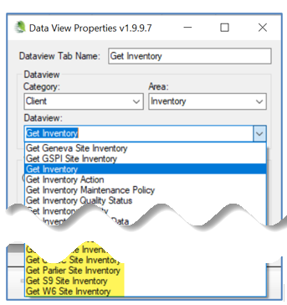
GRIN-Global System Inventory Records
In GG, when creating a new accession record, a default inventory record, referred to as the System Inventory record, is always created. These records cannot be edited. They do not represent physical inventory. Please refer to the section System Inventory Records for more details.

Inventory Dataview Areas
The CT has two areas for inventory related dataviews:  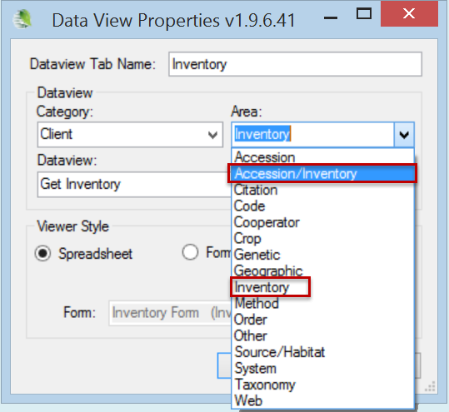 |  | Why two areas? Because some inventory dataviews pertain strictly to inventory records, such as Inventory Action, whereas others can apply to either inventory or accessions. An example of the latter is “Names,” which can be assigned to an accession in general or to a specific inventory lot.
Inventory  Dataviews | Accession/Inventory  Dataviews |  | Site Specific Inventory Dataviews
Inventory  Inventory Action  Inventory Maintenance Policy  Inventory Quality Status  Inventory Viability  Inventory Viability Data  Inventory Viability Rule | Accession Inventory Annotation  Accession Inventory Attach  Accession Inventory Group  Accession Inventory Group Map  Accession Inventory Name  Accession Inventory Voucher |  | Geneva Site Inventory  GSPI Site Inventory  NC7 Site Inventory  NSSL Site Inventory  OPGC Site Inventory  Parlier Site Inventory  S9 Site Inventory  W6 Site Inventory

Some of the GRIN-Global Tables 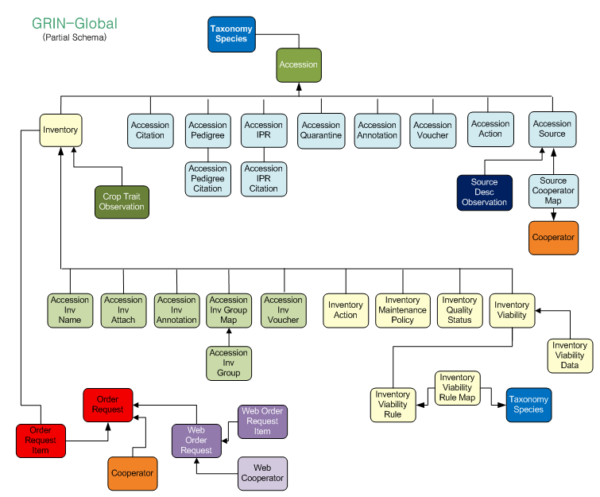

Each Inventory Record has a Parent Accession Record
Reading from top down, the diagram above is showing dependencies. An inventory record must be associated with an accession record. Note also that the accession record references an accepted taxonomy species.
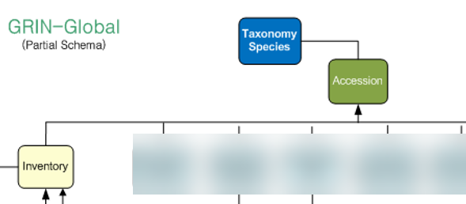

How does Inventory relate to what is displayed on the GG Public Website?
The question “What is necessary for an accession to be requested?” is often raised by genebank staff who are privy to seeing the many database fields in the accession and inventory records. Explained in more detail later, but in short, multiple fields from both the Accession and Inventory records impact the the visibility of accessions on the website as well as the user’s capability to request accessions:
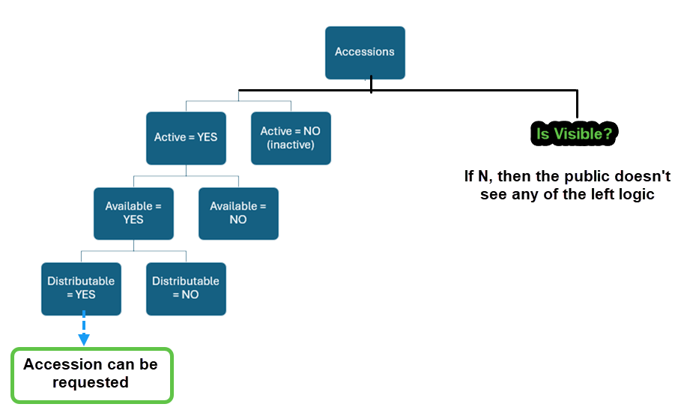
Fields impacting the website
Accession record fields: Is_Visible? (Y/N) and STATUS (Active/Inactive)
Inventory record fields: Is_Available? and Is_Distributable? (Y/N) (Both must be “Y” for an inventory to be requestable.)
The illustration above shows some of the basics to consider. We’ll see later that GG now has a Seasonal Availability feature that optionally can be used to restrict the request of germplasm to a specific date range. [ If you are curious now, see Seasonal Availability. ]

Two broad kinds of Inventory Records: System and Physical
In GG, when an accession record is created, GG automatically generates a system inventory record. This software-generated inventory record does not represent physical inventory. These system-generated inventory records are always denoted with a ** for their Inventory Type (as contrasted with Seed, In-vitro, etc.). Think of these records as records needed by the GG software. A CT user should never need to edit these records.
Physical germplasm will never use the ** as their Inventory Type indicator. Physical inventory instead will use type codes for seeds, plants, in-vitro, etc.
What is the purpose then for system inventory records? In some cases, related data records may be associated with accessions either at the accession level (and therefor all inventory records) or only at a specific inventory record. More on all of this later.
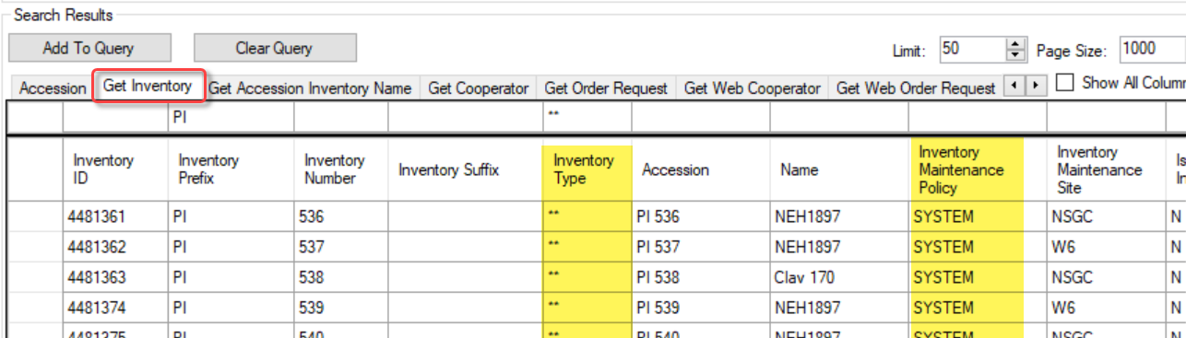

Recording New Inventory Items
Seed genebanks generally have multiple lots for each accession. Each physical lot should have its own respective GG inventory record.
Two main methods are used for adding new inventory records into the database. One record at a time may be manually added via the Curator Tool’s Inventory dataview. The alternative is to add many records by dragging them from a spreadsheet into the Inventory dataview.
The Inventory dataview is used to record the inventory’s identifier, its form (is it saved as seeds or is it saved as a plant?), its date of harvest, the quantity on hand, the form that is distributed upon request, where the germplasm resides (on a shelf in a freezer, in the field in a specific row/plant location), etc.

To Add a New Inventory Record
In the Curator Tool, it is not essential to have the accessions listed when you start adding inventory – but it may be helpful.
Shown: an accession on the left list panel; the Inventory dataview in the right grid; the user has clicked the Add New button. The colors provide a visual clue: fields that cannot be edited in the current dataview are gray, and fields that allow editing, but which are not required, are white. The pink fields are required. This can be misleading, because most genebanks often require that the Inventory Number, Suffix, and Type Code fields all be filled.
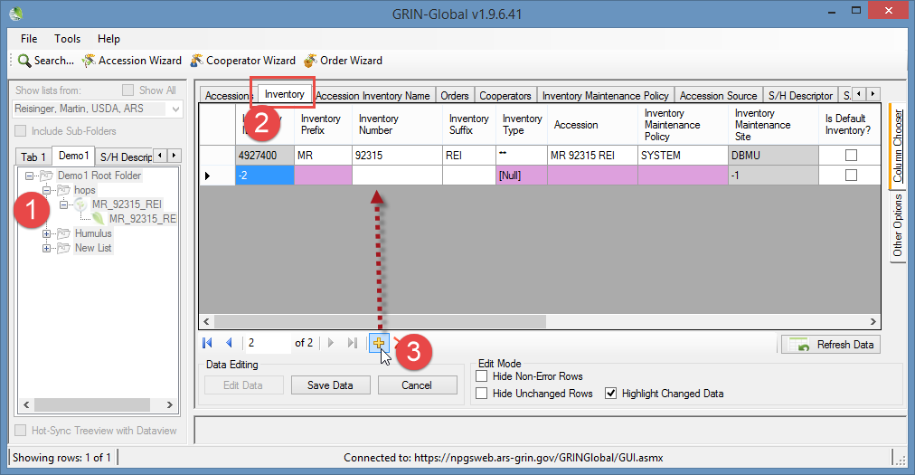
Clonal sites will typically create one inventory record for each clone and assign each clone an inventory number. Clonal inventory will have a type that indicates what the material is: TC - Tissue Culture, IV - In-vitro, and CT - Cutting, etc. Managing clonal data is described in a later section, but basically all inventory is managed similarly.

Inventory Dataview Form
Users can switch to a form when using the Inventory dataview:
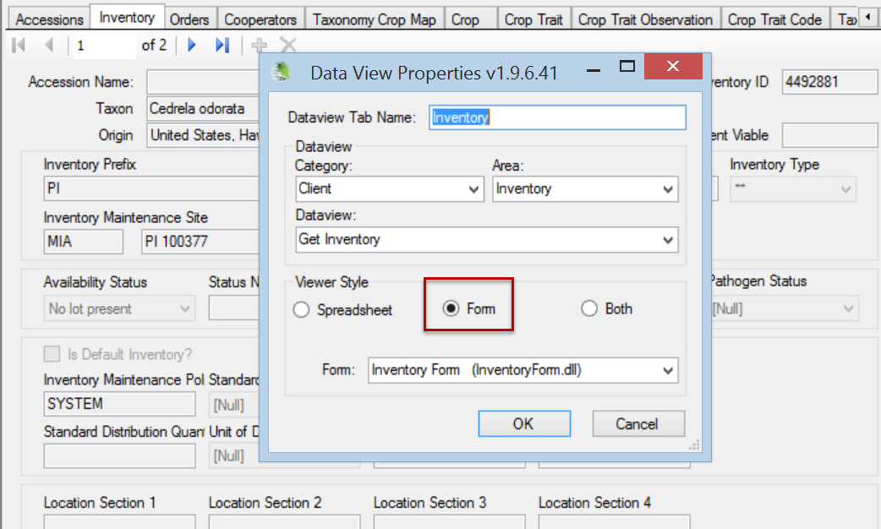
The Edit button is on the main CT window – not on the form.

The following graphic shows a list of the fields that comprise the main Inventory dataview. Most of the inventory dataview fields are explained in the following sections.
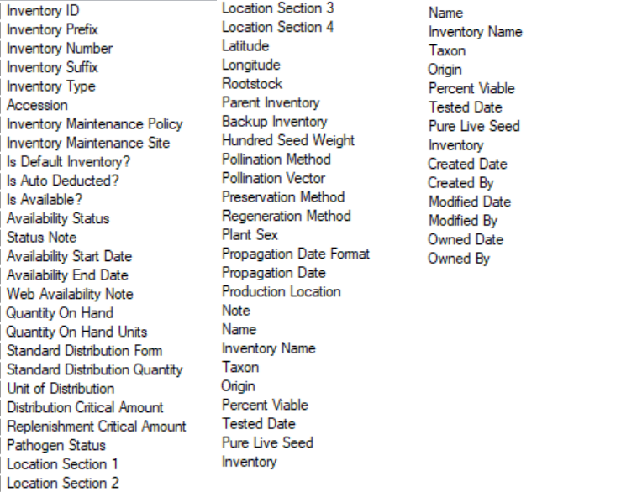
Use the vertical tab on the CT to display the dataview fields:
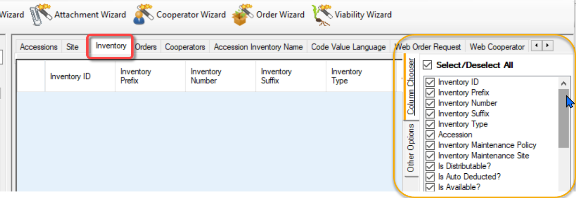
Not all Inventory dataview’s fields can be edited directly because they are either calculated fields or they are stored in the database in a table other than the Inventory table. In Edit mode, these fields are displayed with a gray color.

Each Inventory Record has a Parent Accession Record
Reading from top down, the diagram below is showing dependencies. An inventory record must be associated with an accession record. (Note also that the accession record references a valid taxonomy species.)
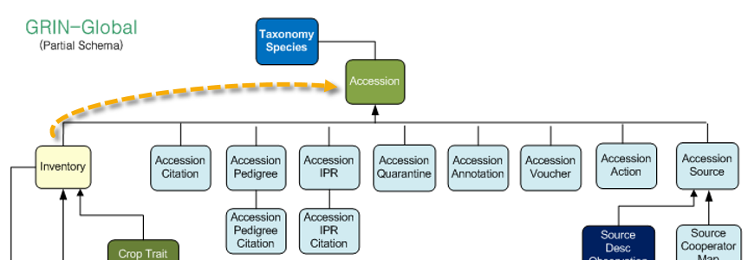

Inventory Dataview Field Details

Prerequisite Fields
Inventory records have five required fields. For example, when creating an inventory record, you must select an accession to which it is related. The five required fields are:
- accession
- inventory maintenance policy
- unique identifier (its inventory “name”)
- inventory type
- availability status – must be one of the INVENTORY_AVAILABILITY_STATUS Code Group values in the Code Value table.

Accession
Complete documentation is online at https://grin-global.org/docs/gg_accessions_and_passport_data.docx

Inventory Maintenance Policy
When creating a new inventory record, the Inventory Maintenance Policy field is a mandatory (required) field. In creating a new inventory record, the user selects a name of an IMP from a lookup window. This implies that you must have an existing Inventory Maintenance Policy record before you can save a new inventory record. For more details, review the Inventory Maintenance Policy section.
Think of the Inventory Maintenance Policy more as a template than a policy – it fills in some fields in a new inventory record. If you later change the policy, the CT does not adjust any existing inventory record data. However, the owner of the IMP is always the owner of the inventory record so a change in ownership of the IMP will affect the ownership of the inventory record. Also, the owner’s site is the Inventory record’s Maintenance Site.

Unique Identifier - Inventory Naming Conventions
Every genebank has its own considerations and typically develops genebank-specific naming conventions for its inventory lots.
In naming inventory, the Inventory Identifier consists of four fields:
- inventory-prefix
- inventory-number
- inventory-suffix
- type-code
The combination of the Inventory -Prefix, -Number, -Suffix, and Inventory Type must be unique in the database. Note that the Inventory Prefix, Number, and Suffix do not need to match (and often do not match) the Accession’s.

Type-code
These types use GG codes. The GERMPLASM_FORM Code Group stores this inventory type data. Many of the common form codes are often abbreviated: BD (Budwood), CT (Cutting), PL (Plant), and SD (Seed). Genebanks can determine what codes to use for their genebank. As with all codes used in GG, the GG administrator manages/updates the codes.

Naming Examples
Genebanks should develop standards for their inventory naming. Ideally the inventory identifier may provide some information intrinsic with the name. The following examples were created by several USDA genebanks.

Examples of Inventory Names (from National Plant Germplasm System (NPGS) Sites
Accession | Inventory
PI 554670 | CVAC 799 .000 SD and CVAC 799.001 PL – two inventory forms for this accession – one is seed (SD) and the other a living plant (PL)
PI 597892 | PI 597892 91ncai01 SD – the suffix, 91ncai01 is used in a very site-specific manner. Refer to the Inventory Suffix section in the Appendix for an elaborate example of using the suffix
GMAL 274 | GMAL 274 .a SG – the G is for Geneva, MAL for Malus. The 274 was a number assigned in a numeric order as the new variety came in. Suffixes with an .a or .b were germinated from an original seed lot. … SG is seedling

Partial View of the Inventory Dataview
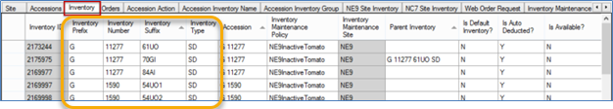

Inventory ID
ID fields are automatically assigned to all new GG records. The ID fields can never be edited or deleted. Basically, as a user, you rarely reference the ID field directly because it has no curatorial meaning.
However, the IDs are important in drag and drop operations where you may be taking data from a spreadsheet and updating existing inventory data in the Curator Tool. In that case, you always include the ID column. When updating, the IDs in the spreadsheet rows must match the existing inventory records’ IDs. (When adding new Inventory records, the spreadsheet cells for IDs must be empty.)

Inventory Prefix, Number, and Suffix
Each genebank should establish their own naming standards. An inventory does not necessarily need all three fields filled, but they usually are. More information…

Inventory Type
The Inventory Type is a dropdown field that gets its data from the code values stored in the GERMPLASM_FORM code group. You must select one of the entries. This ensures data integrity and prevents typos and other misspellings. (If a form type is needed, contact the genebank’s GG administrator can who add that type to the database.)
Inventory dataview (partial) | Inventory Type (dropdown)
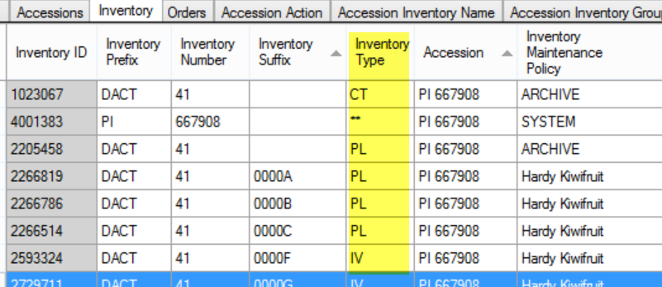 | 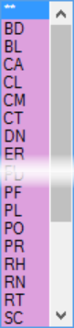

Using the GG Admin Tool, the GG administrator can add or edit the GERMPLASM_FORM code values to meet the needs of the organization. (The U.S. NPGS used two-letter codes in their GRIN system so the codes as shown here are a carry-over; however, an organization implementing GRIN-Global most likely will use more descriptive codes.)

Accession ID
Since every inventory record has a parent accession record, an accession ID must be selected from the accession lookup list:
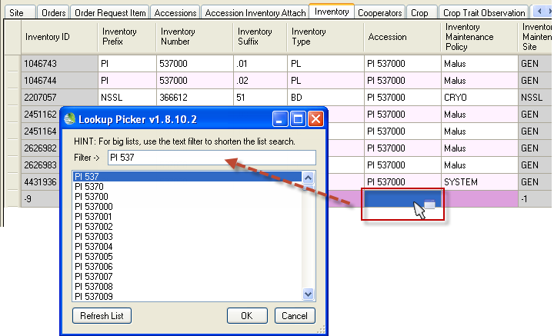
If the accession is not listed, it may be because the Accession Lookup table is not current. Maybe the accession was added immediately prior? If you know the accession exists but is not listed, update the Lookup Table. (Lookups are explained in detail: http://grin-global.org/docs/gg_lookups.pdf)

Availability and Visibility Fields
Users sometimes confuse two issues: an accession being displayed on the Public Website and whether the accession will be available for germplasm requests.
Several fields in the Accession and Inventory records relate to visibility and availability. Also, it is important to know what version of GRIN-Global your genebank is using, because older versions behaved differently – the idea of what inventory can be available has significantly evolved.
In older GG versions, it was only possible to have one inventory record per accession to be available at any point in time. Two “flag” fields, is_default? and is_available? had to both be set to “Y.” If either field is set to “N,” the accession was listed on the Public Website as “Not Available.” Review the Multiple Inventories Available and Seasonally Available section for details on more recent GG versions.
To indicate that another inventory was available, if some other inventory was considered available, it would need to be noted as unavailable and its record would need to be edited.
Table / Field Name | Field type | Impact / Effect
Acc. /  Is Web Visible? | Y / N | Public Website (PW) will display (or not), the accession on the Public Website
Acc. /  Status | Coded (Active, Inactive, Backup…) | If the Status Code is neither equal to ACTIVE or INACTIVE, the accession will not be listed in any search results. INACTIVE usually indicates this is a historic record – data exists, but no physical germplasm
Inv. /  Availability Status | Coded (Low, Available, Not Available, Dead…) | the value does not determine the availability on the PW. Can be confusing, because some genebanks use “Available” and “Not Available” as possible values. Serves more as documentation to the internal genebank staff.
Inv. /  Is Distributable? | Y / N | Would be better titled as “Is Distributable?” This flag field can be used to stop distributing for requests, even temporarily. For the inventory to be distributed, this field must be “Y”
Inv. /  Is Available? | Y / N | For the inventory to be distributed, this field must be “Y”

The PW examines the Inventory record to see if its two columns, Is Default? and Is Available? are set to “Y.” An inventory record with a value of 0 for its Quantity on Hand would be considered Available and the Cart link would display. This may or may not be the curator’s intent.

Multiple Inventories Available and Seasonally Available
In server release 1.10.4, released on 2019, March 9, a major change was made to allow more than one inventory lot for the same accession to be viewed as available on the Public Website. Beginning with this release, the inventory trigger allows one inventory lot (record) to be is_distributable (Is Default? = “Y”) for each inventory type.
Example: An accession can have both Seeds and Cuttings displayed as available on the Public Website.
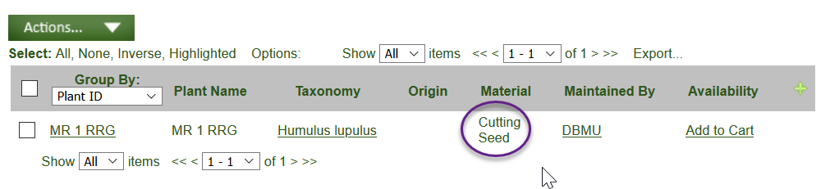
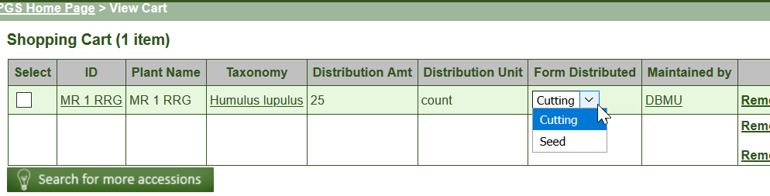
In GRIN-Global server version 2.1.0 (released June 19, 2021), a significant change was made to the Public Website – now users were able to request germplasm either by accession or by inventory. This change was primarily made to accommodate requests for clonal material.
In GRIN-Global server version 2.3.0 (released May 21, 2022), GRIN-Global was enhanced to have accessions seasonally available. By including a new table, Inventory Maint Policy Season, GG makes it possible to identify start and ending dates when a specific inventory form is available. If the user is using the PW during that period, germplasm inventory is listed as available. Outside of the period, the inventory is listed as unavailable. For more details, refer to the online document, http://grin-global.org/docs/gg_inventory_seasonal_availability.docx

Is Auto Deducted?
When Is Auto Deducted? = “Y” and the Availability Status value equals “Available,” a trigger will set the Availability Status (availability_status_code) value to “Low Inventory” when the qty on hand goes below the critical distribution qty. The GG AutoDeduct trigger ignores any other status codes..
When it can, the Order Wizard in the Curator Tool automatically selects an inventory lot to fill the order. As mentioned, the inventory must have both fields (Is Default Inventory? and Is Available?) set to “Y.” What happens when multiple inventory lots potentially could fill the order? The database software uses its internal rules to highlight one of the possible inventory choices.
The genebank staff person using the Order Wizard can override the default choice and manually select another inventory lot from the list. In the Order Wizard’s Inventory Picker window, the user can select a different row in the grid, or input information in any of the three boxes: (Accession Number, Accession Name, or Taxonomy).
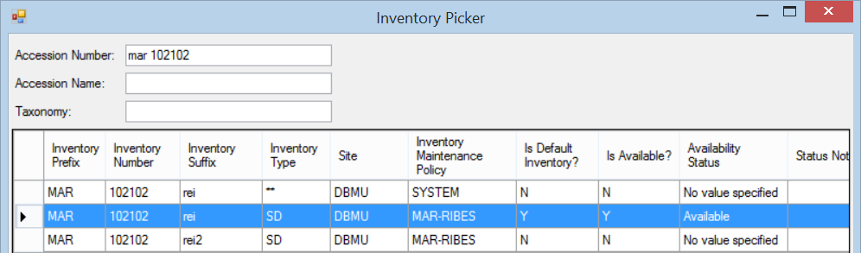

Inventory Maintenance Policy
An inventory record has many fields. When creating a new inventory record, the Inventory Maintenance Policy field is a required field.
When creating a new inventory record, the user selects a policy from a lookup window:
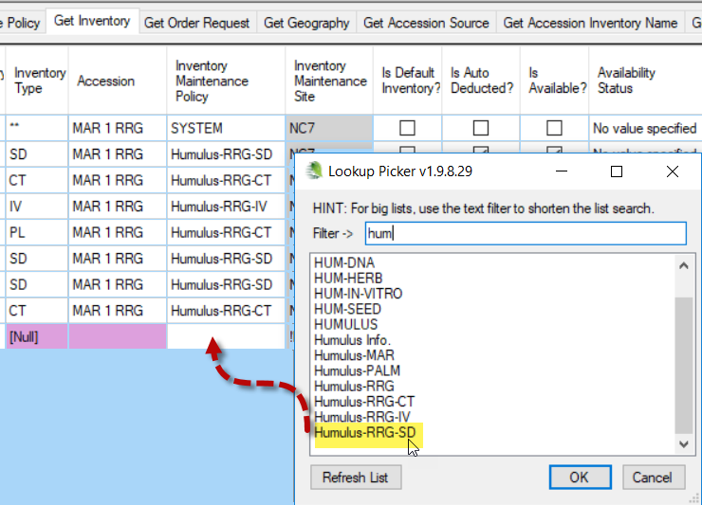
The policy selected will then serve as a partial template for the new inventory record. When an inventory record is being created, many of its fields can be left empty and when the record is saved, matching fields from the selected policy fill in the new inventory’s corresponding fields.

Think of the Inventory Maintenance Policy as a template – it is used to fill in some of the fields in a new inventory record. If you later change the policy, the CT does not adjust any existing inventory records. However, the owner of the IMP is also the owner of the inventory record.

An Inventory Maintenance Policy record (shown here with the red letters) will fill in the respective fields in the new inventory record when the inventory record is saved.
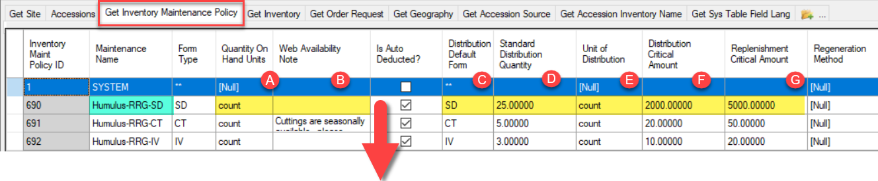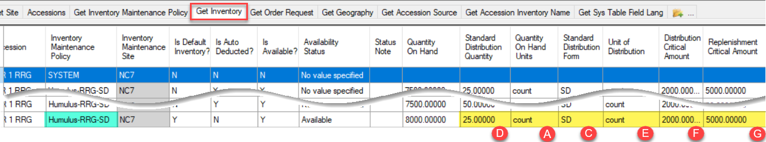
(Web Availability Note not shown in the second graphic, but that field would be empty in this example since the corresponding policy has an empty Web Availability Note field.) Also, the Is Auto Deducted field does not carry over to the new inventory record.

Fields manually entered later in the Inventory record, after the new inventory record has been created, overlay the policy’s corresponding fields.
After the inventory record has been created, its related Inventory Maintenance Policy has no further impact on the inventory record, (but that change might impact the PW display, as explained in the next paragraph). If an existing Inventory Maintenance Policy is changed later, any changes made to the Inventory Maintenance Policy record do not change related existing inventory records.
However, in one scenario the maintenance policy can still impact the record’s Public Website display. When the Web Availability Note field in an inventory record is empty (null), the Public Website displays the Web Availability Note from the related Maintenance Policy record. If a curator were to delete a web availability note from an inventory record and the related inventory policy record had a web availability note, the policy’s note would then display in the PW.
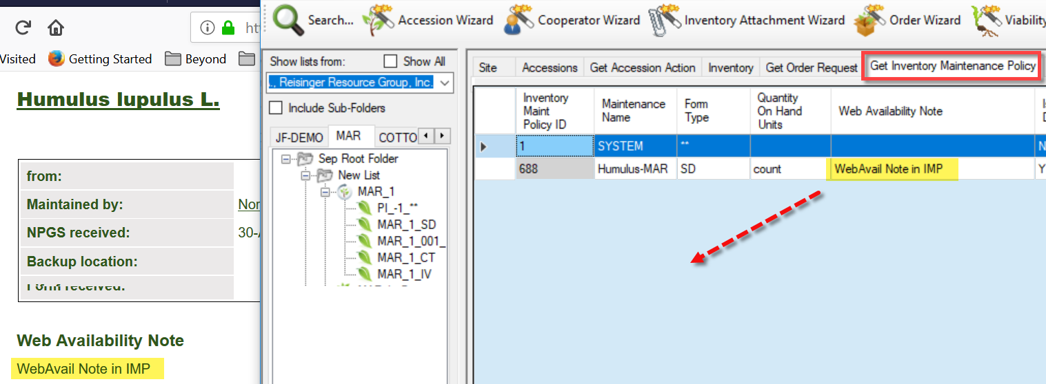
This inventory record has its own unique note, so the note from the policy is no longer displayed on the PW.
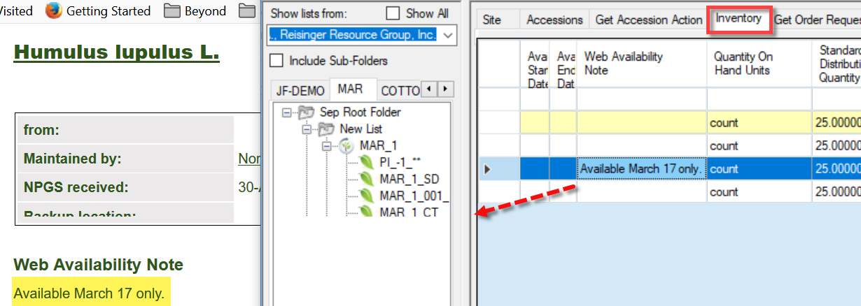

If the inventory record is edited and its note removed, the note from the related policy now displays in the PW:
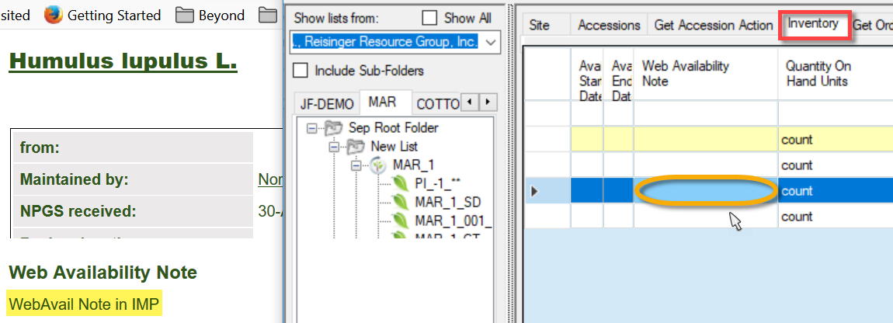

Inventory maintenance policies are created and used by the sites responsible for maintaining the germplasm. A site typically will have many policies, used for applying to various taxa or germplasm types.
Inventory Maintenance Policies can be shared across the organization, but the owner of the Inventory Maintenance Policy record determines the owner of the inventory record. Therefore, it is important that a site use appropriate Inventory Maintenance Policies. (When an organization has only one site set up, this is a non-issue.)
Since the creator of an inventory record will not be its owner when the applied policy is owned by someone else, permissions may need to be set up to allow the inventory creator to also be able to update the record. (Refer to the Curator Tool User Guide Security section for details on changing permissions.)

Policy Naming Examples
One site uses the following convention:
Policy Name | minimum acceptable germination percentage | qty viable seeds used for regeneration | qty of seeds for the distribution amount
NGB_85_100_10 | 85 | 100 | 10
NGB_85_250_250 | 85 | 250 | 250
The name is automatically added to the generated “picking lists” for the seed lab.

Some consistently begin the policy name with the site code and then the crop, such as:
- NE9-Buckwheat
- NE9-Celery
- NE9-Hemp
- NE9InactiveAsparagus
- NE9InactiveBrassica
- NE9InactiveBuckwheat
- NE9InactiveCelery
- NE9InactiveMisc

Purpose of the Inventory Maintenance Policies
Basically, an inventory maintenance policy determines how inventory will be processed for incoming germplasm orders that will use that inventory. The policy indicates the germplasm form to be distributed and other parameters, such as the quantity to be distributed. The policy sets defaults for several inventory columns that would be tedious to remember when entering individual inventories:
- the standard amount of germplasm to be distributed (the default units and type – e.g. 50 grams of seed)
- critical replenishment and distribution levels
- the Web Availability Note – the maintenance policy will insert this note on every new Inventory record.
- the read-only Inventory Maintenance Site field. This field is populated when the inventory record is saved – it is the site of the curator specified by the Inventory Maintenance Policy.
- when creating a new Inventory record, the owner of the Inventory Maintenance Policy becomes the owner of the Inventory record
In the CT, use the Inventory Maintenance Policy to filter records. In the Search Tool, find the policy name in the Inventory Maintenance Policy dataview, and then drag that code to a folder in the Curator Tool. Examples of this are shown in the online document https://www.grin-global.org/docs/gg_grouping_summary.docx
The following fields can be defined when creating or editing an Inventory Maintenance Policy record:
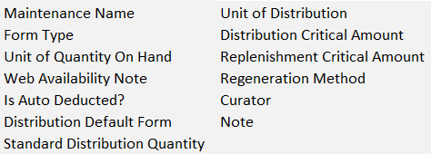
Several fields in the IMP do not carry over when creating new Inventory records: Is Auto Deducted?, Regeneration Method, Curator, and Note.

Fields common to both Inventory Maintenance Policy and Inventory records

Maintenance Name
An Inventory Maintenance Policy’s name is selected for all new inventory record’s Inventory Maintenance Policy field.

Form Type
The default form for the Inventory Maintenance Policy.

Quantity On Hand Units
The units used for the quantity on hand. Must be one of the UNIT_OF_QUANTITY Code Group values in the Code Value table. Examples: counts, cuttings, grams, packets.

Distribution Default Form
The default form for distributions of this inventory sample. Must be one of the GERMPLASM_FORM Code Group values in the Code Value table. Examples: Budwood (BD), Cutting (CU), DNA (DN), Seed (SD), Tuber (TU).

Standard Distribution Quantity
The default distribution quantity for this sample. This field may have been populated by the related Inventory Maintenance Policy (if the policy has a default distribution quantity). Otherwise, the field can be manually entered in the Inventory record.

Unit of Distribution
Examples: count, cuttings, grams, packets. The typical (default) unit by which orders are filled. Must be one of the UNIT_OF_QUANTITY Code Group values in the Code Value table.

Distribution Critical Amount
The “Quantity On Hand” should be greater than this quantity; if not, the germplasm should not be distributed until inventory is replenished.

Replenishment Critical Amount
If the “Quantity On Hand” is less than the Replenishment Critical Amount, then the accession needs to be regenerated. This inventory record field may be populated by the related Inventory Maintenance Policy or manually entered.

Web Availability Note
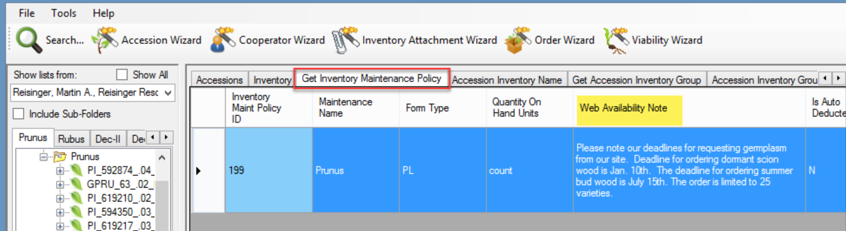
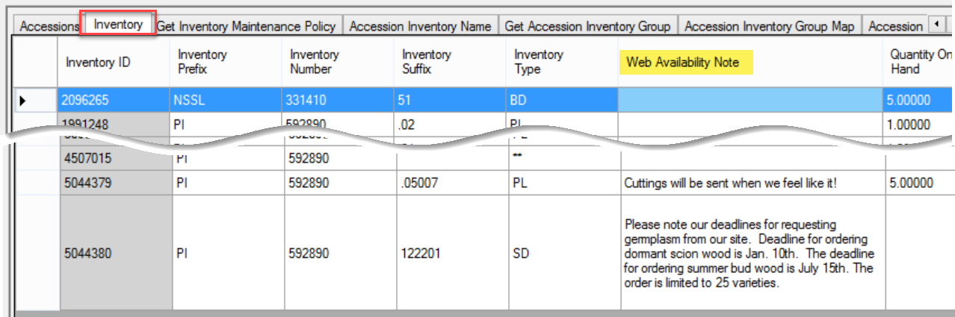
Public Website: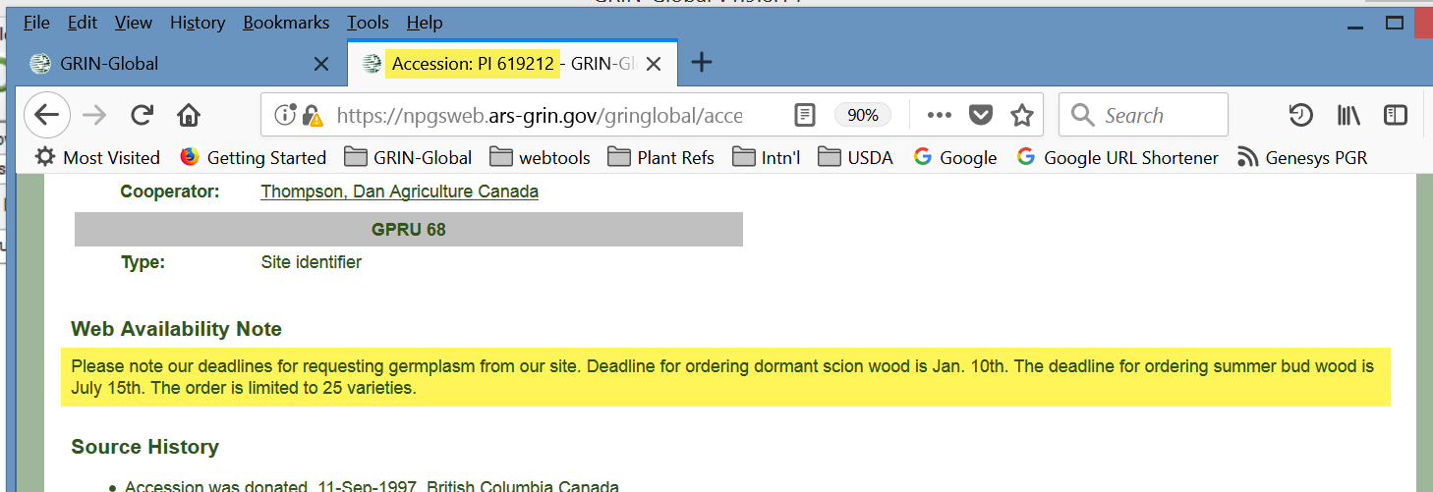

Web Availability Note
The Inventory Maintenance Policy will insert this note on every new inventory record; however, the note can be manually overridden. Use this note to display on the web information about the accession’s availability. For example, curators may include seasonal availability information.
This note will display on the Accession’s detail page in the Public Website when the default inventory records has the note text in the field; otherwise the Public Website displays the note from the related IMP.
Under Availability, the Public Website sometimes displays “Contact site.” 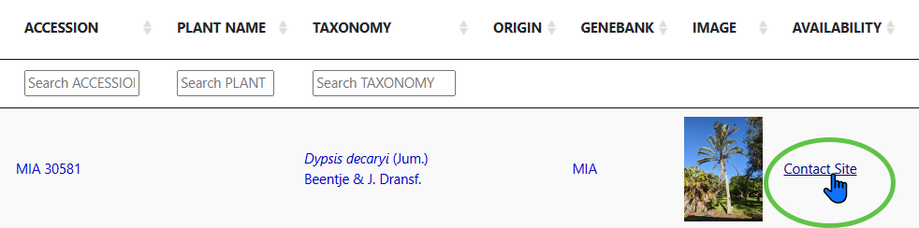
Usually this occurs because the taxon is regulated, such as by CITES listed species. When someone wants to request material, the genebank staff would need to evaluate whether the regulation applies, since there are two stated exemptions: All parts and derivatives, except:

- seeds
- seedling or tissue cultures obtained in vitro, in solid or liquid media, transported in sterile containers

Pollen would be regulated, as is leaves and other parts. CITES regulations apply worldwide. GG doesn’t have a way to make different form types available because form type selection wasn’t an option when the regulations were programmed.

Inventory Maintenance Policy’s Impact on Orders
The Inventory Maintenance Policy is especially useful when orders are filled. The Order Wizard applies the fields in the policy for the inventory that is assigned to the order. When processing orders, genebank personnel can always override the defaults specified by the policy “rule.” For example, a policy can be established to indicate “each order for Maize accessions will receive 50 seeds” or, alternatively by weight (“each order will receive 5 grams of seeds”). If the curator or order filler decides that the order will get 100 seeds or 10 grams, he can override the default.
Also, the Curator specified by the policy will receive an email when a web order has been submitted that is requesting inventory based on that policy.

Adding Inventory Maintenance Policy Records
Inventory Maintenance Policy records are added in the Curator Tool via the Inventory Maintenance Policy dataview.
An organization can create as many maintenance policy rules as needed for its unique situation and assign each inventory maintenance policy a Maintenance Name in the Inventory Maintenance Policy data view. Sites can copy an existing policy, modify it to suit their specific needs and then save the policy under a new name.
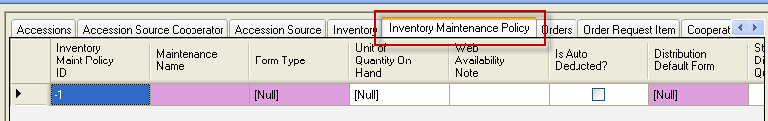
The Inventory Maintenance Policy determines the owner of the Inventory record – the cooperator in the inventory_maint_policy.owned_by field becomes the owner of any Inventory records that are created with that policy. (This is one reason why each site should establish their own policies.)
When naming your policies, use a consistent naming convention. For example, begin with a prefix, such as your site’s code. Examples: NC7-daucus, NC7-portulaca, NC7-quinoa... You can then search for your policies by specifying the prefix in your search criteria:
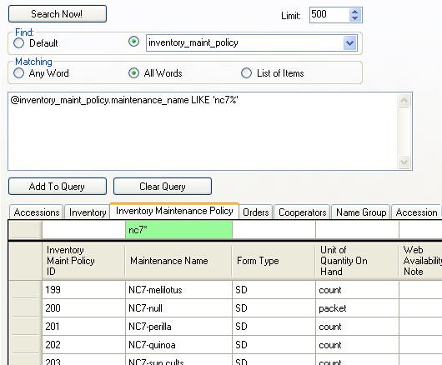

Availability Status Trigger
A trigger exists that uses the Availability Status field. When the Is Auto Deducted? field is set to “Y,” and the Availability Status is “Available,” the trigger will operate when the CT’s Order Wizard is used to fill a germplasm request. The inventory record’s Qty on Hand is reduced by the quantity distributed. If the calculated quantity goes below the Distribution Critical Quantity, the status field changes to “Low.”

Availability Status
The Availability Status field obtains its values from the INVENTORY_AVAILABILITY_STATUS Code Group. By searching this field, you can look for specific inventory situations, such as low inventory, young plants not available, etc.
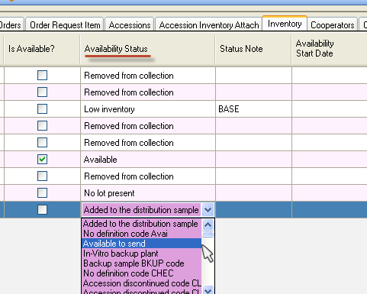
In the Search Tool, Availability Status codes enable searches for a particular group of records, based on a common status.
In the following example, the amount being distributed takes the Inventory level below the Distribution Critical Amount:
Fields | Value Before | Action | Value After
 |  | Order is Filled (standard quantity is shipped)
Quantity on Hand | 80 |  | 70
Standard Distribution Quantity | 10 |  | 10
Distribution Critical Quantity | 75 |  | 75
Is Auto Deducted? | Y |  | Y
Availability Status | Available |  | Low
Is Available? | Y |  | N

Is Auto Deducted?
This TRUE/FALSE flag indicates whether the Quantity On Hand amount is debited when the order item for this sample is shipped. Also, when set to “TRUE,” this field controls the Is Available? field (see Is Available? below).

Is Available?
This is a TRUE/FALSE flag indicating whether the inventory is available for distribution. When the Quantity On Hand becomes less than the Critical Amount, the Is Available? field is set by the trigger to "N," that is, the inventory record’s is marked as unavailable. Also, the Availability Status field, if it had been set to “Available,” will be set by the trigger to “Low inventory.”

Status Note
Use this field to store general remarks and comments on the inventory’s availability status.

Is Distributable?
This is a TRUE/FALSE flag indicating that this inventory sample is (or is not) the preferred lot for distribution. Genebanks typically use this field to indicate that this inventory should be distributed first whenever the accession has multiple inventory lots available for distribution.
GG now has significant differences in the various releases regarding this field. Review the Multiple Inventories Available and Seasonally Available section.

Availability Status
The Availability Status field is a required field that was described earlier in this document. (See Availability Status.)

Availability Start and End Date
These fields only serve as comment fields and do not impact anything. A curator may use them as a reminder for when the inventory is typically available. Not used with seed inventories, but more so with cuttings and plants. However, in GG version 2.3.0 (released May 21, 2022), GRIN-Global was enhanced to have accessions seasonally available.
By including a new table, Inventory Maint Policy Season, GG makes it possible to identify a start and ending date in a calendar year when a specific inventory form is available. For more details, refer to the online document, http://grin-global.org/docs/gg_inventory_seasonal_availability.docx

Other Inventory Fields

Inventory Maintenance Site
When adding a new inventory record, the Inventory Maintenance Site is read-only (indicated by its gray color). The site is determined by the site of the owner of the Inventory Maintenance Policy (IMP) record. If the IMP is changed at a later date, all existing inventory records will now be owned by the owner of the IMP record and the Inventory Maintenance Site will reflect the owner’s assigned site.

Quantity On Hand
The amount of germplasm on hand for an inventory sample – the total amount of germplasm stored in the genebank. For example, this may be the number of seeds in cold storage or number on in-vitro cultures.

Pathogen Status
The inventory sample’s pathogen status. The value must be one of the PATHOGEN_STATUS Code Group values in the Code Value table. Examples: FREE, INFECTED, TESTED.
Only the GG administrator can edit or add codes to any of the Code Groups. She uses the GG Admin Tool to do so.

Locations Section 1…4
Four fields can be used to specify the location of an inventory sample. The four location fields can be used to reference the seed storage location such as [Room] [Row] [Rack] [Storage type]. When storing clonal germplasm, the locations may be used to refer to [Orchard] [Block] [Row] [Tree]. Any of the columns can be used or kept blank.

Production Location
This field was added in server release 2.3.1 to the Inventory table. It can be used to capture the geography (Country, State, etc.) information about where each specific inventory lot was grown, maintained, or produced. This field simplifies identifying where the inventory lot was grown (or for clonal plants, where they are physically being propagated).

Latitude and Longitude
Can be used to tag the location of trees in orchards or can also be used for ex-situ samples.

Rootstock
The grafted rootstock used to propagate the inventory.

Parent Inventory
The inventory key field linking this current inventory sample to its parent inventory. For a complete description, refer to the Regenerating Inventory section.

Backup Inventory
The inventory key field linking this current inventory sample to a backup of the inventory at a secondary site.

Hundred Seed Weight
The weight of 100 seeds from the inventory sample.

Pollination Method
The pollination method used to regenerate the inventory. Must be one of the INVENTORY_POLLINATION_METHOD Code Group values in the Code Value table.

Pollination Vector
The pollination vector used during the regeneration of the inventory. Must be one of the INVENTORY_POLLINATION_VECTOR Code Group values in the Code Value table.

Preservation Method
This field links to a method in the method table.

Regeneration Method
This field links to a method in the method table.

Plant Sex
Must be one of the INVENTORY_SEX_CODE Code Group values in the Code Value table.

Propagation Date
The date you take cuttings (or plant seed if you wish to use it for that purpose).

Propagation Date Format
The date format. Must be one of the DATE_FORMAT Code Group values in the Code Value table. Examples: MM/DD/YYYY, MM/YYYY, PRE YYYY.

Note
General remarks about the inventory. As with all GG “Note” fields, not displayed on the Public Website, but used primarily for internal comment purposes.

Name
The plant name ("top name") assigned to the accession whose plant_name_rank has the lowest value.

Taxon
(Read-only) The internal species identifier which indicates the taxonomy of the accession.

Origin
(Read-only) The geography key field showing where the accession was collected, developed or donated. Links to the accession_source table.

Percent Viable
(Read-only) This is a calculated field for the latest viability testing record. You can go to the rule in the viability table to find out how it was done when a rule is indicated.

Tested Date
Date of the latest viability test.

Inventory
(Read-only; calculated field) Combines the four components of the Inventory key field into one field. This is useful for the bulk adding of child records under a parent inventory. For example, when adding accession action records, you need to include the Inventory field (the combined four fields (Inventory
–Prefix, –Number, –Suffix, and –Type).

Pure Live Seed and Percent Viable
Prior to the release of server release 1.10.6 (January 25, 2020), the get_inventory dataview was unable to query on calculated fields such as Pure Live Seed and Percent Viable. This was resolved by creating a database view for inventory-related calculated fields and making use of that for non base table fields in the get_inventory dataview. Nine fields are now handled differently in the get_inventory dataview and can be used in searches: site_id, taxonomy_species_id, geography_id, plant_name, inv_name, percent_viable, tested_date, pure_live_seed, and inventory_id_string.

Inventory Dataviews in the Accession_Inventory Area

Names
Since names can be assigned to either individual inventory lots or to the accession in general, the “names“ dataview is stored under the Accession/Inventory area.
When defining a name, the user associates the name with an inventory record. Notice in the following screen, the Accession field is grayed out and is therefore a read-only field:
When the Name record points to the system inventory record (the type code is **), then the name is associated with the accession, not a specific inventory lot. In the following example, two names have both been applied at the accession level. In this example, the “PlainV” name (with the lowest Name Rank field) is considered the top name:
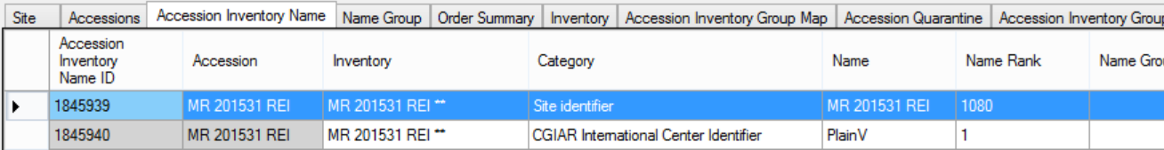
Refer to the Accession Names section in the Accession and Passport Data guide for a detailed explanation of names, including the topics of “top name” and name ranking.
RankCategory.Add("CULTIVAR", 10);
RankCategory.Add("UNVERIFIED", 20);
RankCategory.Add("LOCALNAME", 30);
RankCategory.Add("CGIAR", 35);
RankCategory.Add("INSTITUTE", 40);
RankCategory.Add("DEVELOPER", 50);
RankCategory.Add("DONOR", 60);
RankCategory.Add("COLLECTOR", 70);
RankCategory.Add("EXPLOREID", 150);
RankCategory.Add("PLOT", 140);
RankCategory.Add("TRANSLATION", 75);
RankCategory.Add("SITE", 80);
RankCategory.Add("QUARANTINE", 90);
RankCategory.Add("OTHER", 100);
RankCategory.Add("DUPLICATE", 110);
RankCategory.Add("MISIDENT", 120);
RankCategory.Add("TRADEMARK", 130);

Name Groups
To create a Name Group, use the get_name_group dataview (currently in the Accession area); add records (supply a Group Name):
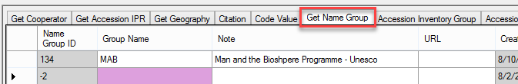
The only required field is the Group Name.

How to Associate an Accession with a Name Group
Use the Accession Wizard (Names tab) or use the get_accession_inv_name dataview. (You must use the dataview if the Name Group pertains to physical inventory (not the system inventory record).
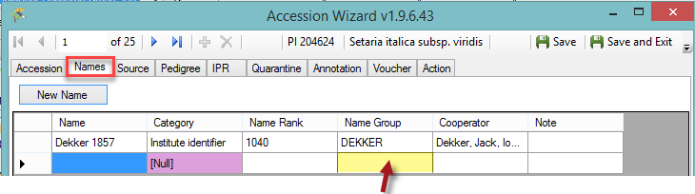
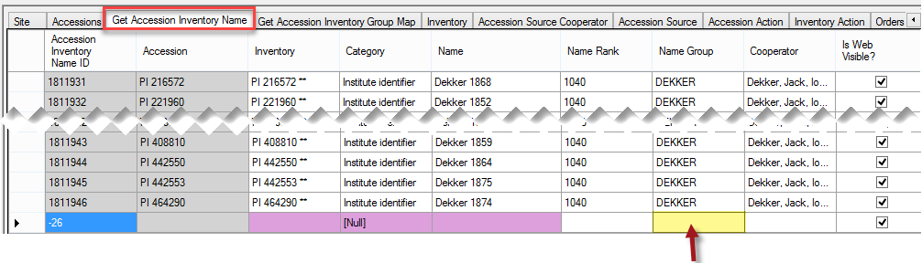

Accession Inventory Groups
Dataview displays the inventory group names used to aggregate accession and inventory records into groups -- optional, but a useful method for searching and working with accessions grouped for a specific purpose. Under Advanced Search, the accession groups can be found on the Public Website by searching for the group.
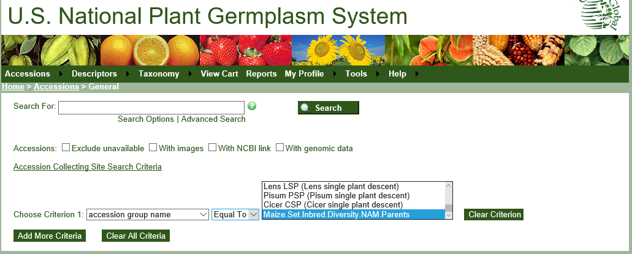

Create Accession Inventory Groups
Use the get_accession_inventory_group dataview; add records (supply a Group Name; indicate if Web Visible or not):
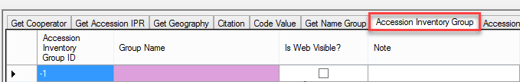

Accession Inventory Group Map
Dataview which accesses the GG accession_inv_group_map table which makes it possible to have many-to-many relationships between accessions and inventory records with the groups.

How to Associate Accessions with Accession Inventory Group
Use the Accession Inventory Group Map dataview; add records:
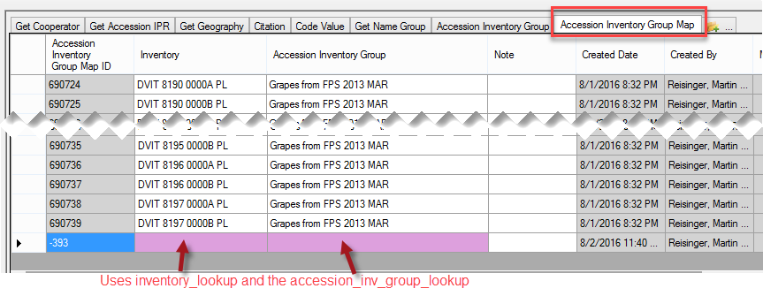

As you can see from the above topics on groups, there are two groups:
- get_accession_inventory_group “Accession Inventory Group”
- get_name_group “Name Group.”
The following table compares them:
 | Accession Inventory Group | Name Group
Dataview Title | Get Accession Inventory Group | Get Name Group
Dataview Name | get_accession_inventory_group | get_name_group
Database Area | Accession / Inventory | Accession
Create the Name by… | using the get_accession_inventory_group dataview; add records (supply a Group Name; indicate if Web Visible or not) | using the get_name_group dataview; add records (supply a Group Name)
Associate records by… | using the accession_inv_group_map table | completing the Name Group field in the Accession_Inv Name records;
Group is available for Web Searches | Yes; using the Advanced Search Criterion: “accession group name” | No
Recommended Uses: | - set up groups of accessions which can be found on the PW as a group (and ordered) | - Name Group groups plant names. An accession inventory name can belong to just one group, so the group usually refers to the source of the name or identifier

Annotations
Dataview displays fields from the accession_annotation table (verifications, official taxonomic name changes, re-identifications and received as) related to the taxonomic names for each accession.

Attach(ments)
The get_accession-inventory_attach dataview links images and/or documents to inventory. A new Inventory Attachment wizard was included with Curator Tool release 1.9.8.14, (released in late 2017), This is fully documented in a separate document. See: https://www.grin-global.org/docs/gg_inventory_attachment_wizard.docx Documentation for the attachment wizard used in Curator Tool releases prior to …14 is included in the Curator Tool User Guide.

Voucher
Dataview accesses the table of herbarium vouchers for accessions or inventory samples. A voucher is a herbarium specimen used to document a taxonomy. The voucher record holds the information on that herbarium specimen -- what accession/lot it applies to, location of the specimen, etc.
(A herbarium is a collection of plant specimens (vouchers) arranged systematically…) A herbarium specimen is used to represent as many parts of the plant as possible including leaves, bark, flowers and fruits (seeds). (A note for NPGS Users: The accession voucher table only holds herbarium samples now so there is no need for a voucher type. The other vouchers in GRIN (images, links) are handled in the inventory attachment table.)

Inventory Actions
The inventory_action dataview refers to the actions performed on the inventory while it is at a repository (genebank). Actions can be used to indicate the initial receipt of the material, verification, transfer, back-up, regeneration, repackaging, etc. The inventory action records provide a history and a means for tracking any activities regarding the inventory lot. Recording these actions consistently across the genebank is invaluable. You can document workflow and make it easier for all to determine the inventory’s current status.
In some cases, the inventory action record may hold partial information about an event before the final results are obtained, such as a germination test or pathogen test. The actions are very helpful in documenting the workflow.
The dataview uses INVENTORY_ACTION codes which the GG administrator can edit or add as needed to meet an organization’s practices. The Codes’ Titles display in the dropdown for the Action Name:
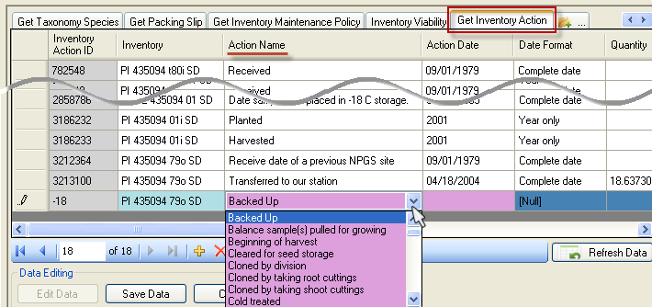
Ideally an organization will review and agree on a set of inventory action codes and edit the default set provided when GRIN-Global is installed. (As with all codes stored in the GG code groups, the GG administrator handles the actual editing and inputting.)

Examples of Inventory Actions
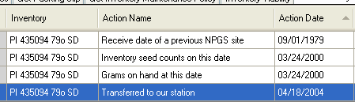
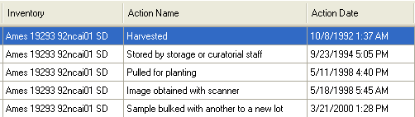
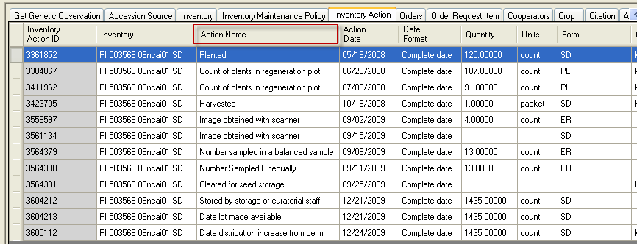
Besides the inventory actions dataview, there is also an accession_action dataview which generally displays data pertaining to actions performed on an accession. Accession actions in GRIN (Classic) were created not only for actions done on an accession as a whole, but to keep information on how the accession was being handled, treated, documented, etc.
The accession_action data evolved from the inactivation process where there is a need to document that the accession died, include details, but not display the details to the public. In the NPGS, the use of accessions actions has also been used to document the passport review process which is difficult to do in one sitting, but can be done over time. The actions can be used to indicate what has and has not been reviewed.

Inventory Actions Fields

Fields
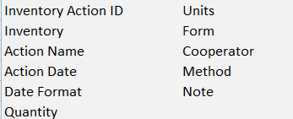

Required Fields
- Inventory
- Action Name
- Action Date
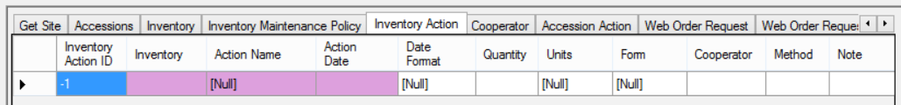
Refer to the online dictionary for complete field definitions.

Inventory Quality Status
The Inventory Quality dataview uses the pathogen tests table which stores the results of pathology tests for an inventory sample. These results can be either individual test results or summary results from a group of tests.

Fields
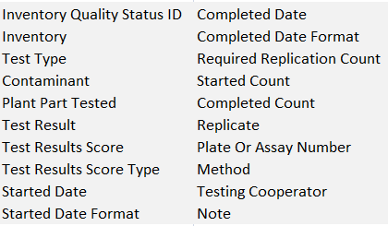

Required Fields
- Inventory
- Test Type (uses the PATHOLOGY_TEST_TYPE Code Group)
- Contaminant (uses the PATHOLOGY_TEST Code Group)
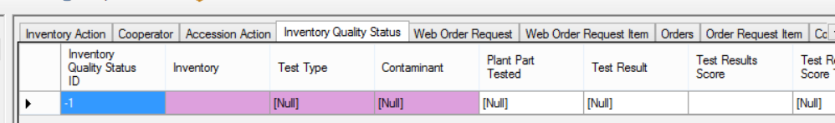
There are five dropdowns used by the Inventory Quality dataview. These dropdowns use codes stored in the Code Groups (maintained/edited by the GG administrator for the organization):
- PATHOLOGY_TEST_TYPE
- PATHOLOGY_TEST
- GERMPLASM_FORM
- PATHOLOGY_TEST_RESULT
- PATHOLOGY_TEST_SCORE_TYPE
If any pathology-test related codes are not in the database, contact the GG administrator to include them.

Viability Testing

Viability
Viability testing is typically done when:
- a new seed sample arrives at a genebank (and the sample has enough seed to be germinated)
- newly regenerated seed samples are being prepared for storage
- periodically to assure viability of seed lots (“maintenance testing”)

Viability Wizard and the Viability Dataviews
The Inventory Viability dataview uses the table of seed germination results and other viability tests. There are three related dataviews in the Curator Tool: Inventory Viability, Viability Rule, and Viability Data.
The GRIN-Global Viability table family has several interrelated tables:
A Viability Wizard was added to the Curator Tool to automate the process of aggregating the raw viability testing data stored in the viability_data dataview. Refer to the online document for details: https://www.grin-global.org/docs/gg_viability_wizard.docx
This Viability Wizard was not available in the Curator Tool builds up through version 1.9.6.43. Many genebanks opt to track viability using spreadsheets or other external tools. They then bulk add the viability data later into GG.

Inventory Viability Dataview
Refer to the GG online dictionary for descriptions of each field (or when viewing the dataview, roll the mouse over the heading to display the column description).
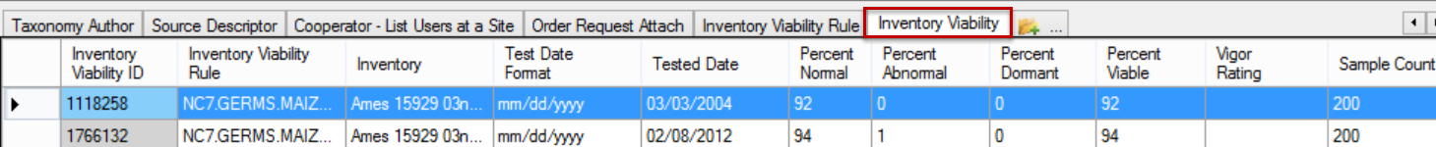
The Inventory Viability table aggregates the results of inventory tests. The raw data collected in each viability test replicate is stored in the Inventory Viability Data table. The Inventory Viability wizard automates the aggregation of the raw data.
Note: some genebank’s using GRIN-Global store their data in the corresponding viability tables, but may opt for a different method of collecting the data, rather than use the GG Viability Wizard. For instance, one Genebank uses a macro driven spreadsheet to collect and store its raw test data.

Germination Tests
Germination tests are conducted for different purposes such as in preparation for storage after a harvest or ongoing (maintenance).
For storage germination tests, a germination order is prepared when all the lots in a particular crop are ready for storage. This is usually done once a year after the material has been cleaned and is ready for storage (i.e. all the cucumber that were grown in 2014 will be germinated all at the same time – after which they are ready for storage).
For maintenance germination tests, a germination order is usually prepared after reviewing a particular collection (such as maize) and checking which lots need testing (in the case of maize, it is every ten years). See the Pure Live Seed section.

Viability Rule Dataview
The Inventory Viability Rule describes the germination test conditions including the temperature range, the moisture, lighting, etc. (Note to GRIN users – in GRIN, this was the Environment name.)
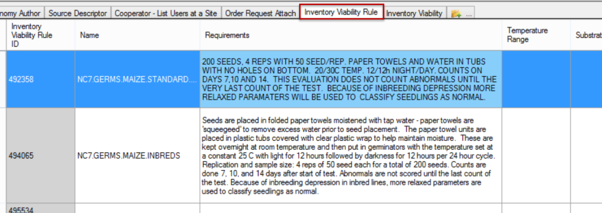

Pure Live Seed (Calculating Live Seed by Using Germination Test Rates)
In server release 1.10.3, a calculated field was added to the Inventory dataview. The calculation is derived by multiplying the quantity on hand with the latest germination percentage to get “pure live seed” (the actual number of viable seed propagules).
For example, if you have 1000 seeds and the germination test says 50%, then you only have 500 seeds that are viable.
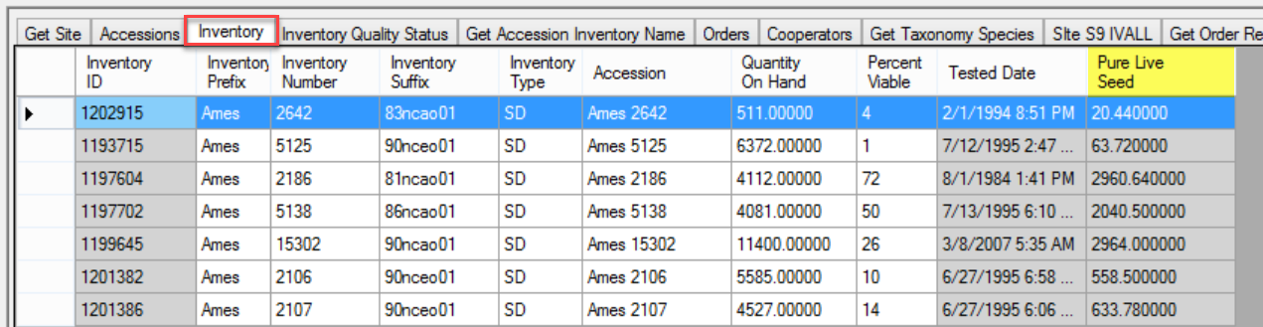

In the following example, at first glance it appears that these inventory lots have a Quantity On Hand that is sufficient, that is, greater than the Distribution Critical Amount:
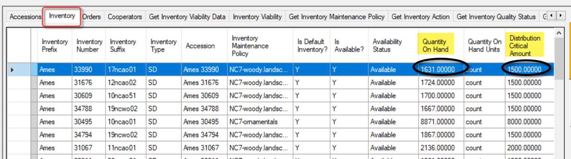
However, looking further (and scrolling to the right), the amount of viable seed may be less than the Distribution Critical Amount:
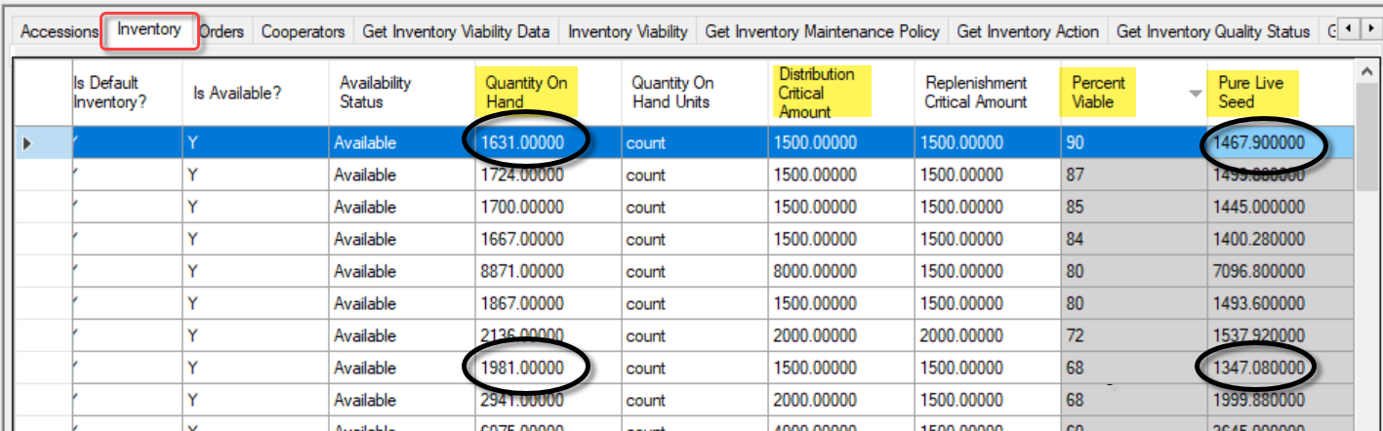
The inventory lot’s most recent viability test had results of 90% viable. The Pure Live Seed (the “viable” seed), is a calculated field, and in the two cases circled for illustration, you can see that the Pure Live Seed quantity is less than the desired Distribution Critical Amount, even though the Quantity On Hand is greater.
The following code can be used in the Search Tool to identify lots with viable seeds in quantities less than the Distribution Critical Amount:
WHERE inventory_number_part1 = 'Ames'
AND quantity_on_hand > regeneration_critical_quantity
AND @inventory.is_distributable = 'y' AND @inventory.is_available = 'y'
AND
@vc_inventory.pure_live_seed < @inventory.distribution_critical_quantity

In my example above, I used the Prefix “Ames” to filter from all of the “Ames” inventory records in the database. But other criteria could be included. One useful technique is to filter by a specific Inventory Maintenance Policy, such as in the following example:
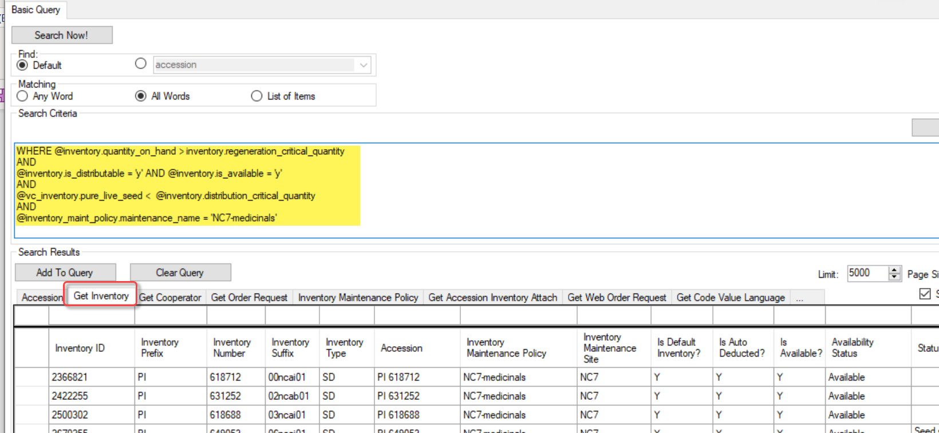
The code above:
WHERE @inventory.quantity_on_hand > inventory.regeneration_critical_quantity
AND
@inventory.is_distributable = 'y' AND @inventory.is_available = 'y'
AND
@vc_inventory.pure_live_seed < @inventory.distribution_critical_quantity
AND
@inventory_maint_policy.maintenance_name = 'NC7-medicinals'
In the query above, 13 inventory lots were identified as having quantities of viable seeds that were less than the desired distribution quantities.
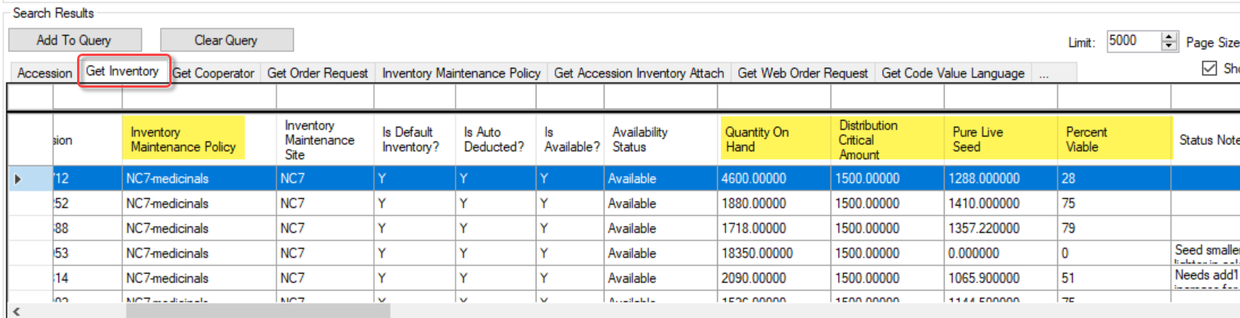

Pathology Testing
The pathology information goes in the Inventory Quality Status dataview – the dataview also holds the GEO (Genetically Engineered Organism (“GMO”) data.
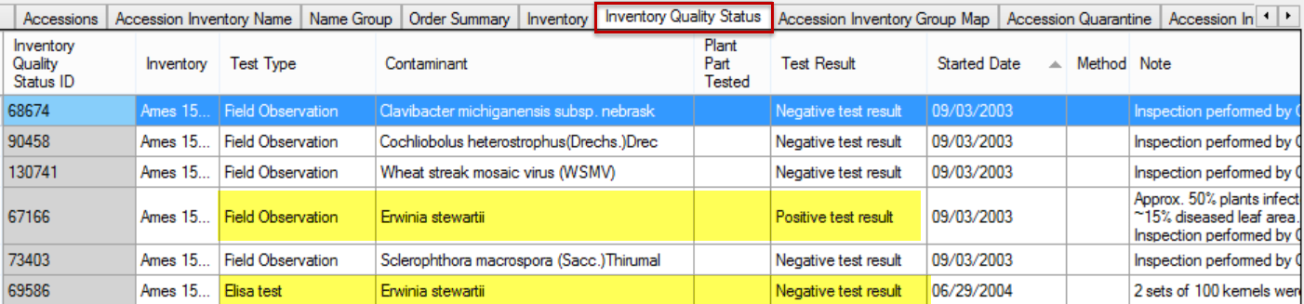
In the above example, two highlighted records are for the same inventory lot. The first record shows that the field observation was positive for Stewart’s Wilt, but then the ELISA lab test was performed and demonstrated that the lot was clear and suitable for exportation.

Regenerating Inventory
In planning for seed regeneration, site manager/curators consider population size, method of pollination, compatibility factors, presence of seed-borne pathogens or pests, susceptibility to indigenous pests, and risks of gene flow or other factors that complicate efforts to maintain germplasm true-to-type.
There are multiple steps in GRIN-Global to be followed when a genebank regenerates their inventory. The first step of course is to determine what inventory is low.

Search for Low Inventory
Search for your inventory maintenance polices and low amounts of germplasm Refer to the Pure Live Seed section.

Create Replenishment Orders

Prioritize Inventory that Need Replenishment
Drag the search results to a spreadsheet. Use whatever criteria you consider necessary and prioritize the inventory which you intend to increase. One way to prioritize is to add a Priority column in your spreadsheet and then use a scale to manually rate the priority.
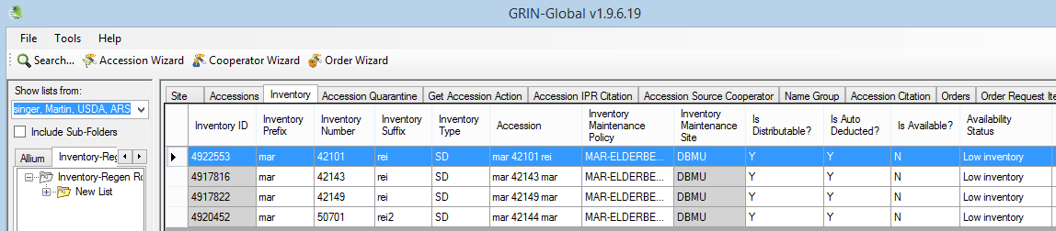

Add Low Inventory Items to an Order via the Order Wizard
To create a new replenishment order, you can start a new order: drag inventory records from the spreadsheet into the Order Wizard grid; use the New Order (the + button); indicate a recipient; and change the Order Type to Replenishment/regrow:
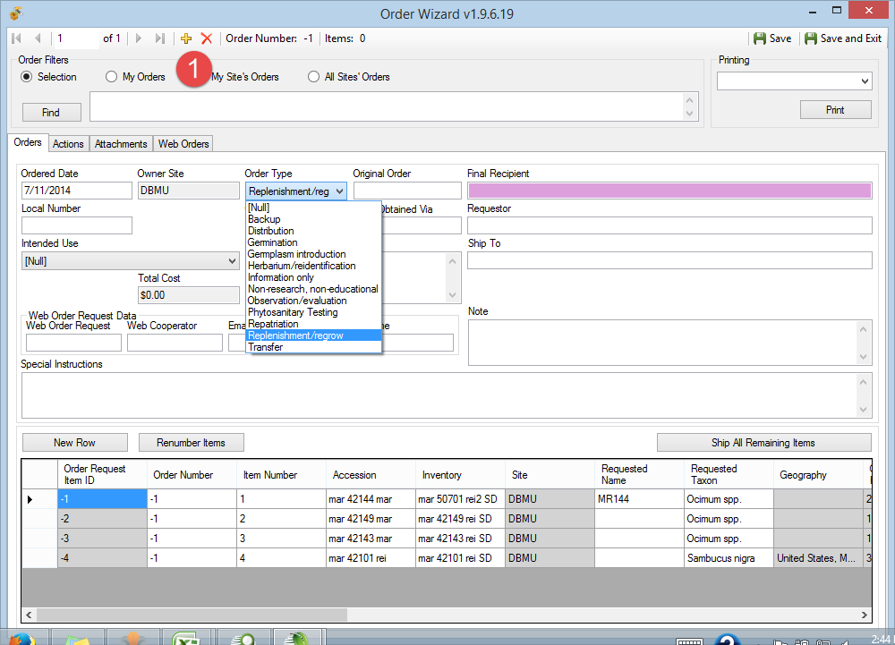
Select an appropriate Order List from the Print dropdown:
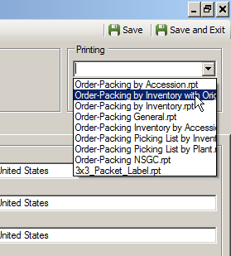
Click the Shipped All Remaining Items... button. When prompted, you can add the order to a list in the CT.

Create New Inventory Records Indicating Their Parents
To plan for the new physical inventory, you will want to create inventory records in GG. After the germplasm has been grown and harvested, you can update these records with the quantity on hand, the storage location, etc.

Steps:
Drag into Excel the original inventory records that were used to generate the order request Items. Since you are using the old records as the basis for making new records, you will need to clear the Inventory ID (otherwise you would be updating the original records).
Also, clear the Location and the Suffix fields and assign the new inventory a new suffix name corresponding with your site’s naming conventions. (Examples) The Availability Status of these new records should be “Planted for regeneration” (if that truly reflects the status).
Delete any columns that you do not intend to drag into the CT (or simply rearrange the spreadsheet columns). Remember that when you drag and drop, the CT matches columns by their mutual headings (Excel and the CT), and does not care about the column order.
Inventory that results from regeneration efforts needs to reflect its parent inventory.
Since you are using the original Inventory records as a basis for creating new inventory records, in Excel rename the Inventory field to Parent Inventory. (Scroll to the right to see this Inventory field.)
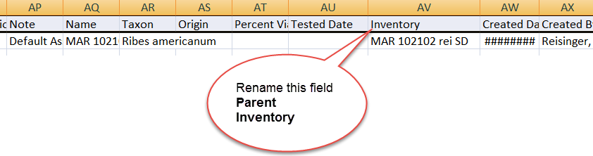
After successfully adding the new inventory records in the CT, for each accession you should have the original inventory record and a new one modeled after the original. 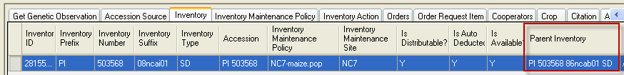
At this point, you can use these new inventory records to manage and input data such as Propagation Dates, Regeneration Methods, etc.
Create Inventory Action records to document your activities and tasks relevant to the handling of the inventory. (Refer to the Inventory Actions section for details.)
After the regeneration process is completed, update the new inventory records with their respective quantities and so on.

Appendix: Inventory Naming Conventions

Inventory Suffix
Organizations will need to create their internal naming standards for naming inventory. (This is also true for naming accessions.) The table below is primarily focused on seeds; below the table is a second example with clonal names.
The example and table below illustrates how one GG site uses the inventory suffix in naming their inventory. They use this convention consistently.
Some may argue that although it is true the suffix can handle any “meaningful” text, combining data in the suffix that may be found elsewhere in other fields is not ideal. For example, GG now has a field for the propagation date, as well as the production location.

Example inventory: AMES 10848 1990ncai01
(prefix) (number) (suffix)

Suffix
Character  Position | Denotes | Valid Codes | Code  Meaning
1 - 4 | year the material received or grown or bulk created
 |  | 1990
5 – 6 | abbreviation of the site
 |  | nc | North Central
7 | information about the source of the seed lot
 |  | a | sample was increased (or bulked) in Ames or the sample is the first sample received when the accession first appeared as an Ames number
 |  | n | sample received from NE-9, Geneva, NY
 |  | s | sample received from S-9, Griffin, GA
 |  | w | sample was received from W-6, Pullman, WA
 |  | f | sample received from NCGRP (formerly NSSL), Fort Collins, CO
 |  | p | sample increased or bulked at the PIO office or any outlying station connected with the Beltsville, MD office
 |  | e | sample was received from somewhere other than one of the above mentioned possibilities (“elsewhere”)
 |  | u | source of the seed is unknown
8 | contains information on the type of seed lot
 |  | o | sample is original for the accession
 |  | i | sample is an increase or material that arrived later
 |  | b | sample is a bulk of similar increases or originals
 |  | x | sample is being grown as a check variety
 |  | u | sample is of unknown origin
9 – 10 | in lots maintained as seeds, these two characters denote the lots for that accession for a given year
 | Examples
 | 1990ncai01 |  | seed was grown in 1990
 | 2001ncao01 |  | seed received as original in 2001
 | 1990ncai01 |  | first increase lot for the year 1990
 | 1990ncai02 |  | the second lot increased in the year 1990
 | 1990ncab01 |  | first bulk made for that accession in 1990
 | 1990ncao01 |  | first original – the accession was received in 1990
 | 1990ncao02 |  | second original received in 1990
9 – 10 | When original samples are split for distribution. For example, the original lot is maintained in the freezer. Characters 9 and 10 will be set to 51 to denote that split lot.
 | Example
 | 1990ncao01 |  | original lot
 | 1990ncao51 |  | distribution part of original lot 1990ncao01
 | 1990ncao02 |  | original lot
 | 1990ncao52 |  | distribution part of original lot 1990ncao02
9 | For lots that are not seeds
 |  | c | sample came in as and must be maintained as clonal material
 |  | m | sample represents a genetically mixed sample
 |  | u | genetic variability of the sample is unknown
 | Example
 | 1988nceim2 |  | second lot of tubers from the accession received in 1988

Clonal Example
The following (partial) inventory data illustrates inventory names used for a clonal accession that has multiple inventory records:
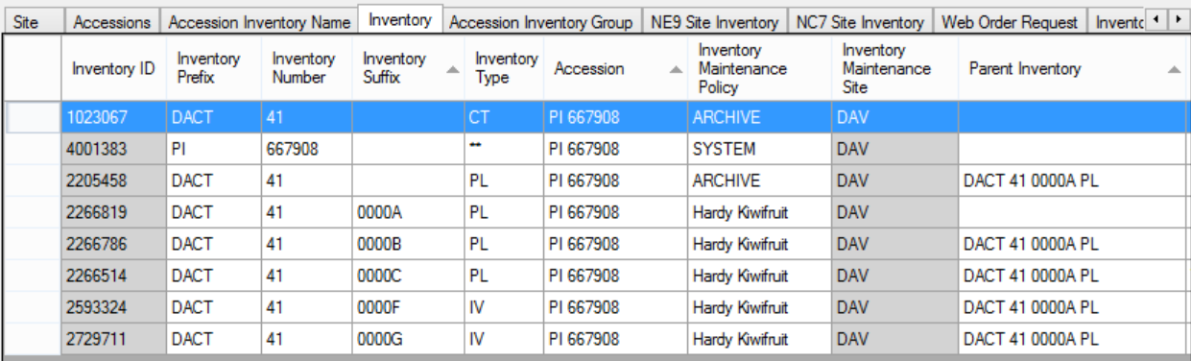

Appendix: Frequently Asked Questions (Inventory)

Question:
What are these Inventory records that have a double asterisk (**) for their type?

Answer:
See the explanation under Virtual (System-Generated) Inventory

Appendix: Document Change Notes

– April 3, 2026
- A note regarding accession with taxa regulated under CITES

– November 28, 2025
- Added text and an illustration regarding availability and requestability
- Included some minor word changes for clarity

– July 1, 2025
- Primarily reworded intro section for clarity

– April 8, 2025
- Repaired broken link to system inventory section

– April 17, 2024
- Wording revisions / screens updated
- Reformatting changes

– September 29, 2022
- Major editing/revision of the document
- Included recent inventory-related changes to GG

– October 13, 2021
- Added note and a screen regarding system inventory records

– July 13, 2021
- Changed references to Pure Live Seed; also minor wording changes

– June 29, 2021
- Changed references from Taxonomy Use to Taxonomy Regulation

– September 17, 2020
- Added an additional note about ownership under Inventory Maintenance Policy bullets

– August 13, 2020
- Minor wording changes to the regeneration section

– April 2, 2020
- simplified table regarding available and visible
- revised and annotated the available statuses displayed on the Public Website

– February 29, 2020
- added text regarding calculated fields
- revamped table explaining available inventory to reflect the capability to have multiple forms available

– December 6, 2019
- expanded description of the Top Name trigger

– August 10, 2018
- added INACTIVE status to the table of availability statuses

– May 23, 2018
- added new section on the Pure Live Seed calculated field
- corrected graphic re maintenance policy – the autodeduct field is not carried over to the inventory record

– May 16, 2018
- tip about using Inventory Maintenance Policies to filter records
- included link to the online Grouping Summary document

– December 22, 2017
- elaborated on the wording pertaining to inventory maintenance policy
- added images for the Web Availability Note section

– September 21, 2017
- minor wording change in the system inventory section
- a link was added to the separate Viability Wizard document

– August 2, 2016
- added more information about accession inventory groups and accession name groups

– January 22, 2016
- added a note regarding clonals need to have a Qty-on-hand inventory
- edited the table regarding what determines availability

– November 5, 2015
- added a note regarding changing permissions for creators of inventory records

– September 28, 2015
- added additional details for adding a new Inventory record

– September 8, 2015
- added details on the image attachments – specifically the affect of the two Category codes Image attachment and URL link

– April 29, 2015
- changed minor wording in the viability dataviews section

– April 14, 2015
- added note explaining that a change to an Inventory Maintenance Policy will not impact existing inventory records
- added Inventory Maintenance Policy to the Table of Contents
- added complete section on Accession / Inventory Names
- added text for the Viability and Inventory Quality Status sections

– March 26, 2015
- significant editing of the entire document
- added example of a site’s naming convention for the suffix

– March 13, 2015
- added additional details on auto deduct

– November 3, 2014
- added additional details regarding the Is Available? trigger

