Installation of Curator Tool Reports (Labels)


Revision Date
May 27, 2025

Author
Martin Reisinger

Contributor
NPGS’s Stacey Estrada did much of the work in designing the newer .rdlc files and testing the Report Manager’s server capabilities.

 | Curator Tool Reports (and labels) require pre-designed report files to be installed on the CT user’s PC. The report files are typically created by software developers or users with advanced IT skills, using other software tools.  This guide explains how to:  - install the report files  - edit text files needed to coordinate the CT with the report files

 | Within the Curator Tool, a user does not have the capability to create report files.

Questions?
Please email any questions to marty.reisinger [at] usda.gov.

Table of Contents
Summary 4
Three conditions must be met for CT reports to function 4
Brief descriptions for completing typical CT “report” tasks are summarized in the table below. 5
How Do I… 5
Background 6
Quick Overview 6
Wizard Reports caveat – a manual step must be completed… 6
Missing a Report? 8
Inventory Dataview Mapped to Reports (example) 9
Future Developments 9
Report Manager 10
Folder where CT report files are ultimately stored 10
Select a Report file Server 11
Report Server (NPGS) (example) 11
Download (or Update) report files from the server 11
No reports mapped to the active dataview (example) 12
Mapping report files to dataviews using Report Manager 13
Copying report files from a drive into Report Manager 14
Replace a report file with a new version 14
Using Report Manager (and Windows Explorer) to add a report file 14
Two versions of a similar report file mapped to the same (Inventory) dataview (example): 15
Using Windows Explorer to add a report file 15
Delete a report file (disconnect it) 16
Launch (run) a report for an active dataview (example) 16
AppSettings.txt file (Order & Viability Wizard reports) 17
Extra step needed to activate reports used within the Order and Viability Wizards 17
Order Wizard missing its report files (example) 18
AppSettings.txt file (example) 18
Order Wizard reports not working (example) 19
ReportsMapping.txt File (Manually editing) 20
CT user text files folder name 21
Keeping two versions of a report 21
Appendix A: GG Administrator/IT Support Notes 23
Report Mapping Details 23
ReportsMapping.txt file example 23
AppSettings.txt file 24
AppSettings Table on the Server 24
Report Files Source 25
Appendix B: Show hidden Windows folders 26
Default File Explorer Settings 26
Appendix C: Create Local Report Tables Feature 28
(v1.9.9.8 and later) 28
Appendix D: Document Changes 29
2025 May 27 29
2025 February 19 29
2025 February 10 / 7 29
2024 December 17 29
2024 September 5 29
2024 February 9 29
2021 May 18 29
2018 August 31 29
2017 December 5 29
2017 July 5 29

Summary

Three conditions must be met for CT reports to function
GRIN-Global’s Curator Tool can display and print reports as long as three conditions are met:
- the report files are installed/stored on the CT user’s PC
- the report files have been “mapped” to CT dataviews properly (via the Report Manager or by manually updating the ReportsMapping.txt file)
- the.txt file AppSettings.txt on the user’s PC must be properly configured for all reports used by the Order and Viability Wizards
More on the three conditions…
When the CT is installed, a base set of report files will be automatically installed on the user’s PC, but they are not automatically usable. To use the reports, the CT user must map them to dataviews via the CT’s Report Manager feature.
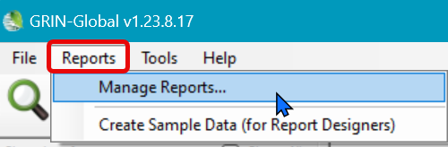
The Report Manager can handle the mapping for most dataviews, but an additional step must be completed for reports used within the CT’s Order or Viability Wizards. This last step must be done manually.
The report files initially used in the Curator Tool were reports created via the Crystal Reports software with an .rpt file extension. As of 2024, any report development at NPGS has been using Microsoft’s report utility; you can recognize these reports by their file extension, .rdlc.

Brief descriptions for completing typical CT “report” tasks are summarized in the table below.
Also, refer to this document’s Table of Contents to click on, and navigate directly to a topic.

How Do I…
Task (“How do I….”)
Install new reports | To retrieve copies of the latest version of the report files, use the Report Manager and select the report file server. More…
Update reports from a server | To retrieve copies of the latest version of the report files, use the Report Manager and select the report file server. More…
Find “missing” reports | When installing a new CT version, you may need to re-map report files to dataviews. More…
Copy reports from a folder on your hard drive | It is possible to use report files that you previously used if these files are somewhere where you can access them – on a network drive or your hard drive. More…
Delete (or disconnect) reports | You don’t need to delete the physical file if you no longer wish to use it in the CT, you simply “disconnect” it. More…
Map reports | Report files do not work in the CT unless they have been mapped to a CT dataview. More…
Display report names in the Order Wizard’s Printing dropdown | Report files do not work in the Order Wizard unless (1) they have been mapped to a CT dataview and (2) have been configured properly in the AppSettings.txt file. More…
Edit .txt files | Two .txt files exist on the PC that coordinate the CT reports with dataviews. The Report Manager updates the ReportsMapping.txt file and does this for dataviews, but the AppSettings.txt file must be manually edited for any Order Wizard reports. More…
Launch (run) a report | In a CT dataview, you select reports for the active dataview from a context menu. More…
Create a report | You can’t. At least not within the CT. Reports are designed externally to GG using other software. More…

Background

Quick Overview
The Curator Tool (CT) comes “bundled” with a current set of report files. When the CT is installed on a user’s PC, the report files are also copied onto the user’s hard drive. Additionally, two unique .txt files are installed on the user’s PC. These text files are critically important in “mapping” the report files so that the reports properly function when accessed in the CT.
The report files can be either SAP’s Crystal Report (.rpt) files and / or reports created via Microsoft’s SQL Server Reporting Services (SQL Server Reports (.rdlc) files. These report files were designed and created to work with specific CT dataviews.
If you are using files provided by your genebank during the CT installation, then refer to the Mapping section for details. If you need to install report files after a CT installation, then refer to the Copying Report Files section.
A Report Manager feature was added to the CT beginning with version 1.23.1.26. The Report Manager simplified adding and mapping report files because the user can now do these two steps via the Curator Tool. Prior to v. 1.23.1.26, these report files were manually added to a specific folder and in many genebanks, their security requirements prevented the typical CT user from doing this. However, the Report Manager still has a limitation with respect to wizard reports. Please read the next section closely.

Wizard Reports caveat – a manual step must be completed…
At this time, a user cannot completely map wizard reports via the Report Manager. Report files used within the Order Wizard or the Viability Wizard require two steps to be completely mapped. A mapping step still needs to be done via Report Manager, but the user must also configure a text file, the AppSettings.txt file, on the user’s PC. See AppSettings.txt for details. (Note that a request ticket has been submitted to the GRIN-Global development team to simplify this situation.)
The current Printing drop down in the Order Wizard is misleading. Below it appears that you can select and print any one of these reports as listed:
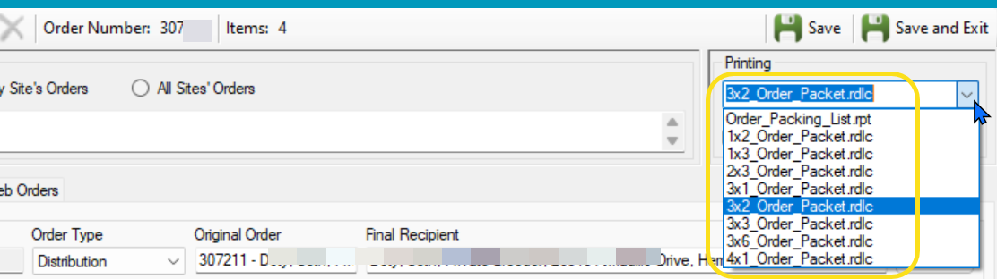
In this example, when the user selects the 3x2 Order Packet label from the list and clicks the Print button, nothing happens.
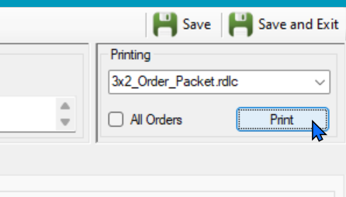
A review of the Report Manager provides the answer: that 3x2 Order Packet report has not been mapped yet in the Report Manager.
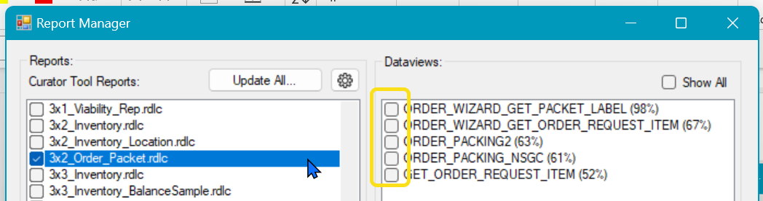
However, in the example below, when the 3x3 Order Packet is selected on the left panel, the right panel indicates that the Order_Wizard_Get_Packet_Label had been mapped properly. 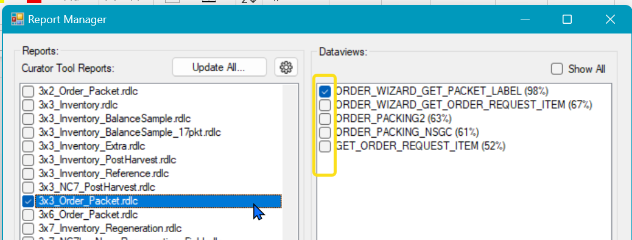
When mapped, this 3x3 Order Packet produces a report (label) when selected in the Order Wizard’s Printing dropdown:
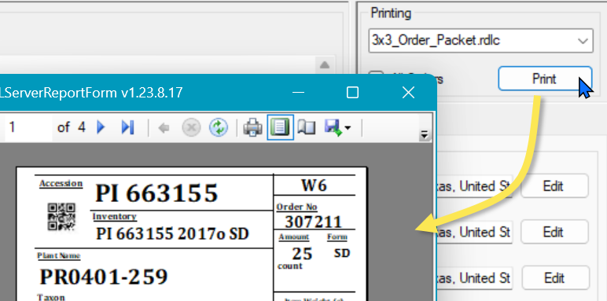

Missing a Report?
Note that two text files (.txt) coordinate the CT report files with the CT dataviews. A user cannot see these files within the CT; these are files stored in a specific folder on the user’s PC.
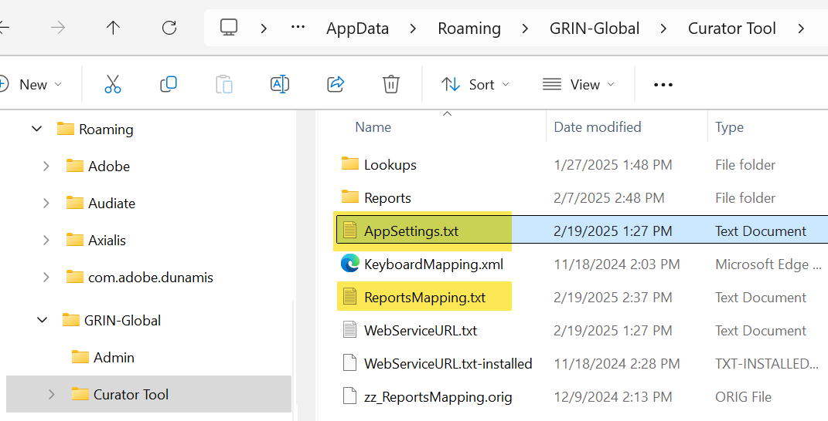

When using a CT dataview, a user may not be seeing a report because the report file was inadequately “mapped, that is, the report file was never adequately mapped to the dataview. Report files must be mapped to dataviews via the Report Manager.
When working with wizards, the Order Wizard or the Viability Wizard, a manual step most likely was never completed.

(Other reasons for a report not being visible to the CT are often due to typing errors in the user’s two CT .txt files or in the report filenames.)

To use reports designed to work with a Curator Tool dataview, the user must first map the report file to corresponding CT dataviews via the CT’s Report Manager.
[If you are a GG administrator or an advanced user wanting more details, please refer to the Report Mapping Details section.]

In Windows, by default, a typical user cannot see certain folders, filenames, and file extensions. See the Appendix if you need to change the PC’s Windows settings.

To start the Report Manager
In the Curator Tool, select Reports | Manage Reports
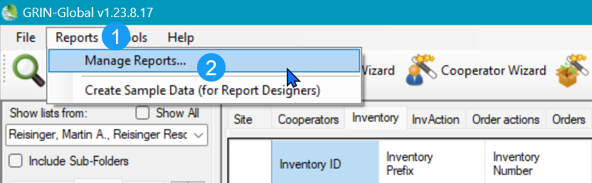
A noticeable delay (~20 seconds) will occur when you select Reports Manage Reports…
(No wait time indicator is displayed.)

Inventory Dataview Mapped to Reports (example)
Example: with the Inventory dataview active the user right-clicks after selecting a few inventory records. After selecting the Reports… menu option, five reports that have been associated with the inventory dataview are listed. The user can select any one of these to run a corresponding report.
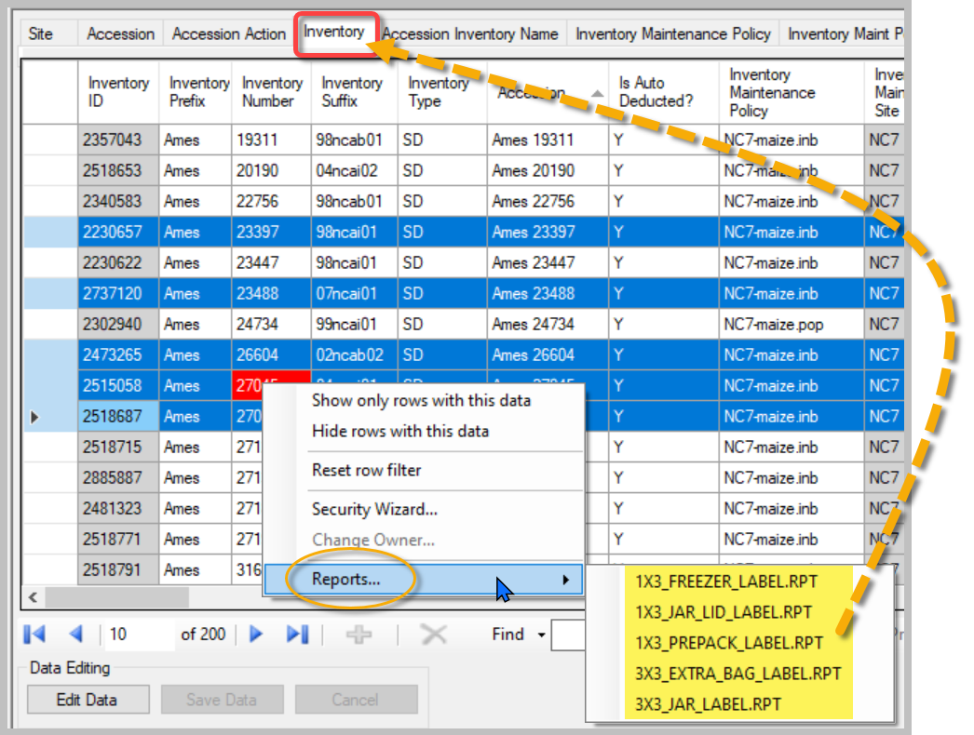

Future Developments
The January 1, 2025 server release added a new field ("is_smta_restricted") that is being used to recognize the condition when a web requested item is considered an SMTA order item. This field was needed to reflect a change made in the US that impacted NPGS. Now accessions, even though they do not have a related SMTA accession-IPR record, under certain conditions will be considered as an SMTA covered item. None of the available reports are using this new field (but will).
All report files currently on the Ames report server are being maintained and updated on an ongoing basis as conditions change or because of popular demand!

Report Manager
Think of the Curator Tool Report Manager as a tool that manages two distinct steps needed to activate reports for the CT. The Report Manager feature can:
- Copy existing report files to a specific folder on the user’s PC (as required by the CT)
- Map a report file to one or more CT dataviews
Reports used within the wizards must also be manually configured; presently the Report Manager cannot do this necessary step.

Folder where CT report files are ultimately stored
The CT report files must be stored in a specific folder on the CT user’s PC:
C:\Users\username\AppData\Roaming\GRIN-Global\Curator Tool\Reports
where username is the relevant user folder name. Starting with the 1.23.1.26 CT release, the Report Manager does this for you – it places the report files into this requisite folder. Example:
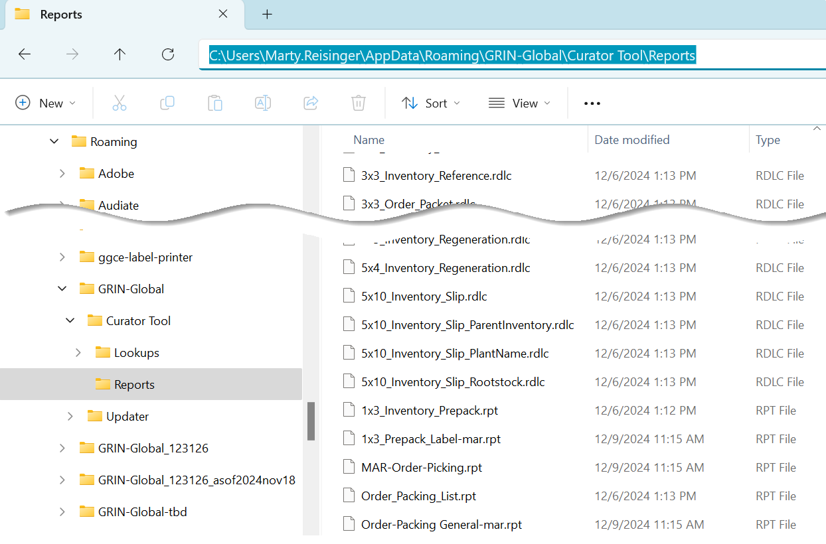
In CT releases prior to 1.23.1.26, the user or IT support person did this manually
The Report Manager is designed to download report files typically from a networked server and place them in a folder which the CT can access. Later, when invoking a CT report via the Curator Tool, you are using a local copy from your PC.

Select a Report file Server
Initially, when using the Report Manager, the reports server information will be missing. After you enter this information, the Report Manager remembers this and will be provided in future uses.

Report Server (NPGS) (example)
- Start Report Manager
- Click the “gear” icon to display the Report Manager Options window. Use the appropriate login credentials, as provided by your GG IT support staff.
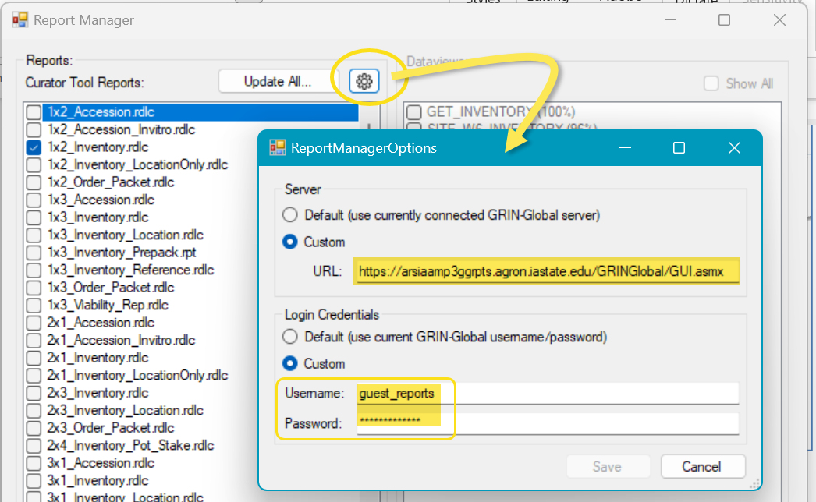
NPGS: – use:
URL: https://arsiaamp3ggrpts.agron.iastate.edu/GRINGlobal/GUI.asmx
Username & Password (for both) – use: guest_reports
Genebanks supporting GRIN-Global can have their own report file server. In that case, the GG database admin or the IT person supporting GG can provide the requisite credentials needed to log in to the server. The screens will be similar to the above screen.

Download (or Update) report files from the server
- Start Report Manager
- Select the report file server
- Click the Update All button on the Report Manager window:
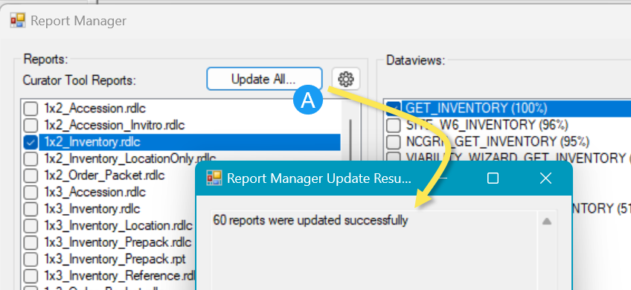

No reports mapped to the active dataview (example)
Initially, the report files are not mapped to dataviews.
In the example below, this CT’s Inventory dataview has never been mapped to any report file. The gray option indicates that no reports have been mapped for the active dataview. To display the menu, the CT user first selected a few inventory records and then right-clicked to display a menu, but the Reports option is grayed out.
When the Reports… menu is grayed, this indicates that no report files have been mapped to the active dataview.
Before proceeding, the user will need to invoke the Report Manager to map report files to the Inventory dataview. After the mapping step has been completed, in this example the user can return to the Inventory dataview and select a mapped report.
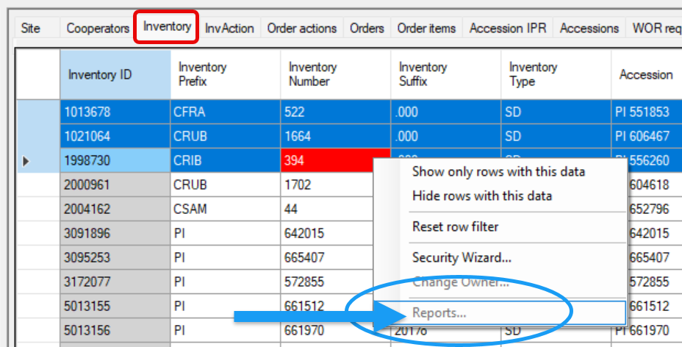

Mapping report files to dataviews using Report Manager
A noticeable delay (~20 seconds) will occur when you select Reports Manage Reports…
The Report Manager window displays:
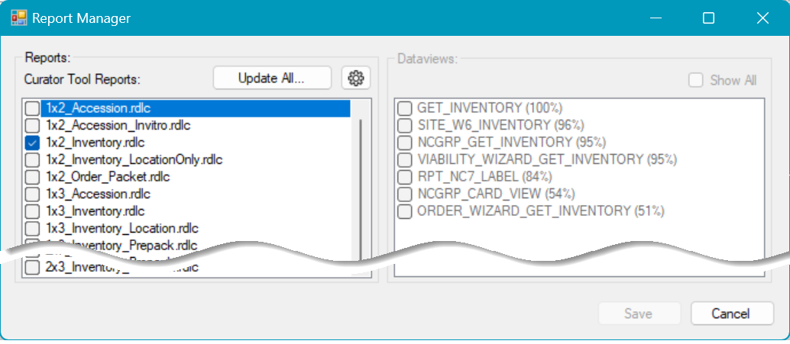
Initially the report files in the left frame are not selected. The dataviews in the Report Manager’s right frame are displayed in a faint gray.
To pair a report file with a dataview, select the report, select the dataview(s), then Save:
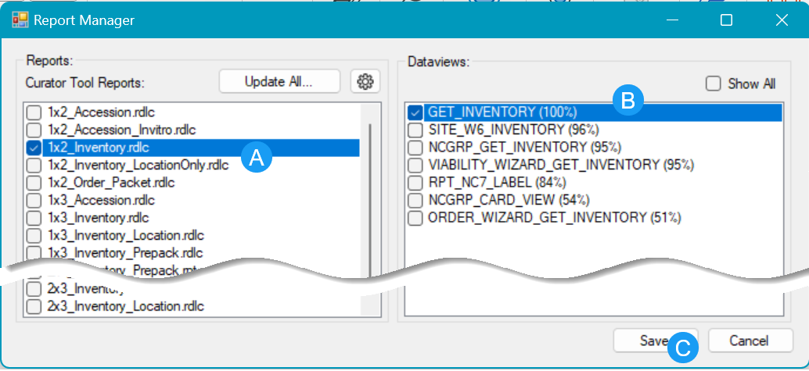
After you select a report filename in the left frame, only relevant dataviews with a score of 50% or better display in the right frame. In the example below, the 1x2_Inventory report has been selected.
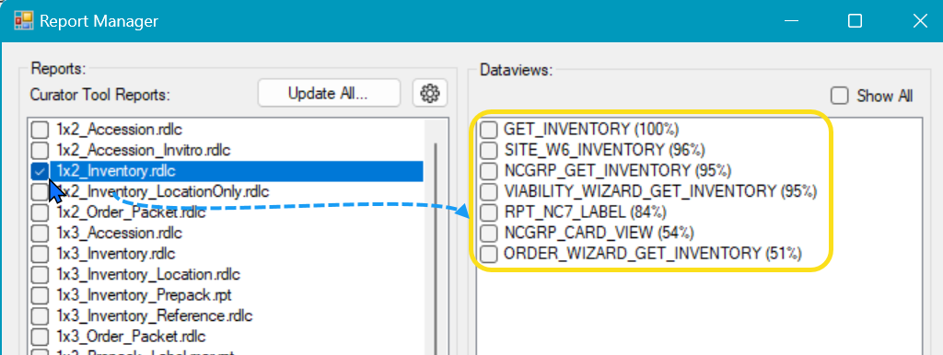
Only relevant dataviews are displayed The ideal match is 100%. (This score indicates the relative number of fields in the report that correspond to the dataview fields.) If you want to display all the dataviews, select the Show All checkbox. (rarely needed.)

Copying report files from a drive into Report Manager
Besides the report files that come bundled with the CT installation, CT users can include other report files that have been designed to work with the CT. Users can drag report files using Windows Explorer into the Report Manager window. (This procedure is similar to the drag and drop feature used by the Curator Tool’s Attachment Wizard.)
Prior to 2024, NPGS uses a series of reports that have been stored at https://grin-global.org/ct_reportfiles/. The zip file contains them all: https://grin-global.org/ct_reportfiles/CR_rpts.zip.

Before dragging into the Report Manager window, name the report files on your PC with unique names, so that you do not overlay an existing report file with the same name – unless you mean to. Consider establishing a folder on your PC for storing your report files.

Replace a report file with a new version
To replace an older report with a newer version, you can manually overlay the original report file stored in the CT Reports folder: Users\yourname\AppData\Roaming\GRIN-Global\Curator Tool\Reports
- Open Report Manager
- In a Windows Explorer window, drag the newer report file to the Report Manager window’s left frame
Both the old and the new file must have the same filename.
The steps below assume you want to have both versions active.

Using Report Manager (and Windows Explorer) to add a report file
- Open Report Manager
- In a Windows Explorer window, rename a report file that is a different version of an existing report file
- Drag the renamed report file to the Report Manager window’s left frame
- Select this second file and map it to the dataview

Two versions of a similar report file mapped to the same (Inventory) dataview (example):
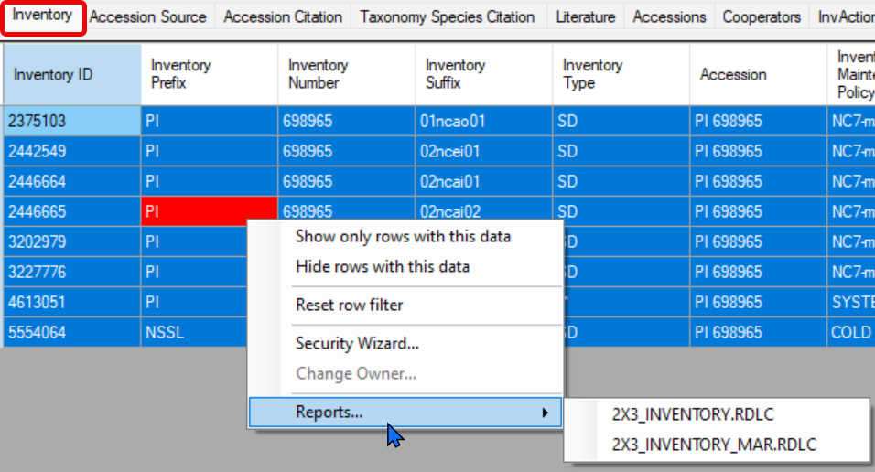

Using Windows Explorer to add a report file
The CT Reports folder is: Users\yourname\AppData\Roaming\GRIN-Global\Curator Tool\Reports
- Open the CT Reports folder (refer to the folder name above)
- Rename the original .rpt file
- Copy the new .rpt file into the CT Reports folder (again, use folder name above)
- Start up the CT – this revised report should display in the CT as needed
- Complete the mapping step to map the report file to a CT dataview.
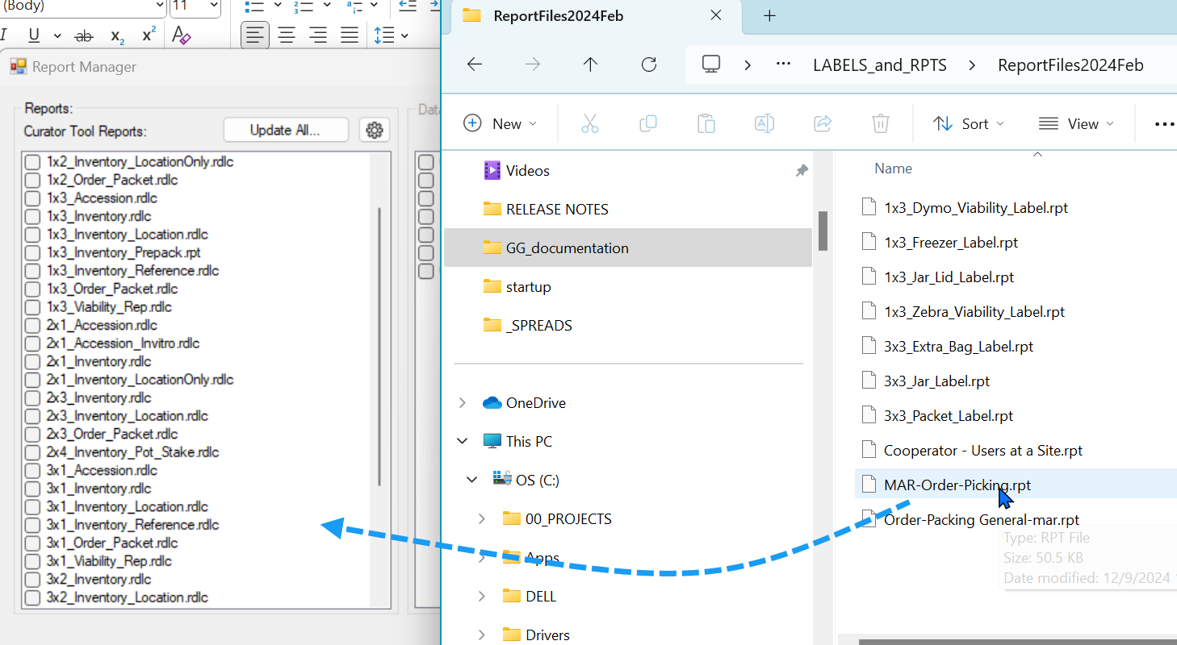

Delete a report file (disconnect it)
The Report Manager connects report files stored on your PC with Curator Tool dataviews. You don’t necessarily need to delete the physical file if you no longer wish to use it in the CT, you can simply “disconnect” it, that is, “un-map” it in the Report Manager. Deselect the dataview and save the Report Manager.
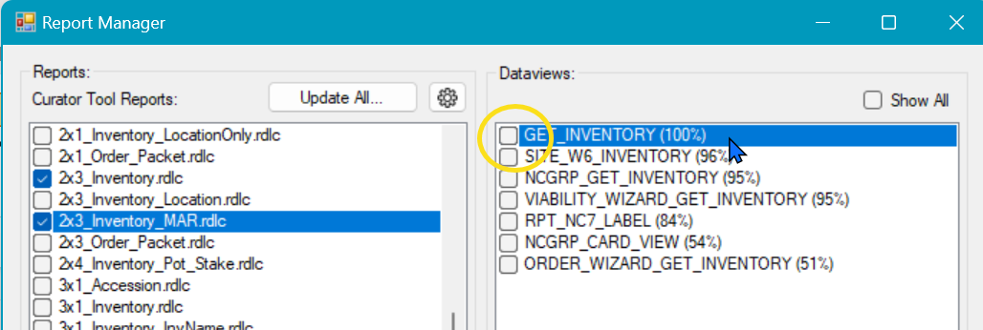
The actual file still exists on the computer’s hard drive, but when the Reports option is selected in the CT, the report is no longer visible.
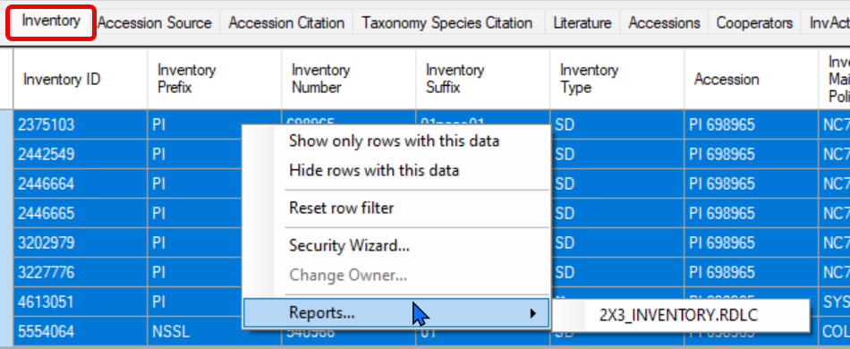

Launch (run) a report for an active dataview (example)
The following directions apply to the standard CT dataviews. See Extra_step… to learn how to map reports when used within the Order or Viability wizards. (This extra step for the Wizards is required, but must be done manually.)
- Select the dataview.
- Select the data.
- Right-click to display a menu.
- Select Reports and then select the desired report (label).
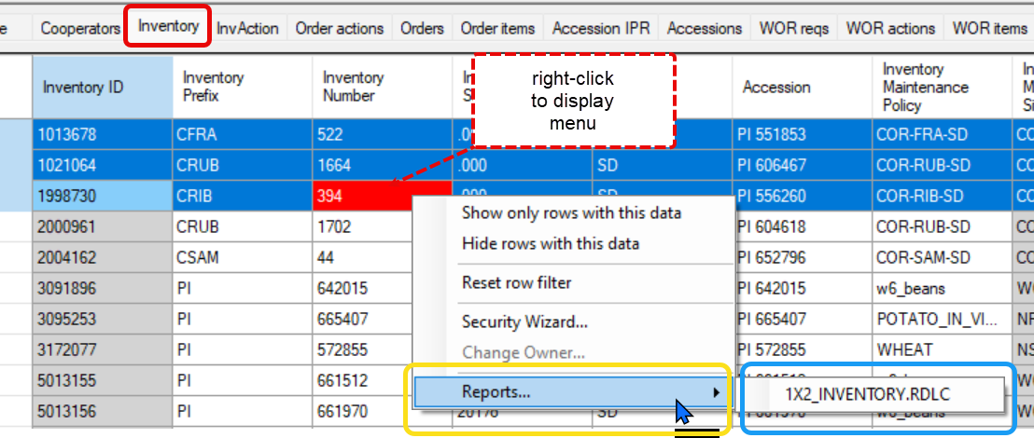
In the example above, only one report (so far) has been mapped to the Inventory dataview.
When using the CT, If you expect a report and it is not listed for the dataview, either the report file is not in the expected folder, or the report file was not mapped to the dataview. Use the Report Manager.
In the CT dataview, after selecting the desired report, the appropriate report viewer will display its window with the report, including the selected data. Use the window’s navigation bar and icons to print, etc.
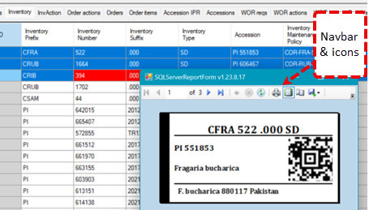

AppSettings.txt file (Order & Viability Wizard reports)

Extra step needed to activate reports used within the Order and Viability Wizards
Two .txt files on the user’s PC coordinate with Curator Tool’s report files. The Report Manager (v. 1.23.1.26 and above) updates only one of the .txt files, the ReportsMapping.txt file. The Report Manager can map a report file with one or more dataviews and in doing so updates the ReportsMapping.txt file. However, the two wizards, the Order Wizard and the Viability Wizard, require an additional step to coordinate the AppSettings.txt file with the wizard dataviews.
If no files are listed in the wizard’s Printing dropdown, then most likely this second, manual step of editing the AppSettings.txt file was never completed properly.

Order Wizard missing its report files (example)
In this example, no reports are listed in the Order Wizard’s Printing dropdown. This usually indicates that the related AppSettings.txt file hasn’t been edited properly.
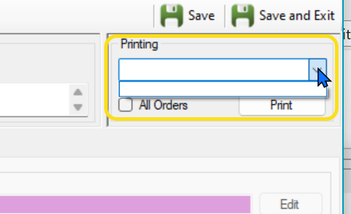
The CT user’s AppSettings.txt file must be manually edited whenever a report is to work with the wizard. This AppSettings.txt file affects various CT features, but here we are only interested in reports. This .txt file must indicate which .rpt files can be used by the Order Wizard’s Printing dropdown.
The AppSettings.txt file’s location is at:
C:\Users\username\AppData\Roaming\GRIN-Global\Curator Tool
where username is the relevant user folder name. Example:
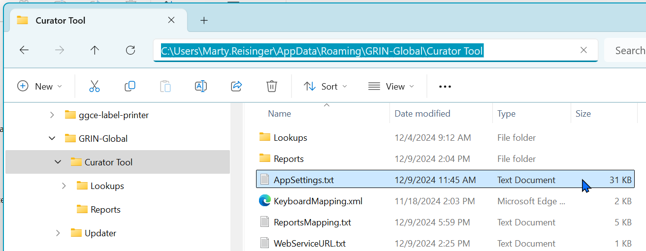

AppSettings.txt file (example)
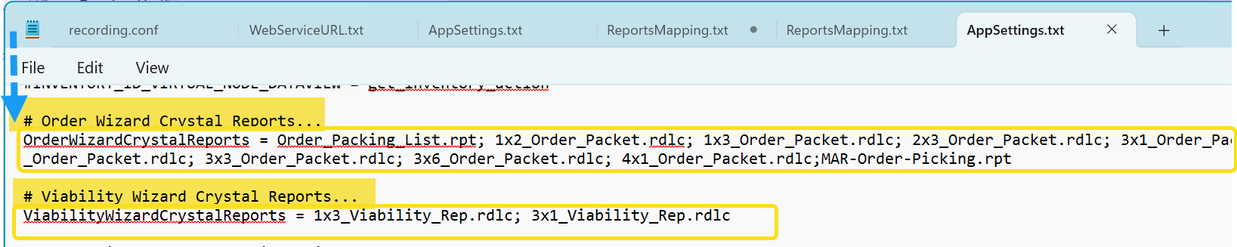
The text in the above image is shown below for readability. Notice that the report list for each wizard uses a semi-colon ( ; ) between filenames AND not after the last filename listed. Correct spelling is critically important; be careful too with the file extensions.
# Order Wizard Crystal Reports...
OrderWizardCrystalReports = Order_Packing_List.rpt; 1x2_Order_Packet.rdlc; 1x3_Order_Packet.rdlc; 2x3_Order_Packet.rdlc; 3x1_Order_Packet.rdlc; 3x2_Order_Packet.rdlc; 3x3_Order_Packet.rdlc; 3x6_Order_Packet.rdlc; 4x1_Order_Packet.rdlc;MAR-Order-Picking.rpt
# Viability Wizard Crystal Reports...
ViabilityWizardCrystalReports = 1x3_Viability_Rep.rdlc; 3x1_Viability_Rep.rdlc
On some lines, the AppSettings.txt file will have a # symbol preceding the code, such as the two bolded headings in the above example. (The leading # character causes the code to be treated as a comment.)

Order Wizard reports not working (example)
In the following example, reports are listed but when the user selects one, nothing happens. In that case, the mapping step of matching the report files to the dataview via the Report Manager was never completed properly.
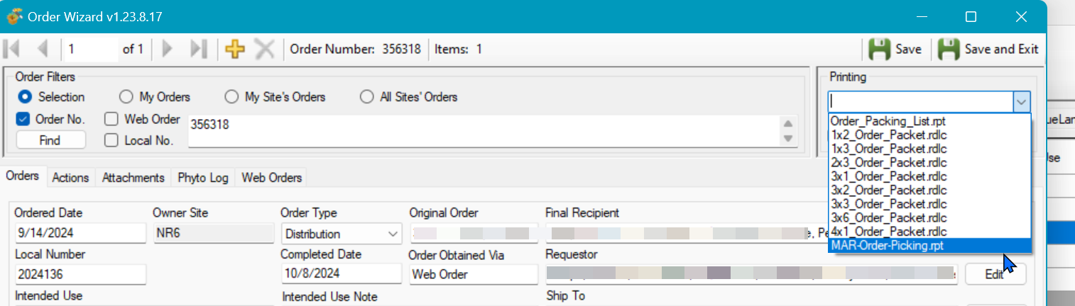

The following screen shows the 2x3 Order Packet label is in Report Manager, but in this case the report file has never been mapped yet to the Order_Wizard_Get_Packet_Label dataview.
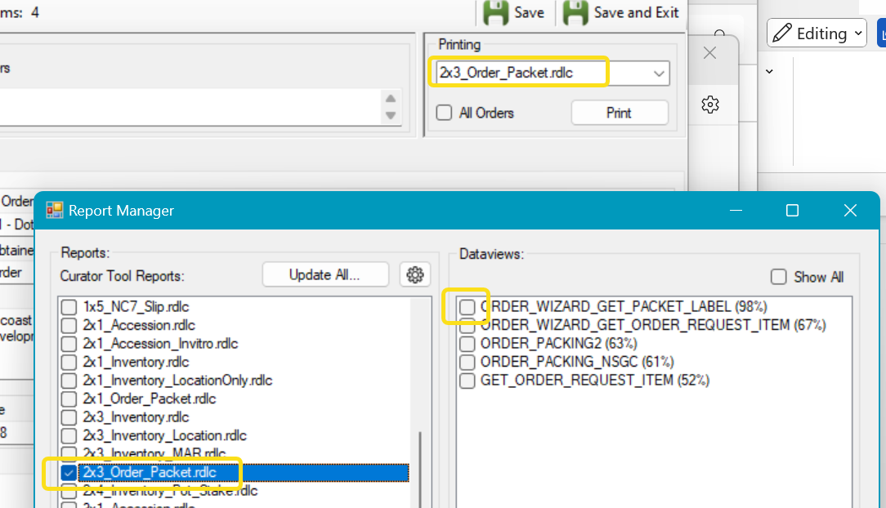

ReportsMapping.txt File (Manually editing)
Earlier, we discussed how the CT’s Report Manager option can map report files to dataviews. When it does this mapping, it also configures the ReportsMapping.txt file on the user’s PC. However, this .txt file can be manually edited to relate a .rpt file with a dataview. (Before the Report Manager feature existed, this was the only method for mapping the report files to the CT dataviews.)
We see in the example below the user’s .txt file was modified to associate the dataview “site_w6_inventory” with the 1x3_Freezer_Label.rpt report file:
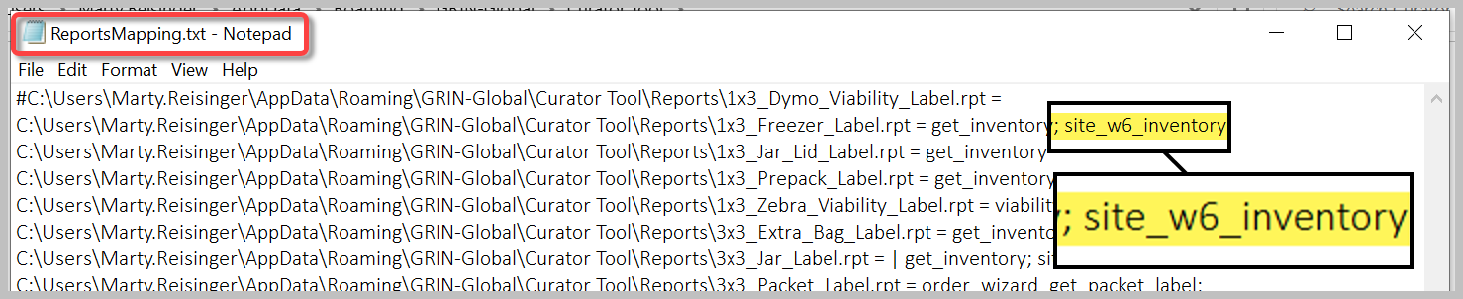
When editing the statements, use a semi-colon and then the dataview name, as shown above.
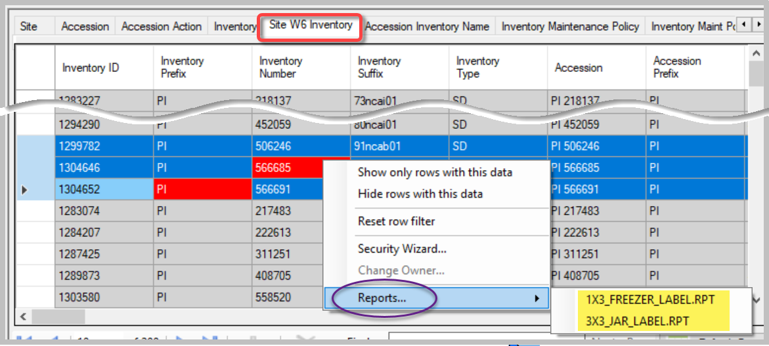

Example of adding a new report for the Order Wizard
Scenario: A revised version of the Order-Packing General report used within the Order Wizard has been updated with SMTA and additional disclaimer text. The CT user wants to keep his older report for a while, but also install the newer version.
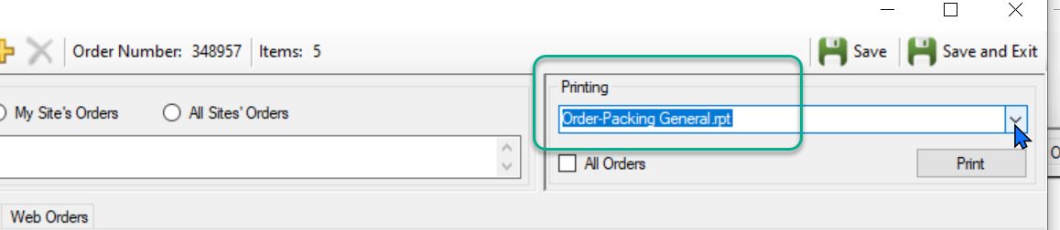

CT user text files folder name
To replace an older report with the new version, you can overlay the original report file stored in the CT Reports folder Users\yourname\AppData\Roaming\GRIN-Global\Curator Tool\Reports

Keeping two versions of a report
However, you may want to have both versions active, even if only temporarily. You need to do a bit more work. Two Curator Tool .txt files on your PC must be modified. The files are stored in a specific CT user folder.
This folder location assumes you are running the current version of the CT (1.23.1.26).
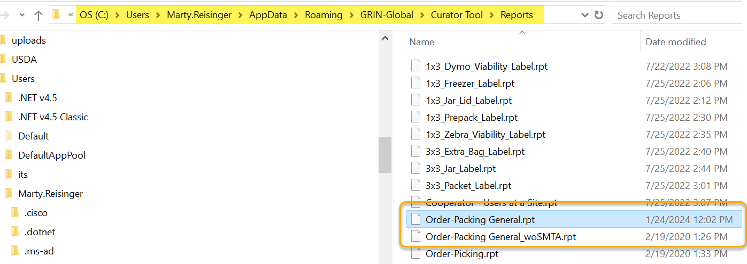
The following steps assume you will use a similar, but different, filename to have both versions active.
- Rename the original .rpt file. In the example above, I tacked on “_woSMTA”
- Follow directions for copying report files
- Edit the AppSettings.txt file.
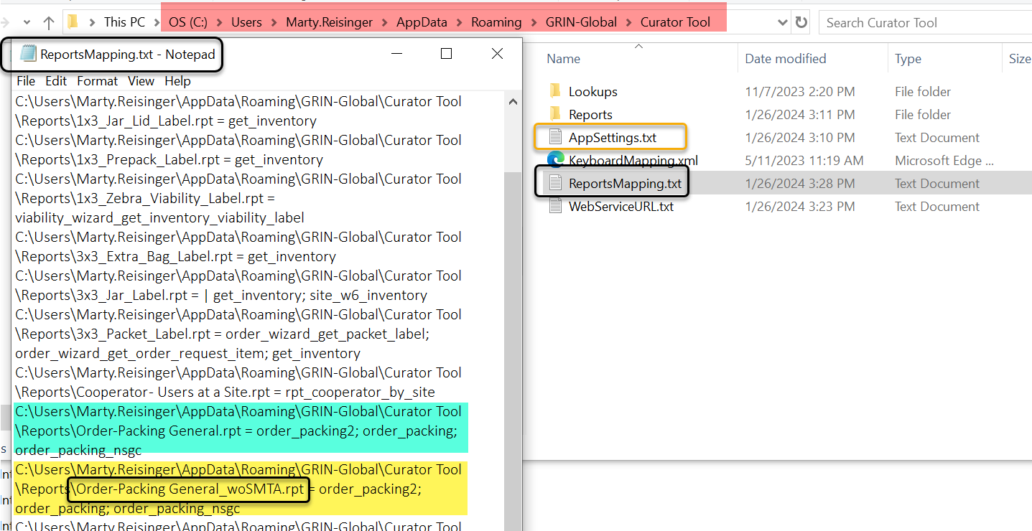
The yellow highlighted text was copied from the ReportsMapping.txt file and copied and used as the text in the AppSettings.txt file. (I could have simply typed the text carefully.)
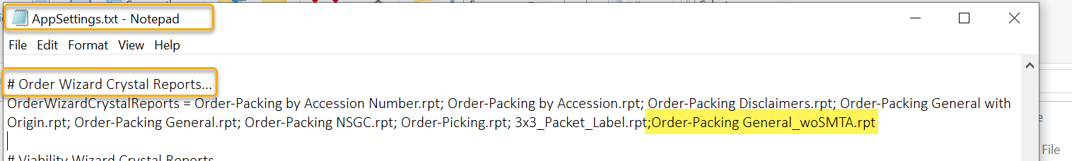

Appendix A: GG Administrator/IT Support Notes
The following information is intended primarily for the GRIN-Global administrators.

Report Mapping Details
The Curator Tool was designed to work with report files that are mapped to dataviews. In older CT versions, this mapping was done manually by editing two .txt files that are stored on the user’s PC. Beginning with v 1.23.1.26, mapping report files to dataviews is done via the Report Manager inside the CT. (However, the manual alternative is still doable.)
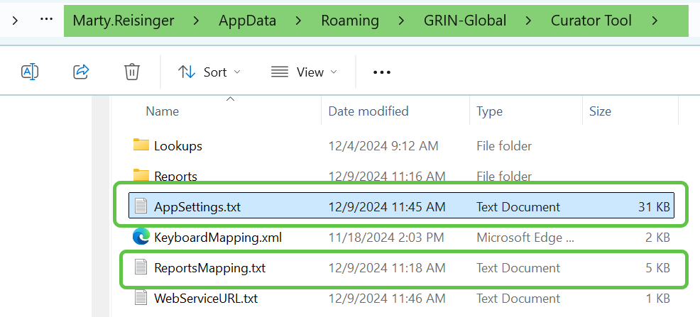

ReportsMapping.txt file example
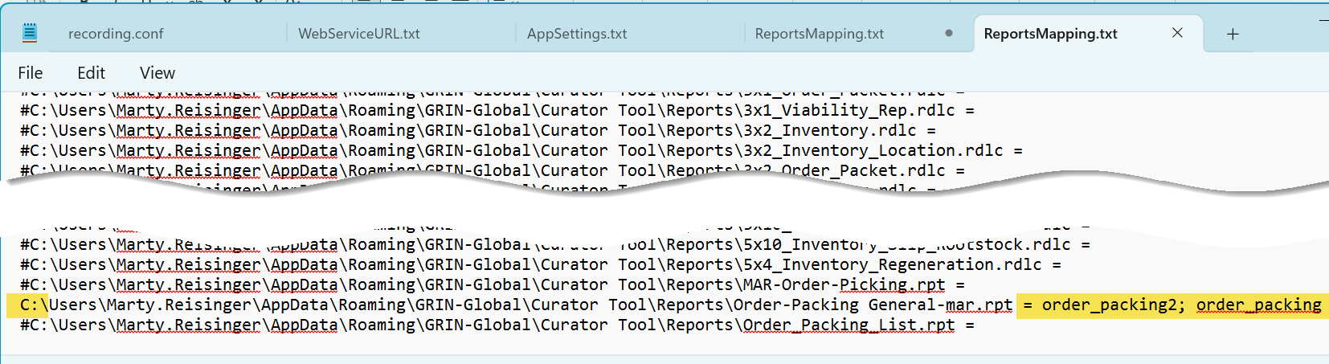
This highlighting in this mapping file shows that the file
...Reports\Order-Packing General-mar.rpt = order_packing2; order_packing
is mapped to dataviews, order_packing2 and order_packing.
The ReportsMapping.txt under the user’s C:\Users\username\AppData\Roaming\GRIN-Global\Curator Tool will initially reference the CT developer’s path. (This can be ignored.) When the CT user maps her first report file, the ReportsMapping.txt file is updated and will look similar to the following image. Shown here is one report file that has been mapped – the 1x2_Inventory.rdlc file is mapped to the get_inventory dataview.
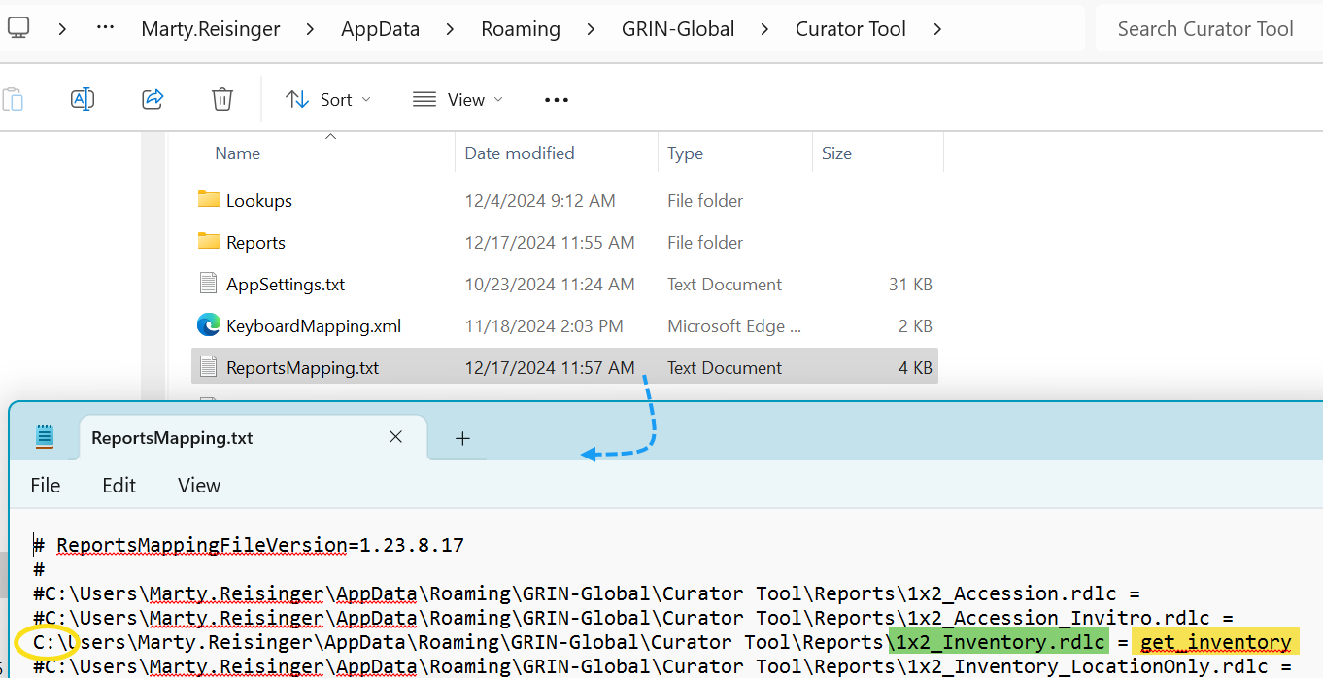

AppSettings.txt file
The CT user’s AppSettings.txt file must be manually edited whenever a report is to work with the wizard. This AppSettings.txt file affects various CT features, but here we are only interested in reports. This .txt file must indicate which .rpt files can be used by the Order Wizard’s Printing dropdown.
Refer to the AppSettings.txt section for details on configuring.

AppSettings Table on the Server
A table that contains some default settings that control each user’s individual settings exists on the server. When the user’s PC contains an AppSettings.txt file with similar statements, the user’s AppSettings.txt file statements supersede the statements in the server’s AppSettings table.

This manual updating of the AppSettings.txt file has been recognized as an issue; in a future release, this should be addressed and ideally the Report Manager will handle the coordination with the reports used by the two wizards.

Report Files Source
When a user uses the Report Manager for the first time, the report files in the PC’s ProgramData folder are copied to the user’s CT Roaming folder:
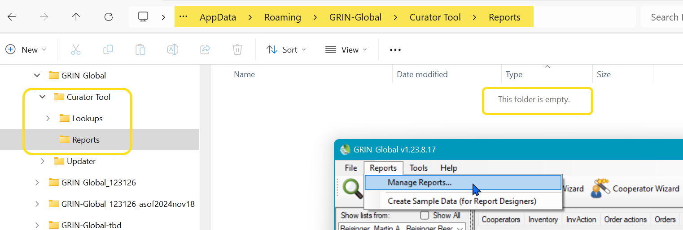
Same folder, after invoking the Report Manager within the CT:
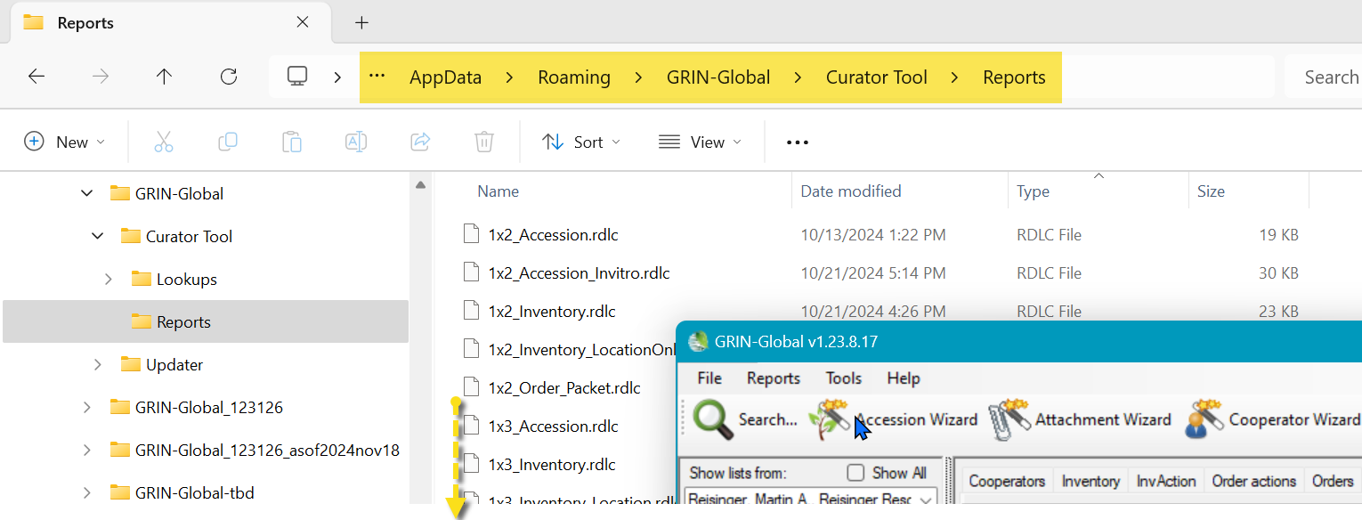

Appendix B: Show hidden Windows folders

Changing Options for Folders
(so that they display - Show hidden folders)
Unfortunately, in its wisdom, Microsoft a long time ago decided to hide certain folders as well as file extensions. In the default view, the folder C:\ProgramData is hidden:
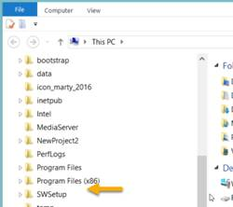
Whenever I get a new PC, I immediately change 3 of the default settings. I use File Explorer extensively, so I change the settings for "Display full path," "Show hidden files…," and "Hide extensions for known types" to be able to see “hidden” folders and files.

Default File Explorer Settings
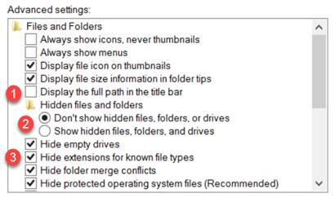

Preferred settings which you can make the default for the entire PC:
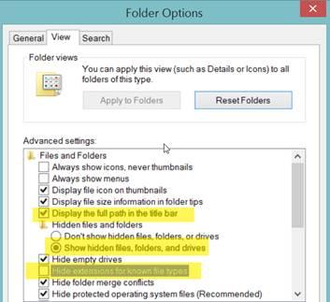
To make the display options apply to all folders, select the Apply to Folders button:
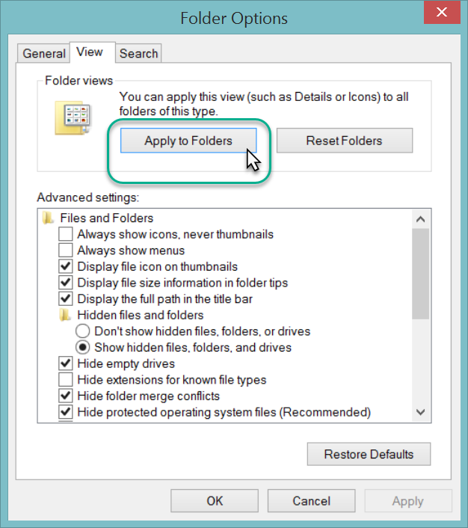
The C:\ProgramData should display. You may need to close the File Explorer window and then reopen it.
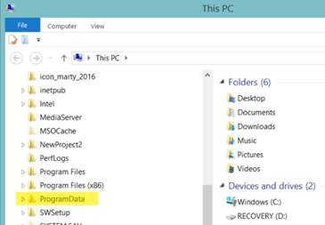

Appendix C: Create Local Report Tables Feature

(v1.9.9.8 and later)
Beginning with CT version 1.9.9.8, a feature was added to the Curator Tool.
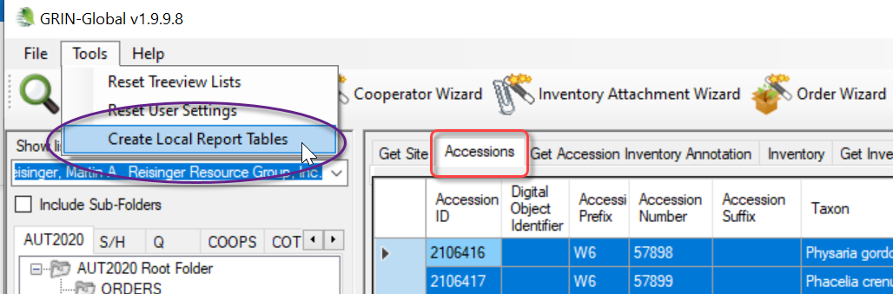
When the Create Local Report Tables option is selected, a copy of the records in the active dataview is saved to a database on the user’s PC:
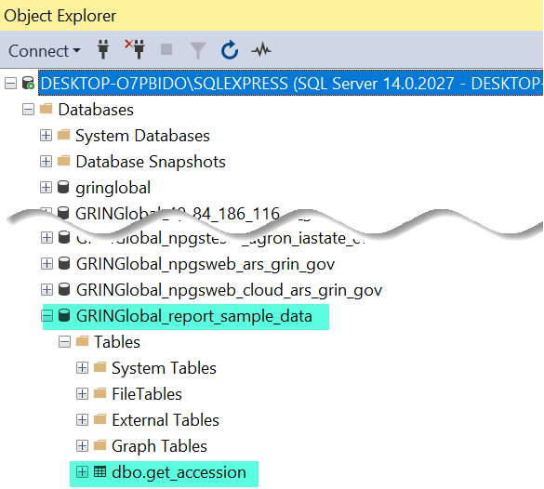
This screen was produced using SQL Server Management Studio. These sample data tables are now ready to be used by a 3rd party tool. The CT does not make reports directly.
GG documentation does not include directions on how to create Crystal Reports files since this is beyond the scope of the typical genebank staff person.

Appendix D: Document Changes

2025 May 27
- Added links to online .rpt files used by NPGS
- Minor text changes

2025 February 19
- Additional screens and text to explain the two .txt files

2025 February 10 / 7
- Major editing and organizing of text
- Additional images

2024 December 17
- Included new images based on CT v. 1.23.8.17
- Major editing of text
- Revised sections to downplay manual updating of ReportsSettings.txt file

2024 September 5
- Expanded text with respect to the Report Manager
- Included links bookmarks to the Report Manager section

2024 February 9
- Updated text and the location of .rpt files
- Major reorganization of document to reflect Report Manager in CT

2021 May 18
- Updated the location of the ZIP file for the .rpt files

2018 August 31
- Edited substantially to reflect the changes to a 64-bit platform and the move to different folders on the CT user’s PC

2017 December 5
- changed the source zip file to https://www.grin-global.org/report_files_for_ct_2017dec05.zip

2017 July 5
- changed the source location for the reports zip file to https://www.grin-global.org/…

