Getting Started with the Curator Tool
(and the Search Tool)



Revision Date
January 23, 2026

Author
Martin Reisinger

Document’s Purpose
This document explains the GRIN-Global Curator Tool (CT) basics. The CT is used by genebank staff to access the GG data. While not a true step-by-step tutorial, the examples in this document should provide you with sufficient detail to illustrate what can be done in the CT.
Detailed documentation on CT topics is located at: http://grin-global.org/userdocs.htm
 | This documentation page can be searched with a “Google search”  

Prerequisites
To follow these directions, ideally you have the Curator Tool installed on your PC. (The general public does not have access to the CT.) Generally, at most genebanks, an IT support person is needed for installing the CT because of security constraints. Also, the installation can be a bit tricky! Complete CT installation instructions, with detailed steps, are online at:
https://www.grin-global.org/docs/gg_install_CT_directions.pdf

TOC

References 3
Installing the Curator Tool 3
Public Website 3
Log in to the Curator Tool 4
Launch the Search Tool 7
Search for sample records to review 8
Filter the found records 9
Lists and Tabs in the Curator Tool 10
Copy (“drag”) records from the Search Tool to the Curator Tool 11
Moving items from one list to another (& renaming lists) 12
Dynamic Lists 14
Create New Database Records 14
Batch Adding or Updating Records 16
Explore Dataviews 18

References
We recommend bookmarking links to the following websites:
- GRIN-Global User Documentation Page: http://grin-global.org/userdocs.htm
- Dataview dictionary: https://www.grin-global.org/docs/gg_dictionary.xlsx
- GG Public Website (USDA example): https://npgsweb.ars-grin.gov/gringlobal/search
- Public Website (USDA TRAINING): https://training.ars-grin.gov/gringlobal/search

Check out the online overview on the Curator Tool:
https://www.grin-global.org/Intro-to-CT/Content/Course-Content/1-Course-Title.htm

Installing the Curator Tool
Assuming you have the Curator Tool properly installed on your PC, you must point it to a GG server. Complete documentation is online at http://grin-global.org/docs/gg_connecting_to_servers.pdf

Public Website
Many of the genebanks using GG will install its public website component for external GG users to review accession data and request germplasm. Besides public users, the genebank’s staff will find many of the website’s features very useful.
As a genebank staff person, when your Curator Tool (CT) and Public Website (PW) accounts have been set up and have been connected by the GG database administrator (DBA), you will have additional features not available to general public users.
As examples of public websites, here are two URLs for the USDA National Plant Germplasm System (NPGS) databases:
NPGS data: https://npgsweb.ars-grin.gov/gringlobal/search
NPGS training data: https://training.ars-grin.gov/gringlobal/search
Other GG public websites can be seen via the GRIN-Global Project menu:
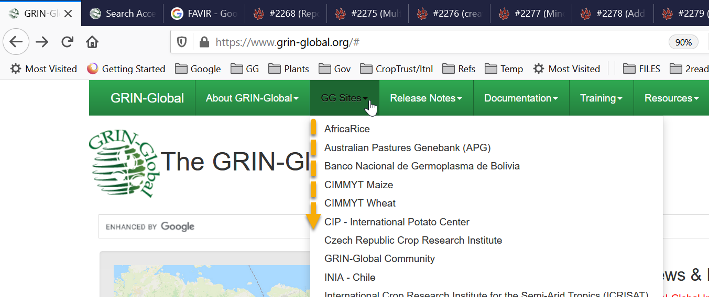

Log in to the Curator Tool
After the Curator Tool has been installed on a PC, its icon should be available on the Windows startup menu; click to start the CT:
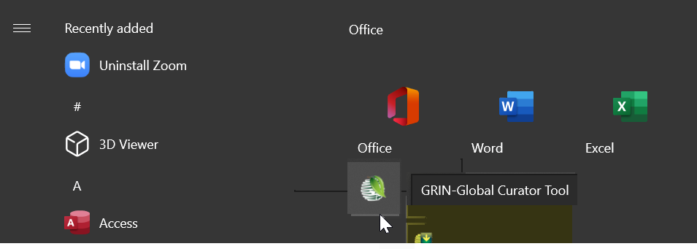
Provide the user credentials and when it’s the first time running the CT, ensure the server connection has been set up properly. Connecting to a server is explained in detail in the document:
http://grin-global.org/docs/gg_connecting_to_servers.pdf
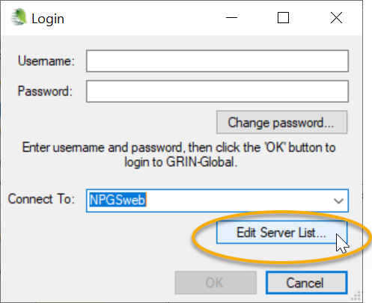
As an example, the settings for connecting to the NPGS’s database are shown below: 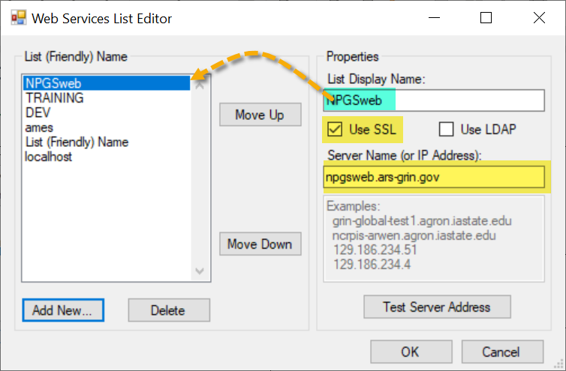
After clicking the OK button in the Login window, a disclaimer prompt displays. Simply click OK to continue.
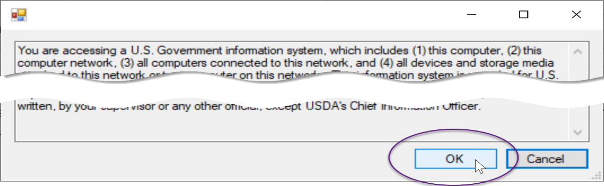

If your name is not displayed immediately under the Show lists from… box (A) then stop! Something about your account is not correctly set up. Contact your GRIN-Global support if this is the case. When a user account is set up properly, and when the CT is set up properly, the account user should be in that box. If it is not, then your user settings will not be saved when you close the CT.
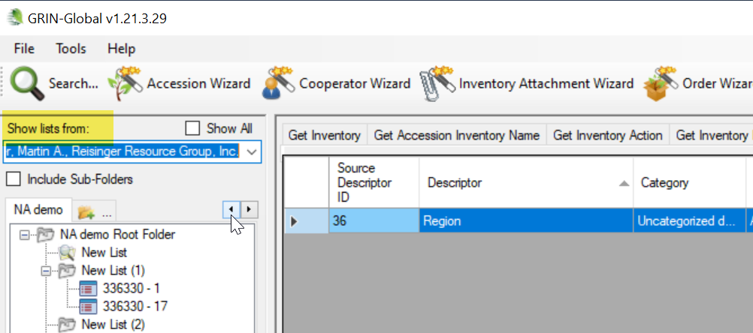
In the image above, mine may look a bit different than yours. I have multiple tabs set up because I was using the CT already. When starting the CT for the first time, you will have only one tab, “Tab 1.” If that’s the case, perfect!

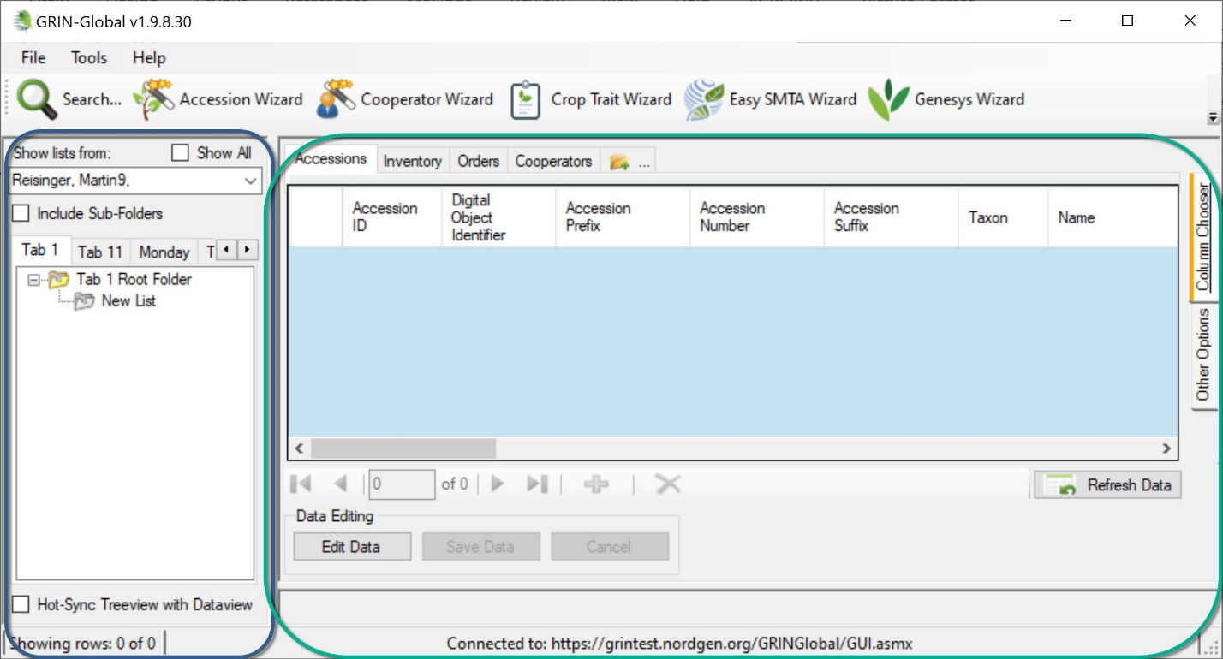
Curator Tool Window
Many of the items above are self-evident. But I’ll point out here that the screen has two panels, a left and right panel.
Think of the left panel as being similar to a Windows Explorer screen – many folders (“Lists”), with many items in each list. These items point to files stored on the PC’s drives; these files are listed on the right panel.

Windows Explorer
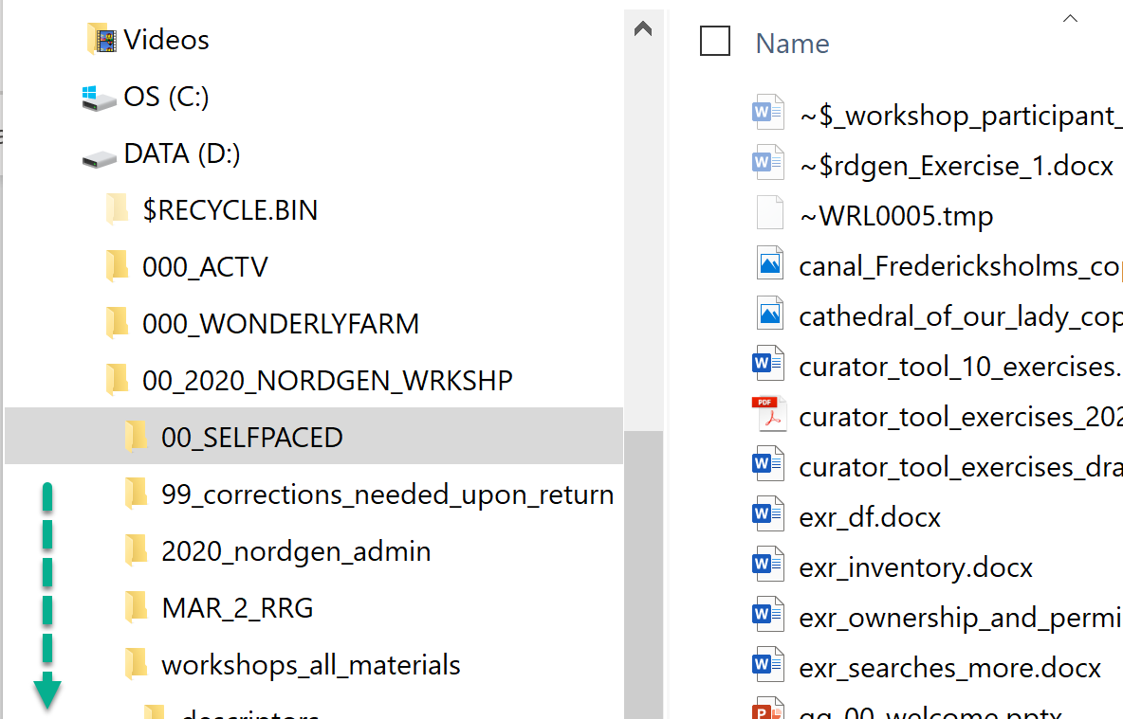
In the CT, a similar situation…
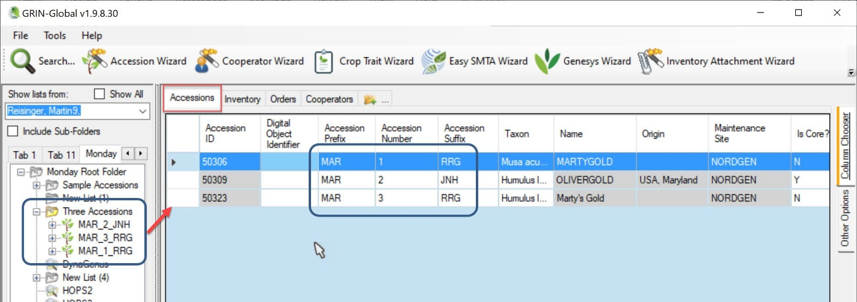
In this example, the folder Three Accessions, is the current folder opened in the left panel. (In CT jargon, the word “folder” is often used synonymously with “list.” The list contains three items; three related accessions are displayed in the right panel in the datagrid. The data in the right datagrid is the actual data stored in the database.
I highlighted the Accessions tab in the right panel. Each of the tabs on the right side are called dataview tabs. Each dataview has been designed to provide the user with a look at specific fields’ data. Think of each dataview as a lens that provides a specific, defined view of the data.
Frequently the dataview includes fields from more than one table. For example, in this case – the data in the Name, Origin, and Maintenance Site fields came from related tables, but most of the data is stored in the Accession table. The gray cell color is a hint that these fields are not in the main (Accession) table.) Much more to be explained on this concept!

Launch the Search Tool
Genebank staff typically use two tools simultaneously, the Curator Tool (CT) and the Search Tool (ST). The ST is launched when needed by clicking the Search button in the CT. Click; be patient - it takes a few seconds for the Search Tool window to display.
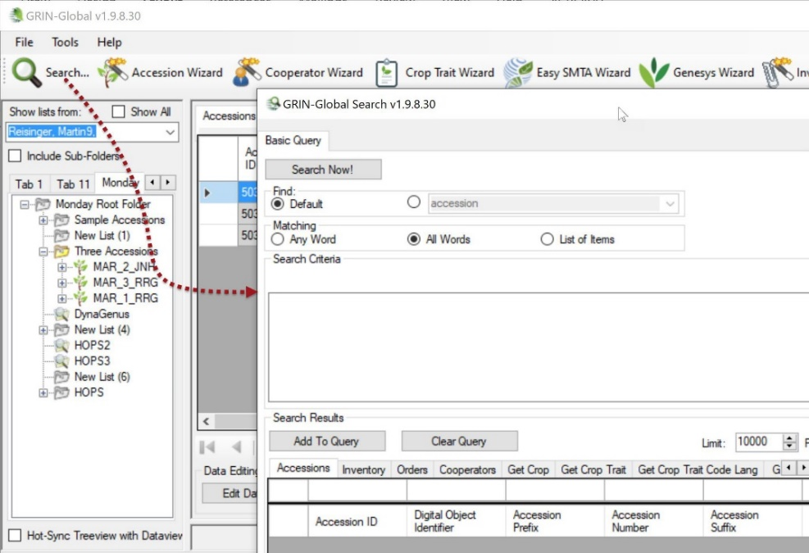

Search for sample records to review
The Search Tool has an entirely different look than the CT. You input or select examples in the query-by-example (“QBE”) cells (1), click Add to Query (2), and then click Search Now! (3).
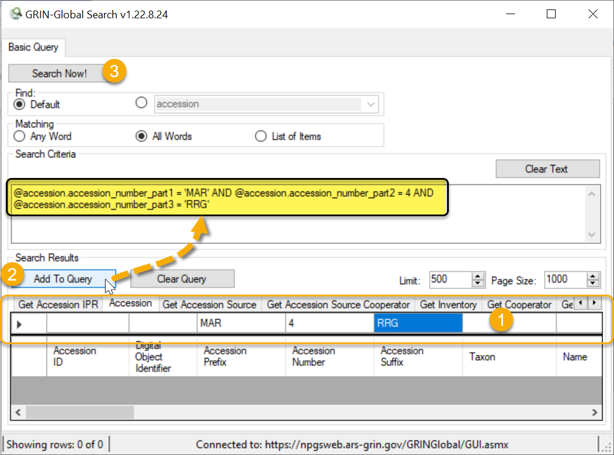
Below the QBE cells, the headings that are shown are the “friendly names” of the database fields. The actual database table and field names are displayed above in the Search Criteria box (highlighted). “MAR” was entered as the sample data for the Accession Prefix field. The actual database table.fieldname is accession.accession_number_part1 (highlighted).
Why have headings and then show the database names? Knowing these actual names will become very handy when creating more complex queries. (Also, some users may know the SQL language and can use these database fieldnames within a SQL command.)
When records are located, you will be prompted with a Query Results window indicating the number found; when none are found, the message will indicate that; in either case, click OK to continue.
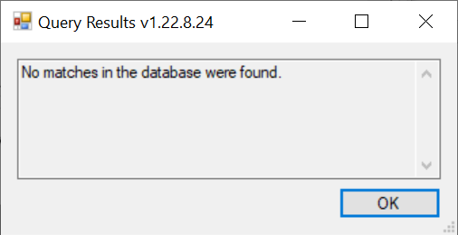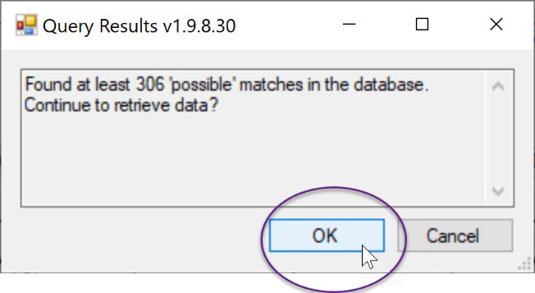
Found records will be displayed in the Search window’s bottom grid. You can then drag those records to the Curator Tool or even to a spreadsheet.
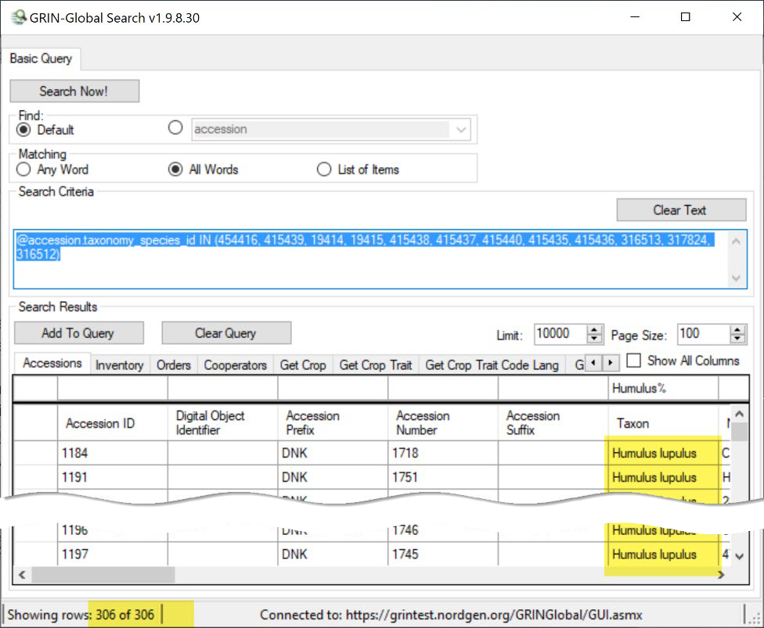

Filter the found records
You can also filter the initial search results by selecting Show or Hide with the mouse on a selected cell. Practice filtering the records to display a subset of those found by the initial search query. In the Taxon (scroll to the right), click in a cell whose data is “Humulus lupulus.” Right-click; and select “Show only rows with this data.” The bottom, left corner of the grid, will indicate how many records are now being displayed:
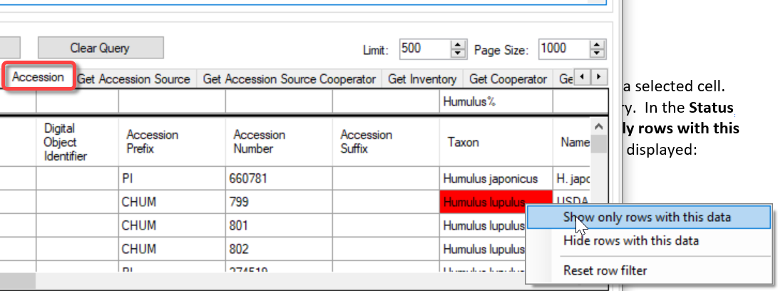
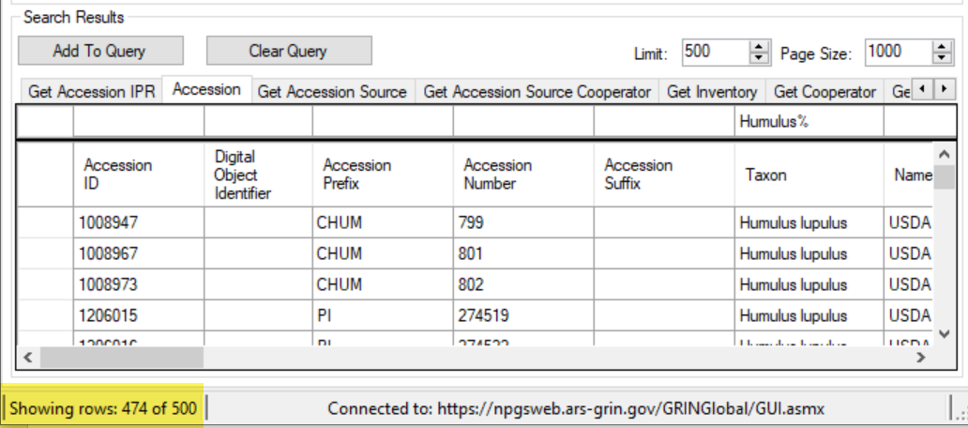

Lists and Tabs in the Curator Tool
You create and name lists (folders) and tabs in the Curator Tool’s left panel as you need them. Static lists are used to store items that point to records in the right panel when the list is actively selected. Lists may be repeatedly used in future CT sessions to locate specific records without needing to recreate a search in the Search Tool.
The left panel is different for every user. Some users will create many tabs, whereas others may have only one or a few. Users create their tabs and lists in unique ways. Name a tab, root folder (top level list), and a sub-list similar to the following. Select a genus in which you are interested.
Right-click! In the CT, right clicking often opens a relevant menu. The displayed menu lists the available options at that point in time.
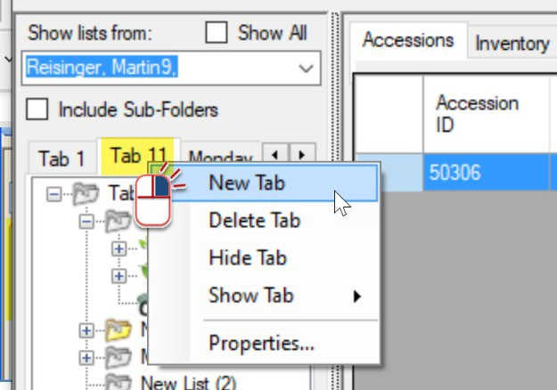
When you right click a tab, the menu displays tab options:  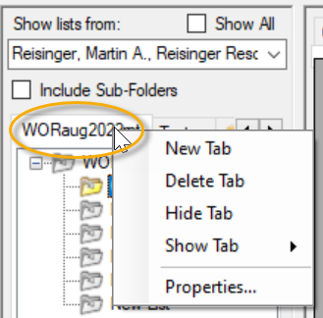 | Right click a folder (list); the menu displays many folder-related options:  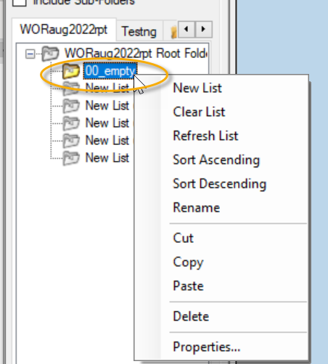

Users in an organization can share lists – see tip further below.

Copy (“drag”) records from the Search Tool to the Curator Tool
This step requires some manual dexterity!
Search for a genus in which you are interested. Then drag the found records from the Search Tool to the Curator Tool.
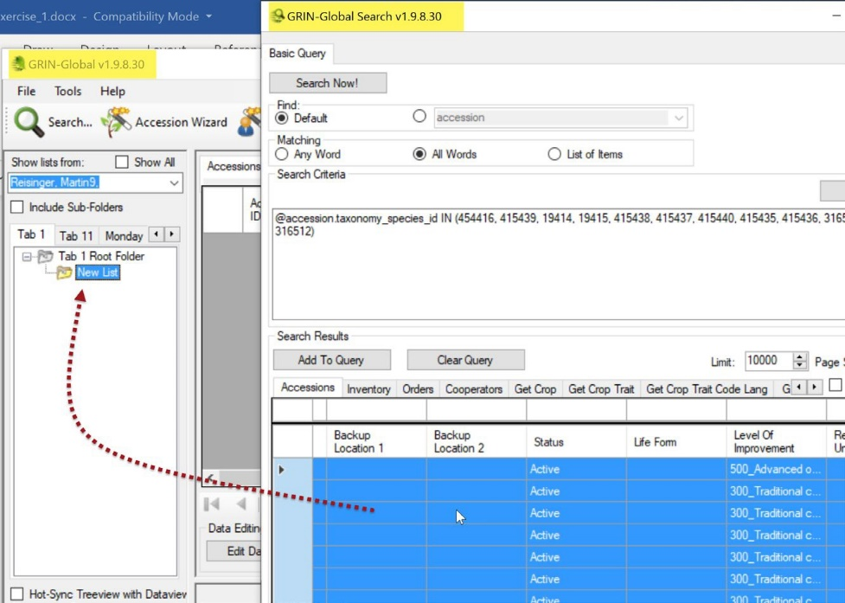
When dragging from the ST to the CT, it is easier when the Search Tool is not full screen, with the Curator Tool behind the ST in the background. You can also drag from the Search Tool (A) to the CT icon on the Windows’ taskbar and then the CT. Below, the user is dragging to the CT icon on the taskbar and then when the CT window displays, over to a list in the List Panel (B):
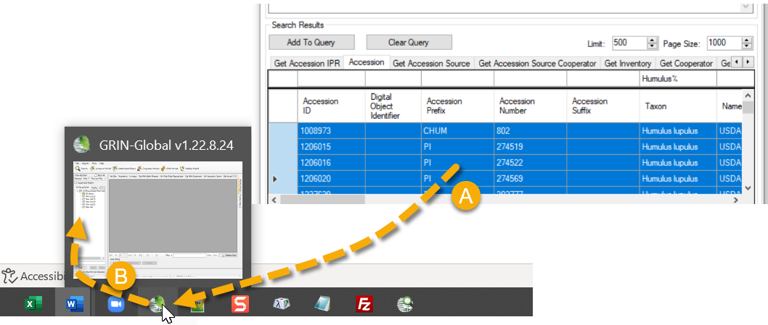
Check out the video: https://www.grin-global.org/videos/lists.mp4

To select the Search Tool’s entire set of found records, click in the upper, left corner:
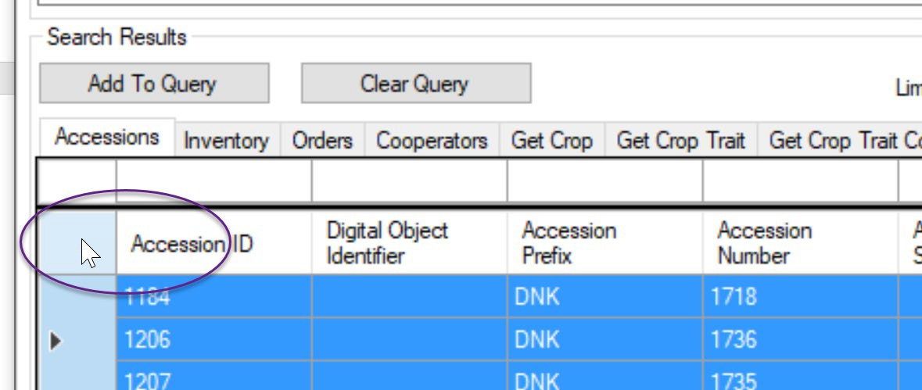
At the left of each row, you can select single rows (or multiple rows using the Shift and CTRL keys while clicking.)
A brief video that demonstrates adding (or updating) data from a spreadsheet is at https://www.grin-global.org/videos/bulk_adding.mp4.

Moving items from one list to another (& renaming lists)
Items in Lists can be moved around. Unfortunately, you cannot select more than one item in a list to move in one operation. However, you can move a list that contains many items, including other lists. Practice moving list items. You can move a list under another list, and you can even move a list to another tab.
Remember that a list’s items are simply pointers to database records that are displayed in the right data grid. If you delete an item in the list in the left list panel, you are not deleting the actual database record.
Your list and tab configuration are stored in the database under your personal account. If you delete the tabs, lists, or items in a list, you have removed that tab/list information from the database, but you haven’t lost any of the genebank’s germplasm data. You will need to recreate a tab or list if you decide at a later point that you want it again.
Lists and tabs are sometimes permanently lost. This happens when the connection to the server has been interrupted.

Close the CT before shutting down your computer. Always close the CT properly as you would any Windows program. (You can click the X in the upper right corner.) If you will be a way from the PC for a while, consider forcing a save of your settings – under Other Options.
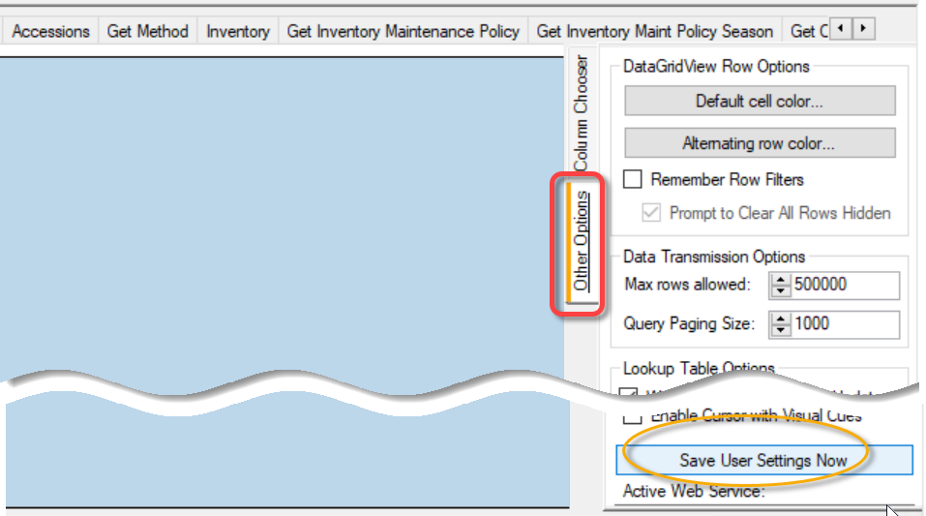

Within the organization, each CT user’s lists are visible to anyone within the organization. If a colleague suggests using one or more of their lists, you can copy them into your environment, that is you can make them “your” lists as well.
Below you can see multiple users listed after the Show All checkbox has been selected (the display this may take a few seconds.) I have two accounts (primarily for specific training issues). When I need to, I will switch to my alternative account and copy a list. Then I switch back to the other account, and Paste the list. Viola!
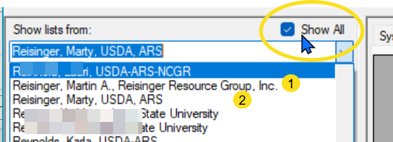

Dynamic Lists
The CT has two broad types of lists. Statis lists were described earlier. Dynamic lists are really different – instead of including items in the list, the list includes a search query. To create a dynamic list, you generally start by using the Search Tool to create a valid query. When satisfied, you then drag the query’s text to the CT.
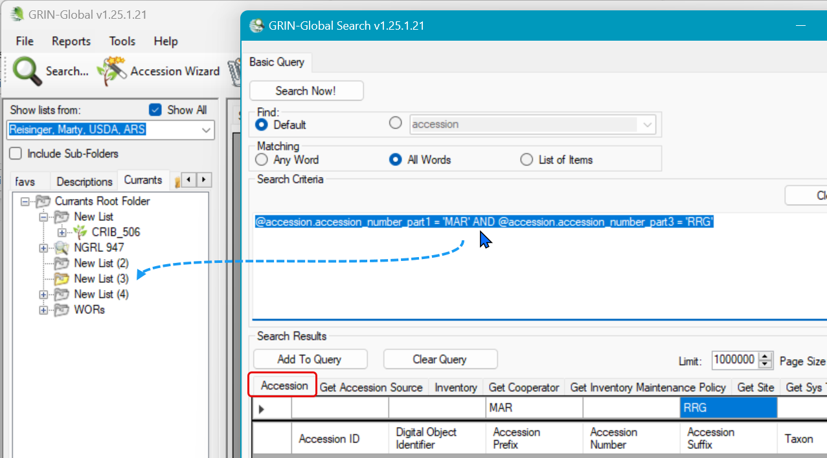
Dynamic lists have been thoroughly documented in great detail – see https://grin-global.org/userdocs.htm#dq.

Create New Database Records
You can create a new accession directly in the accession dataview. (Use a training database!) However, the advatange in using the Accession Wizard is that most of the accession-related dataviews are accessible simultaneously for the same accession. (The accession (passport) data is included in more than one main accession table – in addition to the main accession table, much an accession’s data is stored in supporting accession tables.) In the CT, you could work in one dataview at a time, or use the wizard to move easily among them. In the foreground below, in the wizard window, you see nine dataview tabs in which you can enter data.
The first step is to ensure that the Accessions tab is the active tab in the data grid. If it is active, then click on the Accession Wizard button. The accession wizard displays its own window.
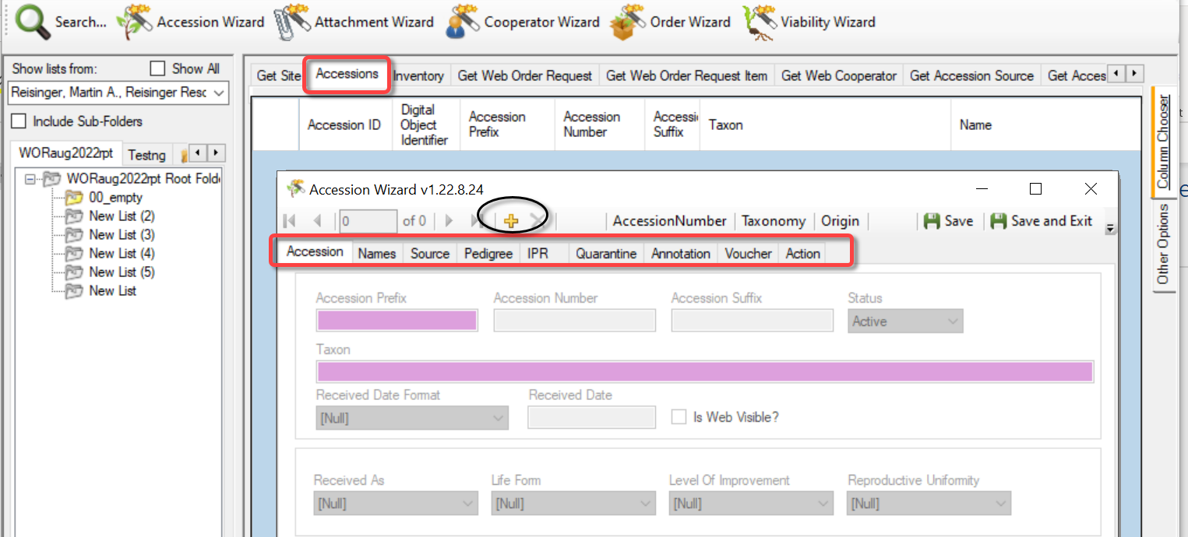
Click the Add new (+) button to begin the inputting of a new accession. Create your own data for the fields. For this practice session, use:
  - Prefix: – your initials
  - Number: - enter a minus one: -1
  - Suffix: some other brief text such as a text combination: I used for example, RRG
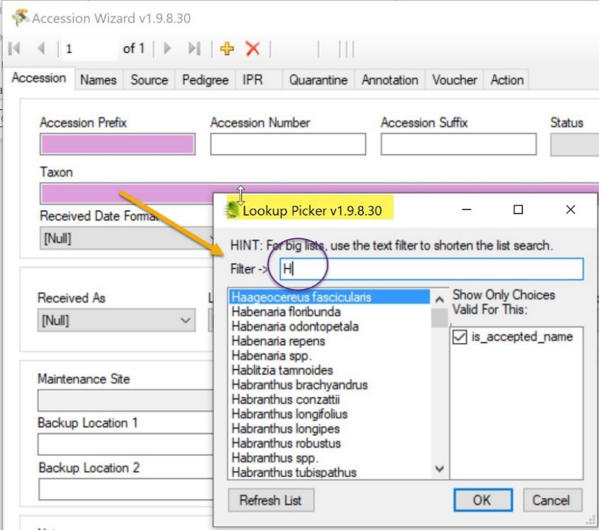
  - Taxon: select a valid Genus species from the Lookup Picker window that pops up. It will pop up when you start typing in the pink box:
Remember to frequently use the Save button (in the upper right corner of each wizard window).

Some fields are required when creating new records. In the Wizards, the pink color is a hint, that the field is required, but in wizards, the significance of the pink color is not consistent.
To practice, at a minimum, fill in the first two screens (the Accession tab and the Names tab). In the Names window, click on the New Name button to start.
Complete three fields in the Names window. For Name Rank, input a number – 1 works! A very brief explanation for this Name Rank field is the following – when an accession has multiple names, the name with the lowest number in the Rank filed is considered the most important.
When finished, click the Save and Exit button in the upper right corner.
Here, and in other parts of the CT, click in another cell or tab to another cell, to complete the entering of data in a cell.

Batch Adding or Updating Records
The Curator Tool was designed to accept large lists from Excel to create batches of new records or to simultaneously update existing records.
Every GG record in the database has a unique ID field. ID fields are automatically assigned by GG to all new GG records. The ID fields can never be edited or deleted by you. You rarely reference the ID field directly because it has no curatorial meaning. However, the IDs are important in drag and drop operations where you are taking data from a spreadsheet and updating existing inventory data in the Curator Tool.
In Excel to GG operations, you always include the ID column. When updating existing records in the GG database, the IDs in the spreadsheet rows must match the existing inventory records’ IDs. However, when adding new records, the spreadsheet cells in the ID column must be empty.

Dragging GG data to a spreadsheet
Besides dragging data from the Search Tool to the Curator Tool, you can drag the data to any suitable Windows program. Spreadsheets are the most frequently used. In fact, GG users often drag data from the Curator Tool to Excel, edit the data there, and then drag the data back to GG to update the GG records.
When using the drag and drop feature:
- always include the ID column heading of the table
- new records always have empty cells in the spreadsheet ID column; when updating existing records, the IDs in the Excel sheet must match the existing GG records’ IDs listed in the datagrid
- the headings in the spreadsheet have the identical spelling as the CT column headings
- although the spelling must match; the column order doesn’t matter
- if you hide a column in the spreadsheet, that data does not carry over to the CT dataview
(tip – rearrange the spreadsheet columns being updated to the left of the spreadsheet – it is easier to drag)
- spreadsheet columns are ignored when their heading names do not match any dataview column heading

In the screen below, the user clicked the Edit Data and then the Add new buttons to determine which fields are required. The pink fields indicate those that are required, but remember that the ID field is always required. (Accessions must have a unique combination of prefix, number, and suffix, and that unique combination is required, but the CT only displays the Prefix in pink. The only other required field is the Taxon.)
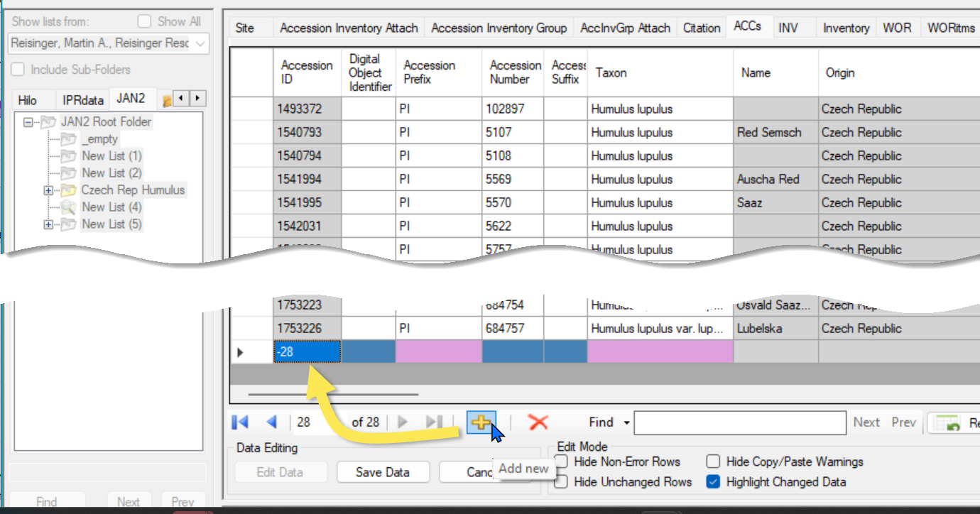
Based on the prior screen, we know that most of the accession fields are not required, so when using Excel to update existing CT records, you typically only need the ID column and the fields being changed.
In the following example, the user is preparing to drag records from Excel to the Curator Tool. They are currently only interested in updating two fields, the Status and the Is Web Visible? But they must also include the Accession ID field.
The Excel column headings are spelled identically to the CT’s. (In the illustration, the CT’s Status and Is Web Visible? columns are not shown.) The records being updated must be in the CT’s datagrid, and the CT must be in Edit mode. The row order of the Excel rows does not need to match the CT’s order.
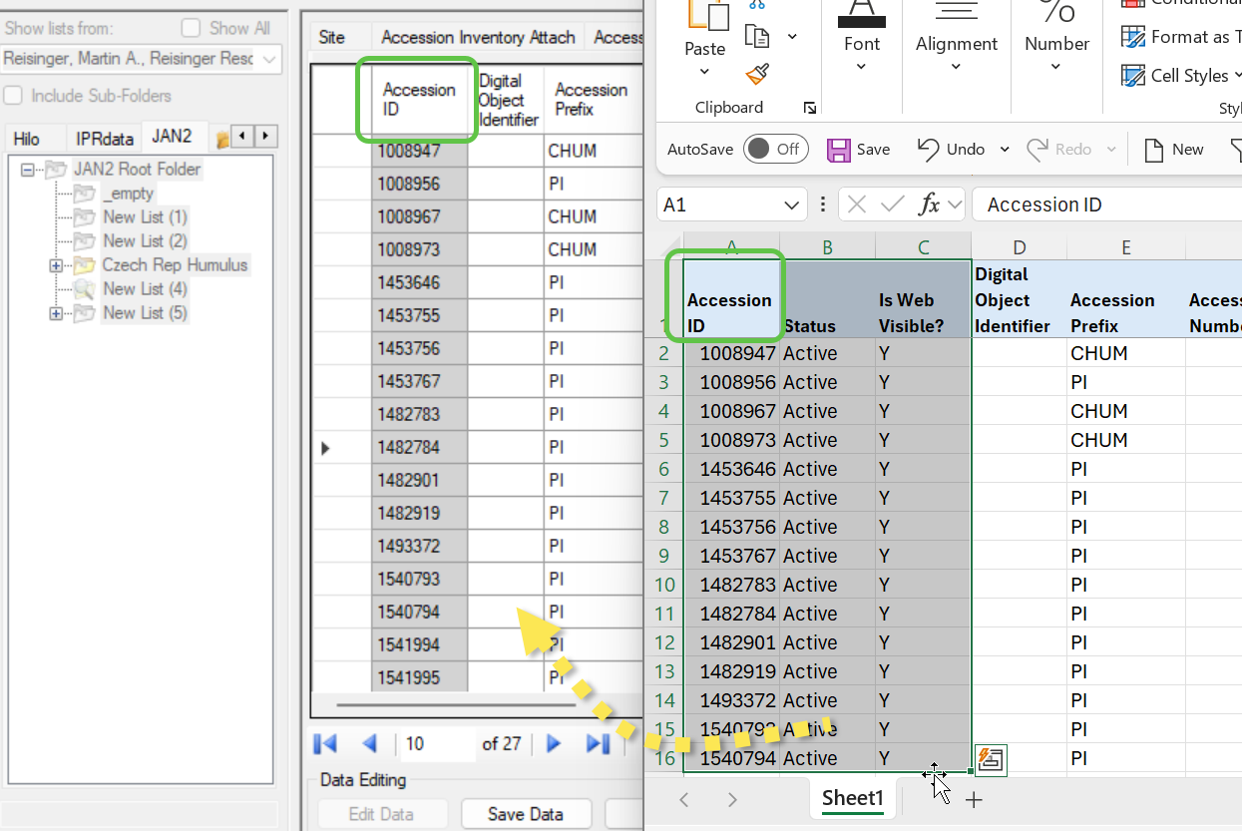

Explore Dataviews
For practice, open at least one dataview whose tab is not visible in the data grid.
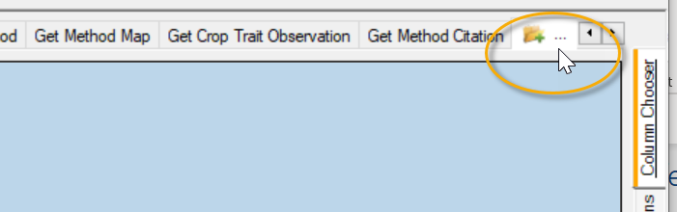
For example, open the Get Code Value dataview:
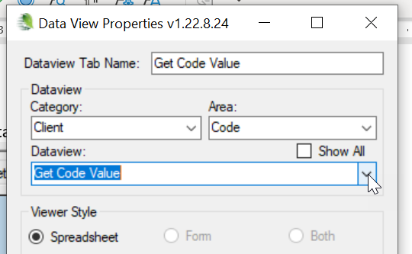
What are these Code Value records? They are used to populate many dropdowns in dataviews that assist the user in selecting a valid entry, such the codes for Status:
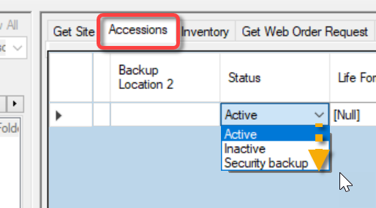
Congratulations! You completed this brief Curator Tool overview. Many more resources are available online at the GG website: https://www.grin-global.org/ Besides the Documentation | User Documents, option check out the Videos link under Training:
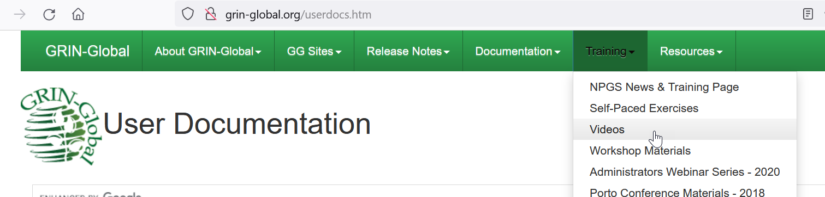

Revisions
January 23, 2026
- Added additional text for emphasis to explain batch updates

January 7, 2026
- Added text re dynamic lists and sharing lists

October 9, 2024
- minor text revisions;
- added links to videos
February 27, 2024
- added details regarding drag and drops

