Cooperator Records



Revision Date
September 16, 2025

Author
Marty Reisinger

Comments/Suggestions
Please contact Marty Reisinger at either marty.reisinger@ars.usda.gov or mar@rrginc.com with any suggestions or questions related to this document.

 | Complete documentation on many aspects of GRIN-Global is available online at the GRIN-Global website’s documentation page: https://www.grin-global.org/userdocs.htm. Recommended: bookmark this page, and avoid printing, as the GG documents are under an ongoing revision process.

Table of Contents

Overview of Cooperator Records 3
Two Main Cooperator Types 3
Cooperator Lookup Tables 4
Cooperator Wizard 5
Creating a New Cooperator Record 6
Cooperator Fields 6
Status Codes 6
Fields Defined 7
SQL for Displaying Cooperator Fields 7
Editing / Updating an Existing Cooperator Record 8
“Super” Cooperator Editors 9
Determining who is a Super Coop Editor 9
Deleting a Cooperator Record 10
Merging “Dups” to become One ACTIVE Coop 10
Appendix A: Clearing Cache Files for the Big Cooperator Lookup 15
Appendix B: Document Revision Notes 16

Overview of Cooperator Records
Individuals and organizations involved with germplasm activities (donors, collectors, breeders, requestors, CT users, etc.) are stored in the GG database as cooperator records. Besides the main Cooperator table, you will see below that several other specialized cooperator tables exist in GG.
When a cooperator record is created for a person, the person’s surname (last name) and first name are included in their respective fields. A cooperator record for an organization omits any entry in these fields.
 | Not to be confused with the Cooperator table, a Site table exists in GG. The Site table is used to specify the sites within the GG organization. For example, in the USDA National Plant Germplasm System (NPGS) has more than 20 sites in that table. Each location within the NPGS has its own respective Site record.

Two Main Cooperator Types
Two types of cooperator records exist in GG:
- “web” cooperators
- “standard” cooperators
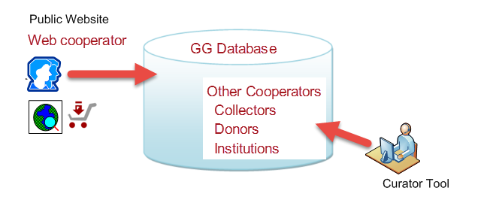 | - web cooperators – users who self-enroll on the Public Website  - standard cooperators  Can be an:  - individual  - organization -- Last Name & First Name fields are empty
We will always distinguish between the two types of cooperator records by including “web” when referring to “web cooperator records.” Otherwise, when stating “cooperator records” we are referring to the main cooperator table (the standard cooperator records).

Web Cooperator Records
A user on the GG public website has an opportunity to self-register – during this registration process the user’s contact information is stored in a web cooperator record. This web cooperator record is not the same thing as the GG cooperator record. (But the information in the web record will get converted into a cooperator record when the user submits an order.)
A web user can indicate multiple shipping addresses and indicate which is the default address to be used when submitting a request from the public website.
Genebank personnel, using the Curator Tool (CT), or by any method, cannot edit the data stored in the web cooperator and web address tables. (The web user is the actual owner of this data.)

Standard Cooperator Records
As mentioned previously, cooperator records contain data on individuals or organizations involved with germplasm activities (donors, collectors, requestors, etc.) Besides storing active address and organization data, cooperator records can be used to store historic data containing the previous addresses of a person or institution.
Sample (partial) Cooperator Record:
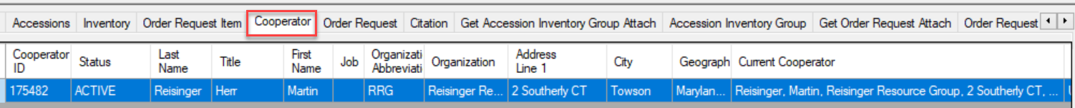
 | Whenever working with, or searching for cooperators or web cooperators, we recommend that you update the cooperator lookup tables.
 | For various reasons, the cooperator table may have similar records for the same person or organization. The Merging “Dups” to become One ACTIVE Coop section explains how to manage “duplicates” and have them linked to each other. Ideally, for any person or organization, there is only one ACTIVE record. Other records should be either INACTIVE, or HISTORICAL.

Cooperator Lookup Tables
Three lookup tables exist to synchronize the three “cooperator” tables.
- Web Cooperator
- Cooperator
- Cooperator (Big)

Why three cooperator lookup tables?
The “Web Cooperator” lookup organizes the Public Website users.
The “Cooperator” lookup has a display field formed by cooperator last name, first name, and organization. It is a simple string used as a lookup on the GG records’ audit fields such as owned_by. It doesn’t need to be too defined because it is used for displaying which curator owns a record.
The “Big Cooperator” lookup includes five fields in the display string so that curators can distinguish public cooperators with similar names. This lookup pertains to the main cooperator table and is the lookup table that a Curator Tool user is typically using when selecting a cooperator.
The Big Cooperator lookup uses five fields:
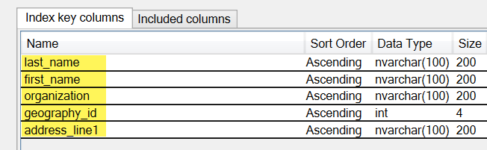
When searching the Lookup Picker for an organization cooperator, if you enter a comma, space, comma, space – before the text, you will bypass the individuals. If you prefer, you can also start with the % wild card, but individuals may be listed as well.
In the following example, the user is looking for the Abbott organization to fill in the Cooperator field in an Accession Source Cooperator record. (The first three fields the lookup is using are Last Name, First Name, and Organization. An organization cooperator record will have empty Last Name and First Name fields.)
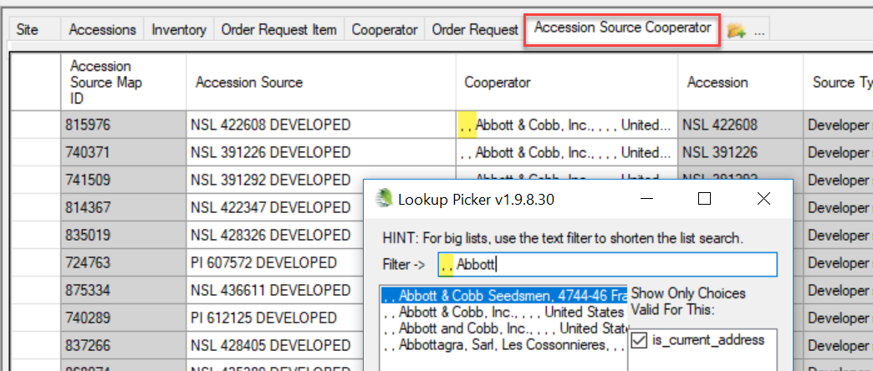
Use the % wildcard anywhere in the text string when searching to broaden your search. (Releases prior to 1.9.9.4 would display an error when the % sign was used in the middle of the search string, but that issue has been resolved .)

Cooperator Wizard
Use the Cooperator Wizard to add new cooperators or to edit existing ones. If you intend to edit an existing cooperator record, use the Cooperator Wizard to quickly locate the desired cooperator record. You can do this from any vantage point in the Curator Tool – you do not necessarily need to be in the cooperator dataview. In the following example, while the user had the Accessions dataview as the active dataview, he clicked on the Cooperator Wizard button and began searching for cooperators with a Last Name beginning with “reising”:
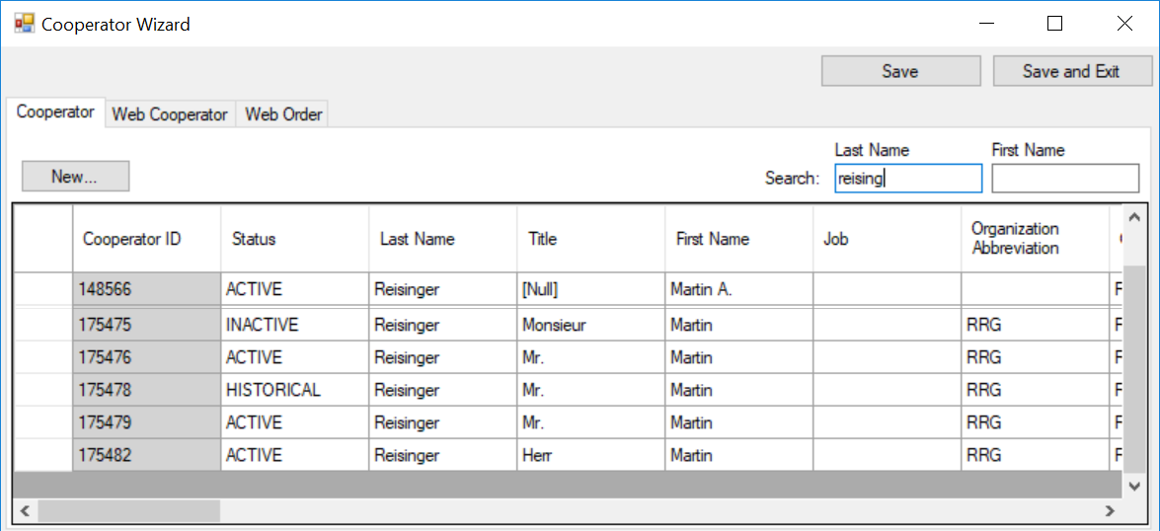
Always search with either the Search Tool (ST) or the Cooperator Wizard before inputting a new cooperator. Use the ST when looking for institutes. Use a wildcard (the % ) to broaden searches.

Creating a New Cooperator Record
Using the cooperator wizard is straightforward. Click on the New… button to create a new cooperator record. The wizard window starts a new row:
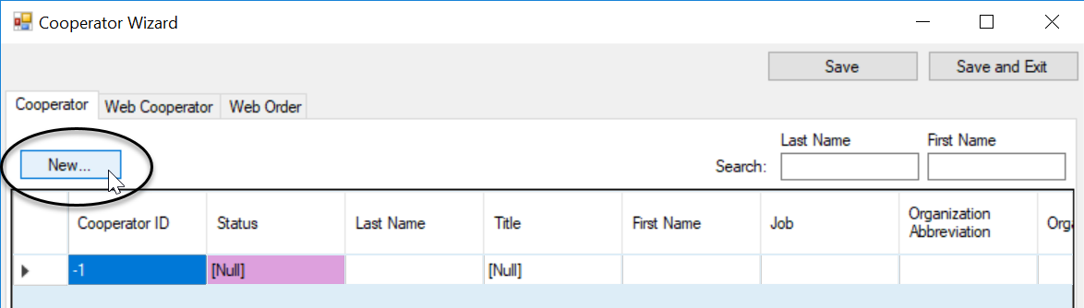

Cooperator Fields
Only two fields are displayed as required – Status and Language. (Language is not shown above – the field could be seen if the window was scrolled to the right.)
If the record is representing a person, the Last Name field should be filled. If the record is representing an Organization, then the Last Name and First Name fields should be left empty.
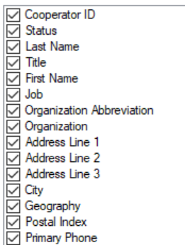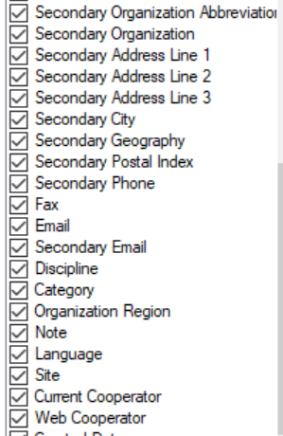

Status Codes
The Status field uses a code from the COOPERATOR_STATUS Code Group.

Fields Defined
These fields are documented in the online GG dictionary at https://docs.google.com/spreadsheet/ccc?key=0AvdWZS-UqEE7dHFaRnRsR1RxOUx0em9KZmhNZTVlRnc&hl=en#gid=2

You can also run a SQL query in the Public Website to display the table’s definitions when you are logged in (if the GG administrator has linked your Public Website account to your CT account. You must be logged in. Sample SQL is shown below the image.
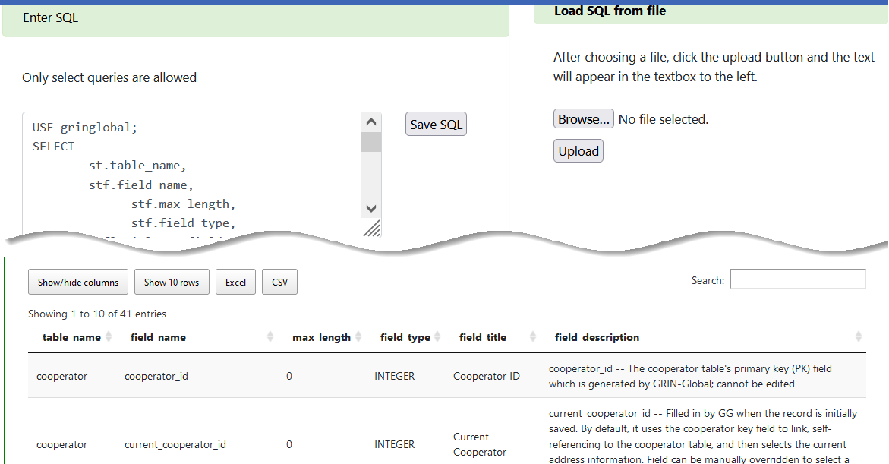

SQL for Displaying Cooperator Fields
USE gringlobal;
SELECT
st.table_name,
stf.field_name,
stf.max_length,
stf.field_type,
stfl.title as field_title,
stfl.description as field_description
FROM
sys_table st
JOIN sys_table_field stf
ON st.sys_table_id = stf.sys_table_id
LEFT JOIN sys_table_field_lang stfl
ON stf.sys_table_field_id = stfl.sys_table_field_id
LEFT JOIN sys_lang sl2
ON stfl.sys_lang_id = sl2.sys_lang_id
LEFT JOIN sys_table_lang stl
ON st.sys_table_id = stl.sys_table_id
LEFT JOIN sys_lang sl1
ON stl.sys_lang_id = sl1.sys_lang_id
WHERE
sl2.sys_lang_id = 1
AND st.table_name = 'cooperator'
ORDER BY
st.table_name, stf.field_ordinal

Editing / Updating an Existing Cooperator Record
Either use the Cooperator Wizard or the Search Tool to find the record to be edited.
You can edit directly in the Cooperator Wizard – find the record, make the edits, and then save the record. (If you need to cancel, click the Order Wizard window’s X in the upper right corner.)
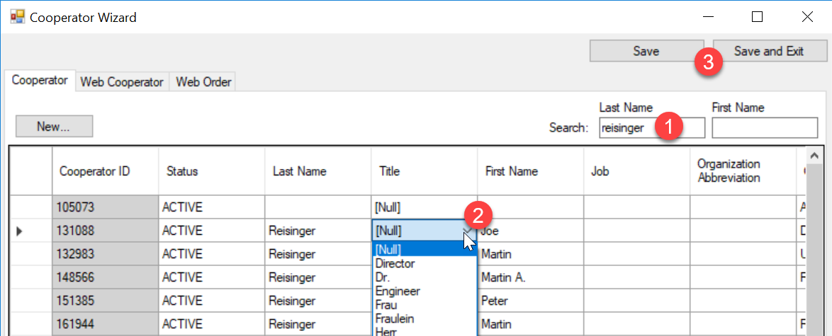
When using the Search Tool, move the record into the Curator Tool, and then use the Cooperator dataview to edit.
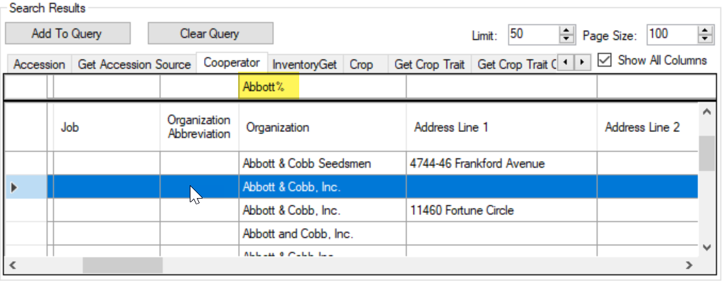

“Super” Cooperator Editors
In NPGS, a permissions GROUP was created by the DBA to allow any CT user included in the group to have full permission to edit any record in the COOPERATOR table.
In GG organizations with multiple sites, it can be a nuisance if a CT user created the cooperator record (and owns it), but someone at another location later needs to edit the record. Adding trained users to a GROUP that can edit any record is very handy.
DBA Information Only:
The following screen is the screen the DBA uses in the Admin Tool to create the group:
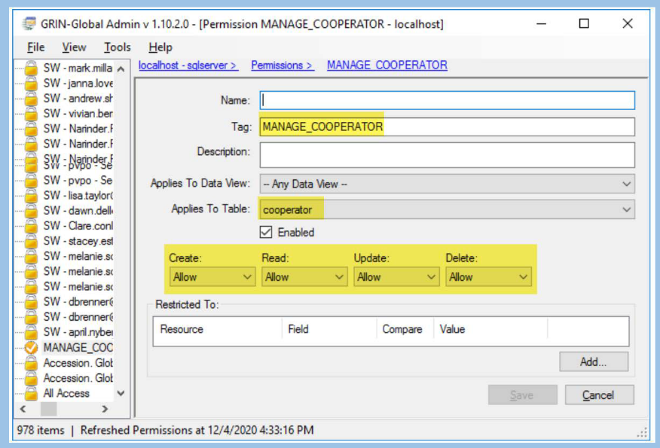

In a GG database administrator’s workshop series, a session covered this topic in depth. A video and slides are available at https://rrginc.com/documents/admin_webinar.html

Determining who is a Super Coop Editor
Run this SQL query in the PW, under Tools:
SELECT c.site_id, su.user_name, sg.group_tag, sp.permission_tag, st.table_name, CONCAT(c.first_name, ' ', c.last_name) AS owner
FROM sys_user su
JOIN sys_group_user_map sgum ON sgum.sys_user_id = su.sys_user_id
JOIN sys_group sg ON sg.sys_group_id = sgum.sys_group_id
JOIN sys_group_permission_map sgpm ON sgpm.sys_group_id = sg.sys_group_id
JOIN sys_permission sp ON sp.sys_permission_id = sgpm.sys_permission_id
LEFT JOIN sys_table st ON st.sys_table_id = sp.sys_table_id
JOIN cooperator c ON c.cooperator_id = su.cooperator_id
WHERE
sg.group_tag LIKE 'MANAGE_COOPERATOR%'
AND c.site_id = 3
ORDER BY sp.permission_tag, c.last_name

Deleting a Cooperator Record
You can delete a cooperator record in the Cooperator Wizard, or in the cooperator dataview, using the standard method for deleting any record in the Curator Tool. (One method: select the record(s); then use the Delete key.)
A cooperator record cannot be deleted if it is used elsewhere. For example, if an accession_source_cooperator record uses that cooperator record, you will not be able to delete the cooperator unless you first delete the accession_source_cooperator record that links to the cooperator.

“Duplicate” cooperator records are based on five fields: first name, last name, organization, address line 1, and geography. In the CT, if you were to attempt to change one of these fields and then save, GG detects the record key as a match to an existing one, hence a “duplicate.” However, GRIN-Global will indicate this as a “delete” error.
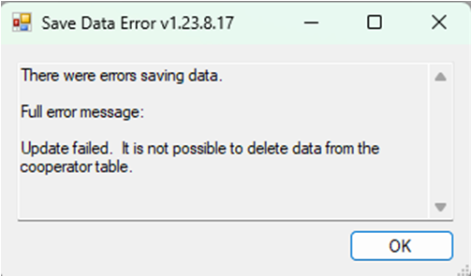

Merging “Dups” to become One ACTIVE Coop
Issue: Two coop records in the database exist for the same person. Both are active records. The goal is to make one INACTIVE, and then have the INACTIVE record link to the active one.
This will result in pooling together any accessions received, collected, or donated by the same person to be tallied correctly on the Public Website. It will also result in having only one cooperator record display for that person in the Lookup Picker for any field that uses the cooperator(big) lookup (the main coop lookup). For example, when creating orders in the Order Wizard, or when selecting a cooperator for the accession_source_cooperator.

Using the following example, two active cooperator records exist for the same person. The older record (175475) is the record to be made INACTIVE, but ultimately link to the other (175482), which will be the only ACTIVE record.
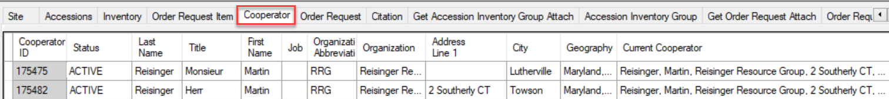
The coop Lookup tables are not current (not unexpected). What is strange – one indicates “Reload,” whereas the other “Update.”
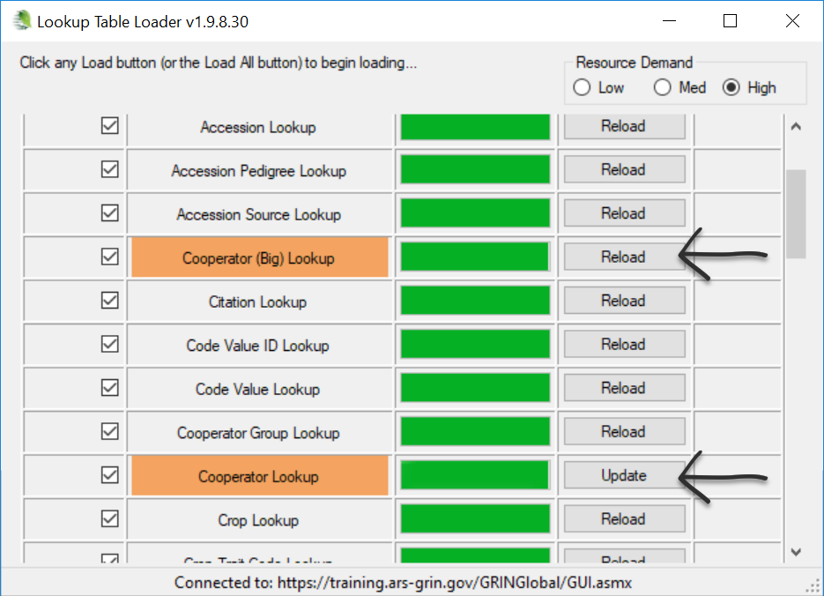
In any case, both should be “refreshed/Updated/Reloaded/whatever.” The table we are primarily interested in the Big Coop.
When adding a cooperator for accession source coop, both display in the lookup. 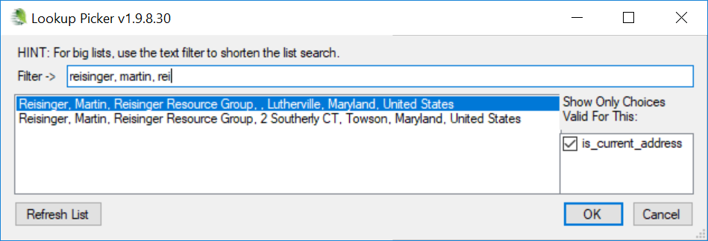
What is displayed in the Current Cooperator field is from the lookup big_cooperator_lookup. Sometimes the Big Cooperator Lookup table must be completely reloaded.
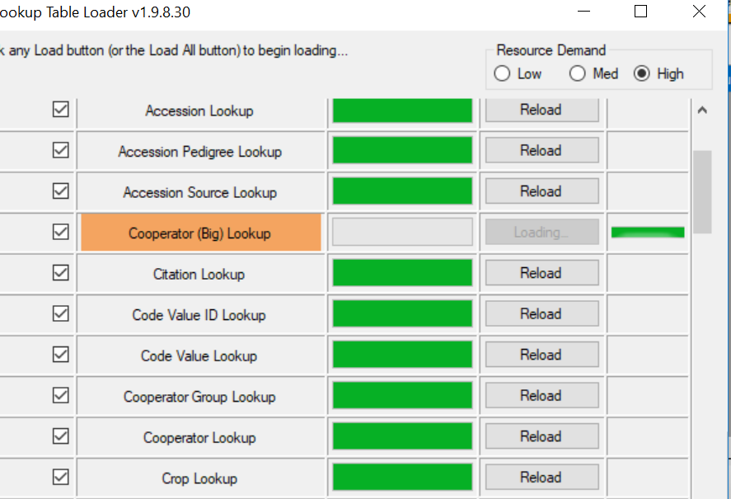

I edited the old record and made two changes:
- Changed status to INACTIVE for 175475 (the older coop record)
- Changed 175475’s Current Cooperator to match the Current Cooperator of the new record (ID # 175482)
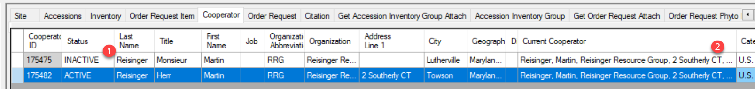
To complete step 2, when using a lookup to fill in the Current Cooperator field, when searching for a cooperator to add data to an accession source coop field, I see two coops:
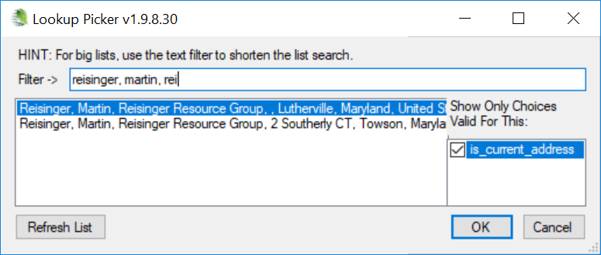
So I checked the Lookups. They appeared to be current. However, I reloaded the Big Coop anyway.
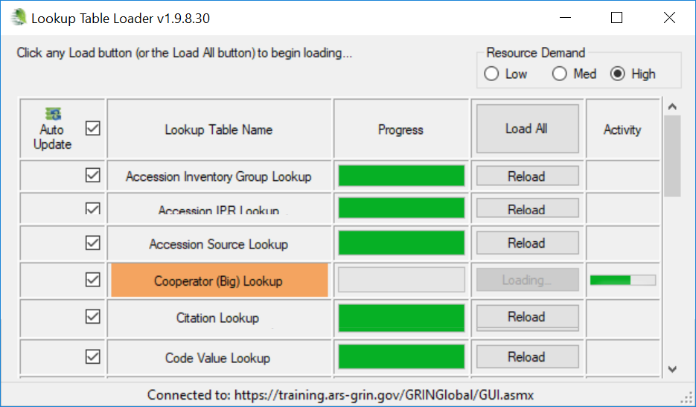

Now when I search for a coop when adding a cooperator to an accession source coop field, with the is_current_address checked, I see only one coop – the ACTIVE coop. I select that cooperator to fill in the Current Cooperator field:
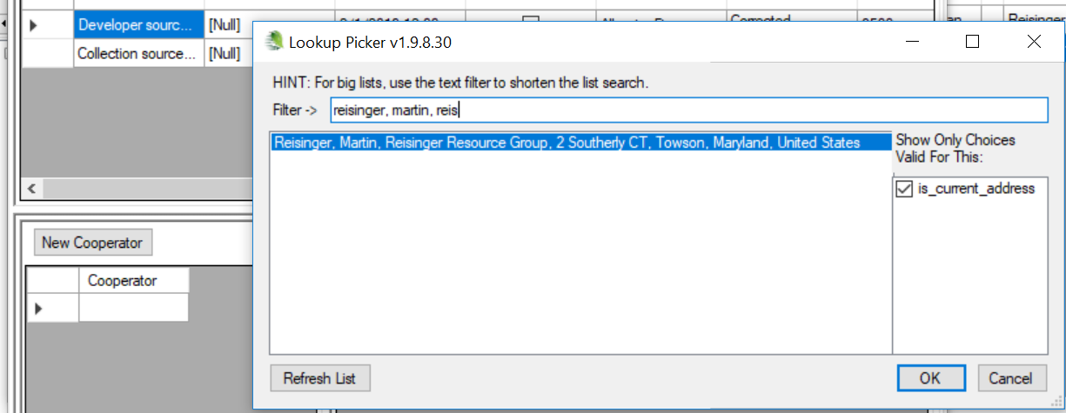

The ultimate goal is reached: the two coop records are “tied together.” The inactive record uses the lookup value of the newer ACTIVE record:
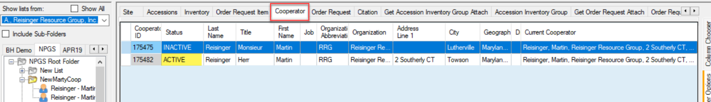

Appendix A: Clearing Cache Files for the Big Cooperator Lookup
If the reloading of a lookup fails, you can always try manually deleting the cache data in
C:\ProgramData\GRIN-Global\Curator Tool\GRINGlobal_training_ars_grin_gov.
Specifically, for the Cooperator (Big) Lookup, the files big_cooperator_lookup_cache.dat and big_cooperator_lookup_RLUT_cache.dat can be deleted.
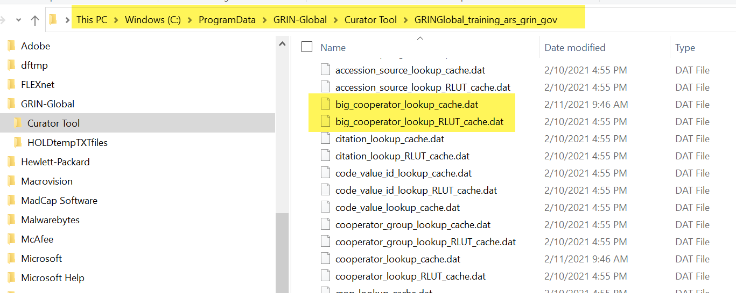

After deleting these files, use the Lookup Table Loader to rebuild the lookup (Other Options | Lookup Table Maintenance):
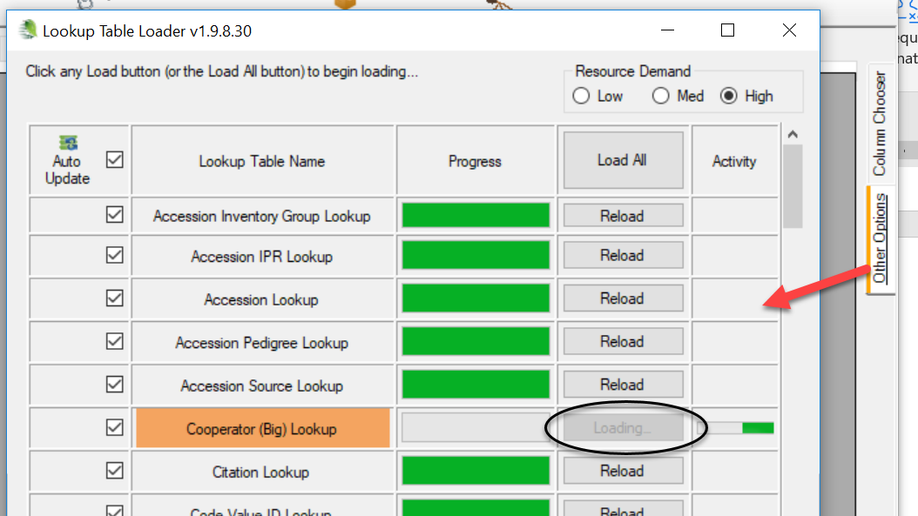

Appendix B: Document Revision Notes

– September 16, 2025
- Added a note and image regarding the updating of a cooperator key when the key matches an existing one

– August 20, 2024
- Fixed a typo
- Minor wording and formatting changes

– November 28, 2023
- Added SQL code example for determining who is included in the MANAGE_COOPERATOR group (Super COOP Editors)

– June 9, 2022
- Added tip regarding the MANAGE_COOPERATOR group permission (Super COOP Editors)

– February 11, 2021
- Added tip / note regarding using a wildcard when searching in the lookup picker
- added screen showing cache data in ProgramData

– May 17, 2019
- Initial creation. Consolidated text from the CT User Guide and other cooperator-related documents.

