Code Groups & Codes in GRIN-Global


Revision Date
Ocotber 10, 2024

Author
Martin Reisinger

Question:
In the Accession dataview, what do all those abbreviations mean in the Received As field?
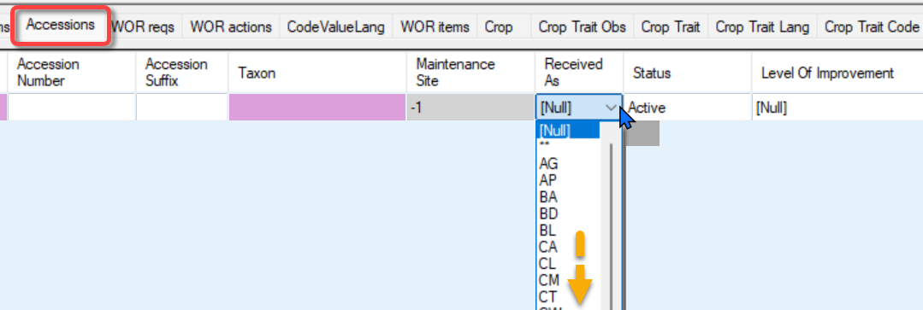
Short answer: These are Germplasm forms (and are abbreviated – USDA curators and technicians have used these abbreviations for 40 years), but any genebank using GG can modify these. In GG, these and any codes in the Curator Tool (CT) dropdowns can be changed to meet the organization’s specific needs.
Long answer:
Several generalities first…
- All CT dropdowns get their options from a Code Group:
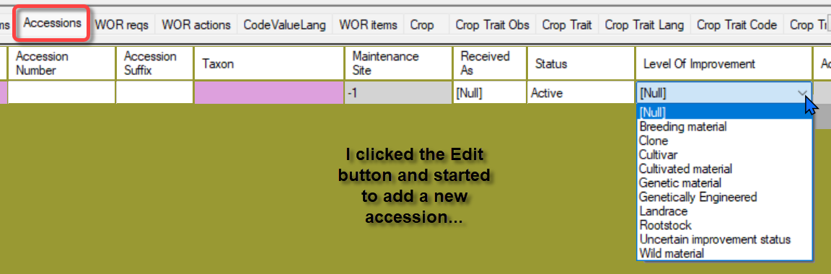
- See the video: https://www.grin-global.org/videos/codes.mp4
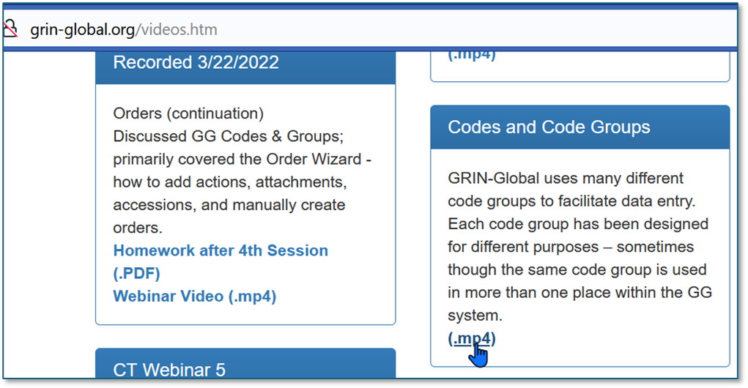
- Administrators - See also: pp. 6-7 in https://www.grin-global.org/docs/gg_recommended_procedures.docx Note that the Admin Tool’s Import Wizard is mentioned, but I do not recommend using the Import Wizard. Use the AT’s Code Group editor or the CT to manage your codes.

- For most CT headings – when you roll over them w/ the mouse – a brief explanation displays. Shown below is the Received As field (A) in the Accession dataview. The rollover states the actual database field name (B) and then a description. In this case (C), the text indicates which Code Group is being used for this field.
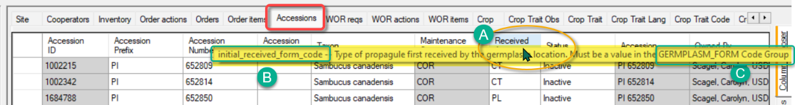
- These groups and codes are documented and can be reviewed from the GG project site. A spreadsheet of codes is provided (but is slightly out of date)

SQL is also provided in that workbook so that you can run SQL against your own database:
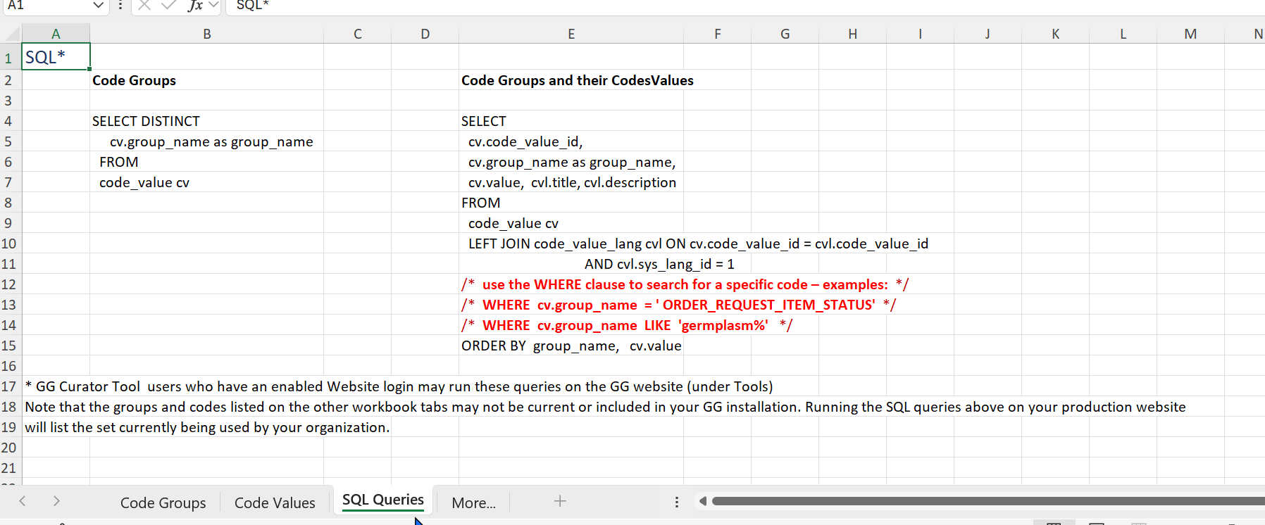
 | Running SQL via the Public Website is documented fully online. Briefly, a CT user account who has a Public Website account can run SQL queries. ( See http://grin-global.org/sql_examples.htm )

- An Administrator can use the Admin Tool to review (& edit the Codes, Titles, and Descriptions) all the Code Groups:
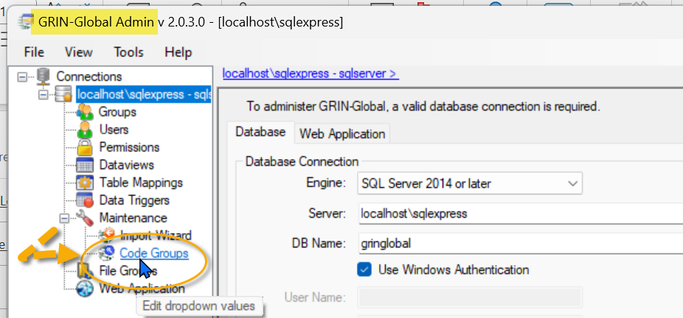
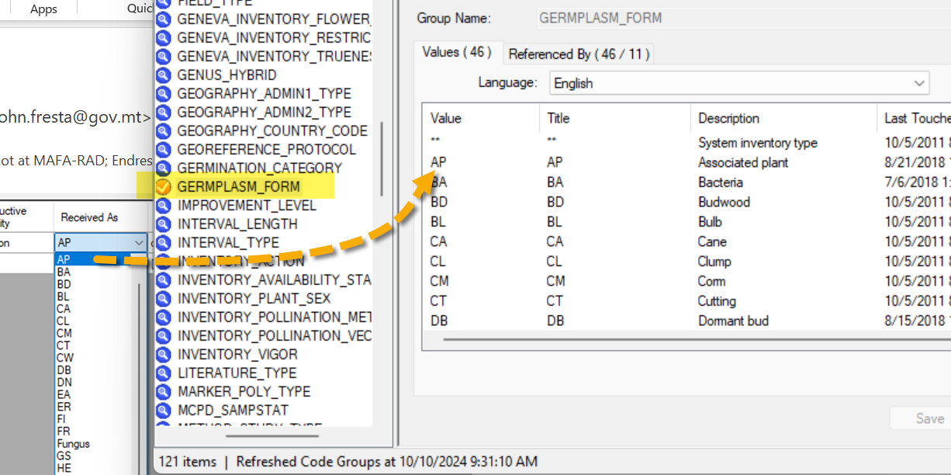
- A CT user can also review the Code Groups and their respective Codes. Below, my current CT list was empty – this allows all codes to display in the Code Value Lang dataview:
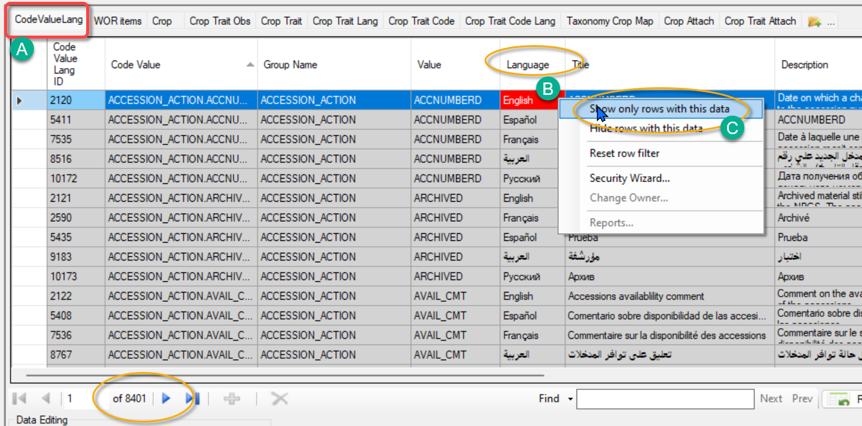

 | An organization should dedicate one person to manage the Code Groups and Codes. Only that person should add/delete/edit these. It does not need to be the GG database administrator (DBA). Users can make suggestions to meet their needs.
 | Administrators: recommended – when implementing GG in a genebank, do not delete any Code Groups (ever), and initially, do not delete any Codes. Use GG for a while. Get user suggestions as you test/proceed. Keep a record of requested changes, and then before implementing in production, make changes and then try them.  The USDA has been using GG for many years, and every month or two, someone suggests a new Code to meet their needs. At the USDA, an Advisory Committee meets monthly to review (among other things) these requests.

