How to Change Information on the
Public Website Site Page


Revision Date
July 18, 2024

Author
Martin Reisinger
In GRIN-Global, on the Public Website, page for each distribution site exists. The data for this page is stored in several inter-related tables; this document explains how this data can be added / updated.

Comments/Suggestions
Please contact Marty Reisinger at either marty.reisinger@ars.usda.gov or mar@rrginc.com with any suggestions or questions related to this document.

 | Complete documentation on many aspects of GRIN-Global is available online at the GRIN-Global website’s documentation page: https://www.grin-global.org/userdocs.htm. Recommended: bookmark this page, and avoid printing, as the GG documents are under an ongoing revision process.

Table of Contents

Background 3
GG Public Website Site Page 3
Site Table / CT Dataview 5
[A] Site (Repository) Label 6
Advanced Search Genebank Option 6
[B] Site Details 7
[C] email address 8
[D] Curators list 8
To find/determine the curators for the site page 8
To add a curator to PW Site Page 9
Editing the Cooperator Map Table 10
Crops and Species for the Site 11
Site Outlook Addresses (USDA / NPGS) 13
Appendix A: Document Revisions 14

Background
The Public Website refers to a site page in several places. The data used by the page is determined by programmed logic and has a legacy that was based on previous GRIN software. Unfortunately the data is not stored in only one table, but is determined based on some legacy relationships. This document will explain where the various data comes from and which tables to use to access the data.
The relevant records that should be kept up to date are in the Cooperator and the Cooperator Map tables. A CT user included in the Manage_Cooperator permission group can update any record in these two tables. For specific how-to instructions refer to the sections To add a curator and Edit the Cooperator Map for more details.

GG Public Website Site Page
Many screens display a link to a site (repository) page, such as the following: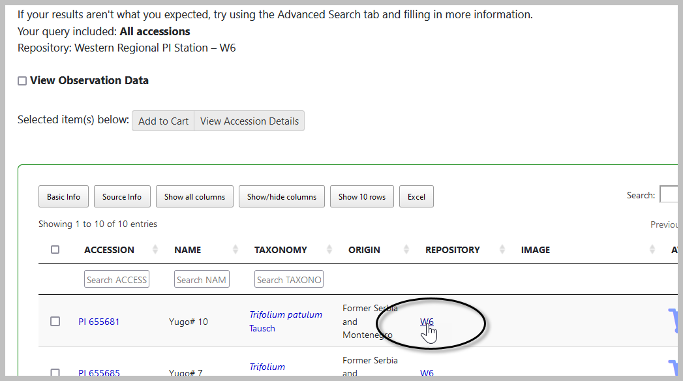
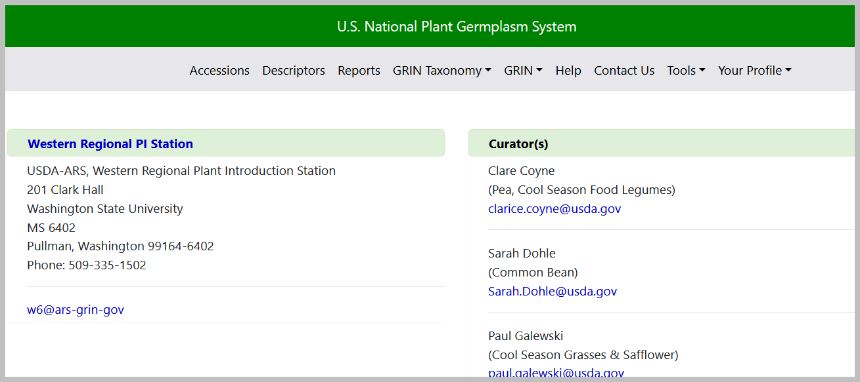
Site pages can be displayed directly using the following URL as a template:
https://npgsweb.ars-grin.gov/gringlobal/site?id=1
where the red number indicates the site’s site_id from the site table:
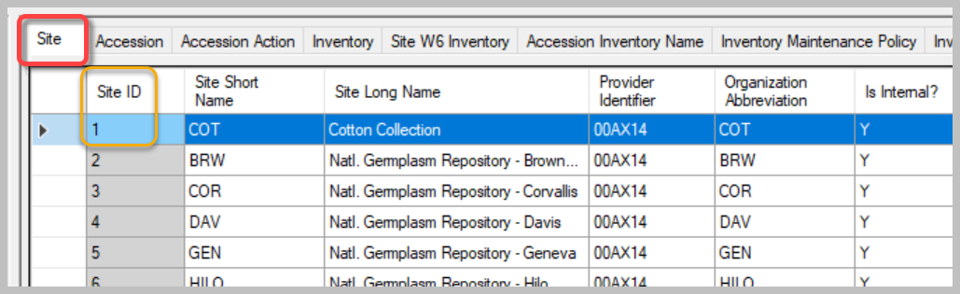
Site W6 is used in the following example and the lettered components are expanded below..
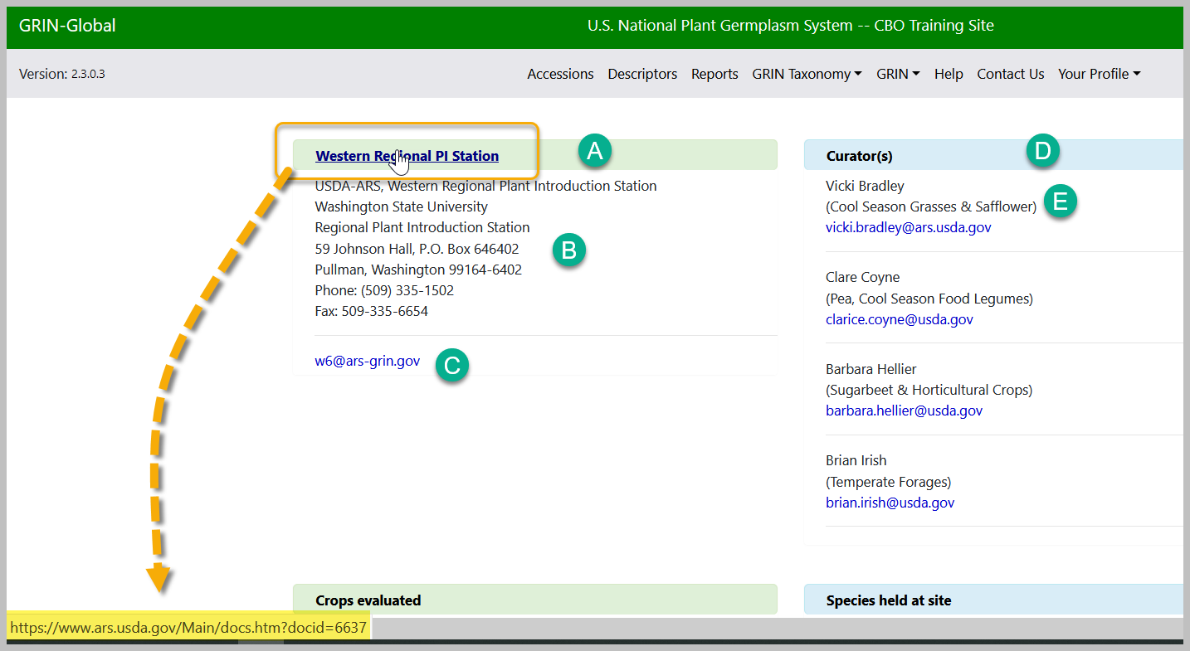

Site Table / CT Dataview
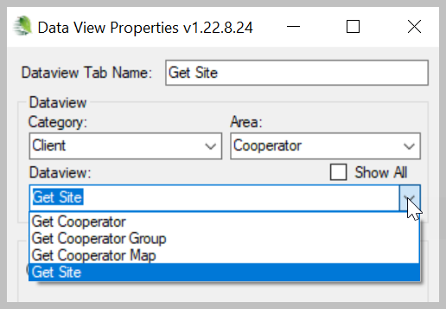

[A] Site (Repository) Label
The label on the PW gets the data form the corresponding Site record’s Site Long Name field:

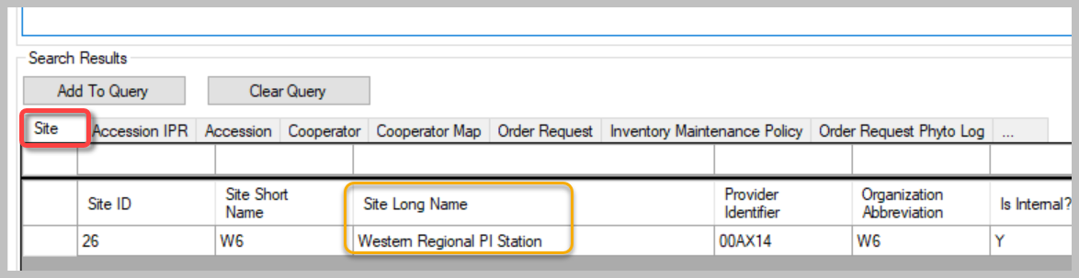

Advanced Search Genebank Option
On the PW Advanced Search, the Genebank option uses two fields (combined).
Table: Site
Field: Site Long Name
Field: Site Short Name
Example: Western Regional PI Station – W6
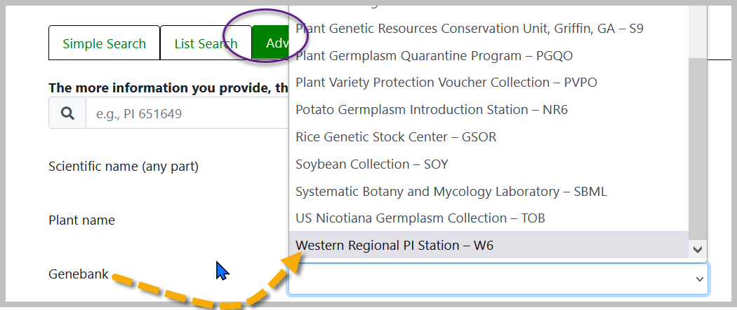
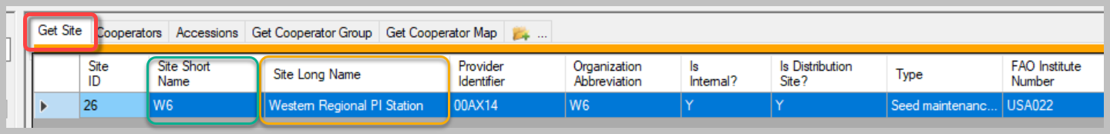

[B] Site Details
Most of the Details (B) and (C) are stored in the site’s Cooperator record.
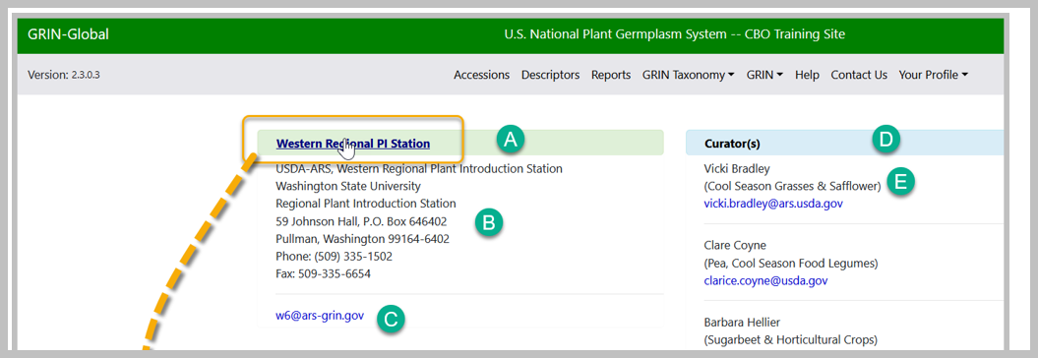
The cooperator record for the site (W6 in this case) has the following conditions:
@cooperator.status_code = 'ACTIVE' AND
@cooperator.last_name IS NULL AND
@cooperator.organization_abbrev = 'W6'
(W6 used as example)
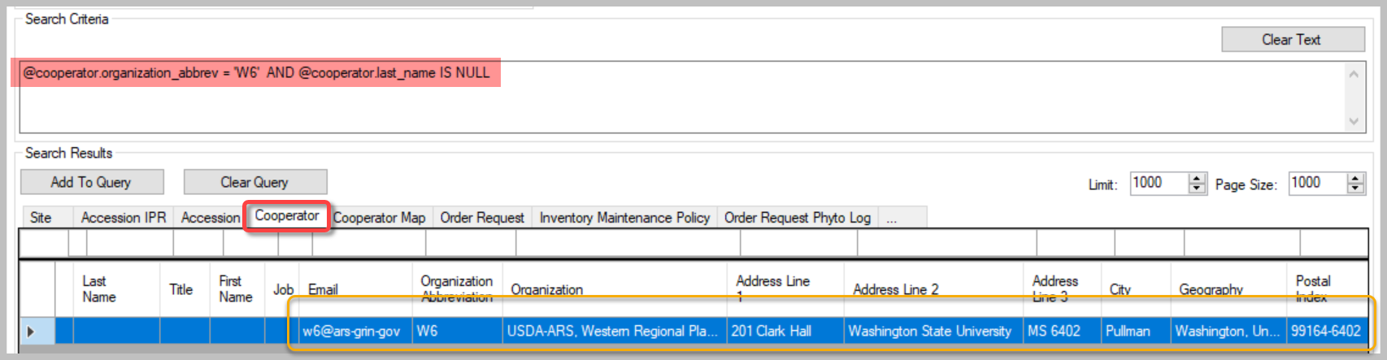
The data on the PW page comes from the record:
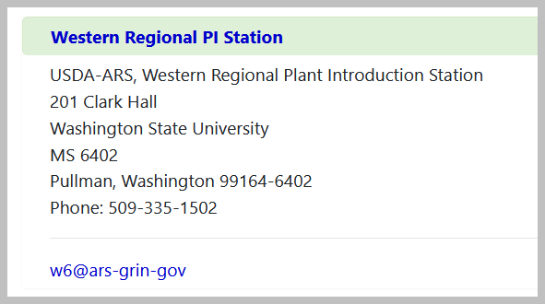

[C] email address
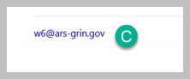
Also stored in the site’s cooperator record in the email field. A site may use several different site “distribution email addresses” for different purposes. For more information on the Outlook email addresses used at NPGS, see Site Outlook Addresses.

[D] Curators list
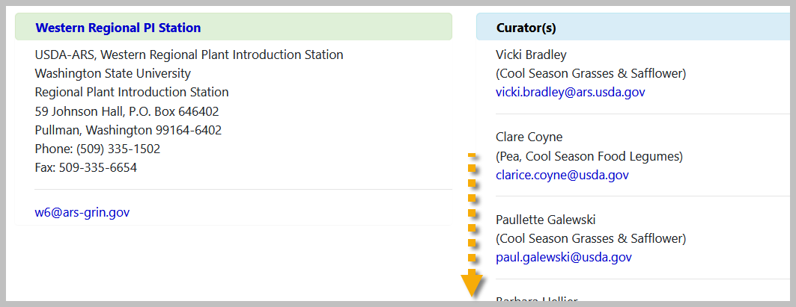

To find/determine the curators for the site page
Search in the cooperators dataview:
@cooperator_group.group_tag = 'W6'
INTERSECT
@cooperator_group.group_tag = 'CURATORS'
 | Note that the status is ignored here – an INACTIVE coop was displayed (this is an older screen image)
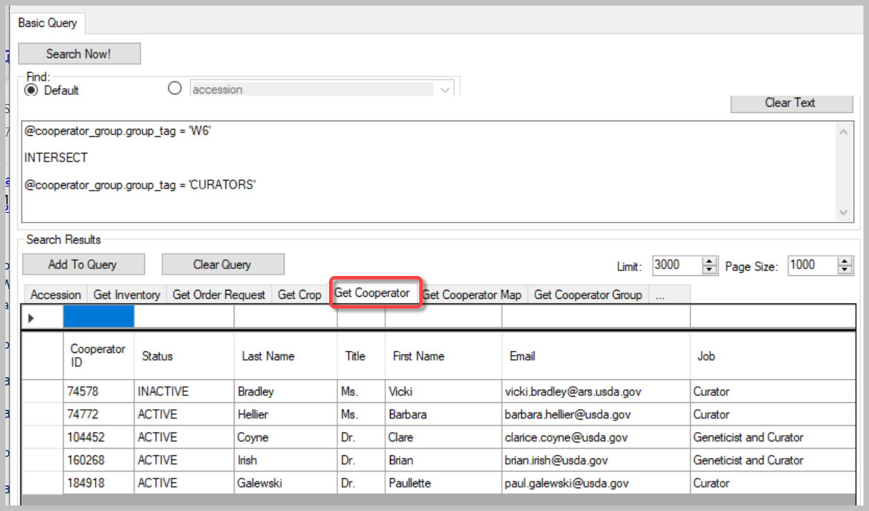

To add a curator to PW Site Page
- The curator must be in the Cooperator table.
- Then two records related to the curator-cooperator must be added to the Cooperator Map table as shown below. For each new record, select the curator for the Cooperator field. For the Cooperator Group field, add:
  - NPGS Repository Curators
  - Staff [– and the respective site]
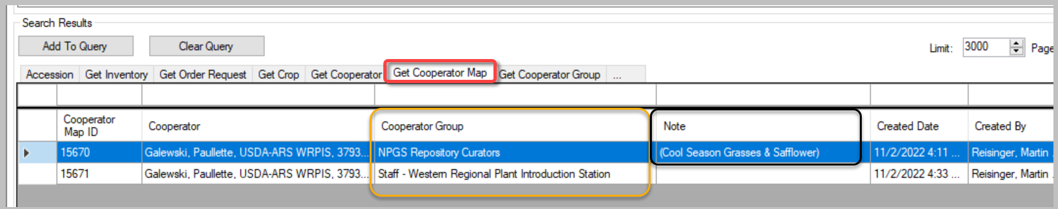

In the Note field for the NPGS Repository Curators record, include in parentheses (for consistency), the crops managed by the curator (E) (see image above)
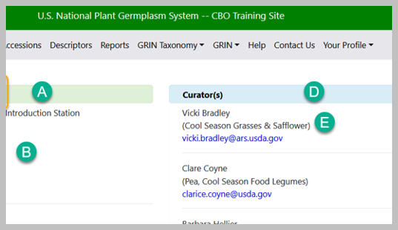

Editing the Cooperator Map Table
Anyone who is included in the Manage_Cooperator permission group can update any record in the Cooperator_Map table (as well as the Cooperator) table. The Cooperator_Map table has the records that indicate the curators used by the site page.
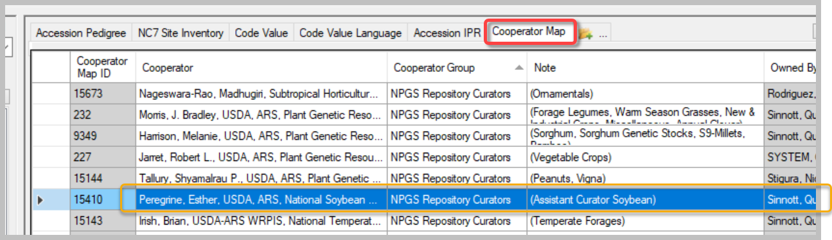
To determine who is included in the Manage_Cooperator permission group, you can run this SQL query on the Public Website:
SELECT su.user_name, sg.group_tag, sp.permission_tag, st.table_name, CONCAT(c.first_name, ' ', c.last_name) AS owner
FROM sys_user su
JOIN sys_group_user_map sgum ON sgum.sys_user_id = su.sys_user_id
JOIN sys_group sg ON sg.sys_group_id = sgum.sys_group_id
JOIN sys_group_permission_map sgpm ON sgpm.sys_group_id = sg.sys_group_id
JOIN sys_permission sp ON sp.sys_permission_id = sgpm.sys_permission_id
LEFT JOIN sys_table st ON st.sys_table_id = sp.sys_table_id
JOIN cooperator c ON c.cooperator_id = su.cooperator_id
WHERE
sg.group_tag LIKE 'MANAGE_COOPERATOR%'
ORDER BY sp.permission_tag, c.last_name

Crops and Species for the Site
Lower on the page, lists of the crops and the species held at the site are displayed. How are these determined?
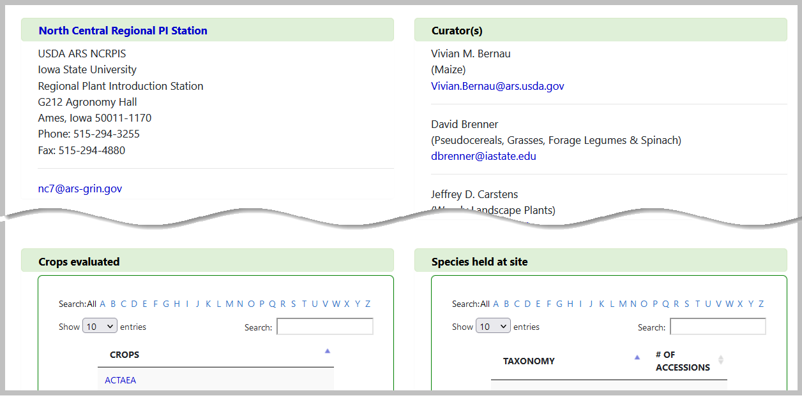
Basically – for Crops, a relationship exists between the site and the crop tables via the ownership of the crop records. Crop records have an owner; the record owners belong to a site. Crops listed on the site page are those which are owned by a user from the site.
Note that these owners are not necessarily "curators" at the site.
Similarly, "Species held at site" on the site page are those species with active accessions owned by a user at the site.
Multiple methods exist for reviewing these. There are some reports under the PW Report menu for internal staff.

The following SQL queries may be run under the PW Tools Query feature:

Curators and their Crops & Species
SELECT distinct ts.name AS Species_name, c.last_name AS Curator, crop.name AS Crop_Name
FROM taxonomy_species ts
JOIN taxonomy_crop_map tcm
ON ts.taxonomy_species_id = tcm.taxonomy_species_id
JOIN crop
ON crop.crop_id = tcm.crop_id
JOIN crop_trait ct
ON crop.crop_id = ct.crop_id
JOIN cooperator c
ON ct.owned_by = c.cooperator_id
JOIN site s
ON c.site_id = s.site_id
WHERE s.site_short_name = 'NC7'
ORDER BY ts.name

SELECT distinct a.accession_number_part1, a.accession_number_part2, a.accession_number_part3, ts.name AS Species_name, c.last_name AS Curator, crop.name AS Crop_Name
FROM accession a

JOIN taxonomy_species ts
ON a. taxonomy_species_id = ts.taxonomy_species_id
JOIN taxonomy_crop_map tcm
ON ts.taxonomy_species_id = tcm.taxonomy_species_id
JOIN crop
ON crop.crop_id = tcm.crop_id
JOIN crop_trait ct
ON crop.crop_id = ct.crop_id
JOIN cooperator c
ON ct.owned_by = c.cooperator_id
JOIN site s
ON c.site_id = s.site_id
/* WHERE s.site_short_name = 'NC7' */
WHERE ts.name = 'Phaseolus vulgaris'
ORDER BY ts.name

Curators and their Genera
SELECT DISTINCT genus_name, s.site_short_name, last_name, first_name
FROM taxonomy_genus tg
JOIN taxonomy_species ts
ON ts.taxonomy_genus_id = tg.taxonomy_genus_id
JOIN accession a
ON a.taxonomy_species_id = ts.taxonomy_species_id
JOIN cooperator c
ON a.owned_by = c.cooperator_id
JOIN site s
ON c.site_id = s.site_id

WHERE s.site_short_name = 'NC7'
AND a.status_code = 'ACTIVE'
/* or by
WHERE genus_name = 'Genus'
*/
ORDER BY genus_name

Site Outlook Addresses (USDA / NPGS)

ARS_GRIN_W6 vs. w6@ars-grin.gov
In 2022, new Outlook lists were created by the DBMU to ensure a consistent naming convention for distribution lists. These lists were primarily used with the GG Ordering process.
Most sites have other Outlook distribution lists that historically had the format sitecode@ars-grin.gov.
The format of the ordering email lists is:
ARS-GRIN-sitecode
The list can be expanded in Outlook to determine who is included:
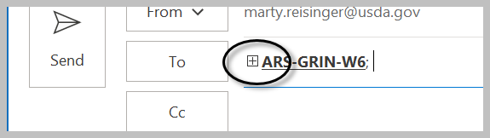
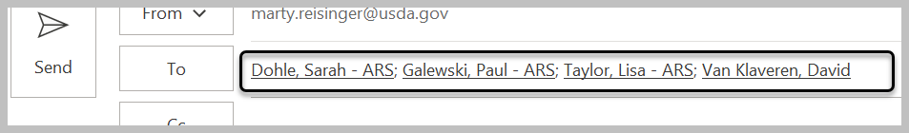

How to edit
Contact DBMU’s Kurt Endress who can edit the ARS-GRIN-XXX(X) addresses. These addresses can also be edited by someone with at your site the proper IT Outlook Admin rights. Email addresses with the older @ars-grin.gov domain can be edited by someone in the DBMU.
An ARS-GRIN-ALL was also created around the time when the site addresses were created. This list combined three prior lists: “ARS-Primaries,” “ARS-Curators,” and “ARS-PGOC.” Contact Matt or Kurt to update ARS-GRIN-ALL to add new staff or remove staff no longer active.
In Outlook, you can expand the address to see its members:
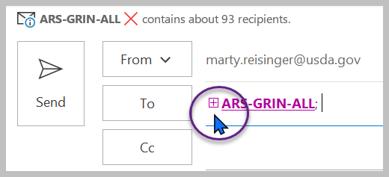 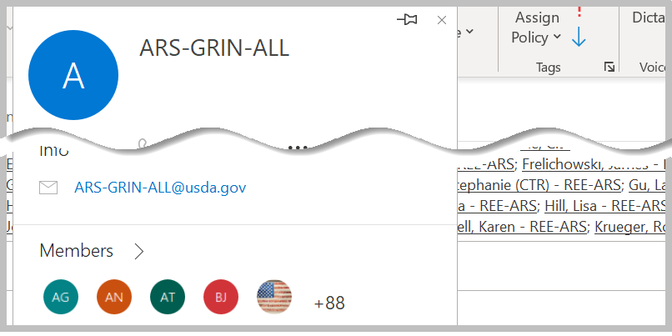

Appendix A: Document Revisions

July 18, 2023
- removed “Matt Riggs”

June 29, 2023
- Added a paragraph in the Background section to jump to the specific how-to instructions

June 28, 2023
- Included a background section, more details, edits in general, and images

June 16, 2023
- Included more details and images on the site’s cooperator_map records

June 8, 2023
- Included more details and images on the site’s cooperator record

