Attachment Wizard


Revision Date
January 23, 2026

This document includes changes to the revised attachment wizard included in Curator Tool version 1.21.10.4 and later versions.

 | Please send any questions related to the wizard to marty.reisinger@usda.gov or mar@rrginc.com.

The Appendix contains change notes pertaining to this document.

Author
Martin Reisinger

TOC

Overview 4
Initial Tips 4
Background 5
Attaching Files 6
Deleting Attachment Files 6
Viewing Attachments 7
Main Wizard Window 7
Steps when using the Wizard (Summary) 8
Viewing Attachments 8
Viewing … in the Curator Tool 8
Viewing … in the Public Website 10
Editing Attachment Records 12
Canceling Changes 12
Errors 13
When Attaching 13
Error Example: Filename Not Matching the Designated Delimiter 15
Known Bugs 16
Folder and File Naming Conventions – Important! 17
Folder Paths Can Impact the Attaching 17
Filename Components 18
What Types of Files Can be Attached? 21
File Include and Exclude Filters 22
Frequently Asked Questions 23
FAQ 01 How do you attach multiple images to more than one accession? 23
FAQ 02: Why is there an Accession button when there isn’t an Accession attachment table? 25
Parsing File Names 25
Smart Parsing 26
Delimited Parsing 26
Fixed Field Parsing 26
Two Other Parsing Options 27
Alternative Methods for Attaching Images 28
Attaching Files Directly to a List Item 29
Batch Method to Select Attachments 30
Drag and Drop Method to Select Attachments 34
Attachment Wizard Window Details 35
Grid View tab 35
Form View tab 36
Attachment Record Fields 36
Attach Date 41
Plant Part 41
Locations of Attachment Files 42
NPGS Attachment File Locations 42
URL Links 43
Alternative Method for adding links 43
Appendix A: Making a Batch of Folders 45
MD – Make Directory DOS Command 45
Changing Options for Folders (so that they display (Show hidden folders)) 46
Default File Explorer Settings 46
Appendix B: Attachment Locations 48
Locations of Attachment Files 48
Examples 49
Appendix C: Document Change Notes 50

Overview
Genebank staff can use the Curator Tool’s Attachment Wizard to upload images and other files (such as PDFs, spreadsheets, documents) to GRIN-Global (GG). In GG, these various files are considered “attachments” because they are associated with, or “attached to,” GG records. These files supplement GRIN-Global (GG) data. (A technical difference is these attachment files are not stored in the actual GG database tables.)
In the GG Public Website, germplasm requesters can add documents with their submitted requests – these files too are “attachment files.” The genebank staff can view these attachments within the CT’s Order Wizard and within the Attachment Wizard.
In GG, it also possible to include links to URLs as attachments. However, sometimes URLs are simply included within the text of a database Note field.

Initial Tips
 | Ensure the name of the file being attached – the image, docx, PDF, etc., is correct. When attaching files to accessions or inventory, the wizard attempts to match the file’s name with a corresponding inventory or accession identifier.
Before invoking the Attachment Wizard, configure your CT so that the selected GG records in the right panel, the datagrid, are the records to which the image/document files are to be attached.
Remember also that you can drag files from the Windows Explorer window to an item in a CT list. In the example below, the user has the Inventory dataview active before invoking the Attachment Wizard. Images will be attached to the inventory records:
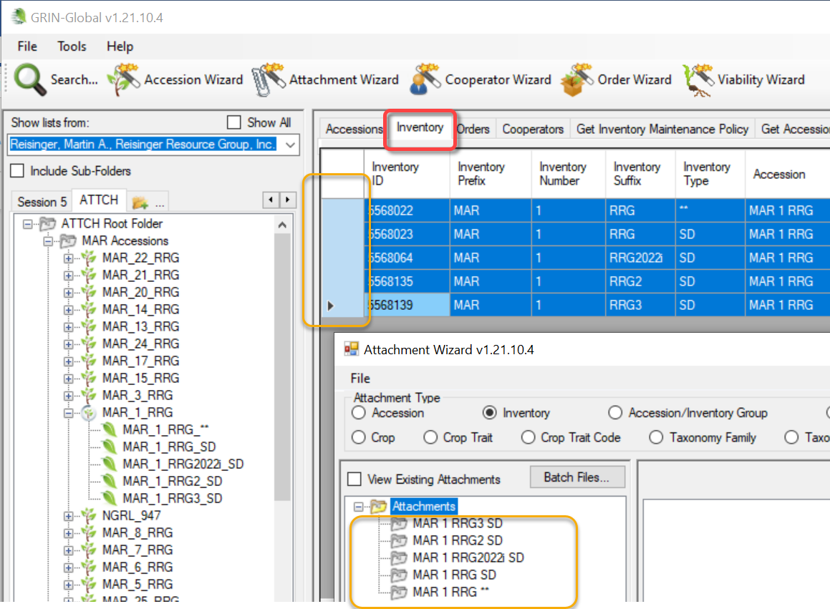
 | When referring to files being attached, throughout the text, rather than state “images/documents” we’ll simply state “images” or “files.” The attachment wizard will be referred to as either the Attachment Wizard or simply the “wizard.” When referring to the Order Wizard, we will state the full name.
 | When using the CT, multiple wizard windows can be open simultaneously.

Background
Besides uploading files, the Attachment Wizard also creates “attachment” records in the GG database. Each attachment record points to an uploaded file and makes it possible to document the attachment records with descriptions, dates, and other information pertaining to the image or document file. The public website can display this information (if the attachment record is designated as web visible.)
GRIN-Global has many attachment tables; prior to release 1.21.10.4, the attachment wizard uploaded attachments specifically with inventory records. The revised (current) wizard, titled the Attachment Wizard, is similar to the prior Inventory Attachment Wizard in appearance. The main enhancement is the ability to attach to additional record types.
When attached to a system inventory record (Inventory Type **), the file is considered to be associated with the accession and not with a specific inventory lot.

Attachment Tables
Beginning with release 1.21.10.4, the wizard can attach files to eight GG attach tables. GG attachment types to which uploaded files will be associated:
- Inventory
- Crop
- Crop Trait
- Crop Trait Code
- Method
- Accession Inventory Group
- Order Request
- Taxonomy Family
- Taxonomy Genus
- Taxonomy Species
URL links can also be treated as “attachments.” However, they are added to the database in a different manner than physical file attachments. Refer to the URL Links section for details.

File Types
The wizards have been designed to handle files with specific formats. We often know what kind of file is by its extension – a Word file is typically named xyz.docx, an Adobe Acrobat file as xyz.pdf, and so on. Sometimes file types are introduced which may not be universally compatible, such as images from Apple iPhones that have an “.heic” extension.
Sometimes there are workarounds. Instead of HEIC, you can save the file as a jpg. On your phone, go to Settings / Camera / Formats … then select Most Compatible. Often there are converters – software programs designed to convert a file type to a different one. For example, “Freeconvert.com” is one source for the HEIC converting.
See the section What Types of Files Can be Attached for more details about file types.

Attaching Files

Curator Tool
In the Curator Tool, three basic methods exist for attaching files:
- Drag files directly from Windows Explorer to an item in a CT list
- Drag files into the Attachment Wizard (from Windows Explorer to an item in wizard)
- Use the Batch Files method in the Attachment Wizard (this method opens a Windows Explorer window in which you can then select the containing folders or the files directly)
The first method is perhaps the simplest. The third method above is generally used when you have many files to be attached at one time.

Public Website
The germplasm requester submits a request and then can add documents as attachments. For details, read the Public Website Attachments section.

Deleting Attachment Files
Don’t confuse deleting the attachment records with deleting the attachments. Currently, if the attachment resides on a storage location where GG has permission to delete the file, then the file will be removed from the storage location - but if GRIN-Global does not have permission to remove files, then the attachment file will remain at that location. However, the attachment record will be deleted.
In NPGS, all GG attachment files added via the attachment wizard can be deleted.
To delete an attachment record, click in the left row header cell(s) to select records to be deleted; press the Delete key; click on the Save or Save and Exit buttons. Hold the CTRL key when clicking to select multiple records, or SHIFT for contiguous records (rows).

Viewing Attachments
When looking at the grid in the attachment wizard, you are viewing the attachment records.
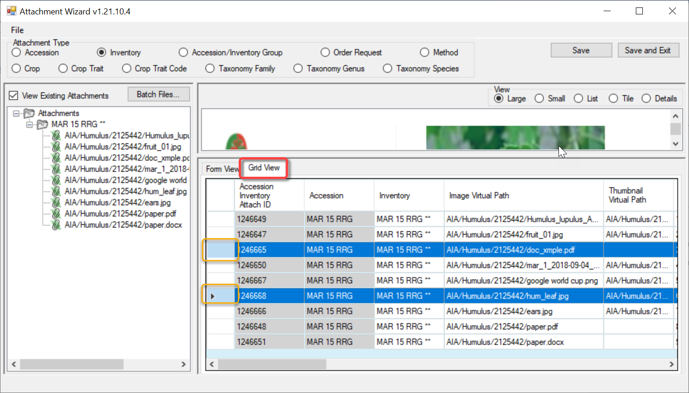

Main Wizard Window
The image below illustrates a wizard window when initially opened. In this example the CT’s folder in the left panel was empty and therefore no records were listed in the grid on the CT’s right panel. Because of this situation, the wizard’s default radio button, Inventory, has been selected:
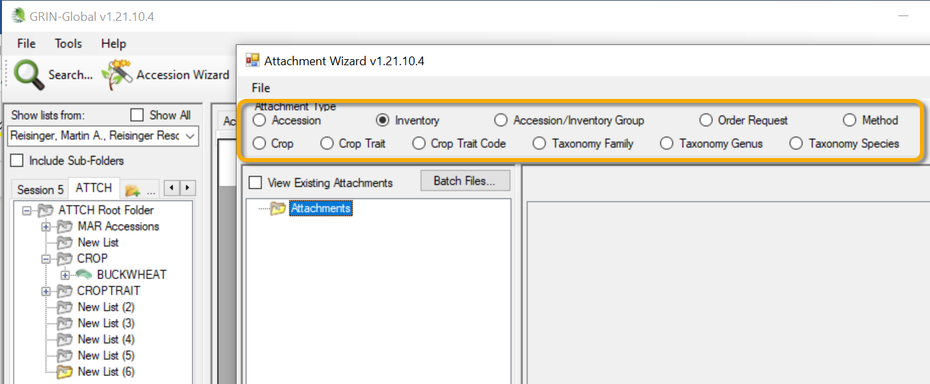
Since the 11 attachment types are selected by using their respective radio buttons, this implies that only one type may be attached at one time.
When you drag/drop a file into the wizard when the Accession radio button is selected, the wizard will assign the file to the system inventory record (type = **) regardless of which child inventory the file was dragged onto.
If you drag the same file onto a (physical) inventory record when the Inventory radio button is selected, the wizard will assign it to the inventory record that the file was dragged onto.

Steps when using the Wizard (Summary)
Steps:
- in the CT’s left list panel, start with a folder (list) of items pointing to one of the valid record types that can have attachments
- in the right panel (the datagrid area), have the corresponding dataview active (Crop dataview if attaching to crops, etc.) and select the records with which you intend to attach files
- invoke the Attachment Wizard
- either highlight and select images in Windows Explorer and drag them to a folder icon in the wizard’s left panel, or click the wizard’s Batch Files... button

When using the Batch Files method, the Windows names of the folder/files are critical. When dragging files to the wizard and attempting to attach to a crop, the manual drag will work regardless of the path/filename. But when using the Batch Files method, the wizard looks for a match to the item selected in the CT list and if there isn’t a match, the attaching will fail.

Viewing Attachments

Viewing … in the Curator Tool
Refer to the Order guide(s) to see how Order attachments can also be viewed within the Order Wizard. Note that external requesters can add attachments via the Public Website. The internal genebank staff can also add attachments to orders via the CT’s Order Wizard or Attachment Wizard.
In the CT, locate the accessions, inventory items , …any GG item that has an attachment. Build a list in the left panel.
In the CT’s left list panel:
- in the left List Panel, start with a list of items pointing to any of the valid record types that can have attachments / select the folder or list item
- in the right panel, the datagrid, have the respective dataview active and select the records with which you intend to attach files
- invoke the Attachment Wizard
- click the wizard’s View Existing Attachments checkbox

Highlight the accessions, inventory records, etc. in the right grid – then start up (click on) the Attachment Wizard icon at the top of the CT. Intentionally, at first no items are displayed until you select the View Existing Attachments checkbox. Double-click the attachment’s icon: 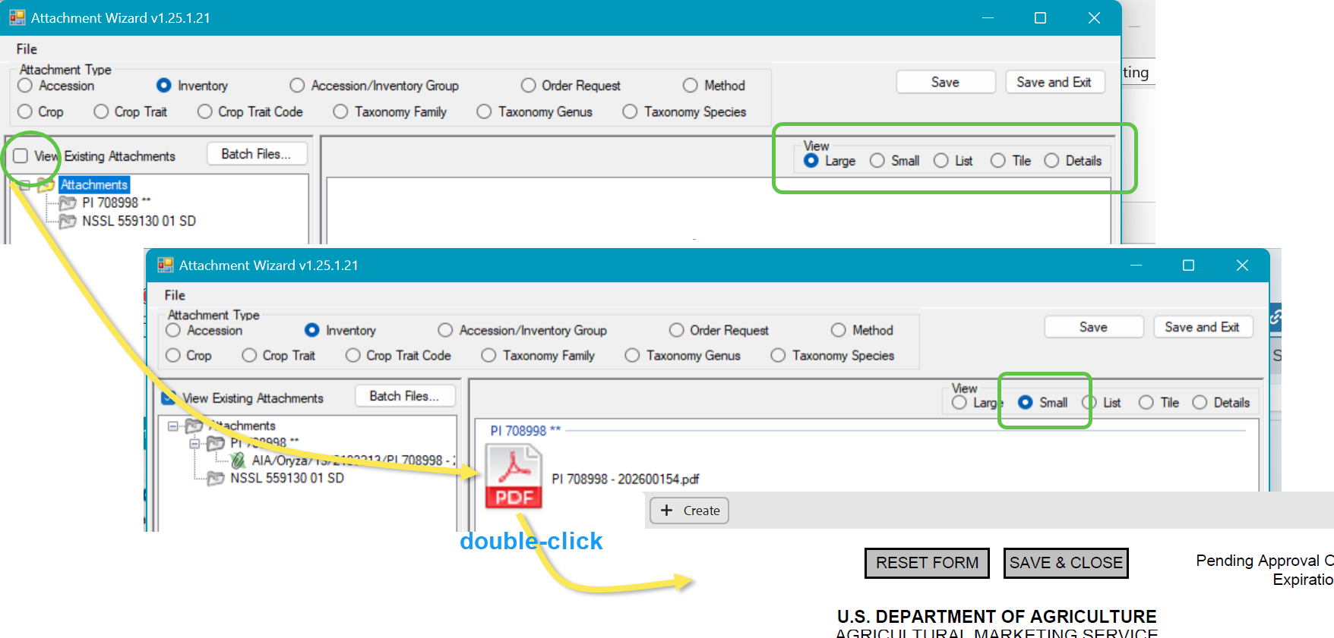

Selective Viewing of Attachments
When you have many attachments, it is possible to select attachment records from a list in the datagrid and then launch the Attachment Wizard. (Click the Attachment Wizard icon.)
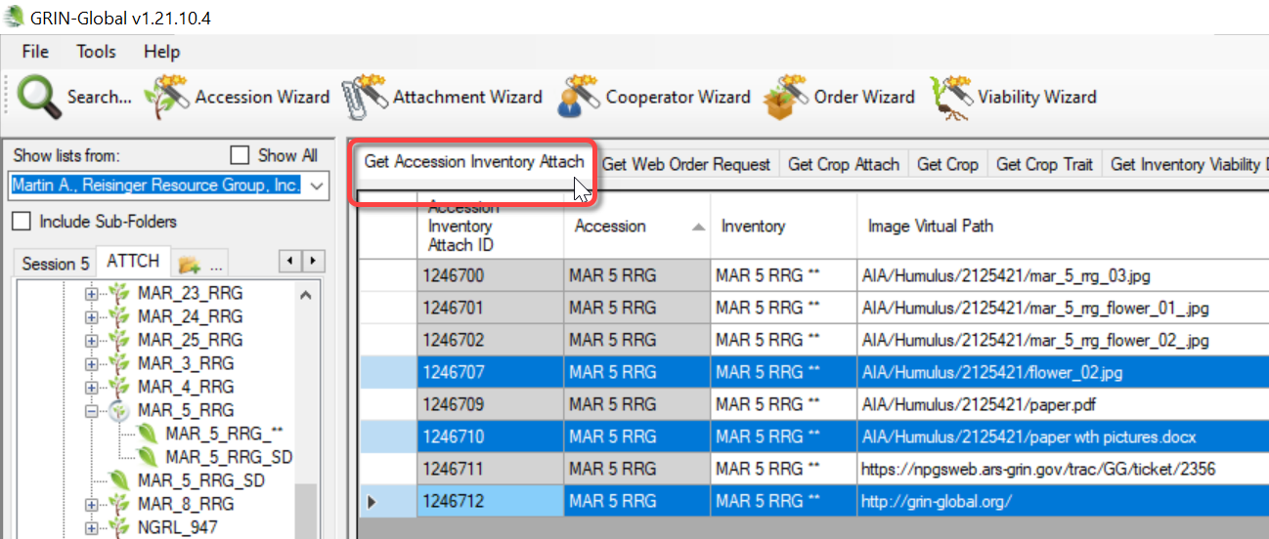
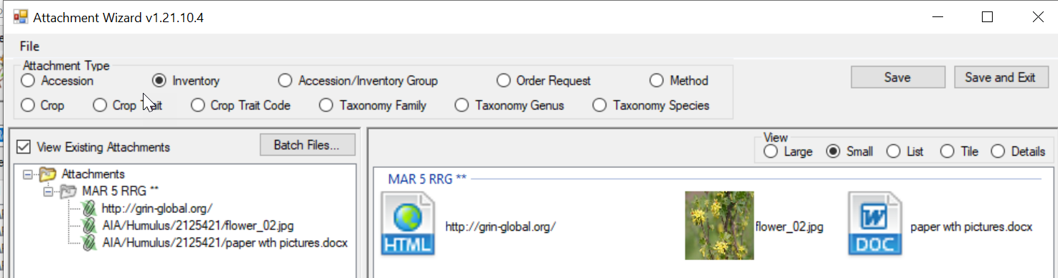
In the following example, a Crop item is selected in the CT’s left List Panel. Notice how the Crop radio button in the wizard is active. Shown here, the user clicked the View Existing Attachments (4) box to display the images:
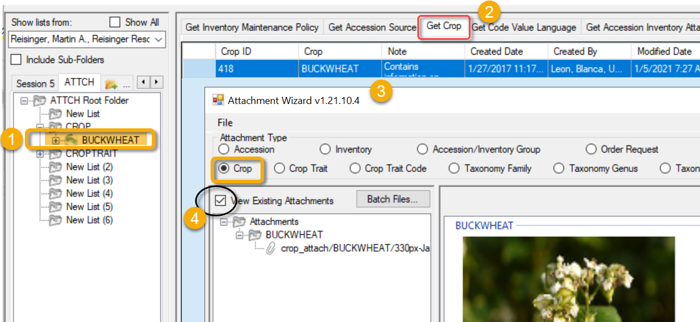

Viewing … in the Public Website

Images
Accession images display on the search results page:
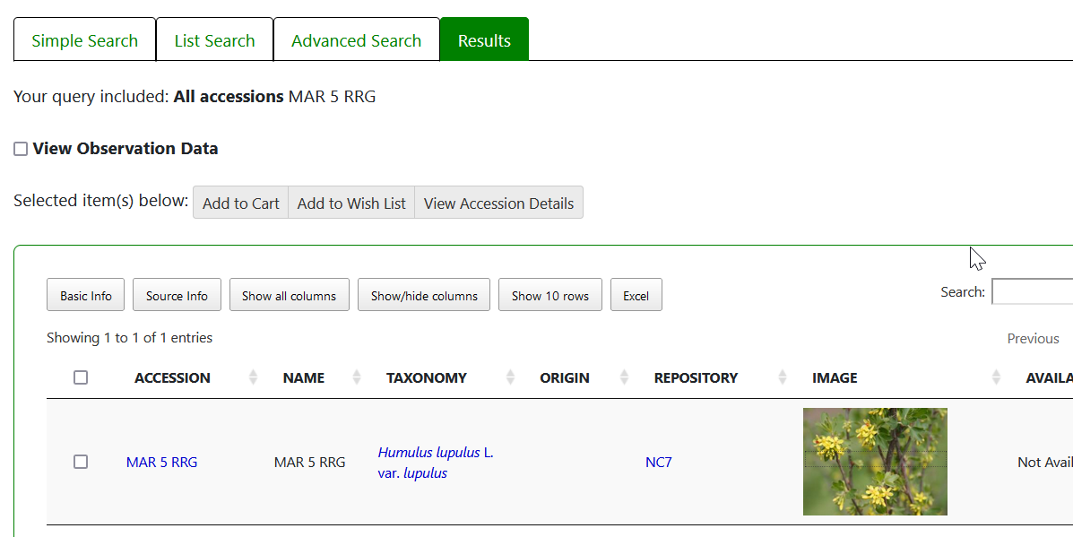
When the image is clicked, if more images exist, image thumbnails will be displayed:
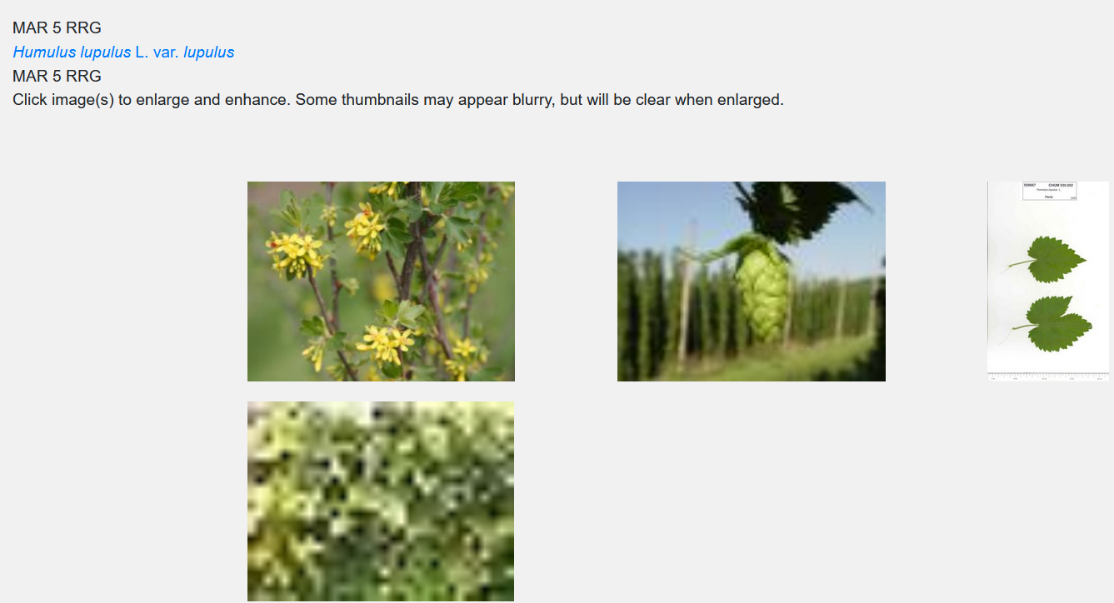
Non-image attachments, such as PDFs, will be listed on the Other tab of the Accession detail page. “Document” is the default text for the link; if a Description for the image had been entered in the CT, meaningful text will display.
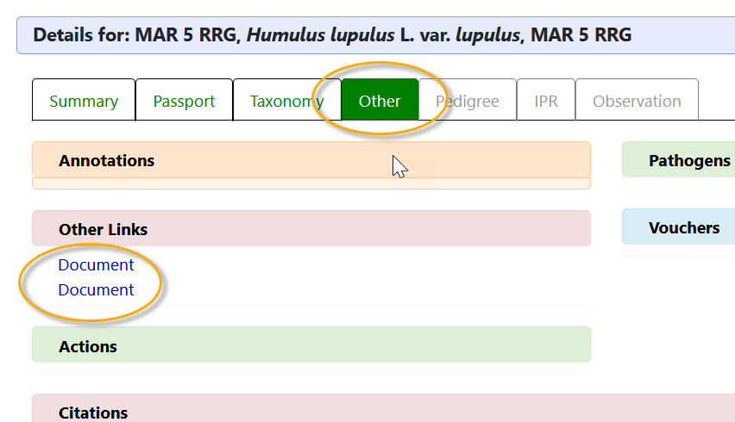 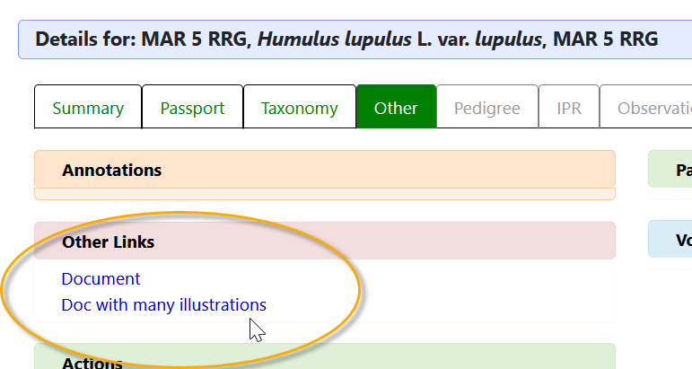
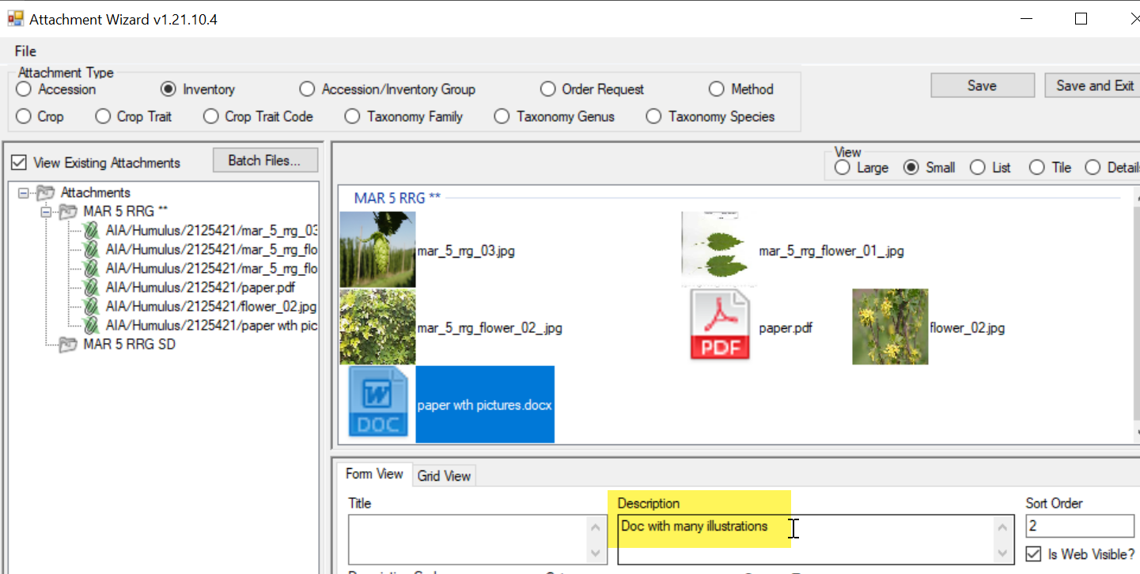

Editing Attachment Records
If you own the attachment records or have permission to edit the records, you can view them in the attachment wizard, make the changes in the respective fields, and then save the records. Either wizard view tab may be used (Form View or Grid View).

Canceling Changes
One way to cancel changes is to close the wizard window before saving:
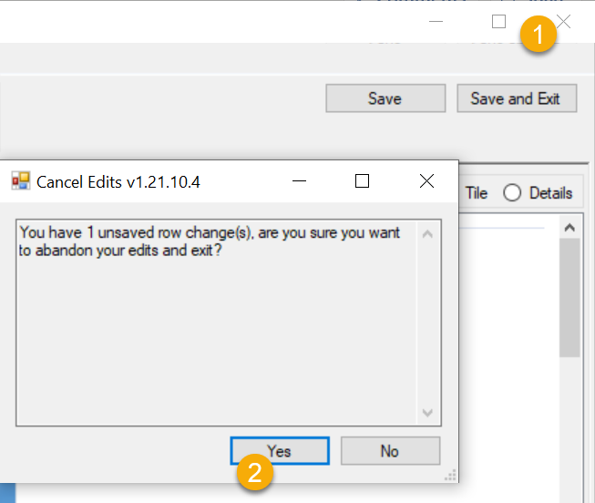

Errors

When Attaching
If the Wizard cannot determine which GG record to attach to, an error message will display:
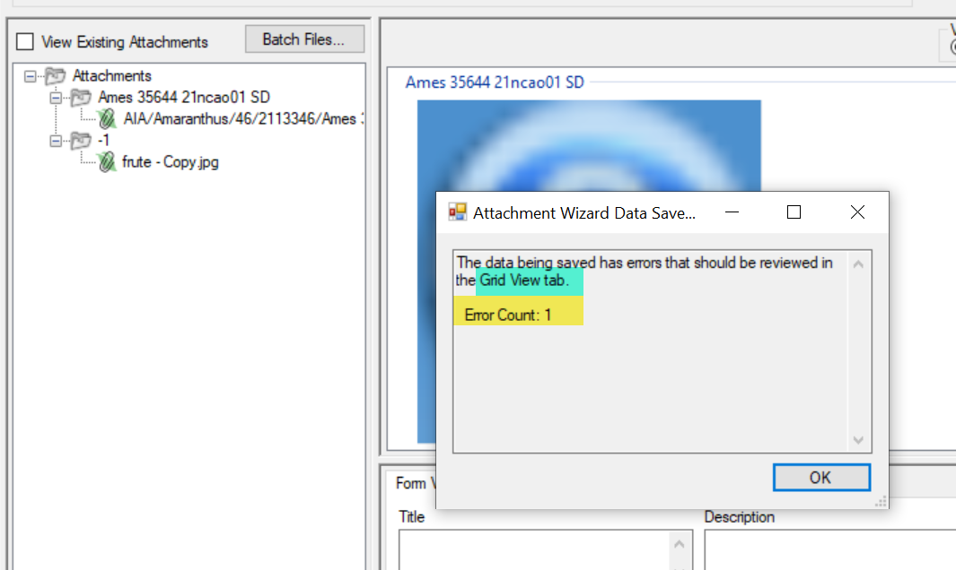
In the wizard’s Grid View tab, information about the error can be viewed by rolling the mouse over the red “I.” Other indicators will be visible. A valuable clue occurs when a “-1” displays instead of an actual GG item. Also, instead of pointing to a pathname on the server, the path will be to your PC’s drive (C: below).
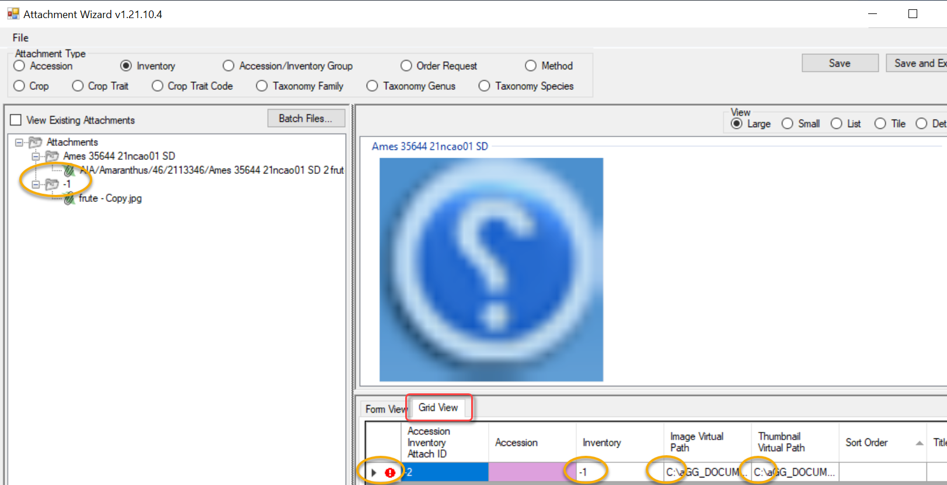
To resolve, examine the filename. Most likely there is a typo of some sort in the name, or the GG item (such as an accession or inventory identifier in this case was completely missing). Another possibility is that you need to review the name parsing options.
When using the wizard’s Batch Files method, the names of the folder/files are critical. When dragging files to the wizard and attempting to attach to a crop, the manual drag will work regardless of the path/filename. But when using the Batch Files method, the wizard looks for a match to the item selected in the CT list and if there isn’t a match, the attaching will fail.
In the following example, the user is using the Batch Files button to select some files from a Windows folder. Unfortunately, the folder name in Windows is misspelled (3rd image). The second image with the -1 next to the folder icon is a visual clue that this attachment is not working properly.
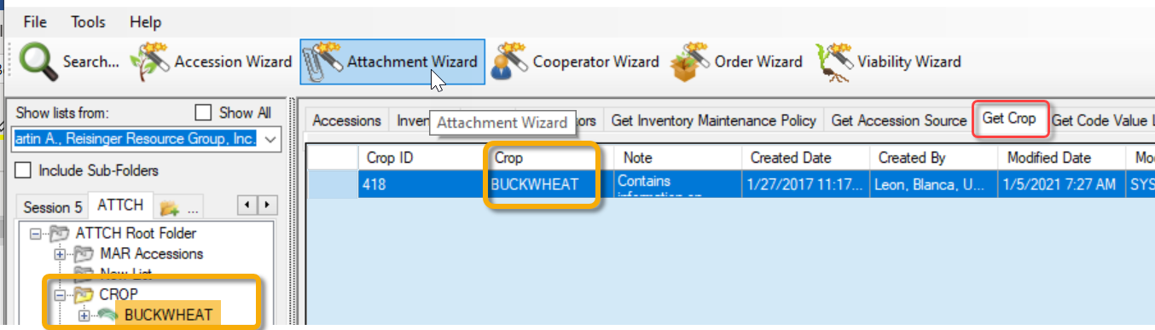
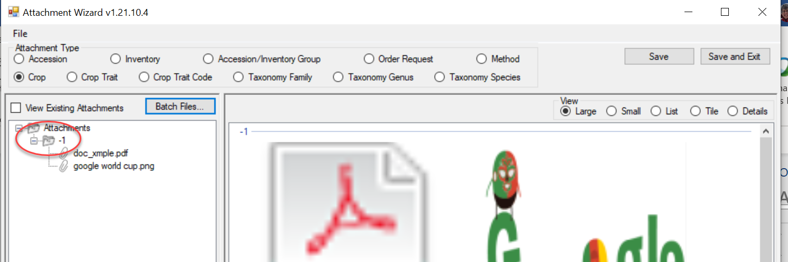
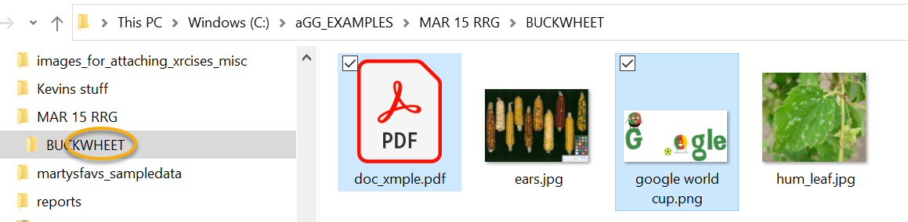

Error Example: Filename Not Matching the Designated Delimiter
In the following example, the name next to the paperclip icon looks like it would match a valid accession identifier: MAR 24 RRG. However, when reviewing the parsing option, the wizard has been configured to work with the underscore character (2nd image below).
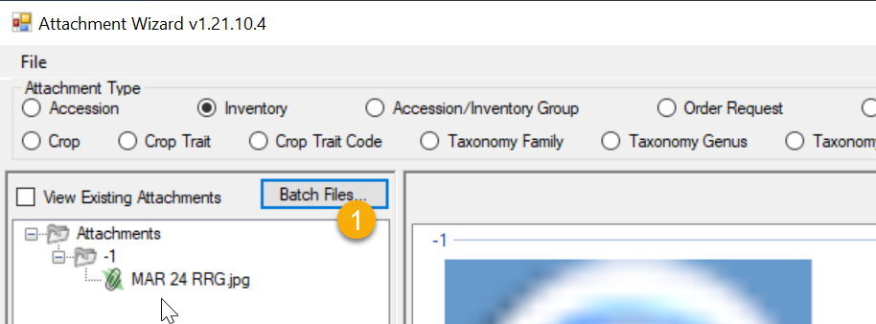
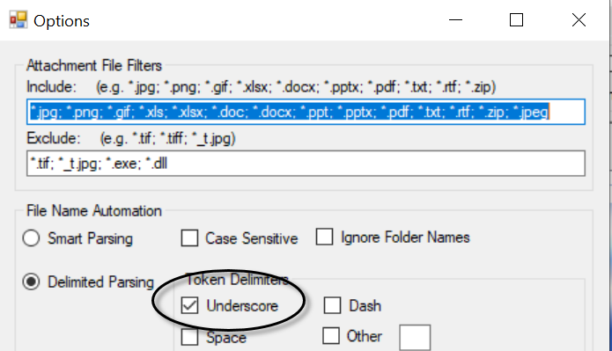
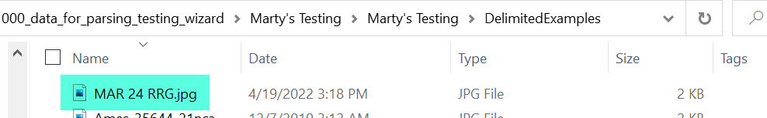
When the filename was edited and the spaces were replaced with underscore characters, the attaching worked properly:
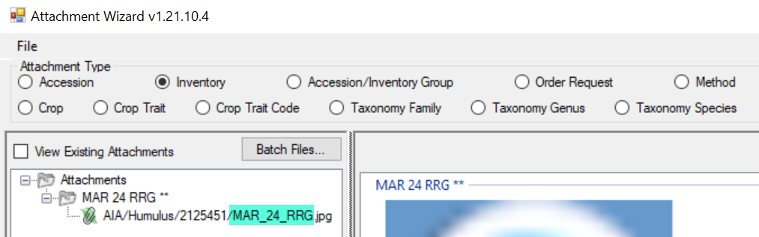

Known Bugs

Not Displaying the Attachments
Sometimes after images have been attached, as a user you may click on another Attachment Type radio button. That action frequently impacts the display of the attachments; you may need to close the wizard and then reopen.

Accession-inventory-group file path
A minor bug was discovered in May 2025 and will be corrected in the next CT build. The bug is rare and most likely will not impact most organizations using GRIN-Global.
The attachment wizard logic currently treats an accession-inventory-group as an accession and attempts to convert it to an inventory. Because of this incorrect behavior, the wizard will not resolve the file path properly and instead uses the default file path.
This is a rare scenario because two things must be true: 1) the user is adding accession_inv_group_attachments and 2) the organization is modifying the default file path for uploading attachment files.

Folder and File Naming Conventions – Important!
The file name or the folder name of the folder containing the files to be attached is critically important, especially when using the Batch Method to attach files with GG records.
The wizard uses programmed logic in the process of uploading images or attachments. The wizard evaluates the Windows folder name and / or the actual file names to determine which GG items to attach.
Shown below, the default radio button Inventory is selected:
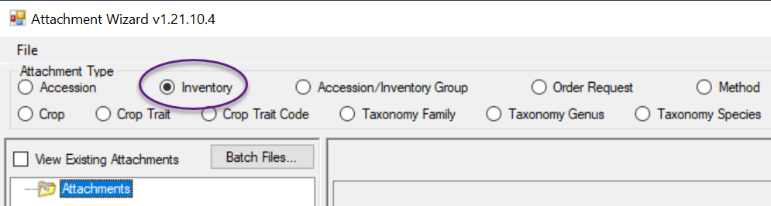
When associating images with inventory records, the wizard evaluates the filename and searches for a matching inventory identifier.
Inventory identifiers consist of 4 components - Inventory:
- -prefix
- -number
- -suffix
- -form type
Accession identifiers use 3 components - Accession:
- -prefix
- -number
- -suffix

Folder Paths Can Impact the Attaching
When either the Accession or Inventory radio buttons are selected, the CT and the wizard are looking for matches by filenames, but when a match isn’t found, the CT software reviews the Windows name of the folder where the image files have been stored. The software not only looks at the Windows folder with the files, but when attempting to match files/folders with GG items, the software will look “up the path” – if the software can’t find a name in an image file’s parent folder, it will look at the folder’s parent folder, etc.
In this example, files are in the 00_pix folder, but its parent folder is MAR 15 RRG which matches an Accession identifier in the database.
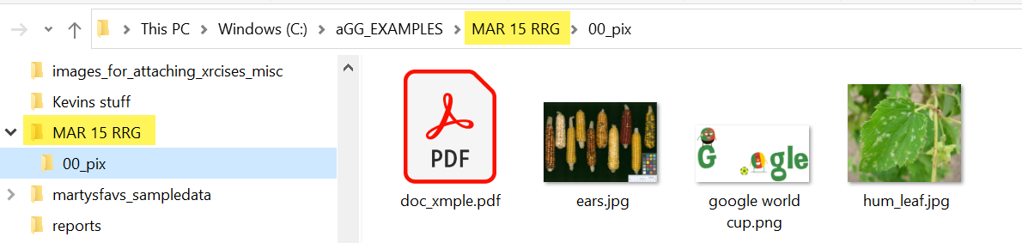

Filename Components
A file name can contain important information interpreted by the wizard. File naming components can be used to fill certain fields in the GG attachment record. For example, you can indicate by the image’s filename that it is a flower.
The wizard has three parsing options available that guide the wizard when it attempts to match file names with corresponding GG names. The default option is Smart parsing. This basically means that the wizard will look for either underscore or space characters to separate the filename components. If your Windows file names use characters other than underscores or spaces, review the Parsing File Names section.

We mentioned previously that the CT uses the folder or file name to match to an inventory record. File naming options can also include a plant part, an order number, and a date (such as the date the photo was taken). For example, the following name is indicating the inventory PI 500000 tr05az SD, January 1, 2005, sort order is 1, and flower. \pi_500000_tr05az_SD_01-01-2005_01_flower.jpg
When associating with Accession or Inventory records, you must include the inventory or accession identifier (in the filename or pathname); all of the other filename components are optional.
Component | Format | Example
inventory identifier*  (& underscore) | inventory_number_part1 + “_” + inventory_number_part2 + “_” + inventory_number_part3 + “_” +  form-type-code +  “_” | pi_500000_tr05az_sd_
accession identifier*  (& underscore) | accession_number_part1 + “_” + accession _number_part2 + “_” + accession _number_part3 + “_” | PI_500000_
date (& underscore)  (optional) | mm-dd-yyyy +  “_”  (more info: Attach Date) | 01-01-2005_
sort_order (& underscore)  (** optional) | nn +  “_”  (more info: Sort Order) | 01_
plant_part  (optional) | (more info: Plant Part);  not exclusively plant parts) | flower
* When attaching to Accession or Inventory items, if the identifier is not part of the filename, then the identifier must be the folder name.
** Unique image order numbers make it possible to have multiple images for the same inventory, plant part, and date.
When using the Batch Files method, if your folders are setup in a fashion similar to the following, with each folder named after an accession, you can use the IMAGES folder to attach all the attachment files from the folders to their respective accessions.
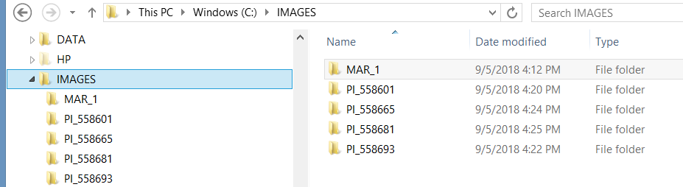
Another example where each folder name matches an accession identifier:
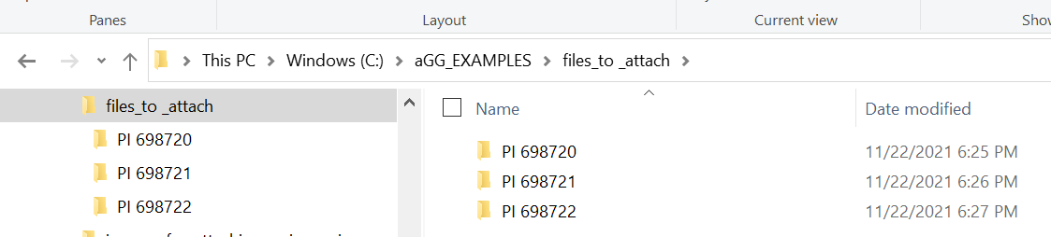
In each folder, files are stored. For example, the folder PI 698720 contains five files:
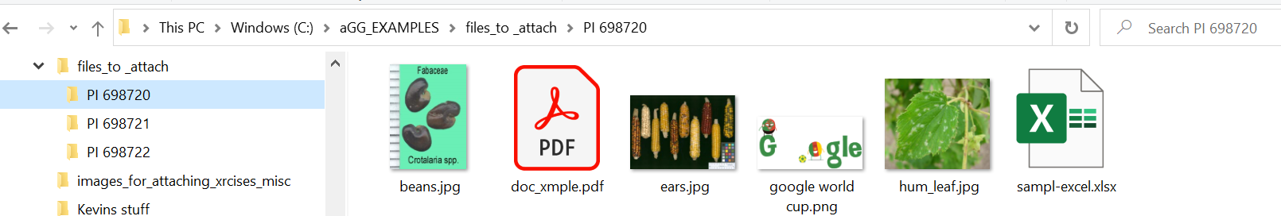
The Inventory Type code for all system inventory records in GRIN-Global is **. Since Windows does not allow asterisks (*) to be used as a Windows filename character, specify the accession identifier (use only accession –prefix, –number, and –suffix).
In this case, the wizard attaches the files to the system inventory record, therefore associating the files with the accession, not a specific inventory record.
In the wizard, you can also use an inventory identifier (the four components: prefix, number, suffix, and Inventory Type), and use the Accession radio button.

Example when Windows files are dragged to a CT List Item
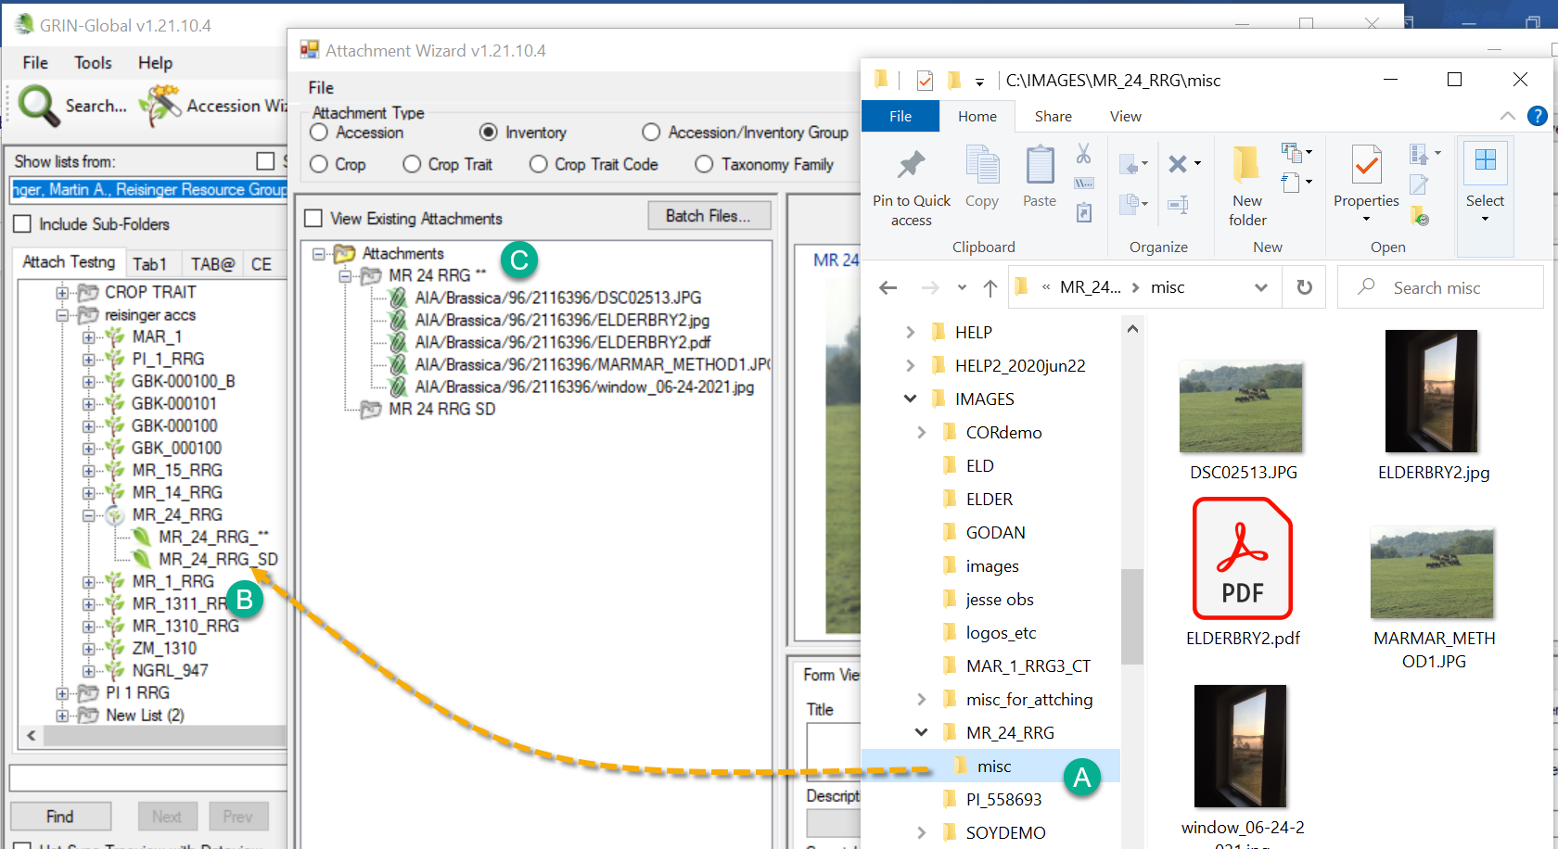
In the above example, the user clicked on the Windows Explorer misc folder. Notice that misc’s parent folder is MR_24_RRG.
The user clicked and then dragged misc to the CT and dropped on the MR_24_RRG_SD item which points to an inventory record. Since neither misc nor its parent folder MR_24_RRG matched the MR_24_RRG_SD item, but matched the accession, the image files were attached to the accession’s system inventory record, MR_24_RRG_**
- All attached files (for all inventory_ids) for the same accession_id are stored in the same folder
- The wizard looks for an inventory identifier (Prefix, Number, Suffix, Inventory Type) within the filename; when not found, the wizard will review the folder name (pathname). It will look “up the path”– if it can’t find a name in the parent folder, it will look at the parent’s parent folder, etc.

When the attaching of the source files is successful, the wizard names the server destination location during the attachment process with a virtual pathname. In this example, the accession_inventory_attachment dataview is displaying the paths:
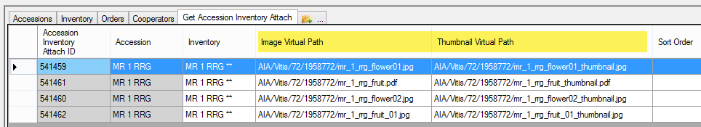
The text “AIA” is used at one level to indicate an Accession Inventory Attachment. The wizard determines the genus of the accession and uses genus for the next level of the pathname. In the following example, the 96 is a random number generated by the software to subdivide folders, ensuring that only a limited number of files are stored in any one folder.
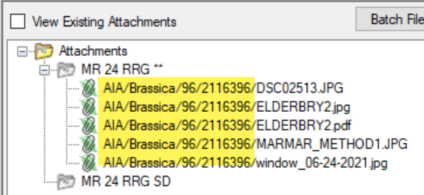
“AIA” is the folder name only used with files stored as accession and inventory attachments. In this attachment wizard, the biggest change was the ability to attach to other attachment tables. These all use different folder names. For details, see Appendix B: Attachment Locations.

What Types of Files Can be Attached?
The wizard window has a menu with one item, File, which in turn has one item, Options…. The primary reason for selecting File | Options… is to indicate which file extensions the wizard can handle (“Include”).
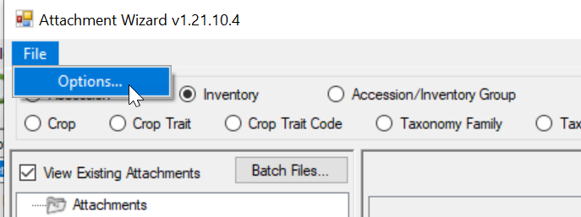

File Include and Exclude Filters

Include
The list of possible file extensions has been seeded with many file types that are most likely to be added as attachments.
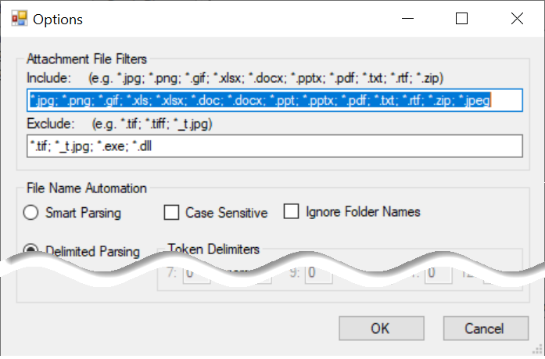
However, if you need to specify additional file types, add the file extension to the list by supplying the semicolon separator (;), an asterisk (*), period (.), and the extension. For example, if you needed to add .JPEG, you would consider the following:
*.jpg; *.png; *.gif; *.xls; *.xlsx; *.doc; *.docx; *.ppt; *.pptx; *.pdf; *.txt; *.rtf; *.zip; *.JPEG
where the red text indicates the new file extension to be included.
The above *.JPEG is used as an example. However, the .JPEG extension has been added to this list since version v1.22.8.24.

Exclude
This list has a few obvious file types that need to be excluded. As with the Include option, if you need to specify additional file extensions to the existing list, do so in the same manner as described above.

Frequently Asked Questions

FAQ 01 How do you attach multiple images to more than one accession?
What is the easiest method to have the same image of .PDF file be attached to multiple GG records?
One way would be to simply repeat the action of dragging and dropping the same image(s) from Windows Explorer to either CT items, dropping on each CT item (repeatedly), or drag them, one folder at a time, to an item listed in the wizard. However, there is a method (requiring some setup work in Windows Explorer), to configure the folders and attachment files a certain way, before using the attachment wizard. Described below:
In Windows Explorer…
- create the folders (see Appendix A: Making a Batch of Folders for a quick method when you need to create many folders)
- name the folders to match the identifiers (use a trailing underscore ( _ ) )
- group the folders under one folder such as “BATCH-MAY8”
- copy the same file(s) into each folder (use CTRL + C to copy the source file(s); paste the file(s) at each target folder, using (CTRL + V)
In the Curator Tool…
- select the records in the datagrid that will get the attachments
- use the wizard’s Batch Files method to select the folder “BATCH-MAY8”
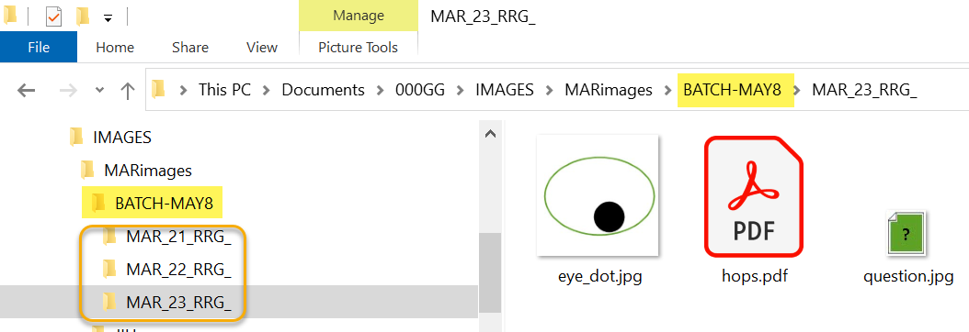
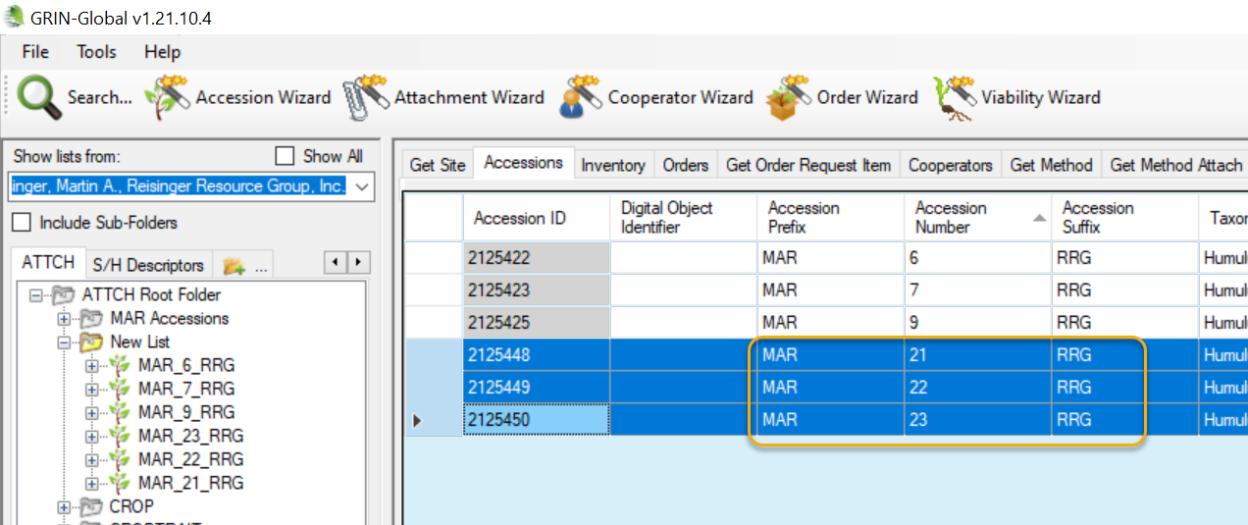

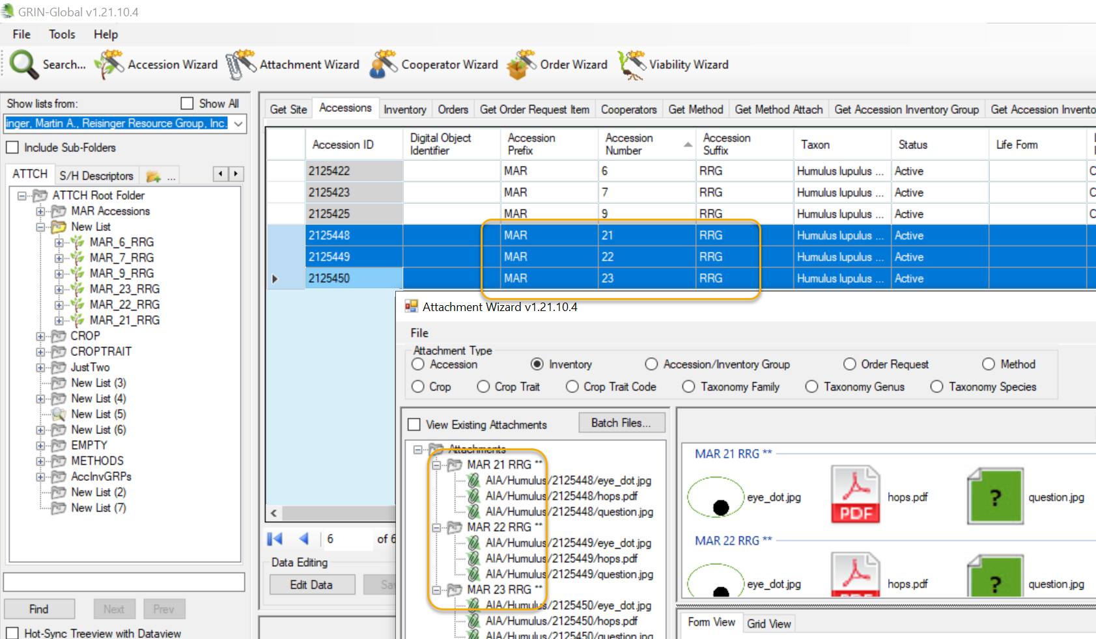

FAQ 02: Why is there an Accession button when there isn’t an Accession attachment table?
This button is used when you want to ensure the images are connected with the system inventory records, that is, inventory records whose Inventory Type code is **. This association denotes that the attachments are associated with the accession, not a specific inventory sample.
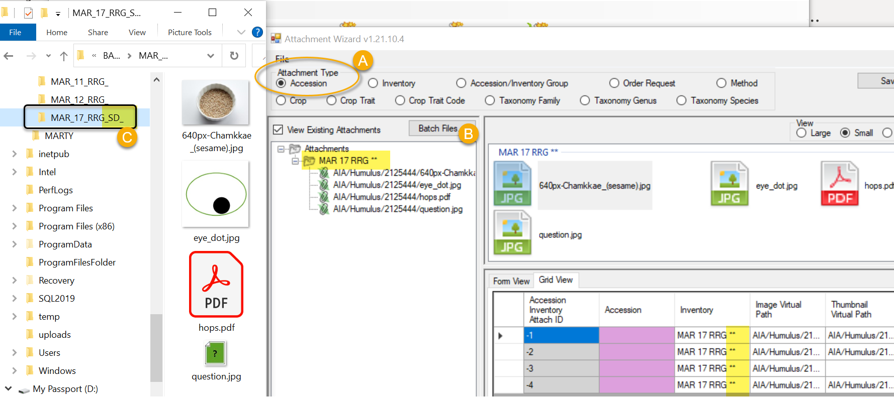

Parsing File Names
As background information, parsing means to split text or other input into pieces of data that can be easily stored or manipulated. Each of the text pieces that is parsed is considered a “token.”
Fortunately, you usually do not need to worry about how the wizard uses the parsing options because the default is the Smart Parsing option. (The wizard has three different parsing options. The software is programmed to recognize certain conventions explained in the File Naming Conventions section.
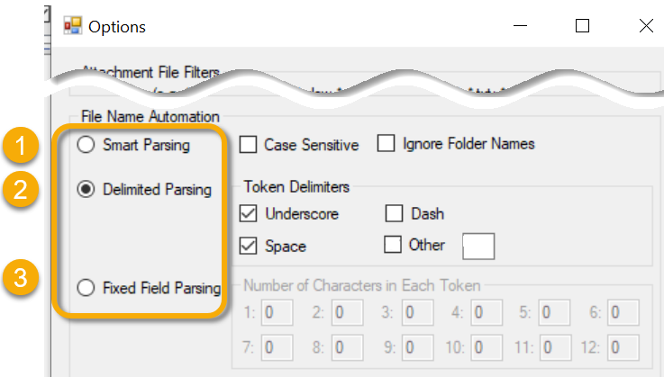

Smart Parsing
By default, unless you select Delimited or Fixed Field parsing, the wizard will parse a file name using the underscore or space characters.
so that filename such as MAR_24_RRG fruit 04-24-1979.jpg will be treated by the wizard as corresponding to the accession MAR 24 RRG, the image is a fruit image, and the date the photo was taken was April 24, 1979.

Delimited Parsing
Specify characters to indicate the separate components.

Fixed Field Parsing
With Fixed Field Parsing, you can indicate how many characters are to be used for each part of the inventory identifier. There are four component parts to the inventory identifier: prefix, number, suffix, and type.) To be able to use this option, two things are necessary:
- The inventory identifier is in a consistent position within the filename
- Each component of the inventory identifier uses the same number of characters
An example is best used to illustrate this parsing option. In this example, the accession_inventory identifier begins in the beginning of the filename. The first 4 positions are used for the prefix, then 6 characters for the number, 8 characters for the suffix, and 2 for the inventory type code.
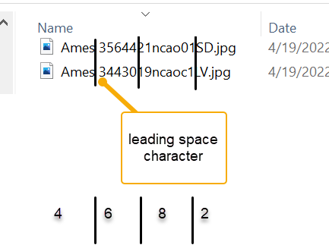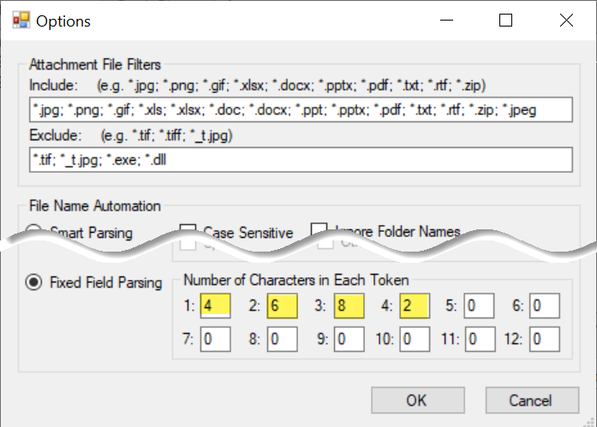
When file names are generated by a system that does not start the file name with the inventory/accession prefix, but then is consistent, you could use the first token box to indicate the number of leading characters, that is, specifically how many characters should be ignored before the prefix token is read.

Two Other Parsing Options
Under File Name Automation, you can indicate when the wizard should use (or ignore) characters used in the filename. You can also ignore the folder names when matching up the attachment files with the GG records.
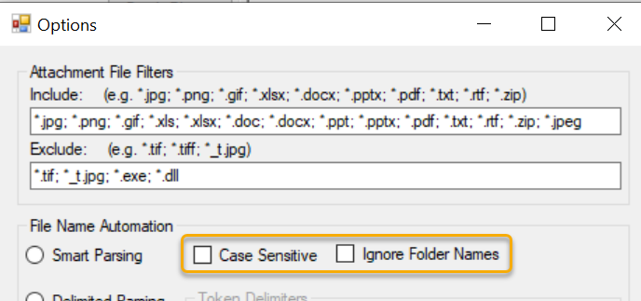
Example: When the Ignore Folder Names checkbox was selected, the following attach process failed because the folder names (MAR_1_RRG and MAR_2_RRG) were not recognized during the Batch Files process:
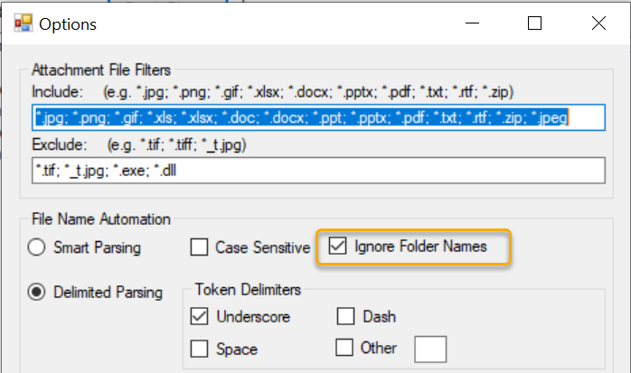
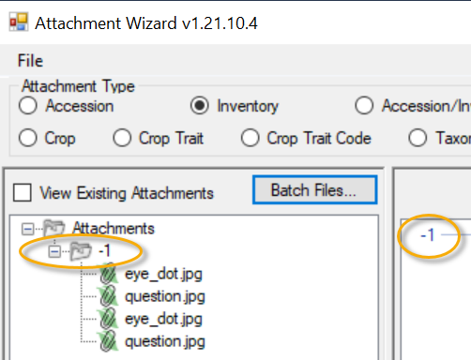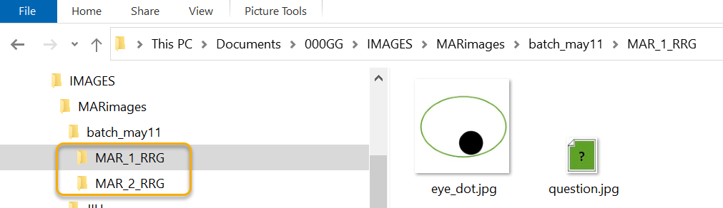

Alternative Methods for Attaching Images
There are several techniques for using the wizard. Perhaps the simplest is to drag files from a Windows Explorer screen directly to an item in the CT List Panel.

Attaching Files Directly to a List Item
An alternative to launching the Attachment Wizard is to drag image files directly from a Windows Explorer window to an item (not a folder) in the CT’s left list panel.
The images are attached and this action immediately launches the Attachment Wizard:
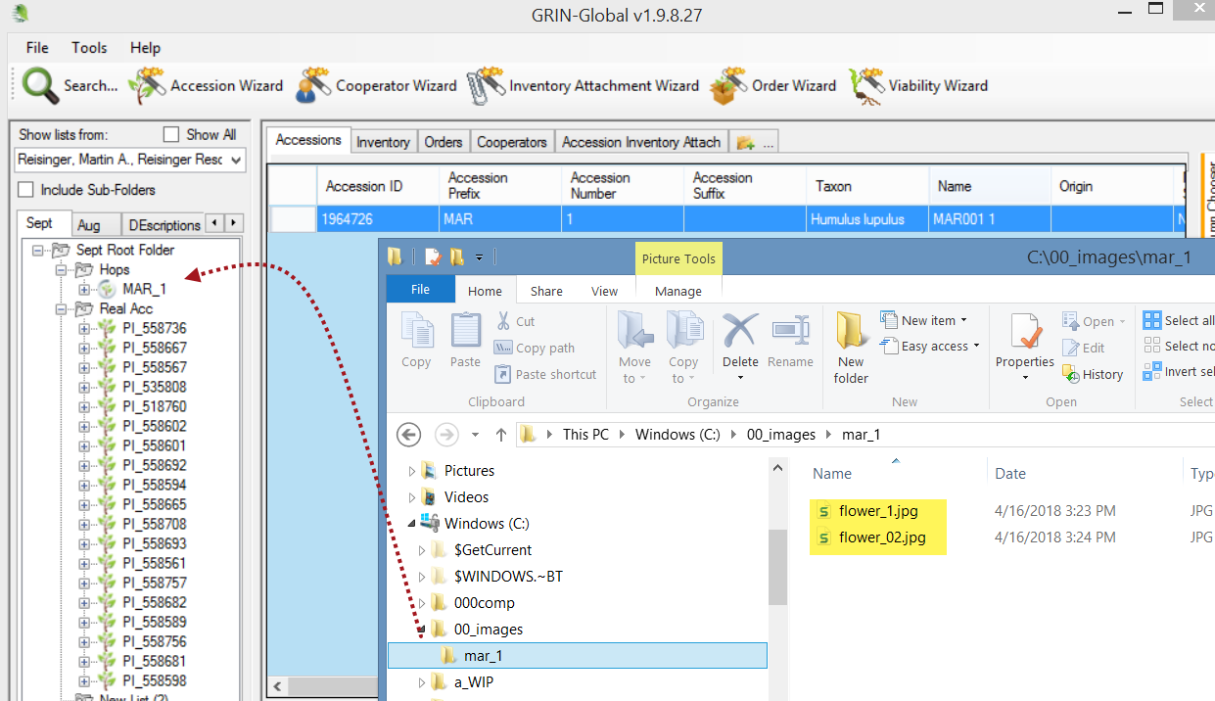

Since you can only select one item at a time in the CT left list panel, this technique is limited. Multiple files can be attached, but to only one GG record.
In the following example, two PDF files are being dragged from a Windows screen. If the user drags them to the item MAR 112 RRG, the attachments will be associated with the system inventory record. When dragged to the MAR 112 RRG SD item, they are associated with the corresponding inventory record.
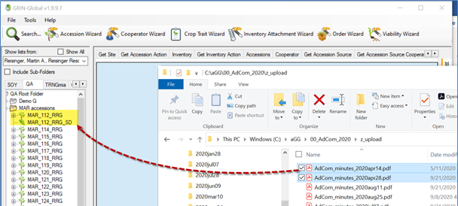

Batch Method to Select Attachments
In the following series of screens, by using the wizard’s Batch Files button, the user has attached images from a folder that was named with the accession identifier: MR 19921 RRG. To work properly, using Batch Files, you must have either the folder or the image files named in such as way (as explained in the File Naming Components section) so that the wizard can associate them to the respective accession/inventory.
- in the data grid, have the desired dataview open (Inventory, Crop, Crop Trait, etc.)
- click the Attachment Wizard button
The wizard is initiated
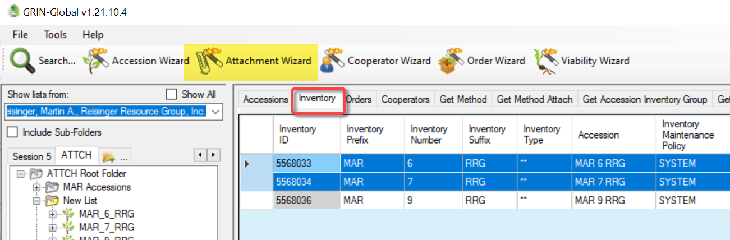
The wizard window displays; click Batch Files:
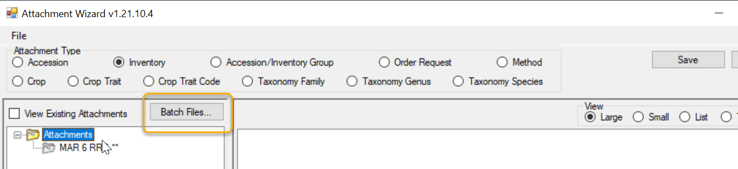
Optional: select the View Existing Attachments checkbox
At this point, an alternative method is to switch to a File Explorer screen and begin a drag and drop operation.

- Browse to the folder where the attachments are stored (PC or network drives available to the PC) and select the folder; click OK
- or -
drop and paste a valid Windows path:
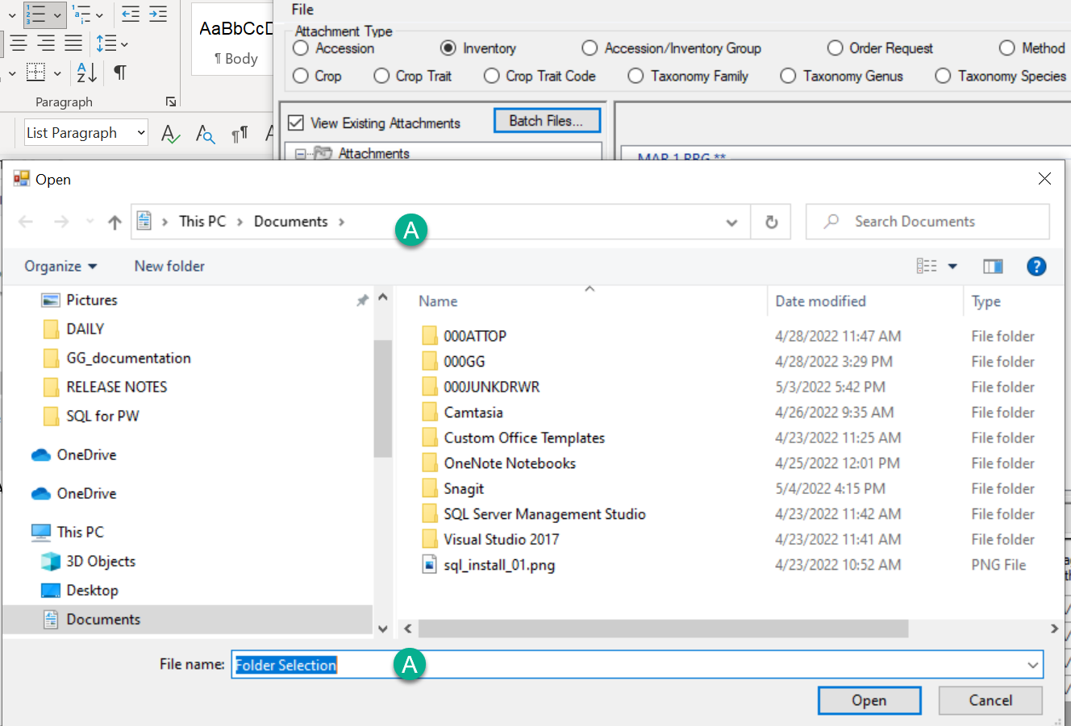
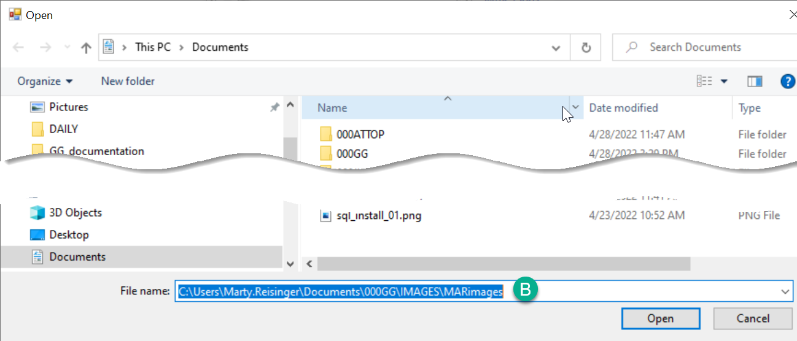
In this example, (A) the attachment wizard displayed this path originally, but the user pasted in the path (B). (You can use either (A) position to paste into.) Click the Open button to switch to the pasted path.
- Begin the attachment selection. In the following example, MARimages was selected.
(The three images below illustrate what files were in the selected Windows folder(s).)
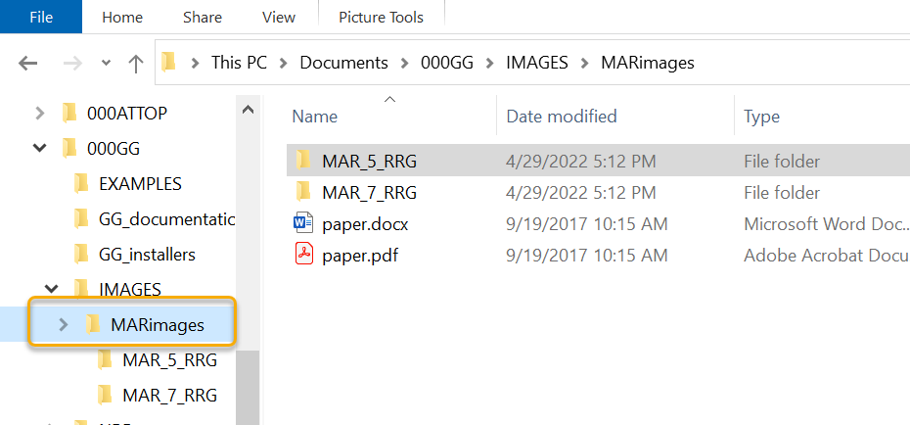
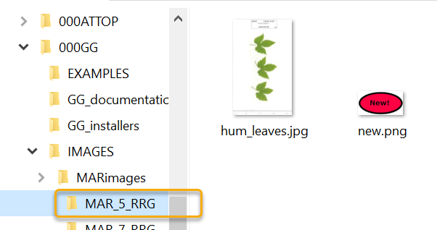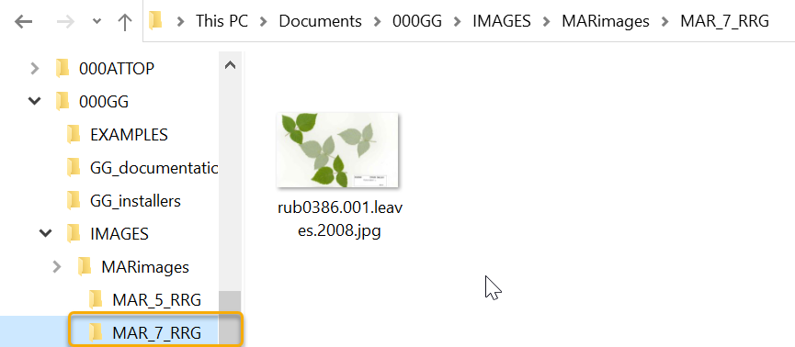
The files being attached are listed in the left panel of the wizard. Thumbnail images are displayed in the upper right panel:
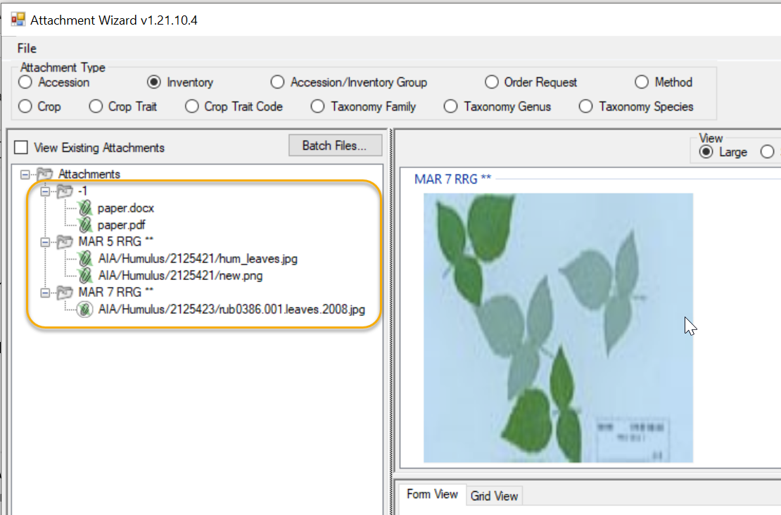
In this example, two of the Windows folders matched GG Accession identifiers – the MAR 5 RRG and the MAR 7 RRG. However, the Windows folder that had been selected was called MARimages. That folder had 2 files – paper.docx and paper.pdf. None of these names – the folder or the filenames – match anything in GGG, so the wizard is not able to match and displays a -1 referring to the non-match to MARimages.
When you see a -1, you should not proceed – typically cancel, and then review your naming conventions. If the goal was to include the paper.docx and paper.pdf files with MAR 5 RRG and MAR 7 RRG, copy the files into the corresponding Windows folders:
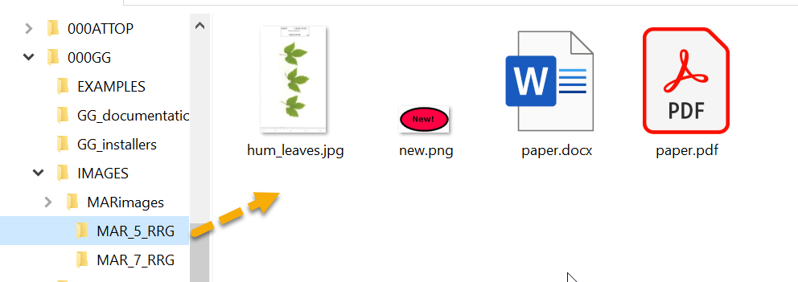

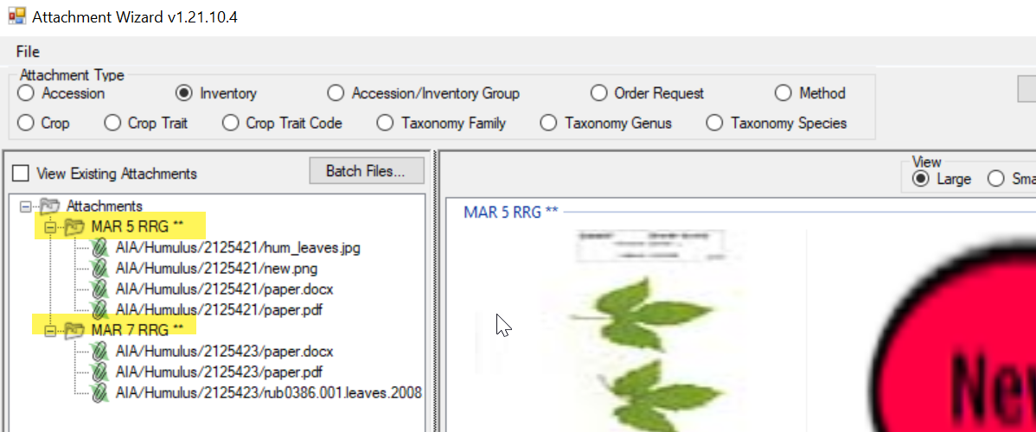
 | When using the Batch File method, the wizard uses the Windows folder or file names to associate the images to the corresponding GG items.

Drag and Drop Method to Select Attachments
This is the alternative method to using the Batch Files method. The two methods produce similar results. However, when you use the Batch Files method, all the folder’s files are included, whereas when dragging and dropping, you can select which files to do so.

Example Using the Drag and Drop Method to Select Attachment Files
In the following series of screens, by using the drag and drop method with the wizard, the user has attached images from a folder that was named with the accession identifier: MR 19921 RRG.
- start with a list of accessions (or other GG items)
- select the accession rows in the right-panel (datagrid)

Wizard is Initiated
- Click the Wizard button.
- Switch to a Window’s File Explorer window; click on a folder, or alternatively, select files in a folder using standard Windows keyboard and mouse combinations, and then drag onto the wizard’s folder icon in top, left panel of the wizard window:
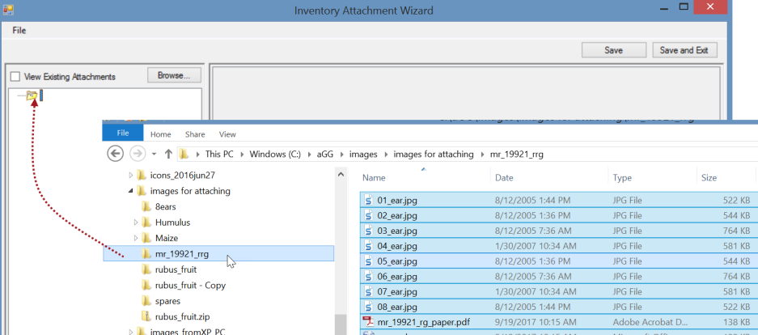
The result: the files are listed under a subfolder. The thumbnail images will also be displayed in the upper right panel.
_____________

Attachment Wizard Window Details

Grid View tab
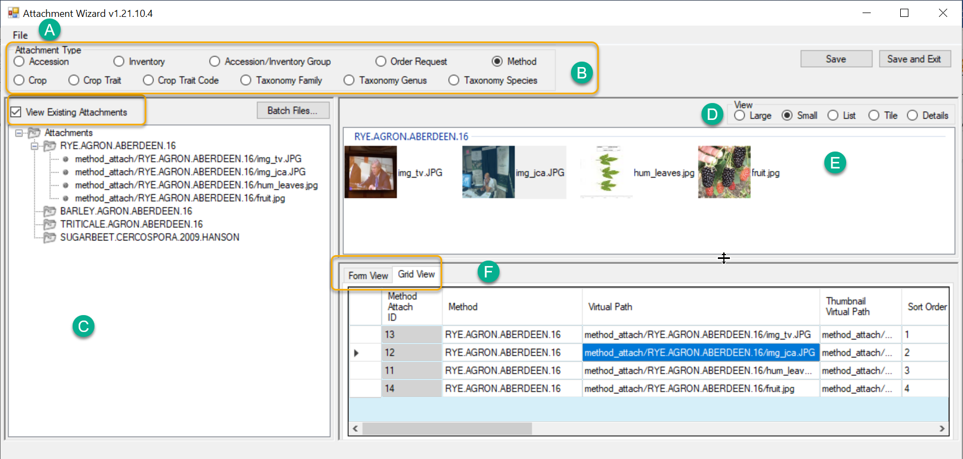
Item | Notes
A | Menu: “File” - use to include/exclude file types or to change the parsing options
B | Radio buttons used to indicate what is being attached
C | The left panel displays the attachments.
D | Radio buttons to control the display/size of the images while viewing in the wizard
E | Icons or thumbnail prints representing each attachment
F | Two tabs. In Form View, you can edit the Titles, Descriptions, Dates, etc. for one image/attachment at a time; the Grid View (shown here) displays all the attachments, in a table view

Form View tab

Attachment Record Fields
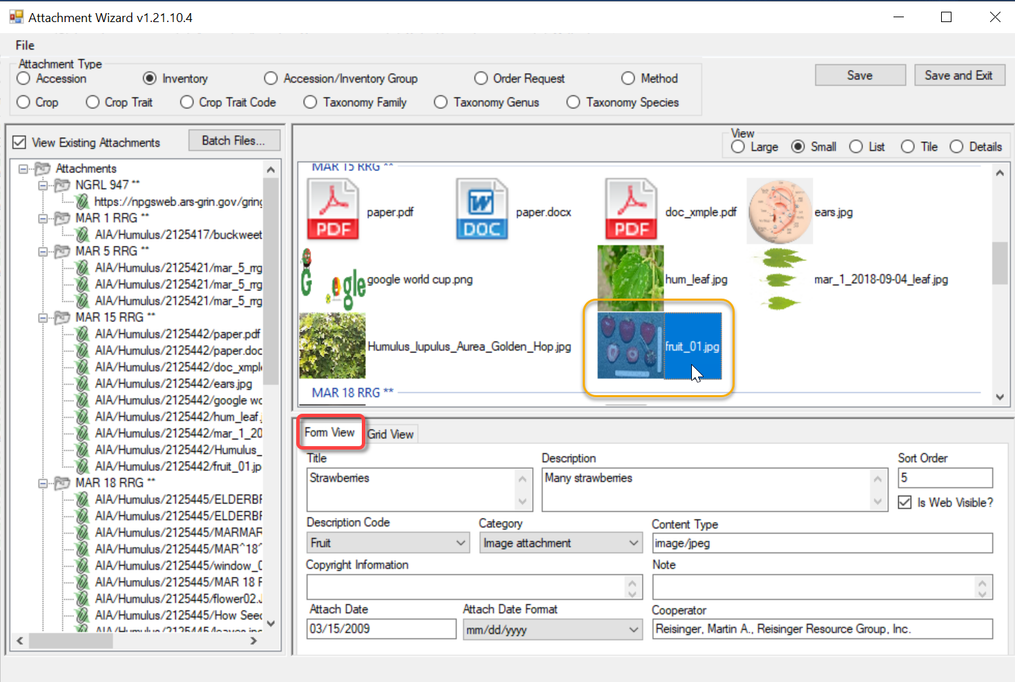

Title
Displays when the user rolls the mouse over the image thumbnail on the main accession details page.

Description
Data supplied in the Description field displays when the image is viewed in a browser window.
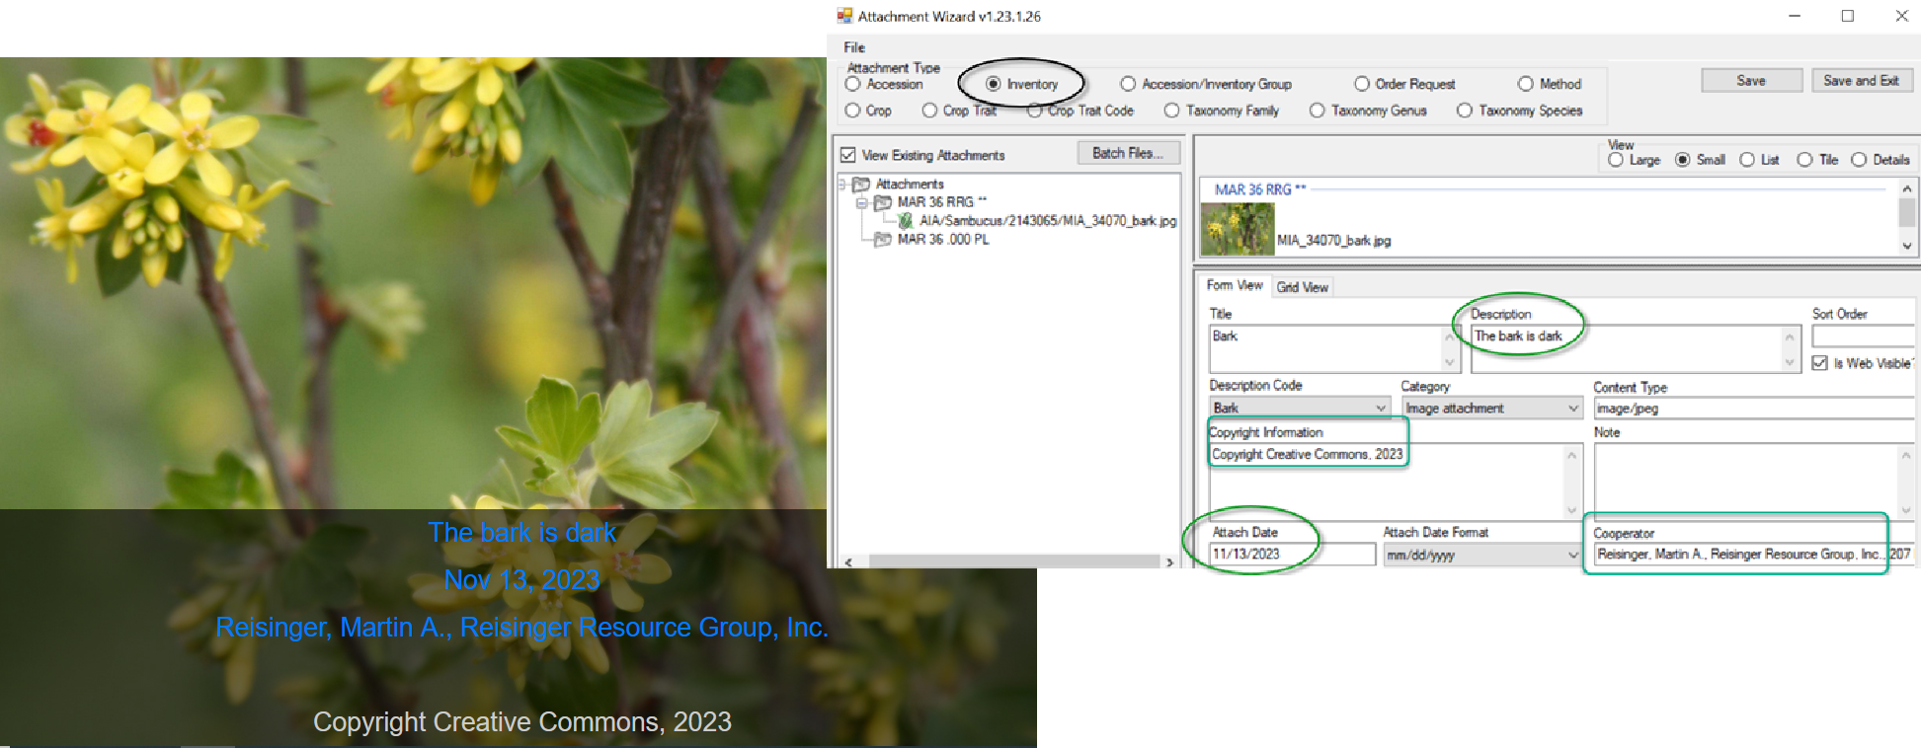

Sort Order
The Sort Order field is used by the PW for displaying images in a relative order. On the public website, the search results page will display the image with the lowest number on the results page. When the accession’s detail page is viewed, the image order is controlled from left to right by the sort order field.
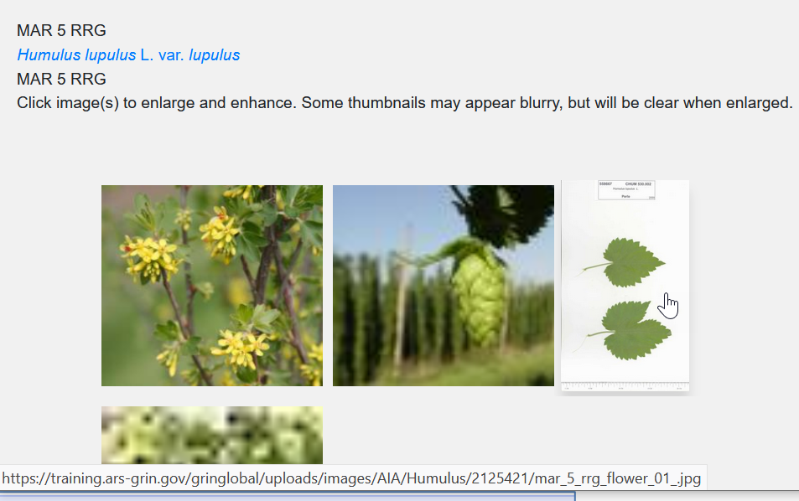

Attachments such as PDFs and other document types (non-images) are listed on the Other tab of the Accession Details.

For documents, be sure to enter a Description, otherwise “Document” is listed for the link:
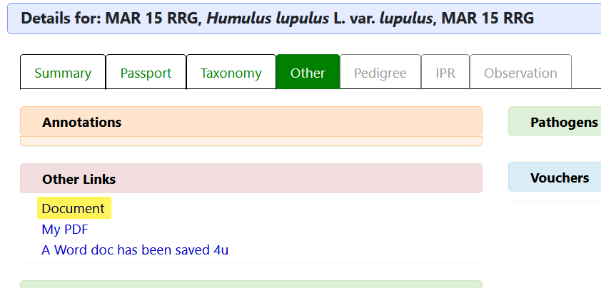

Is Web Visible?
This flag field determines if the image is displayed on the Public Website (or not).
In the current public website, when more than 500 accessions are returned from a search, the image column is not displayed on the search results page, regardless of the Is Web Visible flag.

Attach Date (& Attach Date Format)
If no date data is provided, the date displayed will default to the date attached. (In the current GG, digital photo image Exif data is not used, but plans are to explore this capability in future releases.) When a complete date is unknown, the Date Format field provides alternatives such as NEAR…
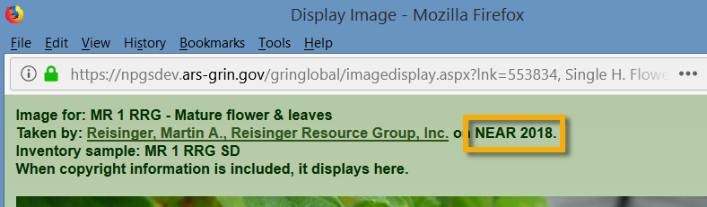
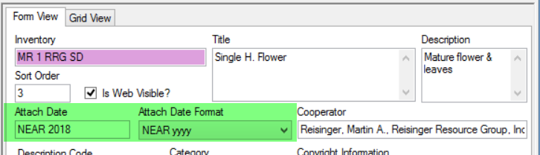

Cooperator
The cooperator information, when supplied to the Cooperator field, will display below the image when it is expanded:


Description Code
The code group ATTACH_DESCRIPTION_CODE contains the list of valid Description codes. (The GG Admin maintains this code group and can modify to meet the organization’s needs. A CT user on the PW with a linked PW account in the Tools | Web Query feature can display any code and code values using the SQL below; refer to the SQL online documentation for complete details.)
The SQL is:
SELECT cv.code_value_id, cv.group_name as group_name,
cv.value, cvl.title, cvl.description
FROM code_value cv
LEFT JOIN code_value_lang cvl ON cv.code_value_id = cvl.code_value_id
AND cvl.sys_lang_id = 1
WHERE cv.group_name = 'attach_description_code'
ORDER BY group_name, cv.value
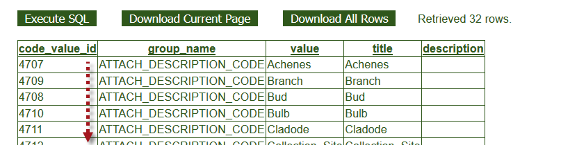

Category
The code group ATTACH_CATEGORY contains the list of valid Category codes. (The GG Admin maintains this code group and can modify to meet the organization’s needs.) If edited after initially loading images, the correct code must be properly selected. For example, Image attachment for images files.

Use the same SQL as shown above for the Description Code, but change the WHERE clause to ‘WHERE cv.group_name = 'attach_category'

Copyright Information
A text field that displays in the browser window.

Content Type
The Content Type field is determined by the attachment wizard’s logic. It is using the image file’s extension and is based on standards (MIME); this makes it possible to display the attached file.

Note
Note is a text field which does not display on the Public Website, but may be used to document the file.
_____________

Attach Date
The attachment file’s name or location can determine if a date is automatically inserted into the file’s Attach Date field.
- When the attachment file’s filename contains a valid date properly formatted, that date will be added to the Attach Date field. The valid format is "mm-dd-yyyy"
- When a date isn’t included in the filename, the programming logic reviews the folder names in the path structure to see if any folder name includes a date. The logic looks at the current folder, and then each higher folder level until it finds a date. When that happens, that date will be inserted as the attached date. (This would allow the same date to be applied to many files in one folder.)
- Finally, if neither the filename nor folder name contains a date, then the current date is inserted in the attachment file's Attach Date field.
Similar to the searching hierarchy described above for dates, the wizard also looks for the other naming components such as accession or inventory identifiers, plant part, etc.

Plant Part
For the “plant_part” component of the filename, in the NPGS, the following terms are valid. These codes are stored* in the ATTACH_DESCRIPTION_CODE code group :
Achenes | Flower | Panicle | Spike
Branch | Fruit | Plant | Spine
Bud | Greenhouse | Pod | Stalk
Bulb | Head | Root | Stem
Cladode | Kernels | Seed | Stipule
Collection_Site | Leaves | Seedling | Tendril
Ear | Miscellaneous | Shoot | Umbel
Field | Nut | Silique | Vegetative
* the current list of valid ATTACH_DESCRIPTION_CODES can be obtained by running a SQL script mentioned earlier.

Locations of Attachment Files
Appendix B has details on the naming conventions for the attachment paths. Each organization running GRIN-Global will have its own unique file server where the image and document files are stored. The GG administrator can assist with deleting the files if necessary.
The following information is intended primarily for Administrators:
The full directory path breaks down into several parts:
Example: C:\inetpub\wwwroot\gringlobal\uploads\images\AIA\Humulus
The web installer puts the GG site in C:\inetpub\wwwroot\gringlobal Then the Middle Tier (MT) controls the next part of the path. It always puts the images in the uploads\images directory under the GG site install directory. (You couldn't change that without altering the MT code and rebuilding.) Then the AIA\humulus part comes from a dataview that tells the Wizard what to use. If an admin wanted to, they could change that part by altering the inventory_attach_wizard_get_filepath dataview.
______

NPGS Attachment File Locations
In the NPGS, use the following convention to locate an attached file at the URL:
https://npgsweb.ars-grin.gov/gringlobal/uploads/images/image virtual path
For example, using the first attachment record in the screen above:
https://npgsweb.ars-grin.gov/gringlobal/uploads/images/ AIA/Humulus/1964682/sample_hum.pdf
(In this example, the number 1964682 is the accession_ID value.)
If you delete the attachment and wish to reuse the same naming convention, but with a different attached file, you can. It is not necessary to first delete the attachment record(s), simply upload the new attachment(s).

URL Links
A URL can be dragged from a browser window and dropped onto an object in a CT list. (The object must have an attachment table.) After releasing the mouse over the object, the wizard will launch (C) and will create a URL link attachment. Enter a Description to describe the link on the Public Website. 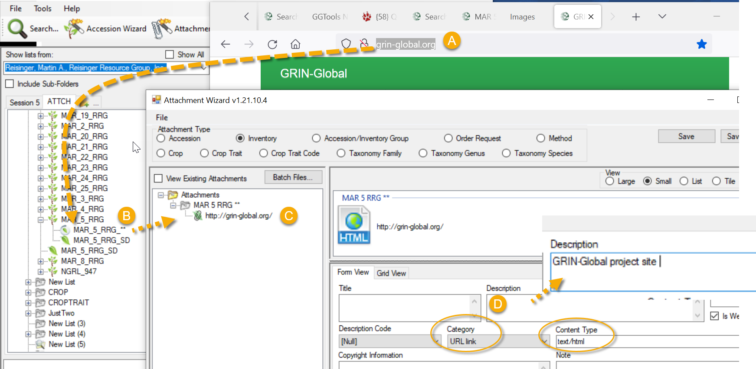
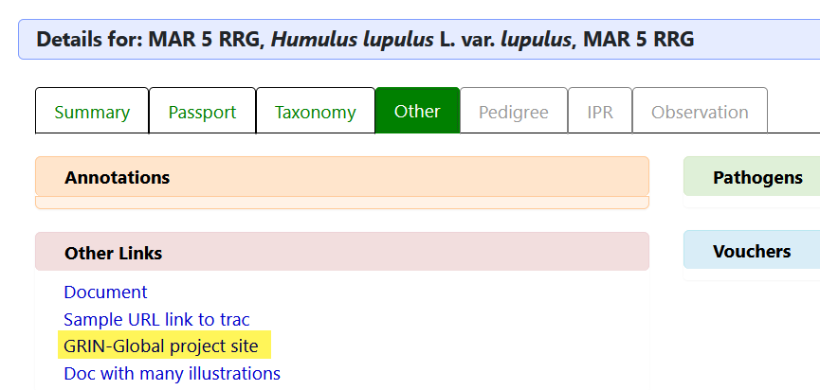

Alternative Method for adding links
URL links can also be added to the database and associated via attachment records. When adding many links, use the respective Attachment dataview (Accession_Inventory Attachment, Crop Attachment, etc.).

To Add a URL Link
Open the desired Attachment dataview; click the Edit Data button. The Crop attachment is used here as an example.
- Select the CROP name from the lookup table.
- Either type the complete URL text or drag the URL from the browser URL box to the Virtual Path field.
- Enter a Description.
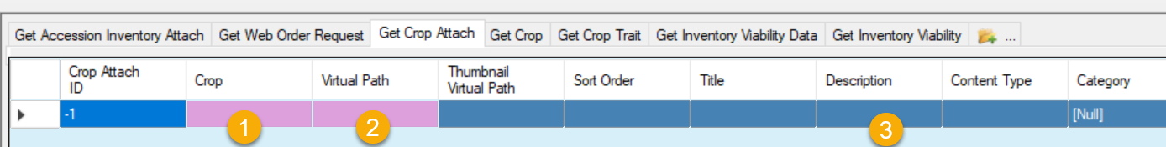
If you need to bulk add many URLs, you can set up a spreadsheet to drag and drop the records, following the steps as with any other drag and drop process.
You can also add URL links by adding a new line in the wizard’s grid. Use CTRL + N to create a new record and enter the three fields that are needed as above.
In the more recent GG public website, these links display in the Accession’s Other tab:
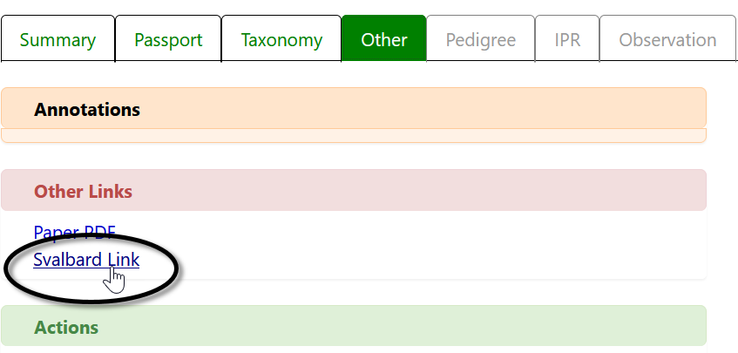

In the original GG public website, the link displays at the bottom of the accession’s detail page:
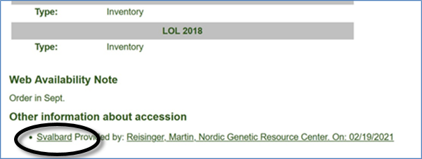

Appendix A: Making a Batch of Folders

MD – Make Directory DOS Command
One way to use the wizard is to select attachment files for many accessions, with each accession having its own folder with the images and other files in the respective folders.
In the following screen, within Windows Explorer, the file buildbetter.bat was double-clicked. The result was it created the 4 new highlighted folders named after accessions. Note that the names include underscore characters, including a trailing underscore:
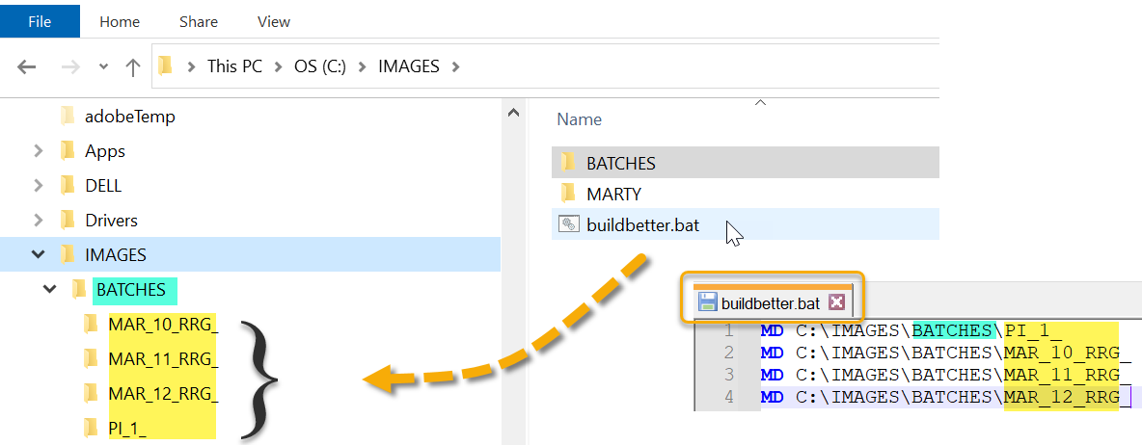
So, what was special about buildbetter.bat?
- it is a plain, ordinary text file with the extension “.bat” (must have the .bat !)
- 4 lines of text were included in buildbetter.bat (as shown above)
- when double-clicked, the bat file executes DOS commands and, in this case, creates 4 folders. (MD is Make Directory. After MD is a space character, and then the path C:\IMAGES\BATCHES where the new folders are to be created.
A bat fie is a text file. You can use ant text file editor such as Notepad, or even Word, to create and save the .bat file. In Word, use the Save as .txt option, and then rename the “.txt” to “.bat”
Change the Folder Options to display file extensions and other good stuff (details in pages below).

Changing Options for Folders (so that they display (Show hidden folders))
Unfortunately, Microsoft decided to hide certain folders as well as file extensions by default. The default view: the folder C:\ProgramData is hidden:
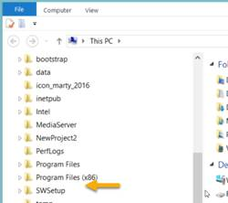
Whenever I get a new PC, I immediately change 3 of the default settings. I use File Explorer extensively, so I change the settings for "Display full path," "Show hidden files…," and "Hide extensions for known types" to be able to see “hidden” folders and files.

Default File Explorer Settings
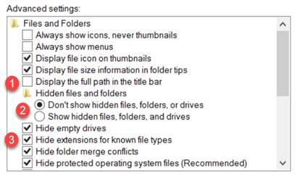

Preferred settings which you can make the default for the entire PC:
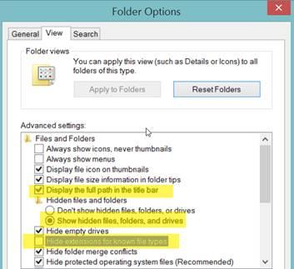
To make the display options apply to all folders, select the Apply to Folders button:
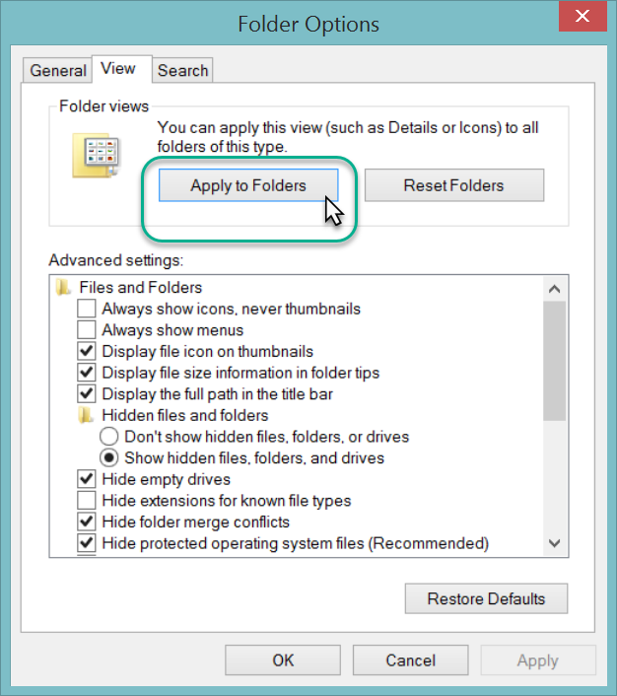
The C:\ProgramData should display. You may need to close the File Explorer window and then reopen it.
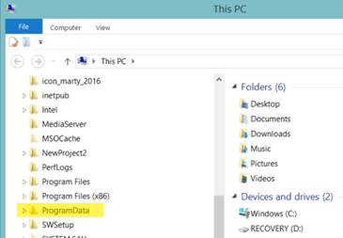

Appendix B: Attachment Locations
Below are the default attachment paths that the new Attachment Wizard uses unless there is an override from a dataview on the Middle Tier.
Administrators: Below are the details (including the calculation the wizard makes, an example of what that calculation resolves to on the server, and the name of the dataview you will want to create if you prefer to override the hard-coded default in the Attachment Wizard).

Locations of Attachment Files
Each organization running GRIN-Global will have its own unique file server where the image and document files are stored. The GG administrator can assist with deleting the files if necessary.
The following information is intended primarily for Administrators:
The full directory path breaks down into several parts:
Example: C:\inetpub\wwwroot\gringlobal\uploads\images\AIA\Humulus
The web installer puts the GG site in C:\inetpub\wwwroot\gringlobal Then the Middle Tier (MT) controls the next part of the path. It always puts the images in the uploads\images directory under the GG site install directory. (You couldn't change that without altering the MT code and rebuilding.) Then the AIA\humulus part comes from a dataview that tells the Wizard what to use. However, if an admin wanted to, they could change that part by altering the attach_wizard_get_filepath dataview.
______
NPGS
In the NPGS, use the following convention to locate an attached file at the URL:
https://npgsweb.ars-grin.gov/gringlobal/uploads/images/image virtual path
For example, using the first attachment record in the screen above:
https://npgsweb.ars-grin.gov/gringlobal/uploads/images/ AIA/Humulus/1964682/sample_hum.pdf
(In this example, the number 1964682 is the accession_ID value.)
If you delete the attachment and wish to reuse the same naming convention, but with a different attached file, you can. It is not necessary to first delete the attachment record(s), simply upload the new attachment(s).
Table | Attachment Default Path [server\folders...]
accession_inventory_attach | * accession_inv_attach\INVENTORY_FRIENDLY_NAME\
accession_inv_group_attach | accession_inv_group_attach\GROUP_FRIENDLY_NAME\
crop_attach | crop_attach\CROP_FRIENDLY_NAME\
crop_trait_attach | crop_trait_attach\CROP_TRAIT_FRIENDLY_NAME\
crop_trait_code_attach | crop_trait_code_attach\CROP_TRAIT_CODE_FRIENDLY_NAME\
method_attach | method_attach\METHOD_FRIENDLY_NAME\
order_request_attach | order_request_attach\ORDER_NUMBER\
taxonomy_attach | taxonomy_attach\FAMILY_FRIENDLY_NAME\
taxonomy_attach | taxonomy_attach\GENUS_FRIENDLY_NAME\
taxonomy_attach | taxonomy_attach\SPECIES_FRIENDLY_NAME\
* NPGS: uses AIA in lieu of accession_inv_attach

Examples
Accession_Inventory attachment:
https://npgsweb.ars-grin.gov/gringlobal/uploads/images/AIA/MAR_1_RRG.jpg
A Method attachment:
https://npgsweb.ars-grin.gov/gringlobal/uploads/images/ method_attach/RYE.AGRON.ABERDEEN.16/img_jca.JPG

Appendix C: Document Change Notes

– January 23, 2026
- additional text and images added to explain the viewing of attachments
- explanation added for converting incompatible file types such as .heic files

– June 10, 2025
- note added regarding accession-inventory-group bug

– November 13, 2023
- editing changes
- a few screens updated to reflect current Public Website

– May 12, 2021
- expanded parsing options section; included examples
- expanded DOS batch file section for creating multiple folders

– May 5, 2021
- this guide is a complete re-write of the previous Accession Inventory Attachment guide to reflect the updated Attachment Wizard released in CT v 1.21.10.4

