Accessions / Acquisitions


Revision Date
February 5, 2024

Author
Martin Reisinger

Summary
When a genebank initially acquires seeds from a donor (as an example), the source data and any other known information about the accession should be recorded as soon as possible.
Much of the accession’s data will be stored in the main accession table, by genebank staff entering the data within the Curator Tool, using the Accession dataview. However, an accession's passport information is not just stored in one table in GG. To enter accession data, the genebank staff will use multiple accession-related dataviews in the Curator Tool.
In this document, we’ll review accession basics and explain the procedures for entering and updating accession data.
Refer to the online document FAO/IPGRI Multi-Crop Passport Descriptors for complete information on the passport descriptors. See https://www.fao.org/plant-treaty/tools/toolbox-for-sustainable-use/details/en/c/1367915/

Topics

General Overview 3
Accession Dataviews 4
Accession Fields 4
Accession Prefix, Number, and Suffix 5
Relationship to Other GG Tables 6
Taxon Field 6
Status 7
What Determines an Accession’s Visibility and its Availability? 7
How are Passport Descriptors Handled in the Curator Tool? 8
Creating New Accessions 8
Overview 9
Create a New Record using the Accession Dataview 9
Create a New Record using the Accession Wizard 10
Create Many New Records (“Bulk Add” Records) by Using the Drag and Drop Method 10
Modify Existing Accession Records 11
Deleting Accession Records 11
Creating Records in Accession Child Tables 12
General Accession Wizard Concepts 13
Bulk Adding Other Passport Data 14
Using the Import Wizard (with a Caveat) 14
Accession Names 14
Bulk Adding Accession Names (Example of bulk adding records) 14
Accession Source Data 18
Source Descriptors, Codes, and Data for Source Habitat Information 19
Other Accession Dataviews 20
Appendix: Changes in this Document 22

General Overview
In the GRIN-Global (GG) Curator Tool, the main Accession dataview primarily displays data stored in the accession table. The following is an Accession dataview example (not all fields are shown):
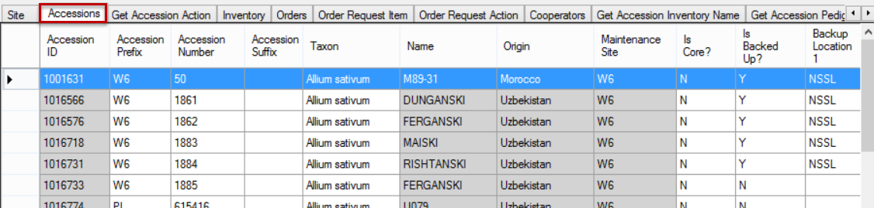
A few fields are stored in accession “children” tables. 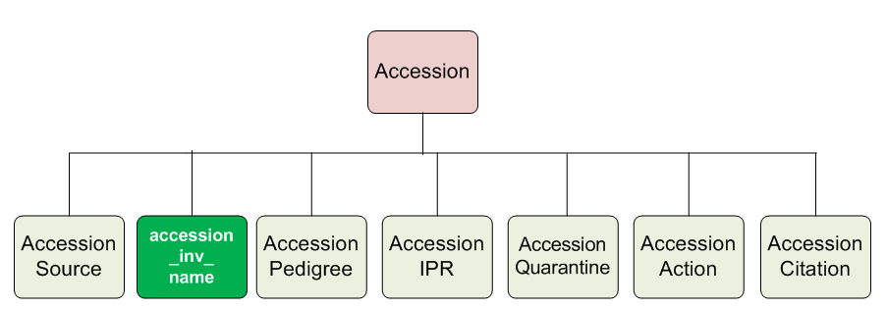
 | The diagram does not show all Accession-related tables.
In the Curator Tool, dataviews have been designed for inputting and editing accession data stored in these GG tables. In fact, there are at least 10 accession-related dataviews.
In GRIN-Global, the multicrop passport descriptors (MCPD) data, and other data, is distributed across multiple tables linked to each other. In contrast, inventory tables contain information about the physical germplasm, such as quantities available for distribution.
Besides this document, for additional details on the various tables and fields, refer to the online GG Dictionary.

Accession Dataviews
The two screens below show many dataviews pertaining to Accessions. The second screen’s dataview applies to both accessions and inventory, hence they were stored in an area titled Accession/Inventory.
Your organization may have additional dataviews that were designed to meet specific user needs for your organization.
(The dataviews shown here were developed by the GG development team. In some GG installations, the word “Get” has been dropped from the dataview titles. )
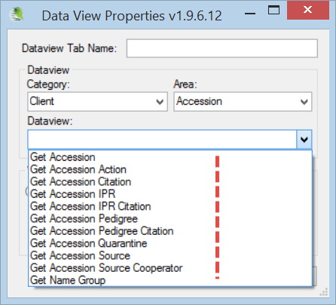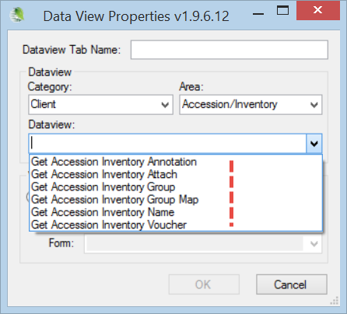

Accession Fields
The following graphic shows a partial list of the fields that comprise the Accession (“get_accession”) dataview:
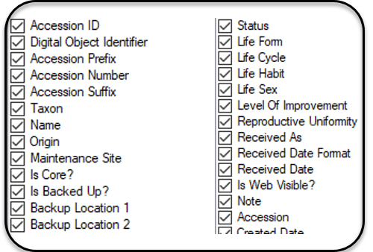
Not shown are the six audit trail fields. (Every GG record has six fields titled Created By, Created Date, Modified By, Modified Date, Owned By, and Owned Date)

Refer to the online dictionary for field descriptions. Also, refer to other documents relevant to accessions:
- Multi Crop Passport Descriptors (MCPD)
https://www.grin-global.org/docs/gg_multi_crop_passport_descriptors_MCPD.docx
- Digital Object Identifiers
https://www.grin-global.org/docs/gg_doi.docx

Accession required fields
- Prefix
- Taxon
- Status

Accession Prefix, Number, and Suffix

Accession Identifier (and Naming Conventions)
Every Accession identifier in the database must be unique. The accession identifier can consist of three fields – Prefix, Number, and Suffix. For different reasons, not all genebanks use all three fields. At a minimum, the database requires the Prefix field to be filled in. Most genebanks establish naming conventions that also require the Number and/or Suffix fields to be completed.

Examples
PI 500000
GMAL 4414 .a
TEMP 499 .00

Temporary (local) accession identifiers
An accession is typically assigned a temporary local identifier until the genebank decides to assign the accession a permanent accession identifier. Typically, in many genebanks, the curator is required to first evaluate the passport data and then grow and observe the germplasm in order to determine if it is unique and whether it should be considered as a unique accession.
For example, a convention used by U.S. National Plant Germplasm System (NPGS) is to identify accessions considered part of the permanent collection with a “PI” prefix and a number. The number is assigned sequentially. (PI is derived from the term “Plant Introduction” and was first used by the USDA in 1898.) Before the accession is entered into the permanent collection, the site evaluating the accession will use an identifier intrinsic to its site, such as CHUM 23456.
 | Whatever form a genebank uses for its identifiers, the combined three fields – Prefix, Number, and Suffix – must comprise a unique combination.  Some genebanks may prefer using numbers for the Accession Suffix field. In that case, we recommend that a leading dot “.” be used, such as .01 or .05. Why? Because the suffix field is defined in the database as a text field, not a numeric field. If you were to drag the data into Excel, Excel would drop the leading zeroes, treating the data as a number, not as text.

Relationship to Other GG Tables
The following diagram illustrates the relationships between some of the primary GRIN-Global tables:
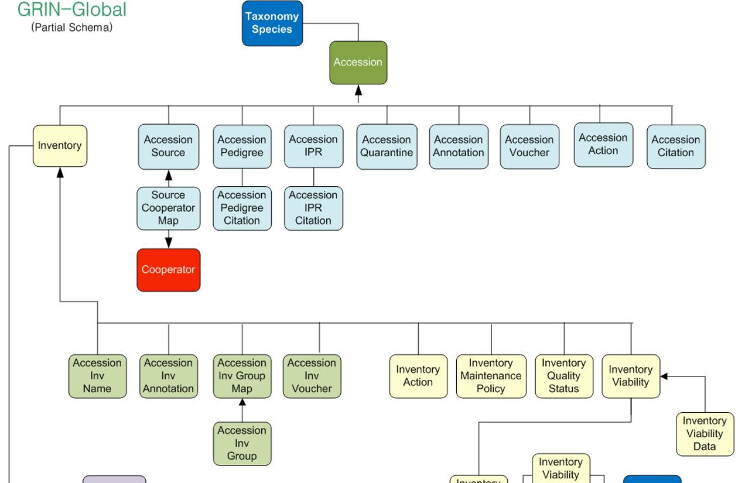
Reading from top down, the diagram illustrates the dependencies and parent-child hierarchy among the data. For example, in order to input an accession, the database must first have the relevant taxonomic data. If the accession’s taxon is Helianthus tuberosus, that taxon must be in the database first. When inputting accession information, the GG user selects the taxon Helianthus tuberosus from a list of taxons, rather than input the same text. This ensures that the taxonomic data is consistent and avoids typographical errors.

Taxon Field
If the taxon is not in the database, then someone responsible for managing the organization’s taxonomy must first add the taxonomy name(s) to their GRIN-Global database before the accession can be added. (Alternatively, GG has taxa where the Genus is used but the species is unknown, such as Malus spp.
All taxonomic data in NPGS’s database is curated by a taxonomist. Curators and other staff must contact the taxonomist with any questions when a taxon is needed to be included in the database.
For the Taxon field, the selected Taxonomy data will not be accepted if the taxon is a synonym and not considered the “accepted name.” Shown highlighted is Oryza sativa subsp. indica (but to see that in the list the is_accepted_name filter was deselected.
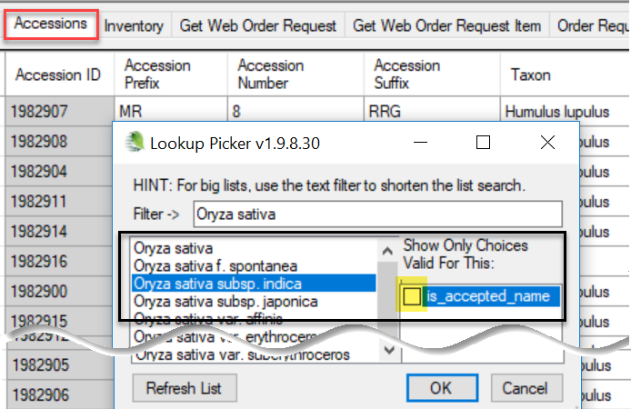
When saved, the accepted name is inserted. This action happens because of the Accession Data trigger. If you don’t want the trigger to do that, the organization’s GG Admin needs to turn off or edit that trigger.
for GG Administrators: The GG Admin can enable/disable these triggers. This trigger’s description is "Checks accession for valid taxonomy and if null set initial_received_date and life_form_code."
In the trigger code, the first section has the comment “prevent link to invalid species (e.g. synonym).” What it does - on an insert or update of an accession, if the taxon field uses a synonym (the current_taxonomy_species_id points to another species) it replaces the taxonomy with current_taxonomy_species_id.

Status
Status is a required field for accessions, but you might not realize this when creating a new accession record. The accession dataview was programmed to automatically include the status “Active.”
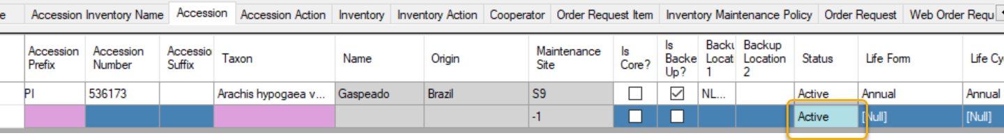
However, genebanks often maintain historic data for accessions but there is no living germplasm. These accessions should have an Inactive status. Since these accessions do not have physical inventory, germplasm cannot be offered to requestors. These historical Inactive accessions will display a “Not Available” message in the Public Website’s Availability column.

What Determines an Accession’s Visibility and its Availability?
Users sometimes confuse two issues: whether an accession is displayed (or not) on the Public Website and whether (or not) the accession is available for germplasm requests.
The GG Accession record has an Is Web Visible? field to indicate the accession’s visibility. GG uses that (Yes/No) flag field to display or not display the accession on the GG Public Website.
The accession’s inventory records establish the criteria that determine the accession’s availability – that is, whether the germplasm may be requested. The rules governing availability are a bit complex and are described in the GG Inventory Guide.

How are Passport Descriptors Handled in the Curator Tool?
In GRIN-Global, passport data is stored among several tables. In the GG Curator Tool, the group of Accession dataviews are used to view and edit the data. [Refer to MULTI-CROP PASSPORT DESCRIPTORS (in GRIN-Global)]

Reviewing Existing Accessions
If an accession already exists in the database, you can use the Search Tool to find it. You can review the data within the search tool; however, If you intend to edit this data, you will need to display the record within the Curator Tool and invoke Edit Mode.

Using the Accession Wizard to Review Passport Data
In the Curator Tool, the simplest way to display or edit much of an accession’s passport data is to select the accession record in the datagrid and then start the accession wizard. Using the wizard, you can review the related accession dataviews where most of the passport data is stored.
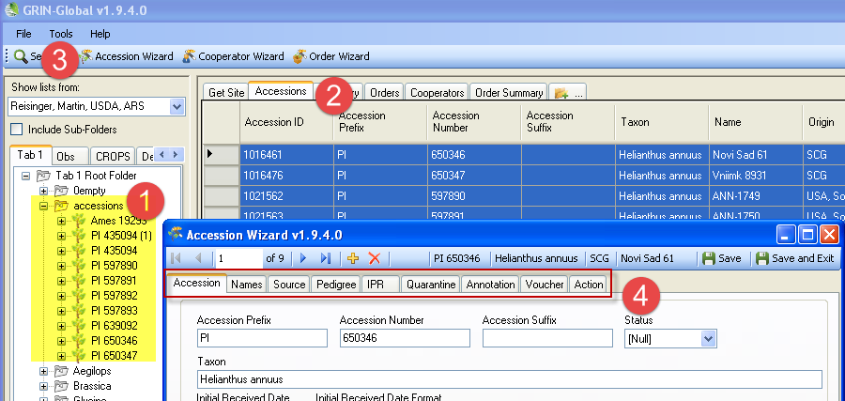
Data on the physical amounts, germplasm forms, etc. is stored in the Inventory dataviews.

Creating New Accessions
You can choose from three main approaches when creating new accession records:
Number of  Accession Records | Approach to Use
one | Accession Wizard or the accession dataview
several | Accession Wizard
many | Drag and drop from a spreadsheet into the accession dataview (“bulk add”)

Overview
The three approaches (accession wizard, accession dataview, drag and drop many records from a spreadsheet) are explained below.

Wizard
The Accession wizard simplifies the initial entering of an accession’s data which is distributed across an accession parent table and many accession children tables. Using the Accession wizard, you can input data that is stored in accession children tables while saving the accession parent record.

Dataview
When using the Accession dataview, you will also need to manually select and choose from the other accession – related dataviews that handle any child accession records.

Many records
The significant advantage in using the “drag and drop” method with the accession dataview is the ability to add many accession records at one time. However, when bulk adding many accession records, since the accession data is spread across many tables, you will most likely perform several additional drag and drop operations to drag and drop data into the respective dataviews, using the parent accessions’ primary keys as the connecting data.

Create a New Record using the Accession Dataview
General directions for adding any type of new record, including accessions, are the same.
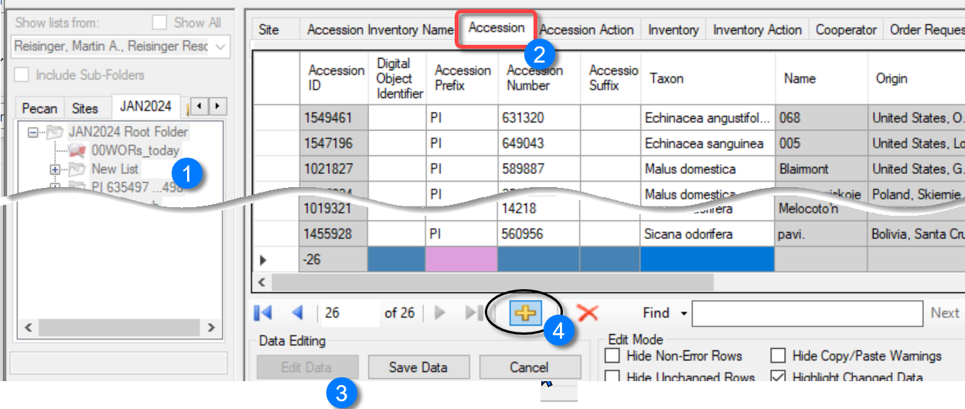
1. In the left (List) panel, select an existing list or create a new list.
2. In the right Datagrid panel, click on the appropriate dataview tab. Accession in this case.
3. Click the Edit Data button to switch to Edit mode.
4. Click the Add New button on the Navigator Bar.
An online video demonstrates this process:
https://www.grin-global.org/videos/adding_new_records.mp4

Create a New Record using the Accession Wizard
When creating a new accession record, it doesn’t really matter which dataview you have open as the active dataview. To start the wizard, click the Accession Wizard button. In the wizard screen, when creating a new Accession record, click the Add New button:
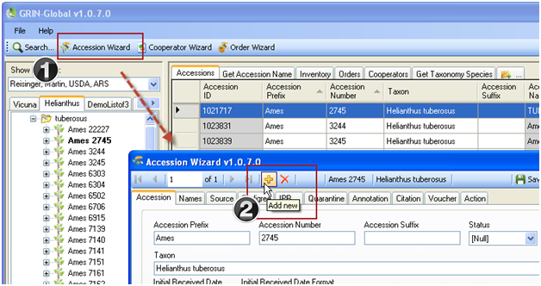

Create Many New Records (“Bulk Add” Records) by Using the Drag and Drop Method
You can easily drag data from a spreadsheet into GG. GG matches the spelling of the headings in the spreadsheet with the CT headings as shown here:
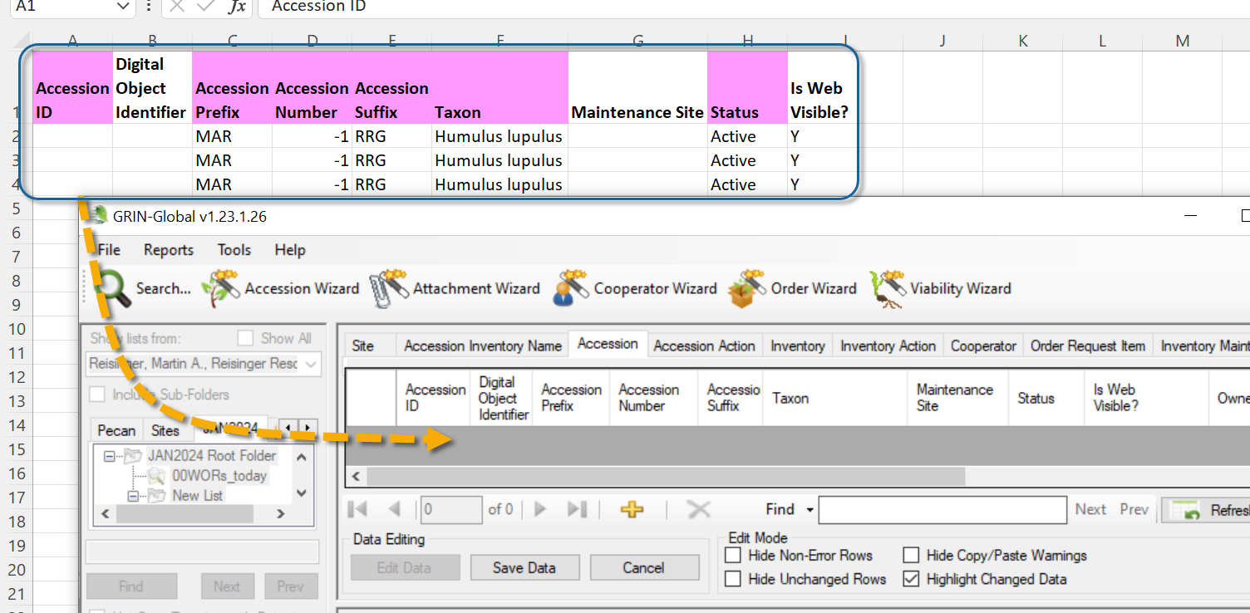
Detailed directions for this are in the Curator Tool User Guide in the “Importing Your Data from an Existing Database into GRIN-Global” section.
Some basic rules:
- Excel’s column headings must be spelled identically as the CT’s
- Column order does not matter
- Data in Excel’s hidden columns do not get transferred into the CT
- You only specify the columns you are adding with one exception – the ID column is always included. But when adding new records, other than the Excel heading, the spreadsheet column is empty (when updating records, the spreadsheet IDs must match existing CT record IDs)

Modify Existing Accession Records
As in creating accession records, there are three main ways in which you can update existing records:
- Open the Accession dataview and edit an existing record
- Select existing records in the Accession dataview and start the Accession Wizard
- Drag and drop data from a spreadsheet into the Curator Tool’s Accession dataview
If you wish to modify existing accession records, before starting the wizard, in the DataGrid, highlight the desired accession record (or multiple records) to be modified, then click the Accession Wizard button.
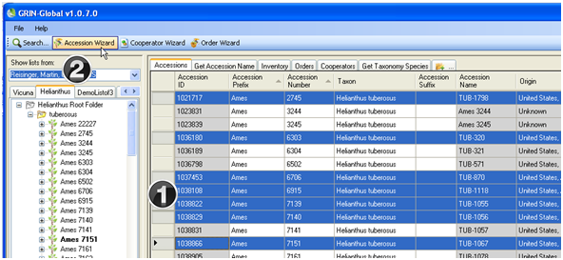

Deleting Accession Records
In a relational database where there are parent and children tables, one general principle that must be followed is that a parent record cannot be deleted if it has any children records. In order to delete an Accession record, (which should be a rare occurrence), you must ensure that all of its children records are deleted first. The Accession Wizard is useful for helping you to do this.
First, select the Accession record in the Curator Tool Accession dataview that you intend to delete; click the Accession Wizard button:
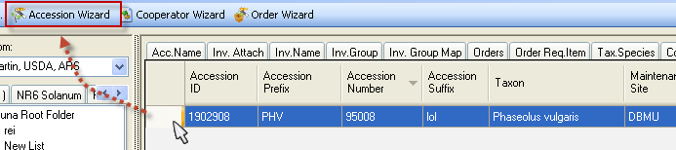
In the Accession Wizard, examine the tabs for children rows. If the accession has a child record, delete that child record by selecting it and then clicking the keyboard’s Delete key. In the example shown below, the Accession has a Name record; the user selected the row by clicking on the left margin; then the user presses the Delete key. Before exiting this tab, the user needs to click the window’s Save button:
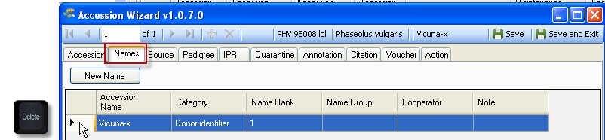
 | In moving through the various subordinate Accession wizard windows, you may have clicked a New button without intending to do so. When you click on Save and Exit, you will be prompted with an error message; click No; on the next window, click Yes:  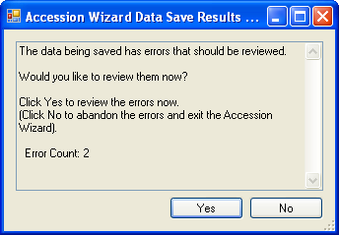 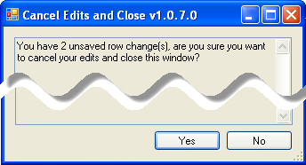
There are several fields in the Accession wizard dataviews which are unique and will be explained in detail here. Otherwise, when you require more information, refer to the online data dictionary for any accession-related fields.

Creating Records in Accession Child Tables
When dragging and dropping data into the Curator Tool, after you create the parent Accession records, you will need to use the Accession identifiers (the combined accession-prefix, -number, and -suffix) to relate the children records. The Accession dataview has a field that combines those three fields, the Accession field:
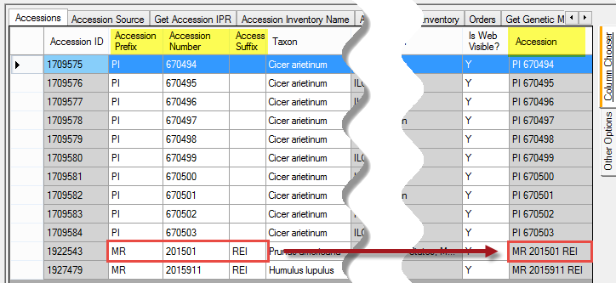

General Accession Wizard Concepts
After the Accession Wizard button is clicked on the main Curator Tool window , the Accession Wizard displays the wizard’s dataview tabs in its own window. The left dataview tab is Accession – this contains the fields used by the parent accession table. After completing the fields under the Accession tab, click the Save button. While using the wizard, you can click on any of the tabs in any order, to display the tab’s corresponding dataview.
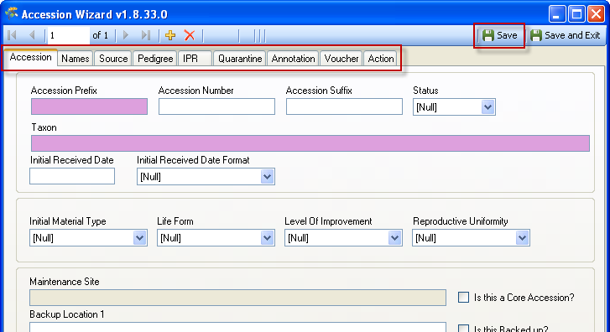
In this example, the Names tab has been selected.
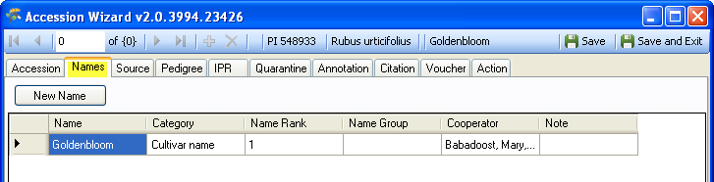

Saving the Data
In any dataview window in which you enter data, in order to save the record, you must input data in the required fields’ data. You do not need to complete every window in the wizard, since the dataviews are independent and view different tables.
When completing (or partially completing) a dataview, before proceeding to the next tab, click the Save button as you continue inputting in the wizard.
Use the Save and Exit button when you are finished using the wizard. Since you can use the wizard to edit existing data, you can always return later and edit the data.
The Save and Exit button will close the accession wizard and return to the Curator Tool, but first it will indicate that you were successful and also prompt you to add an item to the current list folder in the Curator Tool window.
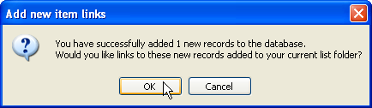
If you select Cancel, the database record will have been created, but no item pointing to the new record will be generated in the current list folder.

Bulk Adding Other Passport Data
Other accession passport data will need to be copied in a similar fashion. For example, accession source records are another type of child record. Refer to the Accession Source section in this document for more information.

Using the Import Wizard (with a Caveat)
[GG Administrators only] The Admin Tool has an Import Wizard. It is useful for doing an initial “dump” of your organization’s base accession data, but it is not recommended to be used later when an organization is maintaining an ongoing GG database. Refer to Cookbook for Importing (for the Import Wizard).

Accession Names
The Accession Name field is not stored in the accession table, but rather in the Accession Inventory Names table. There are several technical reasons for this, but users need to keep in mind two points: (1) Names can either be associated with the accession or with specific inventories for that accession, and (2) although an accession may have multiple names associated with it, only one name will be considered the “top” name and will be the first name that the Public Website user sees.

Bulk Adding Accession Names (Example of bulk adding records)
Accession name data is not entered in the Accession dataview; the name data is stored in a child table (Accession Inventory Name) and must be entered in its corresponding dataview: get_accession_inventory_names.
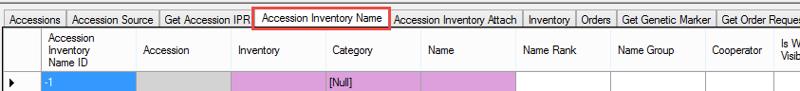
Instead of relating directly to Accession records by their Accession identifier (the accession prefix, number, and suffix combination), name records relate to accessions indirectly via the Inventory identifier. (Notice how the Accession field is in gray – this field is not inputted here.) GG was designed this way was to allow names to be applied at either the accession or inventory lot level.

Steps To Bulk Adding Names
- determine which accessions you will be naming
Accession dataview
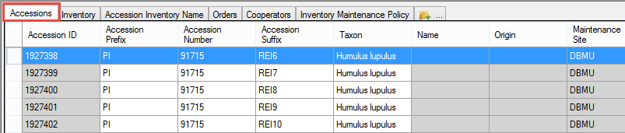
- prepare a spreadsheet: Copy the fields from the get_accession_inventory_names dataview; ensure the get_accession_inventory_names dataview is the active dataview. Select at least one row from the CT. If you don’t have any name rows yet, in Edit mode invoke the Add New function (click the gold plus sign) and select the empty row:
The three required fields are:
  - Inventory
  - Category
  - Name
in the CT, having that new accession_inventory_names record row visible is helpful because the colors indicate which fields are required (violet), which are read-only (gray), and which can be supplied with data (white) (#1 above)
  - Select and drag this row from the CT to Excel.
(In the spreadsheet below, the headings were formatted in Excel to fit (wrap) in the column):
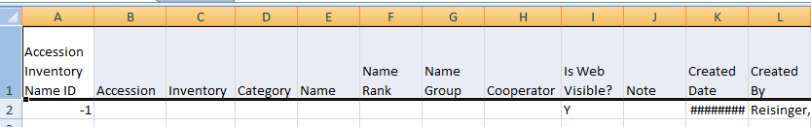
- since you are creating new name records, you will leave the Accession Inventory Name ID field empty -- delete all IDs
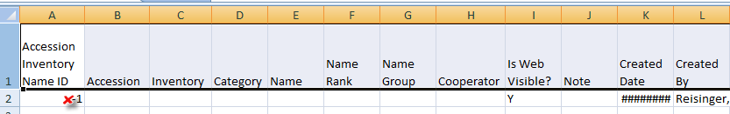

Inventory
- assuming you are assigning names to apply to the accessions (rather than specific inventory lots), from the Curator Tool, in the get_inventory (Inventory) dataview, copy the Inventory field data
Inventory dataview
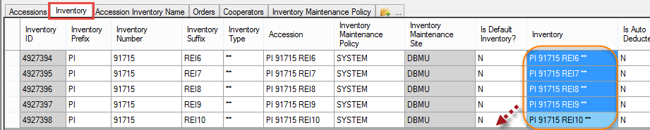
The inventory records with the ** - the system inventory records that represent the accession – are typically used.
- paste the Inventory data into the Inventory column in the spreadsheet:
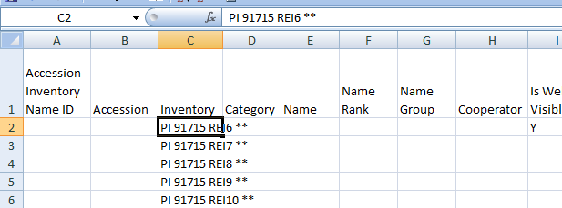

Category
The Category field uses a code for its value, so ensure that you have a valid code (review them by editing/opening a record in the CT. In the example here, “Cultivar Name” is a valid code.
Alternatively, you can omit the Category field data now, but you will see error messages when you drag the data into the CT. Shown here is the Category column filled out with a valid code (Site identifier):
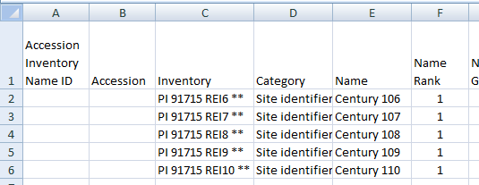

Name
- Input the desired names.
After the required and other desired data is filled in, you drag this spreadsheet, with the column headings and the data, back to the Curator Tool. Be sure to include the empty ID column.
Refer to the Accession Names section in this document for additional information about accession names and the impact of values stored in the Name Rank field.

Names can either be associated with the accession or with specific inventories
In the following example, the first three names are linked to the accession via the system inventory record, the “…**” whereas the fourth name record relates to a physical inventory “…CT”
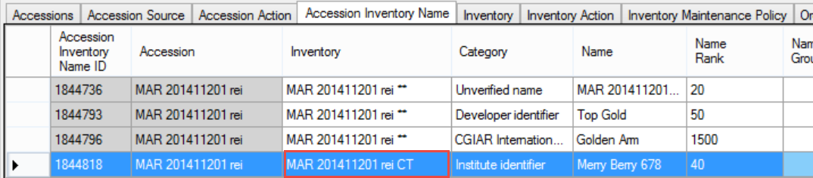

An accession may have multiple names associated with it
The same accession may be referenced by multiple names. For instance, it may have a name designated by the donor as well as a local or common name. Other developed accessions may be known by a breeder’s cultivar name or in some cases a trademark name. GRIN-Global provides the capability for unlimited names to be associated with accessions. In the main Accession dataview, only one accession name is displayed. A subordinate (child) table viewed by the get_accession_inv_name dataview (Accession Inventory Names) stores all of the associated names for the accession.
In the example below, in the Accession Inventory Name dataview, there are three names for the same accession:
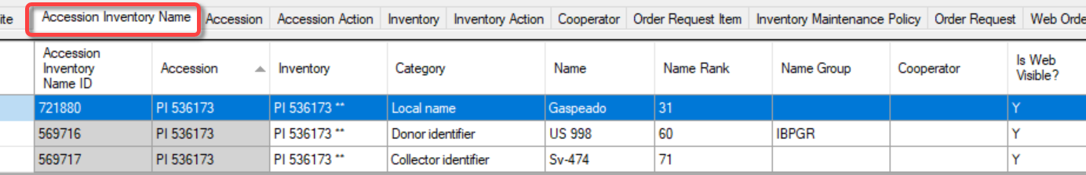
So how does GG determine which name to display in the Accessions dataview?
Switching to the Accession dataview, this is what the CT user will see:
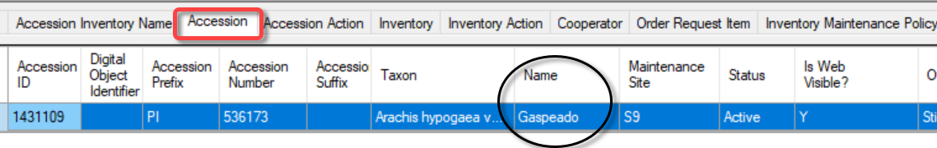
(Each name record in the above example has a “Y” in its respective Is Web Visible? field.) Here’s the Accession displayed on the Public Website search results page:
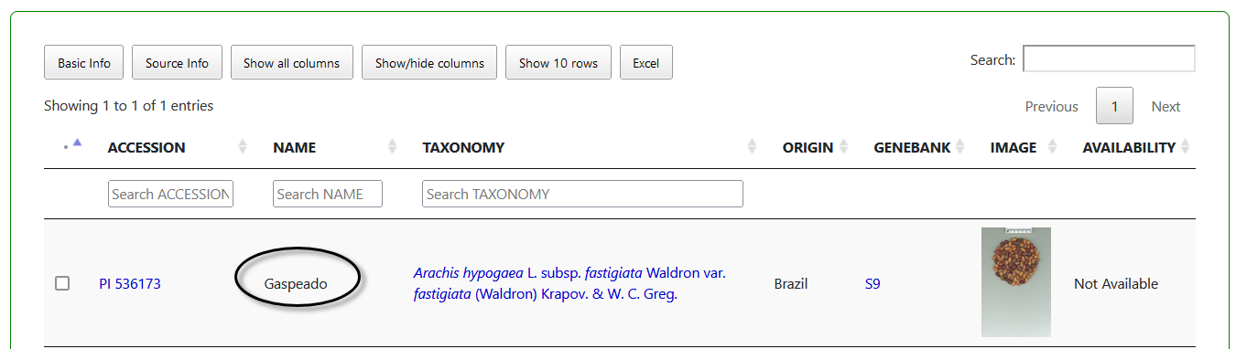
For accession PI 536173 with three associated Name records, the lowest Name Rank value was 31, hence Gaspeado is considered the top name. In the PW details page, the user will see all names:
To keep this simple, if you have multiple records for one Accession in the Names dataview, enter “1” in the Name Rank field in the Name dataview for the record whose name is to be listed in the Accession dataview. (Some genebanks might refer to this as the “top name.”)
Some organizations may use a fairly complicated algorithm for assigning numeric values to names, but ultimately in the Curator Tool the name associated with the lowest value in the Name Rank field determines the name that will be displayed in the corresponding accession dataview record. NPGS has written a trigger to calculate the top name based on certain criteria – some organizations may decide to not use this trigger or create one to meet their specific needs.
If two (or more) accession name records exist for the same accession and have the same lowest Name Rank value, then the one whose name is alphabetically first will be displayed in the accession dataview.
NPGS’s trigger establishes the Name Rank value based on the category that was selected for the Accession Inventory Name record.

Accession Source Data
The Source dataview maintains data pertaining to accessions collected in the wild or obtained from farmers, markets, or other local sources, and donations from breeders.

Source Type
There are three possible Source Types:
- Collection source event
- Developer source event
- Donor source event
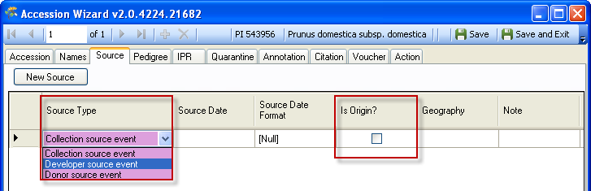

Is Origin?
This “Is Origin?” checkbox, when checked, indicates that this record’s Geography field will be considered as the accession’s source location.

Source Descriptors, Codes, and Data for Source Habitat Information
A core set of collection site/habitat information still remains in the accession_source table, (a legacy from GRIN, the predecessor software to GG), while five new source_tables have been added. The five new tables provide an extremely flexible method for adding detailed information about the collection site which was not possible in GRIN. IN GG, genebank managers can create custom source habitat descriptors and codes and manage an unlimited amount of detail about the collection site.
For example, within a category called Soil Descriptors there could be sub-descriptors such as Moisture, Texture, Magnesium Content, etc. The level of detail and range of descriptors is up to the organization and the GG database manager.
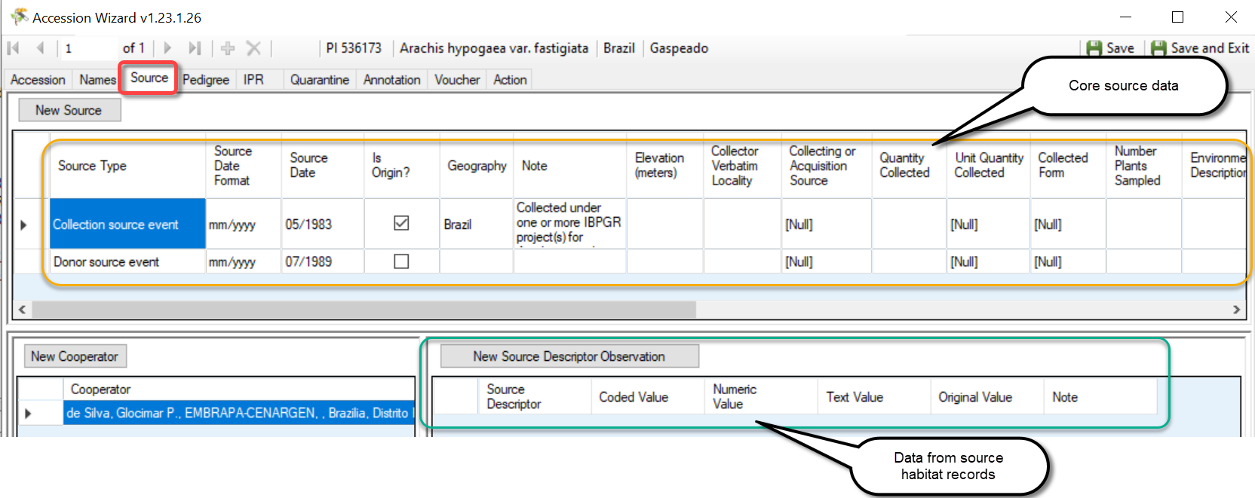
Complete documentation for creating and using habitat source descriptors is available online in the Source Habitat Descriptor Guide at http://grin-global.org/docs/gg_source_habitat_descriptors.pdf.

Accession Wizard and Source Description Observation Data
Using the wizard, click the New Source button and then proceed to complete the window. Generally it is a good idea to first start by indicating the source record (1), then the cooperator(s) (2), and then add as many source habitat observations as needed (3).
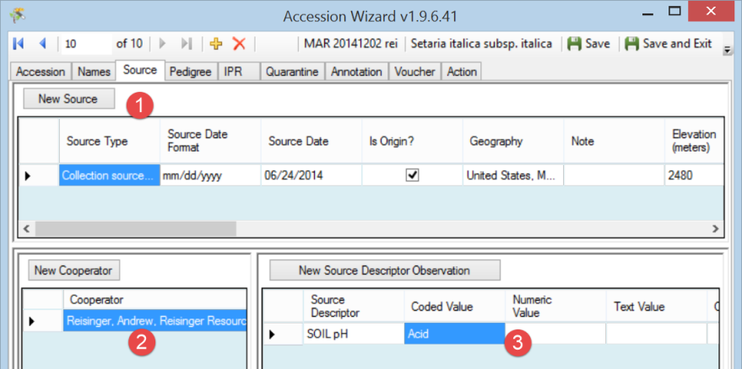

Other Accession Dataviews
For information about the other fields used in the accession dataviews, refer to the online data dictionary. The following notes summarize the “accession” dataviews.
Dataview  accession_ | Note
action | The accession_action dataview displays data pertaining to actions performed on an accession. Examples: INACTIVATED, INCREASED, TRANSFERRED. Accession actions in GRIN (Classic) were created not only for actions done on an accession as a whole, but to keep information on how the accession was being handled, treated, documented, etc. The accession_action data evolved from the inactivation process where you could document that the accession died, include details, but not display the details to be public. The use of accessions_actions has also grown to document the passport review process – often difficult to do in one sitting, but can be done over time. These actions can be used to indicate what has and has not been reviewed.  Accession Action records have an Is Web Visible? field. You can select /deselect to indicate if the action is to be visible (or not) on the PW on the accession’s detail pages.
citation | Displays citations from the citation table that are associated with an accession record.
IPR | Primarily displays the accession's intellectual property rights (IPR). One accession can have several IPR records since the accession can be covered by several IPRs. IPR accession records will be highlighted whenever they are involved in orders.
IPR_citation | Displays citations from the citation table associated with an accession_ipr record.
pedigree | Displays table of pedigree information. Although standards are not used for pedigrees, individual entries should be clear and consistent throughout each crop. Each accession record may have only one pedigree record associated with it.
pedigree_citation | Displays citations from the citation table associated with an accession_pedigree record.
quarantine | Data in the accession quarantine table. When an accession is restricted by several types of quarantine, the accession will have multiple quarantine records; however each accession can have only one occurrence of a particular type of quarantine.
source | (described previously)
source_cooperator | This dataview makes it possible to associate (“map”) multiple source cooperators to multiple accession source records.
name_group | Accessions can be grouped under a name for various reasons – later the name group can be used to locate the accessions collectively grouped under the name. A complete guide to grouping explains this in detail. See Grouping Accessions and/or Inventory.

Appendix: Changes in this Document

– February 5, 2024
expanded information on rules and hidden columns when dragging

– January 4, 2024
- major edits/ rewrite

– June 14, 2019
- section added to explain what happens when synonyms are used in the Taxon field

– December 9, 2018
- wording added for actions to illustrate how to display a comment on the PW

– January 24, 2017
- wording added to emphasize the inputting of source habitat descriptors by a single person or group to ensure usage consistency

– September 17, 2015
- expanded section on bulk adding

– December 12, 2014
- new screens and explanation for the ranking of the Name field when there are multiple names for an accession
- edited text and updated images for accession source and accession name groups material

– September 24, 2014
- edited text regarding accession visibility and inventory availability

