ELDERBERRY Exercise

Adding a Crop, Traits (Descriptors), and
Observations into GRIN-Global


Revision Date
January 25, 2024

Author
Martin Reisinger
Revision notes pertaining to this document are also summarized in the Appendix. The Table of Contents which contains links to the document’s sections

Purpose
This document demonstrates the step-by-step process involved in recording evaluations (observations) in GRIN-Global. It goes beyond that in you will learn how to set up the crop, the traits, and any necessary codes. Although creating new crops, traits, and codes is done relatively infrequently, by learning how to do so should prepare you for making observations.

Topics
Introduction 2
This Document / Activity 2
What is a “Crop”? 3
Crop Dataviews 3
Crop Record 3
Taxonomy Crop Map 4
Elderberry Crop Exercise 5
Crop Traits 7
Three Observation Types: Text, Numeric, and Coded 7
Crop Trait Lang 10
Crop Trait Code 11
Crop Trait Code Lang 13
Observations 16
Points to Remember 19
Appendix: Document Change Notes 21

Introduction

Summary
In this tutorial, you will be guided into creating a new crop and then its descriptors (traits), and other associated records. A new elderberry crop is created as the example crop and then several traits for the elderberry crop are defined. Finally, sample observations are recorded.
For additional information, refer to other documents online which describe in detail how GG handles crops, descriptors, and observations. See:
https://www.grin-global.org/docs/gg_observations_and_descriptors.docx and https://www.grin-global.org/docs/gg_coded_trait_examples.docx
The former document is a complete reference and the second contains examples of actual crops and traits defined in the USDA database.
Three one-hour webinars on crops and traits were given to the USDA genebank staff in 2023. The video recordings and the slides used in the presentations are online. See https://www.grin-global.org/NPGS_news.htm. Scroll down for these dates: February 2, 16, and 23, 2023.

This Document / Activity
Much text is included here, so I apologize up front for all of the reading!
This document assumes you will read through, and then practice, using the Curator Tool. In order to practice, you should already have created at least one accession, ideally one that has one or more physical inventory records.
The accession’s species doesn’t really matter for this exercise, but in a few pages the concept of mapping species to a crop will be discussed. Most likely you will need to create a Taxonomy Crop Map record for your accession’s species. In this exercise, we will be making an ELDERBERRY crop. To be realistic, you might consider first making a few new accessions records, and use Sambucus nigra for the species (Taxon field).
If anything seems to be misleading, please contact me at marty.reisinger@usda.gov and I will address your comment/question.
--Marty Reisinger

What is a “Crop”?
For recording observations, in GRIN-Global (GG) the term “crop” is used to group accessions of related taxa. Note that any species can be included in more than one crop in GG. For example, in the following example, two GRAPE Crop exist: GRAPE-DAVIS, and GRAPE-GENEVA. Curators at two different sites, Davis California and Geneva New York maintain Vitis vinifera accessions and needed to group them in their own respective crop.
We will see how this can accomplished further on in this document.
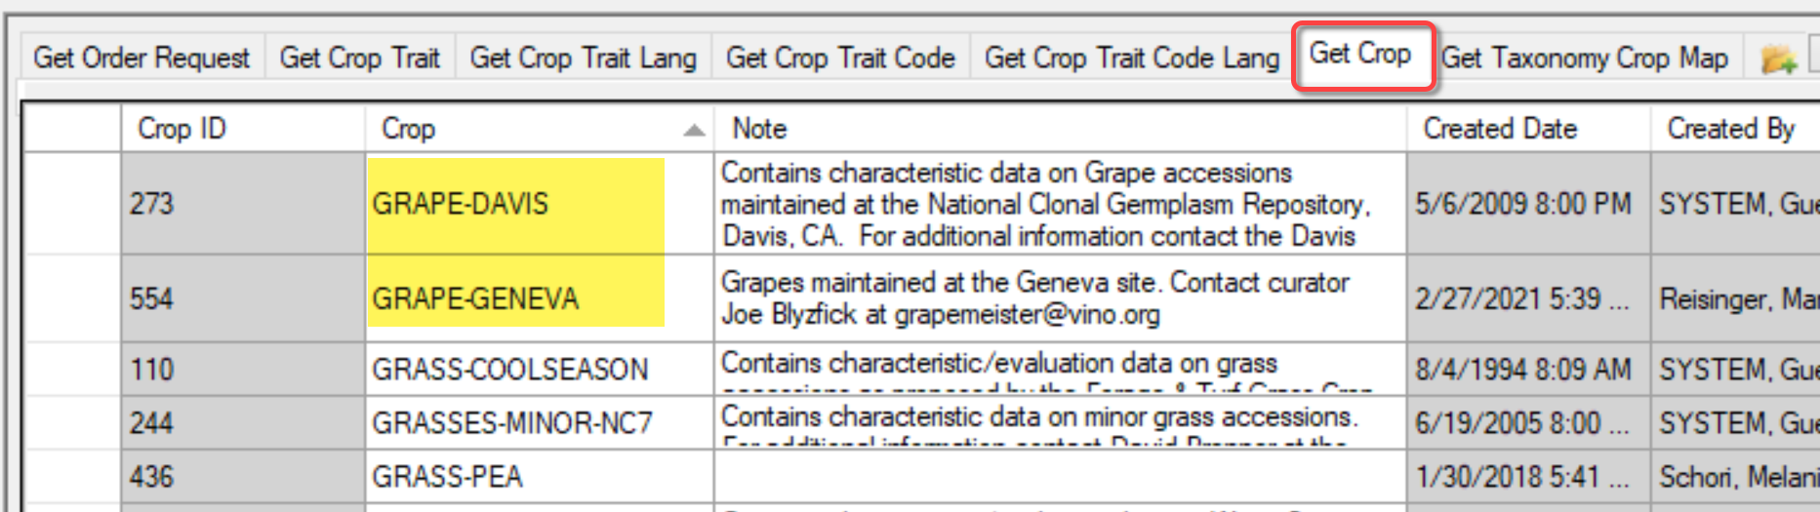

Crop Dataviews
In the Curator Tool (CT), the dataviews we will be working with are all in the same area:
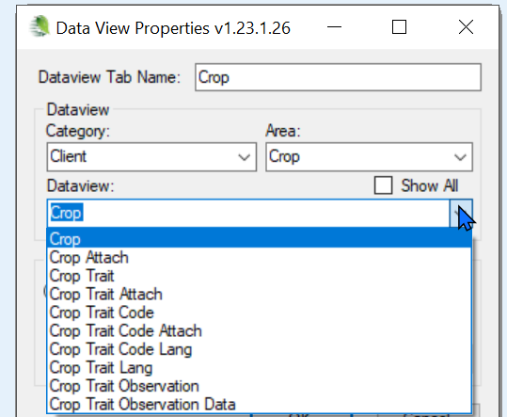

Crop Record
The only required field for a new Crop record is the Crop field. However, the Note field is very useful, as the note will be displayed on the Public Website.
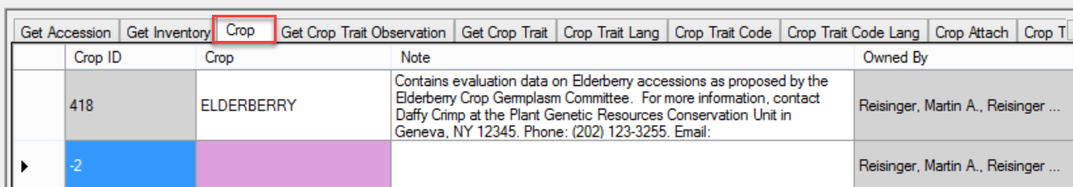

Taxonomy Crop Map
In GG, the Taxonomy Crop Map table should be used to map the crop for each species that is to be considered part of the crop.
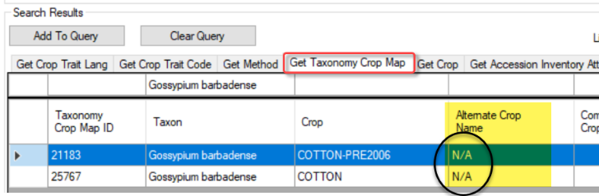
(The N/A is necessary and is explained further below.)
GG has a trigger that can map a species to a crop if the species has not been mapped to any other crop previously. However, it is recommended to map the species to crop records before recording any observations to avoid possible data entry confusion later.
 | Even when a crop has been defined, the GG Public Website will not display the crop’s traits until observation records have been saved in the database.

A GG trigger will display an error message when the user is attempting to save an observation and the accession’s species has not been mapped to the crop being supplied in the observation record. In other words, GG prevents the user from using the “wrong” crop for an accession because GG determined the taxa belongs in some other crop.
When an organization wishes to use the same taxa in more than one crop, Taxonomy Crop Map records must be recorded. For example, two sites may be maintaining Vitis vinifera. To differentiate, one site may call their crop “GRAPES-DAVIS” and the other site “GRAPES-GENEVA.”
The two crop records exist:
This Taxonomy Crop Map dataview shows that both crops are mapped to the species Vitis vinifera. 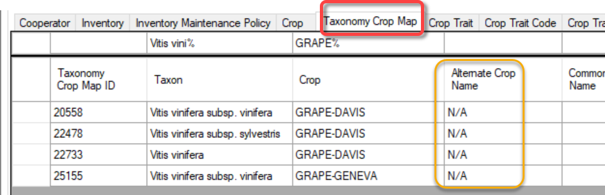
N/A was entered in the Alternate Crop Name field.

Elderberry Crop Exercise
In this exercise, you will create a crop.
Assume that everyone following these instructions will be making an ELDERBERRY crop. For this exercise, in order to have multiple elderberry crops in the same database, follow the steps below, but whenever directions state the crop is ELDERBERRY, replace ELDERBERRY with ELDERBERRY-XXX, where xxx are your initials. For example, if I were to create a new crop, I would call mine ELDERBERRY-MAR.
Crop names are not required to be in uppercase, but historically in the legacy GRIN system, the crops names were all in uppercase. You can use all upper, title case, etc.

 | Practice! Create a new crop  Open the Crop dataview.  The Crop (name) should be ELDERBERRY-XXX (XXX as explained above.)  The Note can be any text you desire. Remember that this text eventually will be displayed on the Public Website, as shown below.  Public Website | Descriptors
The Note field serves an important function – the note displays on the Crop’s page:
Update your Crop Lookup table.
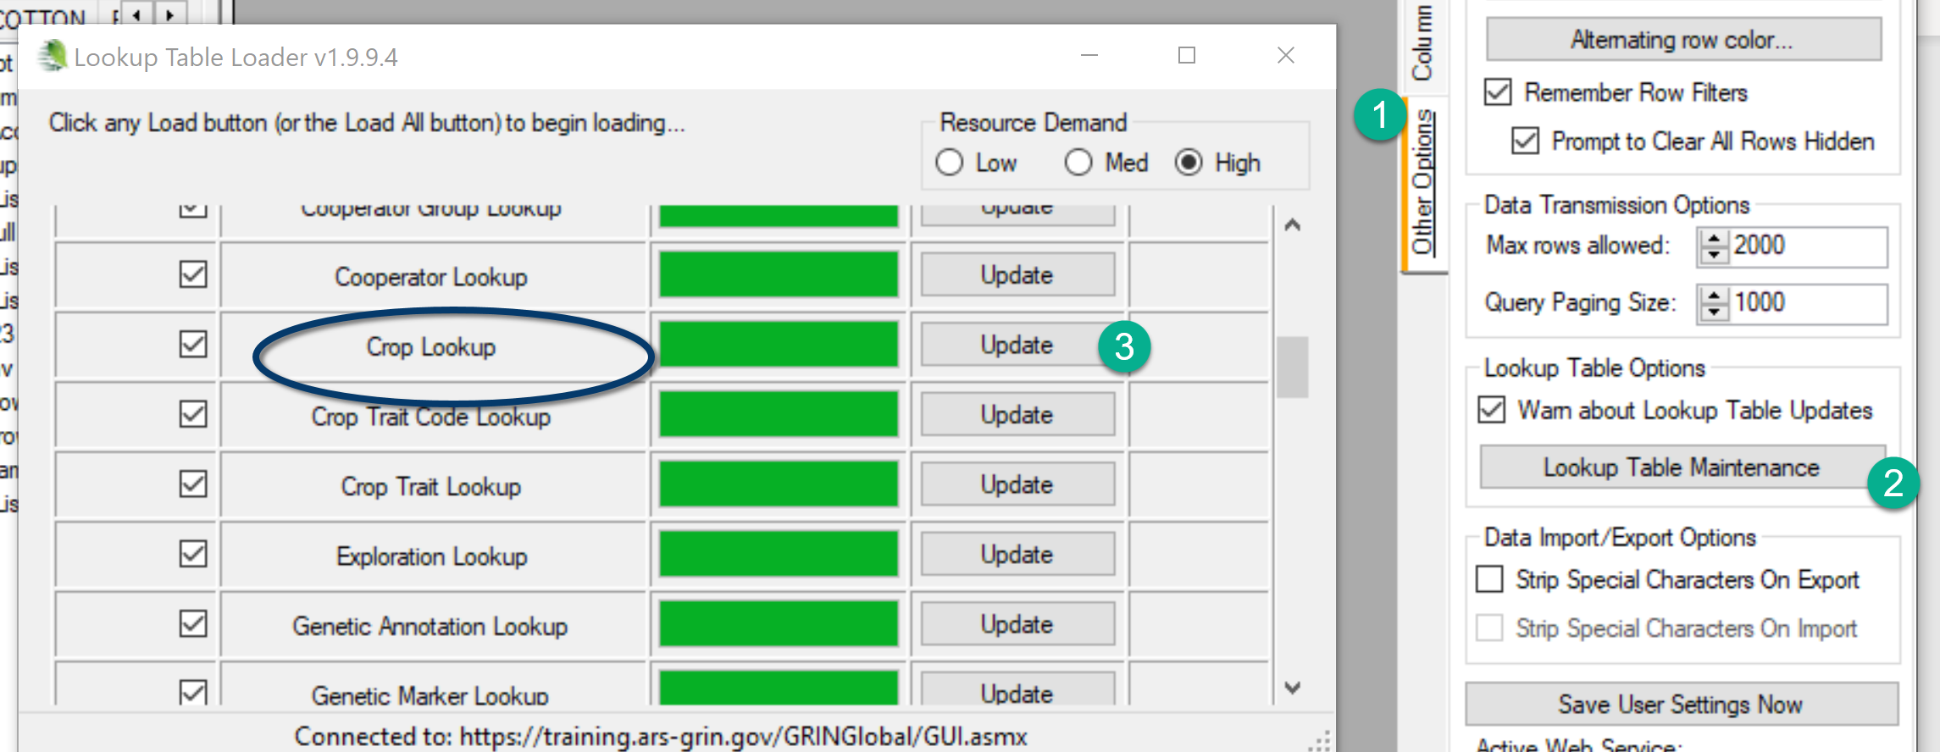

The Elderberry Crop record as shown in the CT (below). Notice the ELDERBERRY Crop item in the left List Panel. Eventually, any traits defined for ELDERBERRY will automatically be listed under the Crop item in the List Panel, but since none have been defined yet, none are listed.
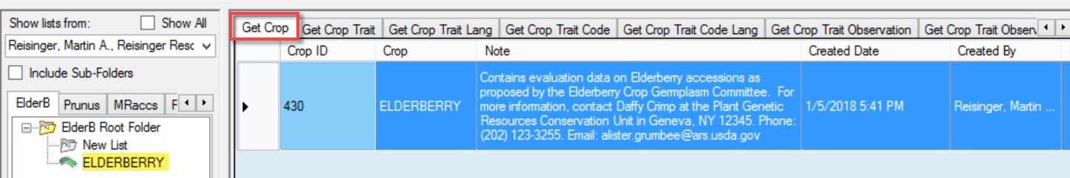

Practice! Create a Crop Map record for your new crop. What taxa should you map to your new crop? What accessions do you currently have in the database? What are their taxa? Ideally, for this exercise, use your accessions/inventory and record the observation on those. Review “your” taxa – and then map that taxa to your new crop.
The various species of Sambucus are commonly called elder or elderberry. You could make some new accessions specifically for this exercise, and use Sambucus nigra for the accession’s Taxon field.
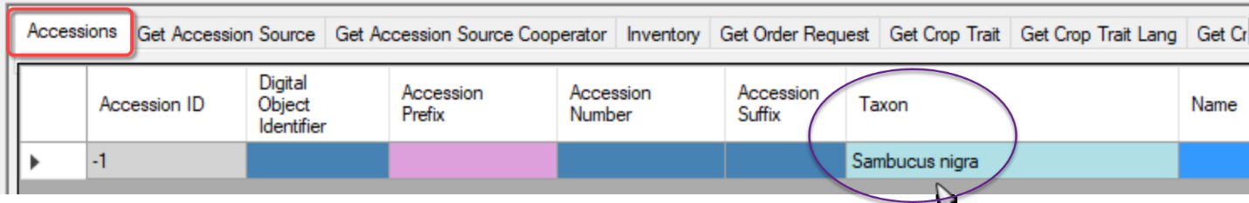
When you create the Taxonomy Crop Map record for your new crop, be sure to set up the record similar to the examples under Crop Map. Use the Taxonomy Crop Map dataview which is under the Taxonomy area.

Crop Traits
When defining traits, there are 3 descriptor types. When recording observations, the data will be one of the following:
- text
- numeric
- coded

Three Observation Types: Text, Numeric, and Coded
A trait is designed to hold one of three kinds of data. The trait determines which type of observation can be entered:
- Text
- Numeric
- Coded
When defining the trait, two fields determine the data type:
Type of data | Field: Data Type | Field: Is Coded?
text (“string”) | Alpha/numeric descriptor | - no -
numeric | Numeric descriptor | - no -
coded | Can be any Data Type, but Numeric is recommended | - yes -
The three types are mutually exclusive. When recording an observation record, one of the values is required.

A spreadsheet with ELDERBERRY data to be used with this lesson is at
https://www.grin-global.org/files/elderberry.xlsx
You will be directed to practice shortly. This spreadsheet will save you some typing. In the meantime, read on.
Shown here is a spreadsheet used to create a Crop Trait record:
Four fields are required (look at the 2nd record below; for this example, ignore the first record which is an existing record already in the database):
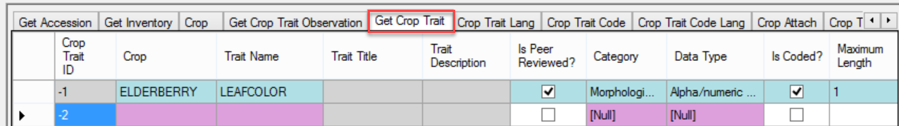
Later, the read-only fields, Trait Title and Trait Description, will be supplied after a corresponding Crop Trait Language record has been completed.
If you create the trait before the Crop lookup table has updated, you will receive an error:
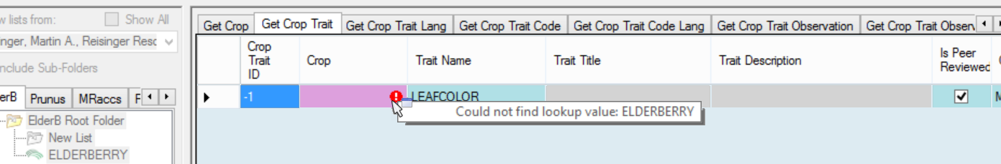

Refresh the lookup table and select ELDERBERRY(-XXX):
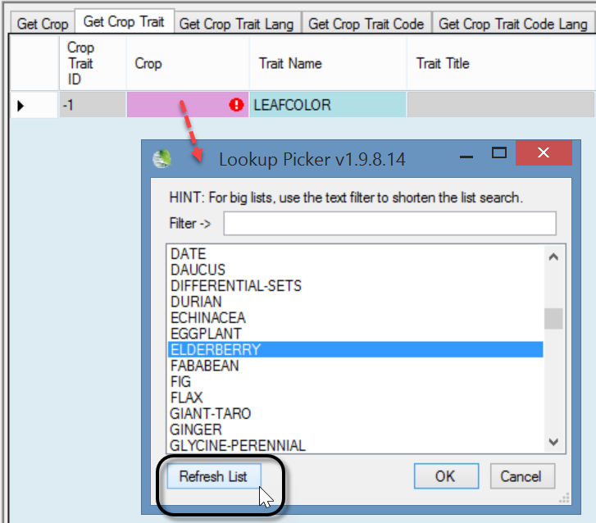

Until the Crop Trait gets its Trait Title and Trait Description fields (via the Crop Trait Lang dataview), the list item displays as it does below – :croptraitid=crop trait record ID
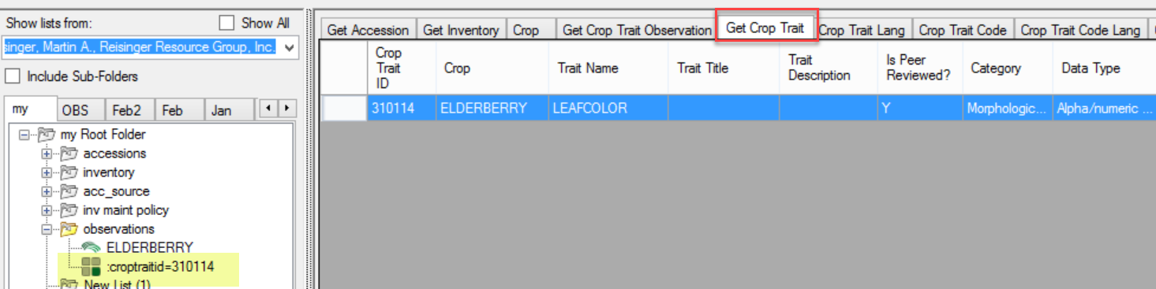

GG uses “lang” tables to provide the Titles and Descriptions for traits. After entering the trait record(s), one should enter the Trait Titles and Trait Descriptions in the Crop Trait Lang table.
Be careful – there are two Crop … Lang dataviews – one is for Traits, and one is for the Trait Codes.
Practice! Adding traits
A spreadsheet with ELDERBERRY data to be used with this lesson is at
https://www.grin-global.org/files/elderberry.xlsx

Create several traits for your ELDERBERRY-XXX crop. Use the Trait tab in the spreadsheet provided above.
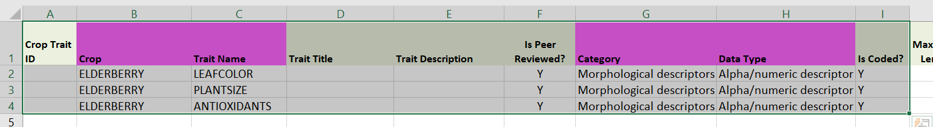
 | Remember to always include the ID column when dragging data from Excel to the CT. The cells below any ID heading remain empty when adding new records. When updating records, the IDs must always be included.

Crop Trait Lang
Shown here is a spreadsheet used to create a Crop Trait Lang record:
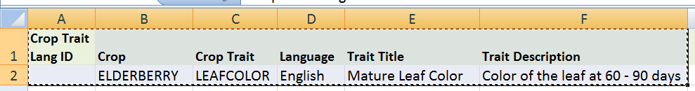

The Curator Tool is showing the required fields. Notice that the record is displaying an error – the Crop Trait field shows the error indicator:
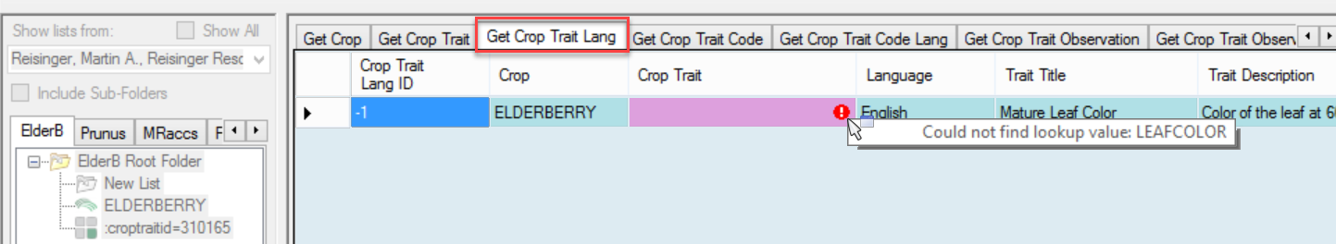
This error often happens because the Lookup Table for Crop Trait hasn’t been updated yet. Click in the Crop Trait field and then refresh the trait list; select LEAFCOLOR:
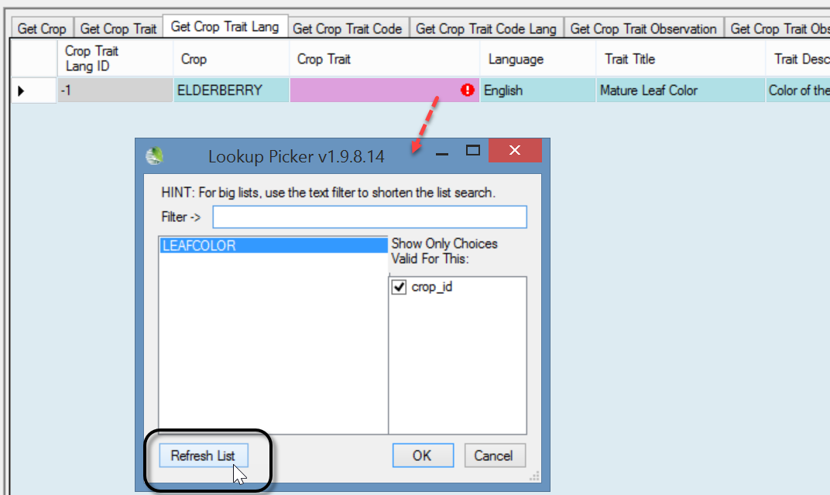

Alternatively, in the datagrid you could have clicked the Refresh Data button and waited for the lookups to update:
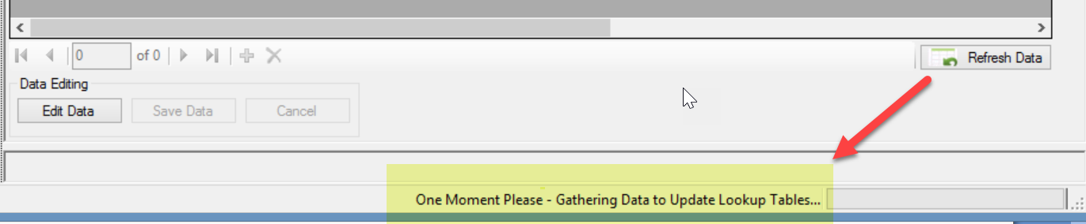
The drag and drop (or the manual inputting of the record) will then work properly and you can save the new Crop Trait Lang record:
Previously the trait list item reflected the record ID number (see croptraitid). After the language record (Crop Trait Lang) is saved, that item indicator will reflect the trait name and the language. The Trait Title and Trait Description will be filled as well:
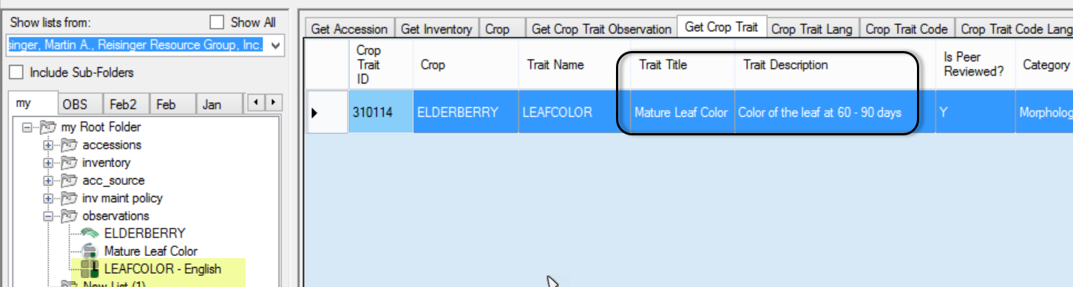
Practice!
Create several Crop Trait Lang records. Use the sample data provided on the online spreadsheet, using the Crop Trait Lang tab.
As mentioned earlier, GG uses “lang” tables to provide the Titles and Descriptions for traits and codes. There are two separate tables, Crop Trait Lang, and Crop Trait Code Lang. After entering the trait(s), one must enter the Trait Titles and Trait Descriptions in the Crop Trait Lang table.

Crop Trait Code
Three fields are required when creating a new Crop Trait Code record – the Crop, the Trait, and the Code:
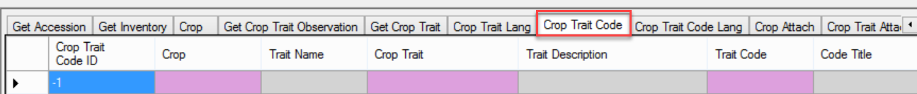
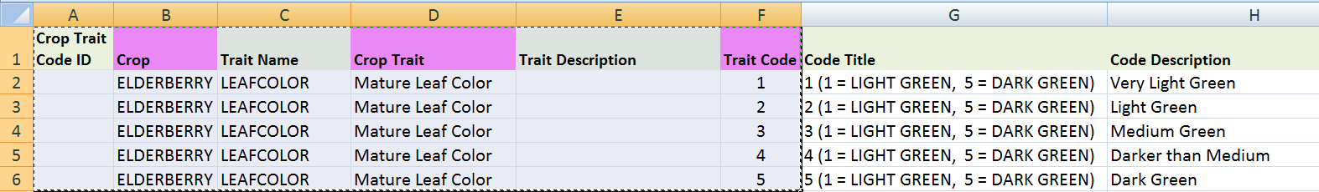
In the spreadsheet image above, also shown are the Code Titles and Code Descriptions. However, these fields have not been created yet. involved yet. But they are shown here for clarity to give you an idea of the meaning of the actual code values.
When using the Drag and Drop method to create new code records, you don’t include the Code Title and Code Description fields. In fact, you can’t here, because these two fields must be defined later in a separate dataview, the Crop Trait Code Lang dataview. The Code Title and Description fields were not shown in the CT’s Crop Trait Code dataview image above, but scrolling to the right, the screen below shows that both of those fields are Read-only:
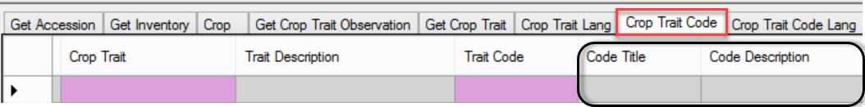
After the drag, but before the records are saved, this is how the new records display:
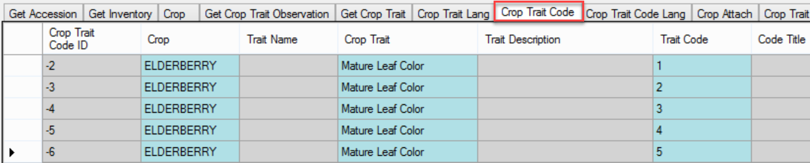
However, if, when you attempted to save, you received the following error, then you need to update the Crop Trait lookup table (as we did earlier when updating the Crop Trait Code Lang – see Create Crop Trait Lang):
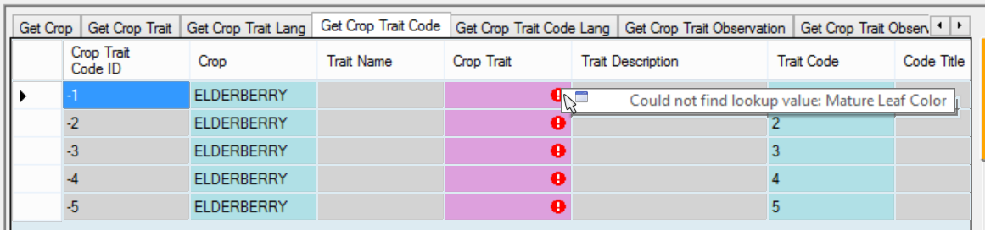
If you refresh the first record’s trait, you can then use Ctrl-D to copy down (similar to the copy down command used in Excel), to copy the trait for all of the new records. Notice in the second screen below (after the save) that the Trait Name and Trait Description have filled in as well:
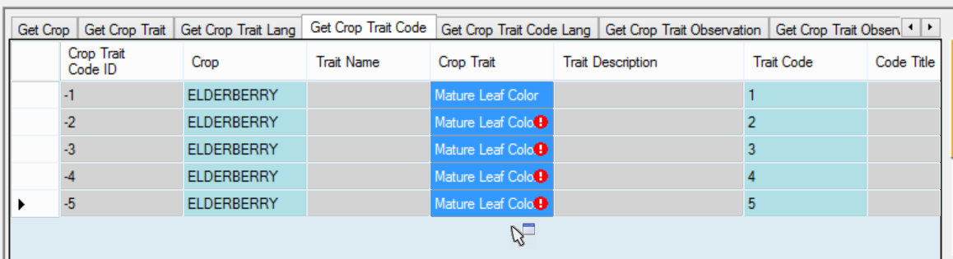
Five codes successfully added:
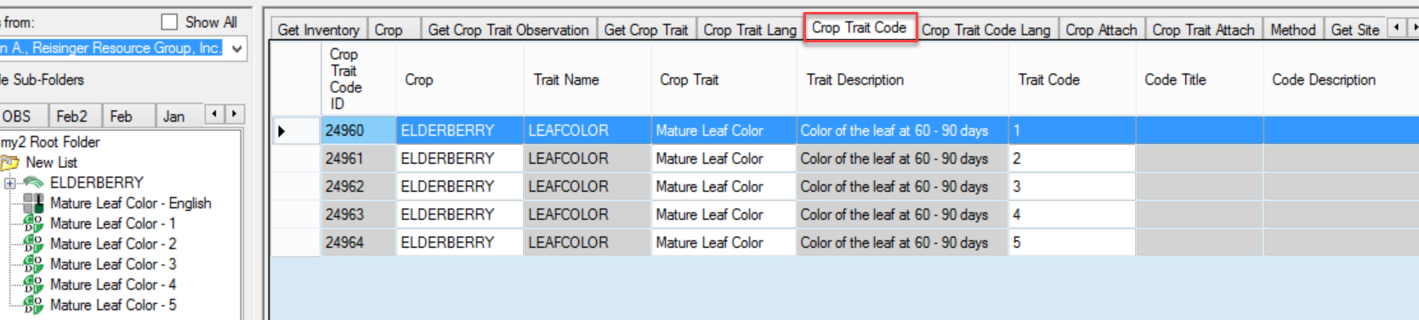
Practice! Add Trait Titles and Descriptions, using the Crop Trait Lang dataview.
Use the Crop Trait Lang tab of the Excel spreadsheet for your data source.

Crop Trait Code Lang
When creating the Crop Trait Code Lang records, four fields are required:
- Crop
- Crop Trait
- Code Definition
- Language
However, the primary purpose of this dataview is to make it possible to add Code Titles and/or Code Descriptions, so you actually need six fields.
Assuming you just completed the step to add Crop Trait Codes, you need to update the respective lookup, else you will get the following error when you attempt to add language records:
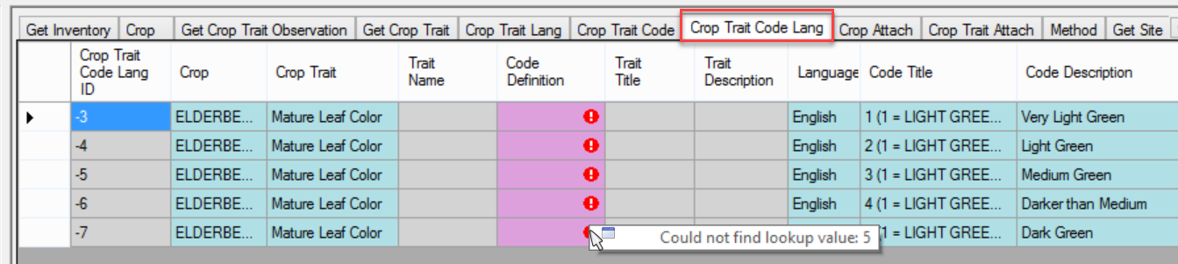
Therefore, launch the Lookup Table Loader and update the Crop Trait Code Lookup:
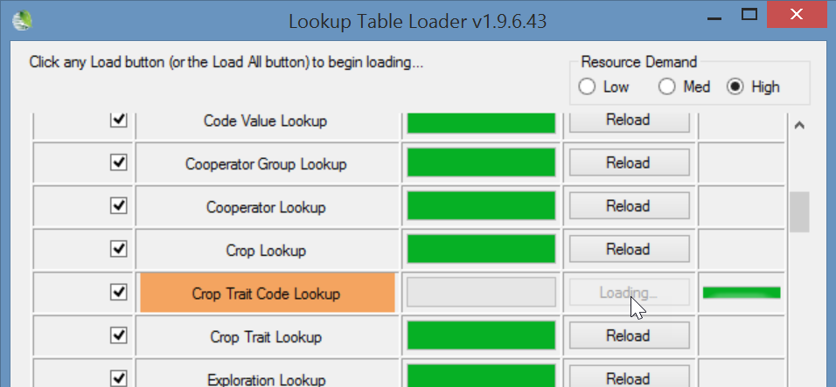
or use the Refresh Data button below the grid:
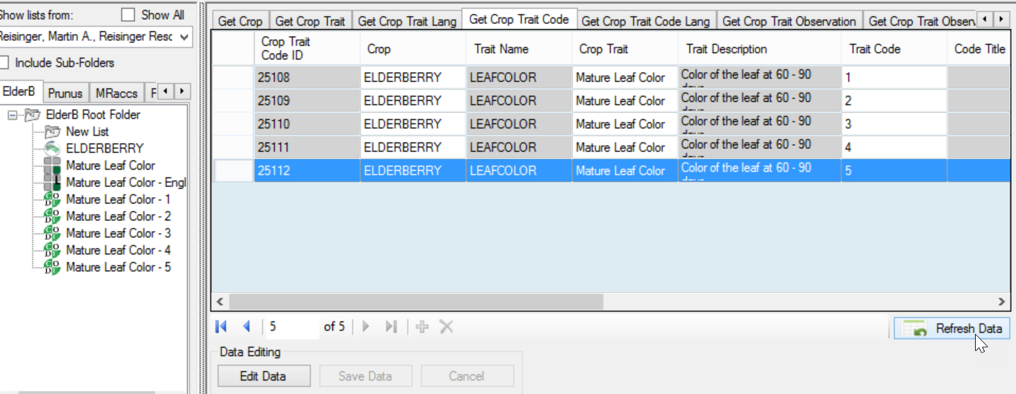
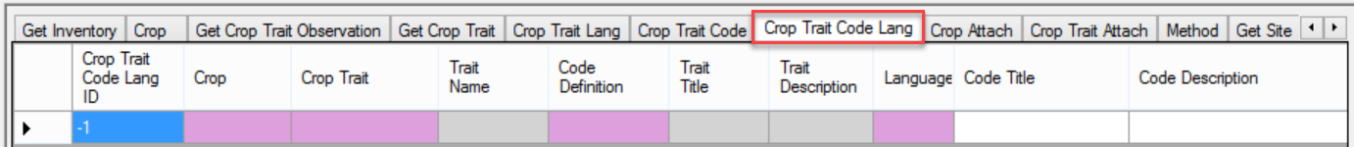
In the following examples, the scale runs from 1 to 5, but use 1 to 9, skipping every other number (for possible future codes. So use …1 3 5 7 9, not 1 2 3 4 5 )
The following Excel shows illustrates the spreadsheet ready for a drag and drop to the Curator Tool:
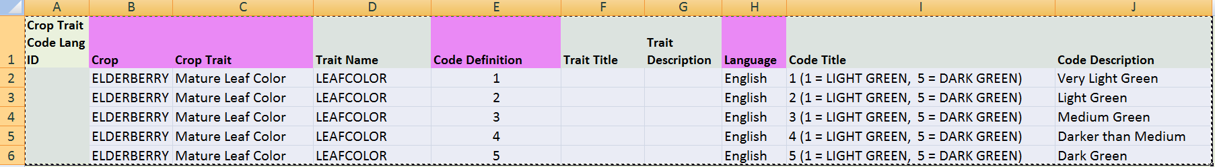
The following screen illustrates the CT before the save:
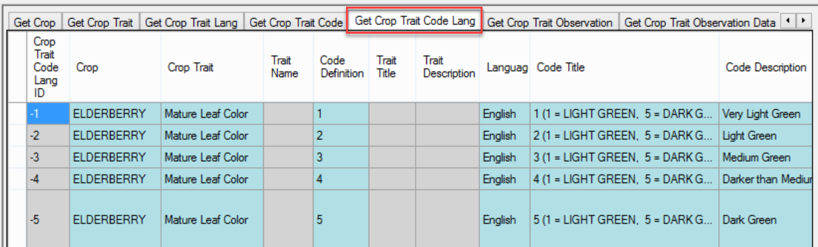
and this after:
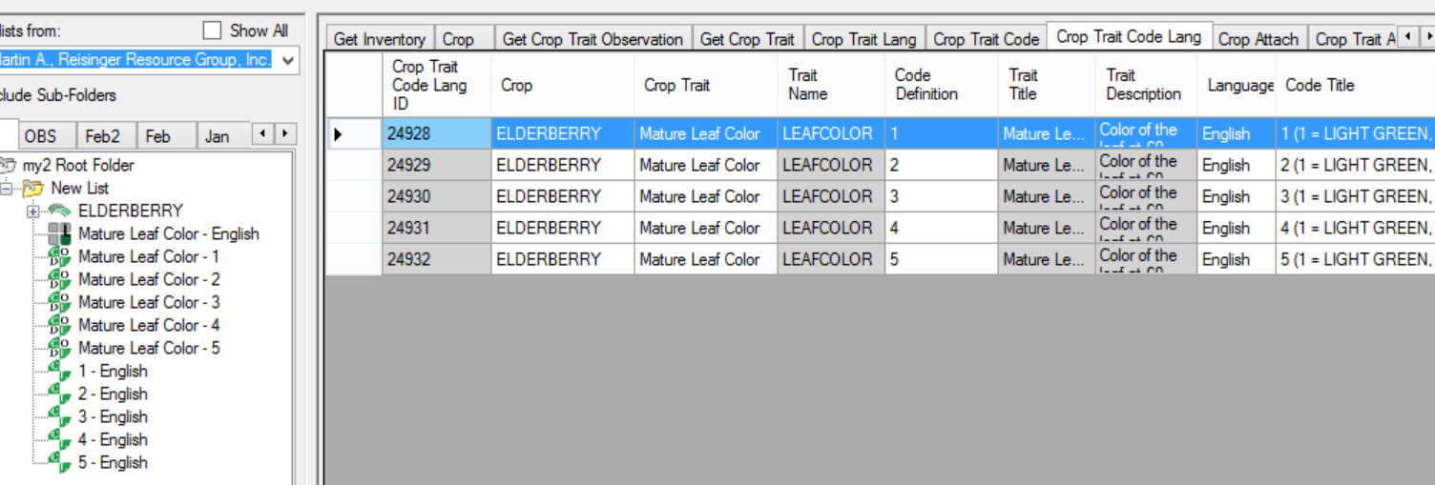
In the List Panel, right-click and Refresh your list:
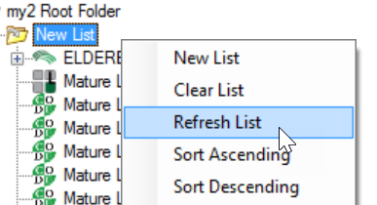
Ideally, the final result:
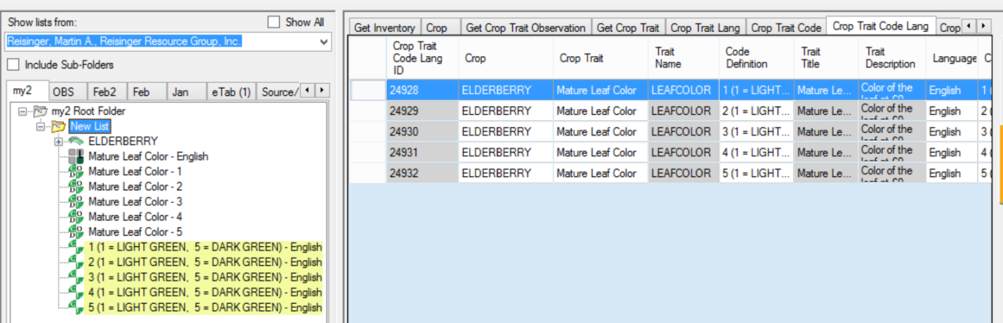

So, at this point, the Crop ELDERBERRY-XXX has been successfully defined, as well as one trait, LEAFCOLOR. LEAFCOLOR is a coded trait, and five codes have been defined for it.
Typically, additional traits and codes would be defined (and could have been at the same time when we created the LEAFCOLOR trait and codes). For simplicity, we won’t here, but instead move on to recording an observation using this new crop and trait.

Observations
The Observation dataview expects certain fields to be filled in:
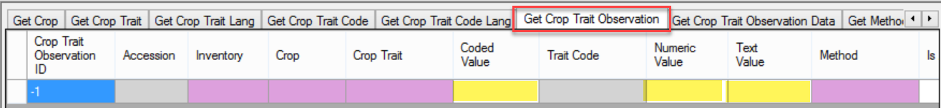
Note that this isn’t the complete dataview – it is wider than what is shown here and includes other fields. The main fields that must be entered are the four required fields (in pink) and only one of the three Value fields (highlighted here in yellow).
Continuing with our example, our trait is a coded trait, so we will be filling in the Coded Value field.
So far in this database we know there aren’t any accessions/inventory that have been observed for this new trait since we just created it. To be somewhat realistic, we’ll use an accession that is in the Sambucus genus. Notice in the Observation dataview above, we will be selecting an inventory record, not an accession. Why? Accession is a read-only field, but the reason is to have observations recorded at the inventory (lot) level, or at the accession level.
(When we want to record an observation for the accession, we will use the accession’s system inventory record. These records always have the ** for their type code.)

In Edit mode:
After we fill in the inventory, crop, trait, and a code:
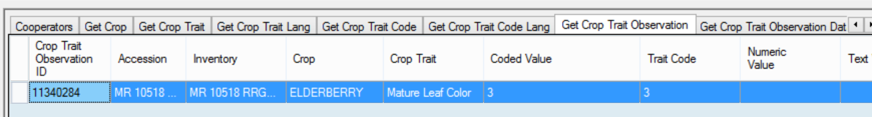
After we refresh the dataview:
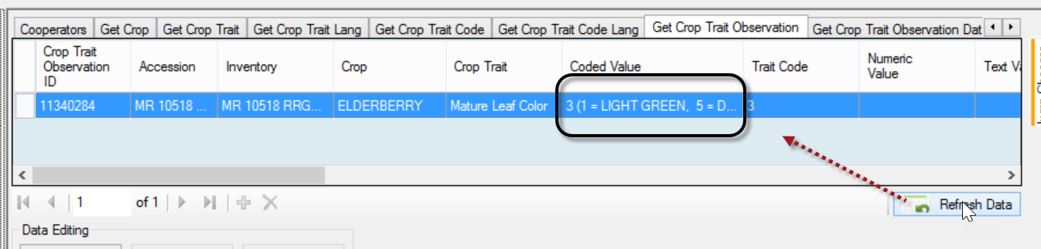
On the Public Website, before any observations are added in the Curator Tool, there will be no crop records for the taxonomy Sambucus.
To search for a crop’s observations, we start at Descriptors on the Public Website menu:
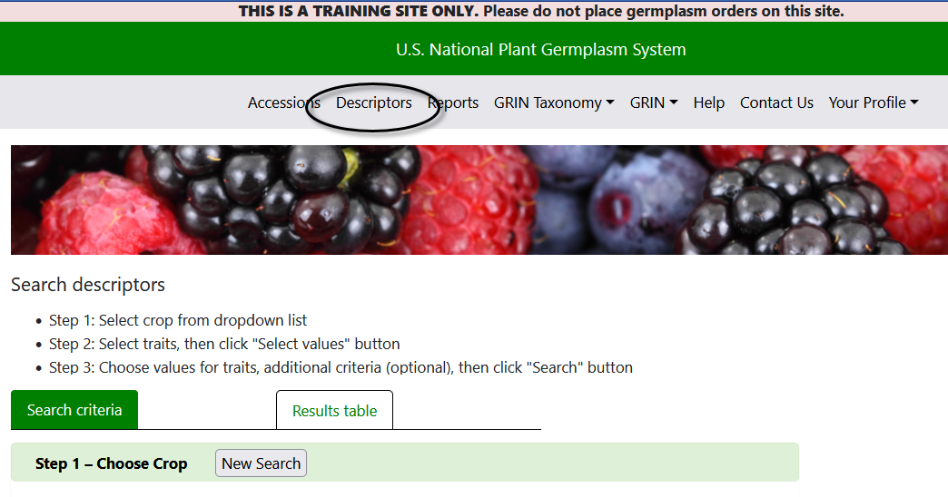
Select your crop:
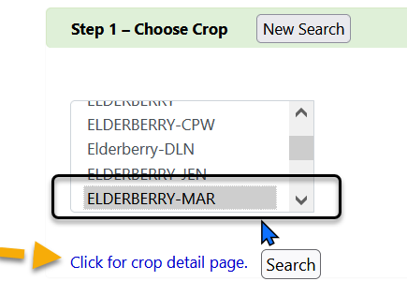
Select Traits and values:
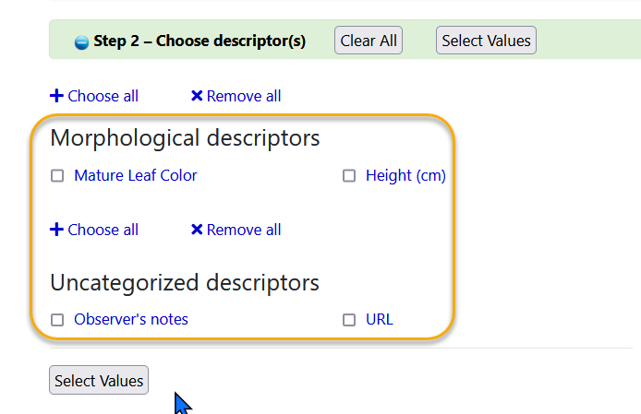
Alternatively, search for your accession(s) that you remember making observations for, and then looking for the observations on the results page:
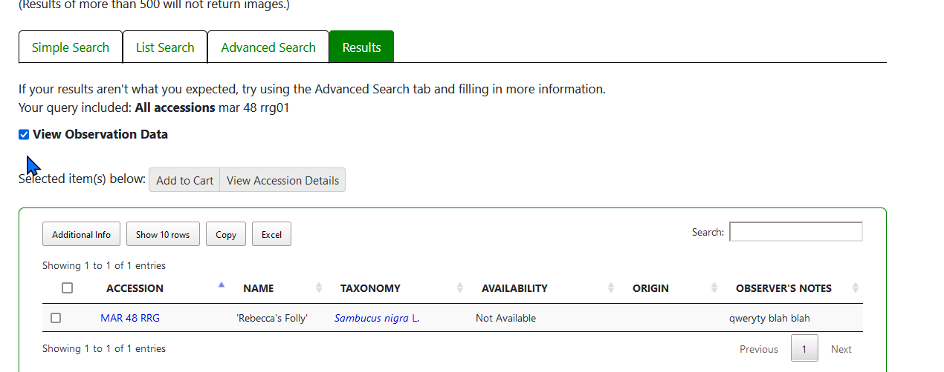
Practice! Add some observations for your inventory.
The spreadsheet has sample observations in the Observation tab.

Points to Remember
- Before a single observation for an accession can be recorded, the curator / genebank staff must define the crops, method, the traits, and any codes that may be used with specific traits.

- The Trait & Code Titles and Descriptions are added also, but in their respective Trait and Code Lang dataviews.
- It is possible to have a species be used in more than one crop. For example, in NPGS, Vitis vinifera is in two crops. (The Taxonomy Crop Map makes this possible.) Refer to the document Observations and Descriptors: CROP Dataviews online at https://www.grin-global.org/docs/gg_observations_and_descriptors.docx for details on setting up the Crop Map records or as discussed earlier.
 | When recording an observation, it is not obvious which value type is valid: Coded, Numeric, or Text. When uncertain, use the Search Tool to look up the traits, or perhaps better yet, set up a folder with the crop in it. When the crop is selected in the List Panel, with the Get Crop Trait dataview active in the right panel, you can review the traits and determine what is expected – coded, numeric, or text value.  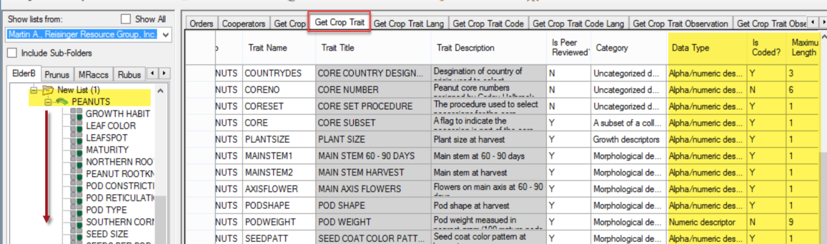
Remember:
A trait is designed to hold one of three kinds of data. The trait determines which type of observation can be entered:
- Text
- Numeric
- Coded
When defining the trait, two fields determine the data type:
Type of data | Field: Data Type | Field: Is Coded?
text (“string”) | Alpha/numeric descriptor | - no -
numeric | Numeric descriptor | - no -
coded | Can be any Data Type, but Numeric is recommended | - yes -
The three types are mutually exclusive. When recording an observation record, one of the values is required.

Appendix: Document Change Notes

– January 25, 2024
- additional material, major review and screen changes

– February 27, 2021
- additional material, especially on mapping

– August 6, 2020
- included practice / exercise material

– March 1, 2020
- included reference for Crop Map details

